

**UNIVERSITY OF PETROLEUM & ENERGY STUDIES**

**Dehradun**

[**Application Containerization Lab**](https://learn.upes.ac.in/webapps/blackboard/execute/launcher?type=Course&id=_49490_1&url=)

**Experiment-9**

**Name: Aakarshit Agarwal**

**Course: B. TECH CSE DevOps (2018-22)**

**Roll no.: R171218001**

**Sapid: 500067782**

**Experiment-9**

**Aim:** Build Docker Image using .Dockerignore file.

1) Checking the contents of dockerfile

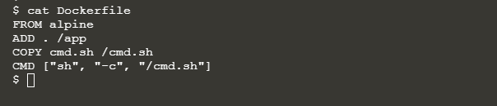

2) Building image

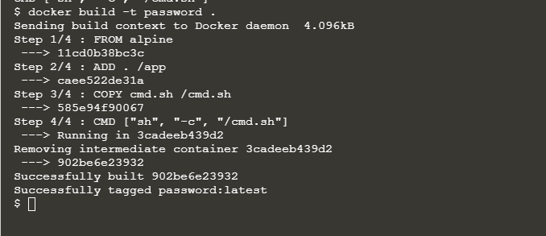

3) Checking the app folder

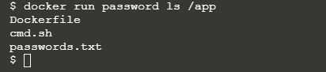

4) Ignoring the password file and checking the app folder

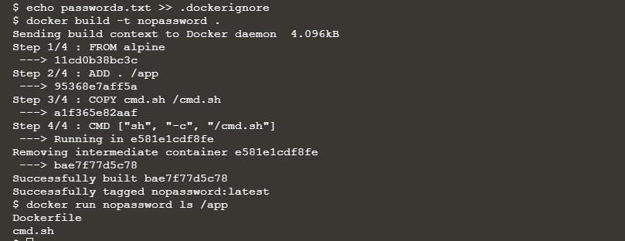

5) Adding a large file

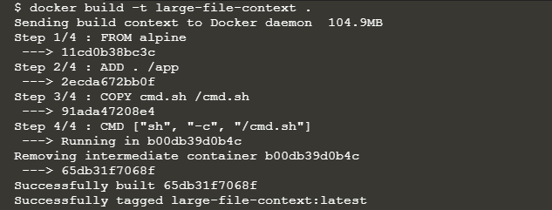

6) Ignoring the big file and building image

