Name: Aayush Kumar

R171218002

500069079

**Experiment 10**

**Aim:** Kubernetes Minikube installation and fundamentals.

**Procedure:**

**1)** Installing **minikube** by **Windows Installer:**

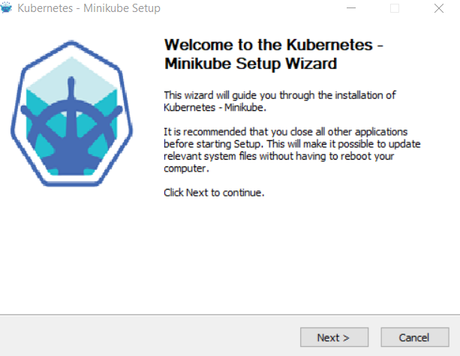

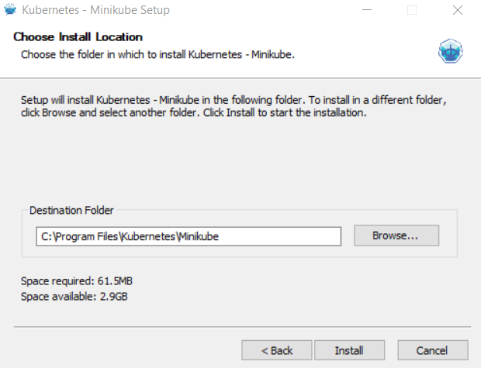

**2)** After downloading **minikube** the directory would look something like the following:

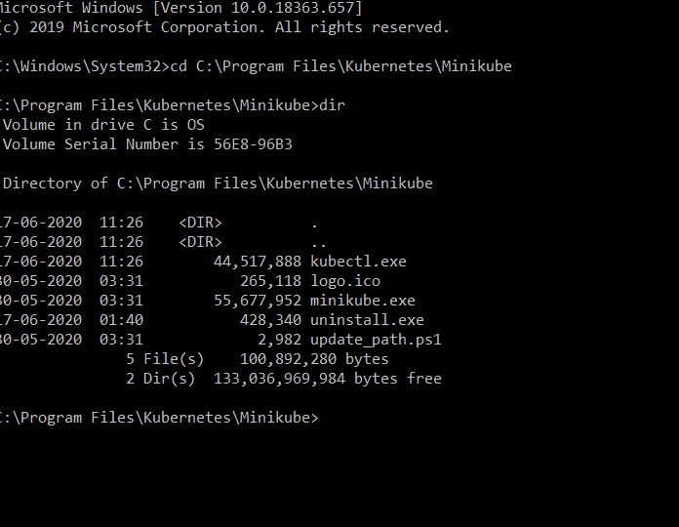

**3)** Downloading the **kubectl** command to interact with the **kubernetes** cluster, downloading in the **same** location as the minikube program:

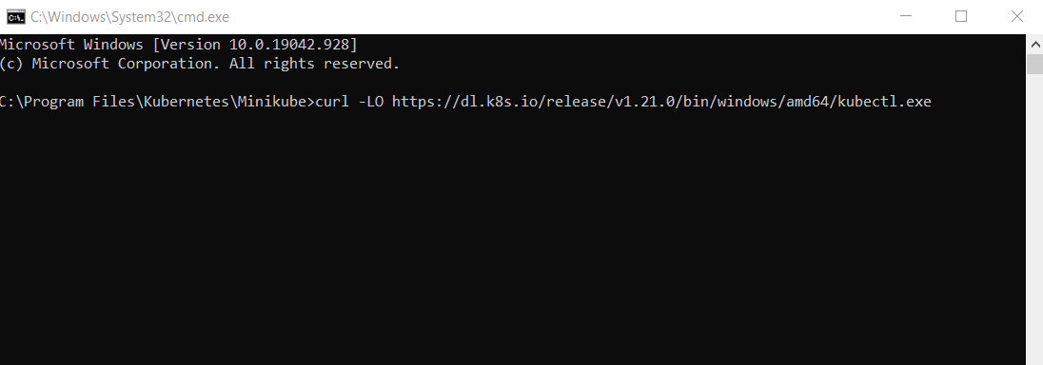

**4)** Starting the **minikube** cluster configured with **kubernetes** and checking its status:

