Name: Aayush Kumar

R171218002

500069079

**Experiment 11**

**Aim:** Deploying Pods and Services on minikube.

**1)** Starting the Minikube.

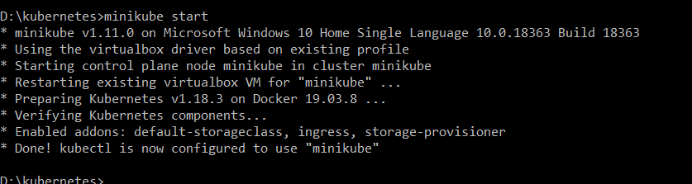

**2)** Creating a pod with image.

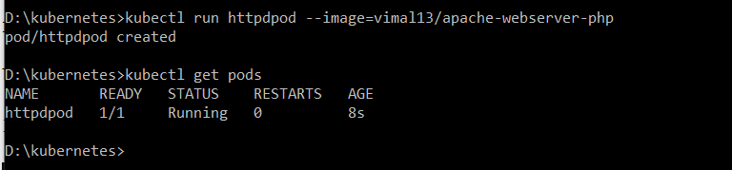

**3)** Expsoing the pod with the NodePort type.

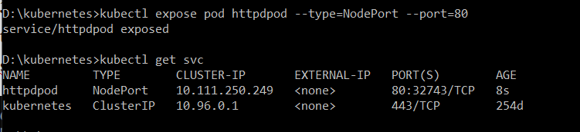

1. Browser Output.

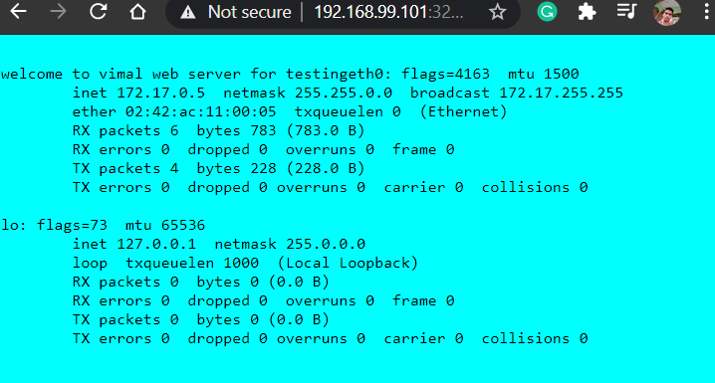

Using YAML File:

1. Write a yaml configuration.

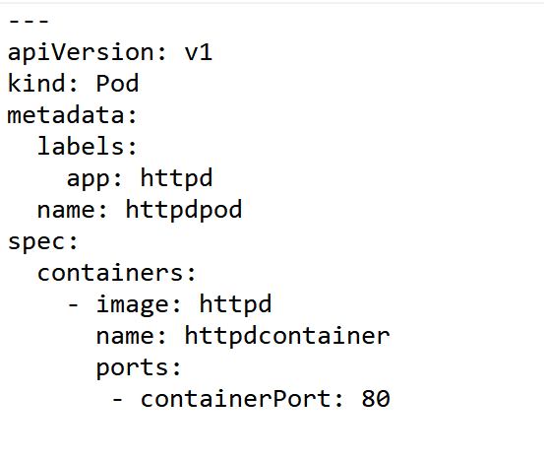

**2)** Creating a pod from the above file using **kubectl create –f** command.

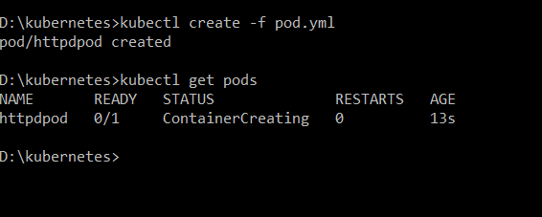

3)Write a service configuration.

