Name: Aayush Kumar

R171218002

500069079

**Experiment 12**

**Aim:** Implement Docker Container Restart Policy.

1. We give the restart policy to the container while creating it using the **–restart** option.

For **always** option:

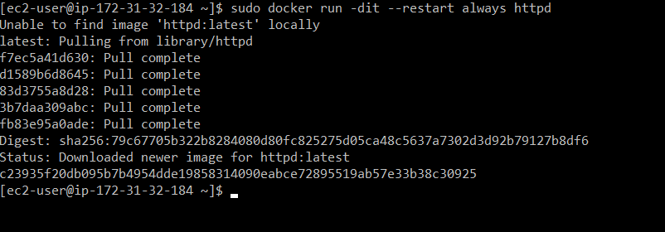

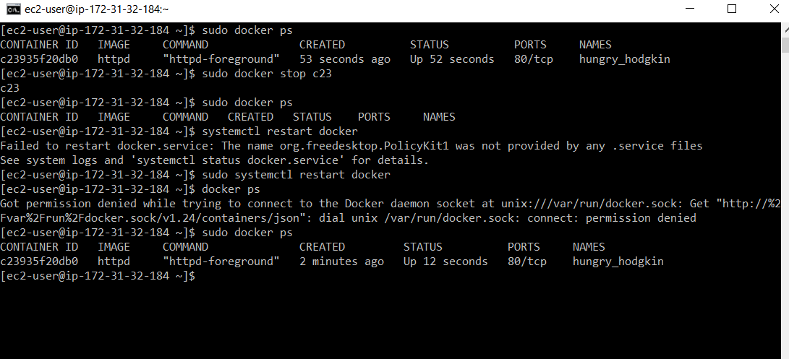

As it can be seen the **container restarts** as soon as the **daemon reloads**.

1. For **unless-stopped** option**:**

Updating the restart policy using the **docker update --restart unless-stopped** command.

As it can be seen the container **does not restart** after the **daemon reloads**.

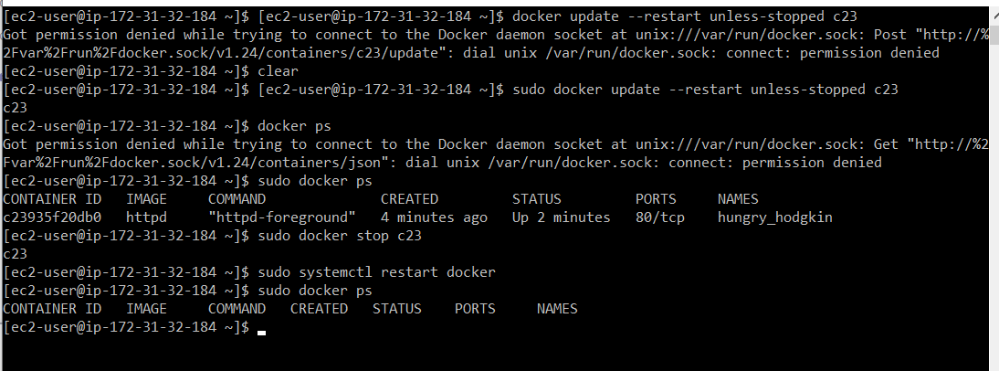

1. For **no** option:

Updating the restart policy using the **docker update --restart unless-stopped** command.

As it can be seen the container **does not restart** after the **daemon reloads**.

