Name: Aayush Kumar

R171218002

DevOps B1

**Experiment 4**

**Aim:** Create a docker image using Dockerfile. Upload the image created on Dockerhub, also launch a container via the image.

**Step 1:** Write the code for the Dockerfile.

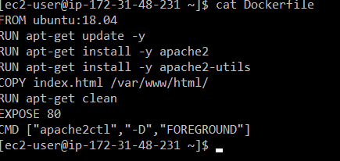

**Step 2:** Build the Dockerfile using the **docker build** command.

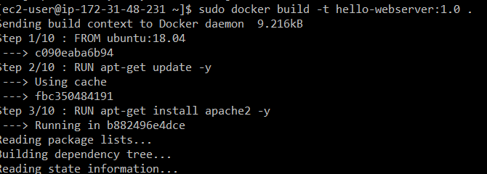

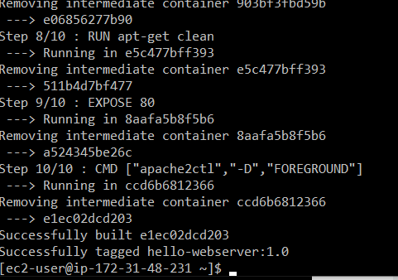

**Step 3:** To push the image created the name of the image has to be changed to the format:

<usernameOnDockerhub>/imagename

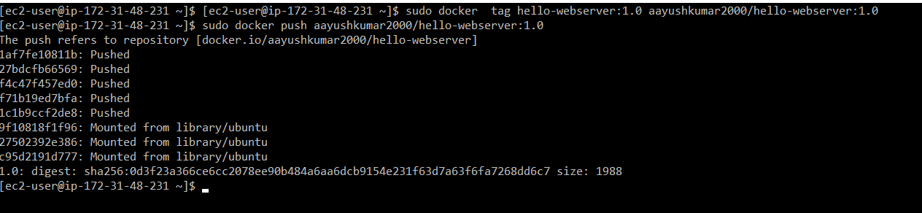

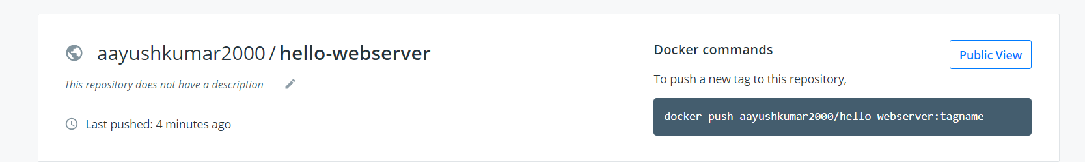

**Step 4:** Launching a container with the image created.

