Name: Aayush Kumar

R171218002

500069079

DevOps

**Experiment 6**

**Aim:** To link one container with another container while launching and monitor the container.

1. First launch one container using command **docker run**. Now while launching another container use option **--link <container-1-name:alias>**

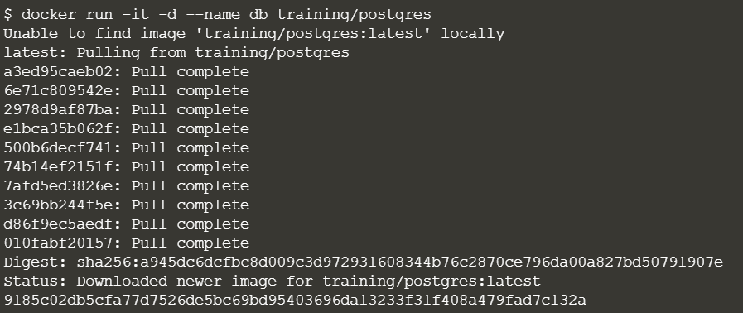

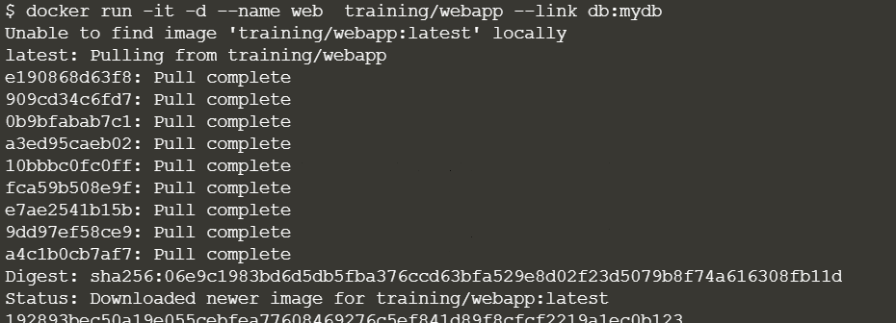

1. Now go inside the second container using command **docker exec -it <container-name> bash**. Once inside the container use **ping** command to ping to first container using.

