Name: Aayush Kumar

R171218002

500069079

DevOps

**Experiment 7**

**Aim:** To create Docker swarm cluster.

1. Use command **docker swarm init** on a node to initialize it as master node.Copy this docker swarm join --token command and run it on the another node to join it in the swarm clusterand configure it as worker node.

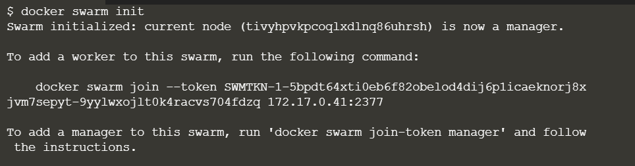

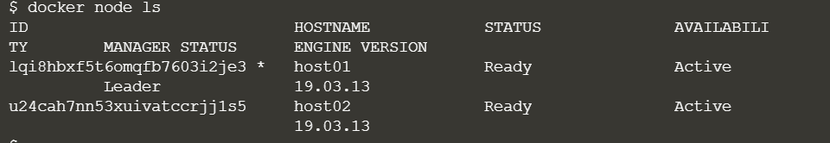

1. To create an overlay network via swarm manager node, use command **docker network create -d overlay app1-network**.

To create a service, use command  
**docker service create --network <network-name> -p <port-forwading> --replicas <replicas> --name <service-name> <image-name>.**

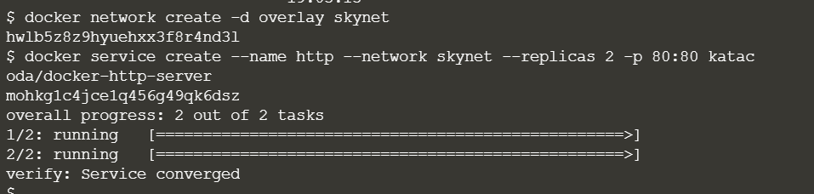

1. Use command **docker service ps <service-name>** to check the state of the service.

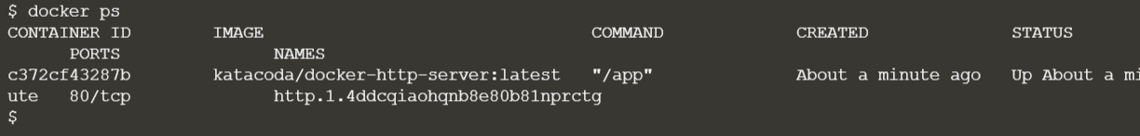

1. Using the ping command

