Name: Aayush Kumar

R171218002

500069079

DevOps B1

**Experiment 5**

**Aim:** To create Docker compose file and launch container using it.

1. First create a **docker-compose.yml** file and inside the file write the code as follows:

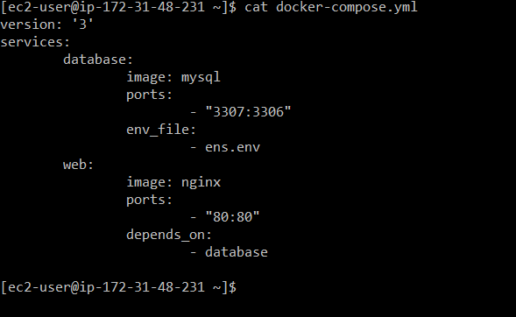

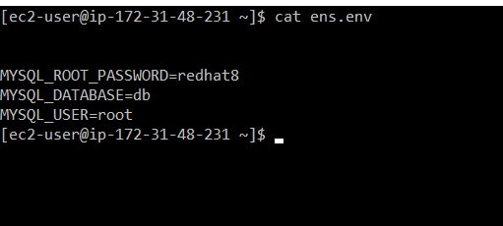

1. After creating docker-compose file, use command  
   **docker-compose up** to launch the architecture in one go. Use option **-d** to hide the terminal output.

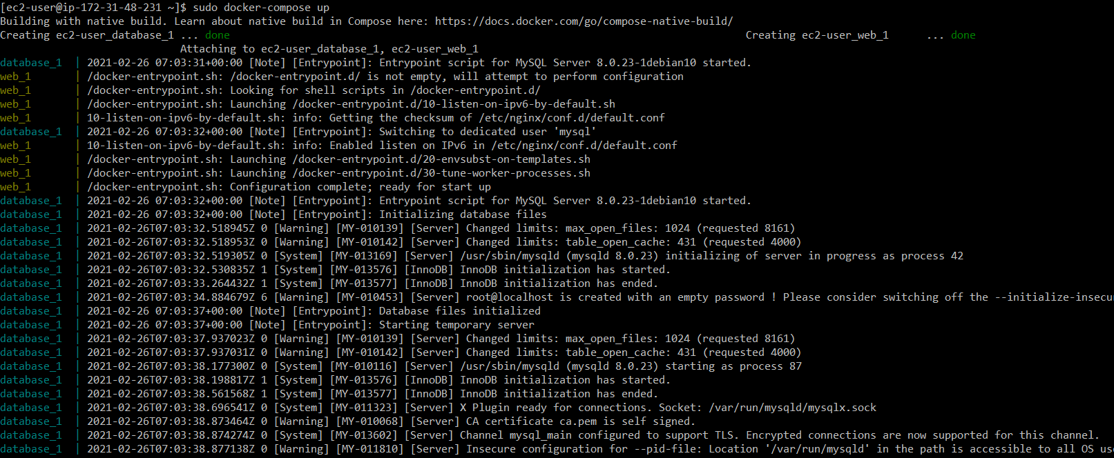



**3)** Use command **docker-compose down** to stop all your architecture in one go.

