Application Containerization Lab

**Name: ABHISHEK SHARMA**

**Roll No: R171218005**

Experiment – 1

(Setting up a virtual machine on Vagrant)

Making Vagrantfile in the directory

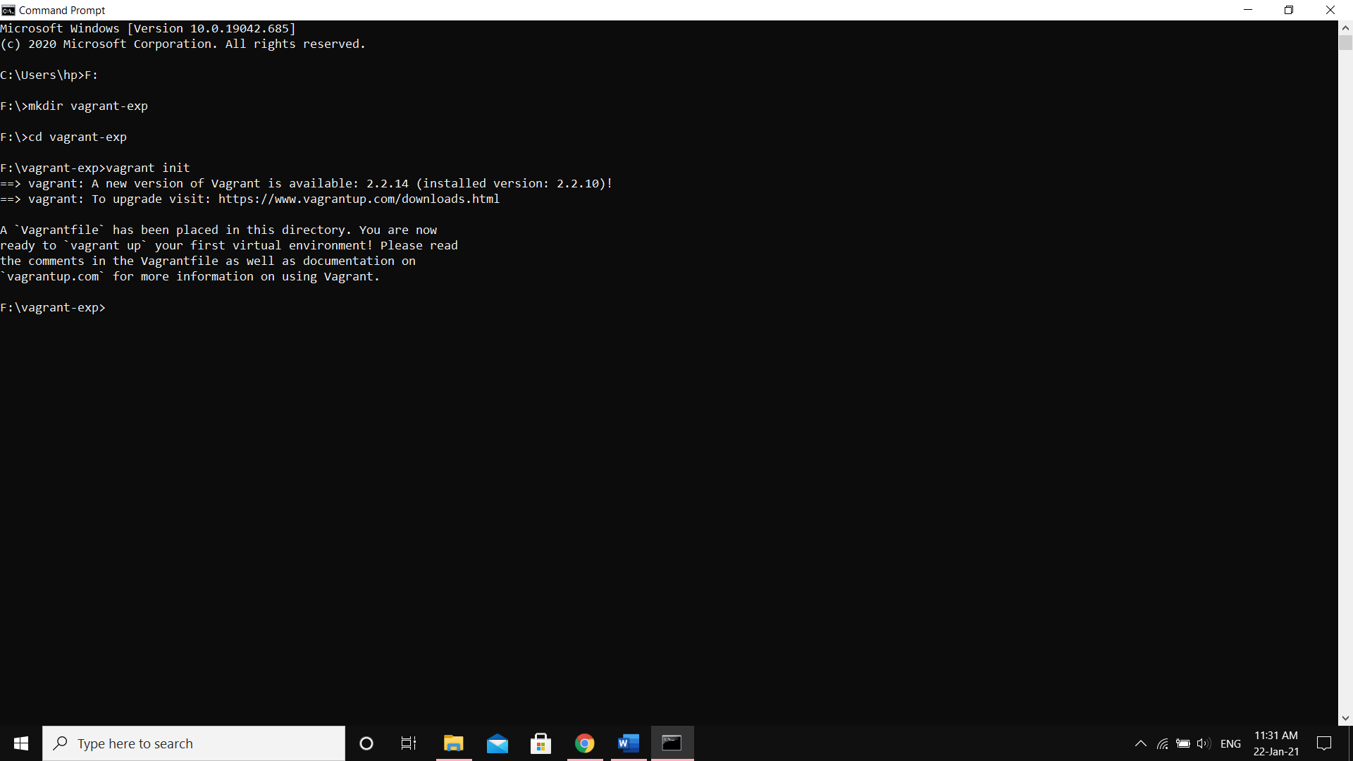

Configuring the Vagrantfile for required VM

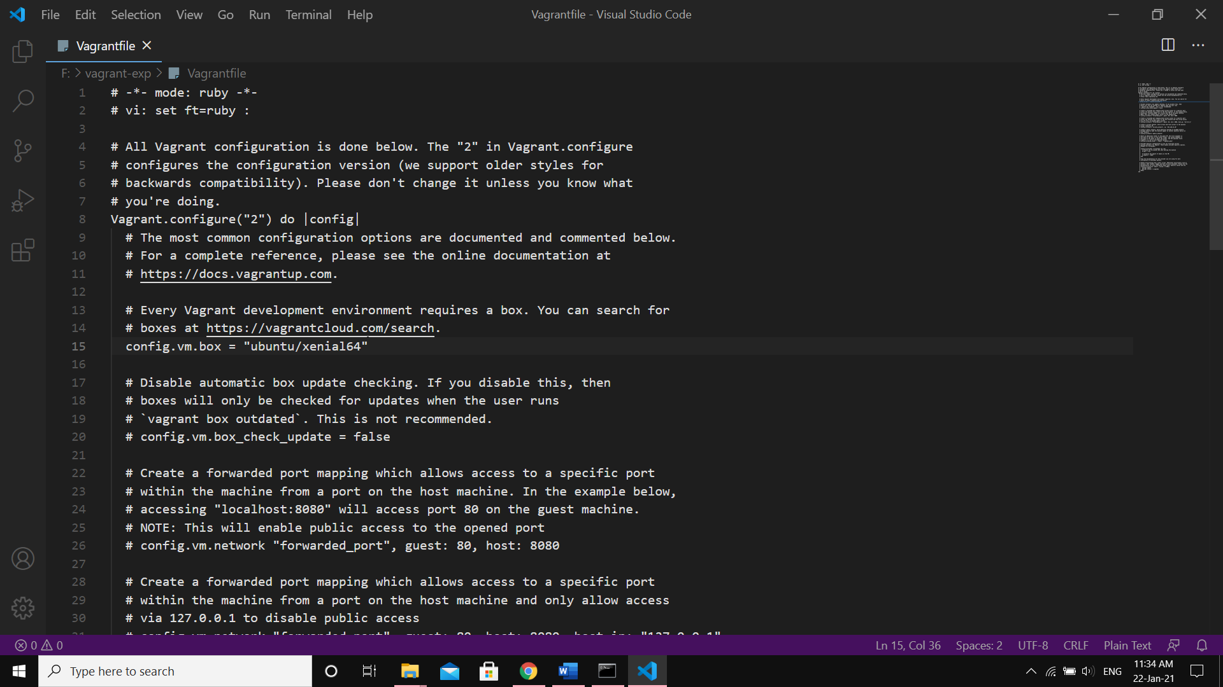

Configuring VM according to Vagrantfile

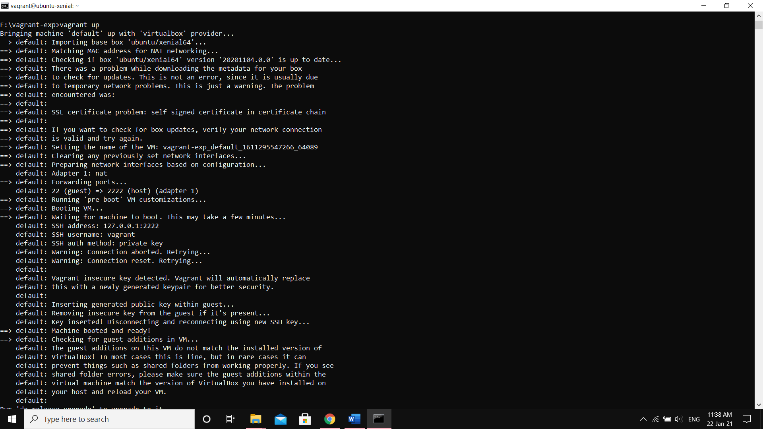

Starting the Virtual Machine

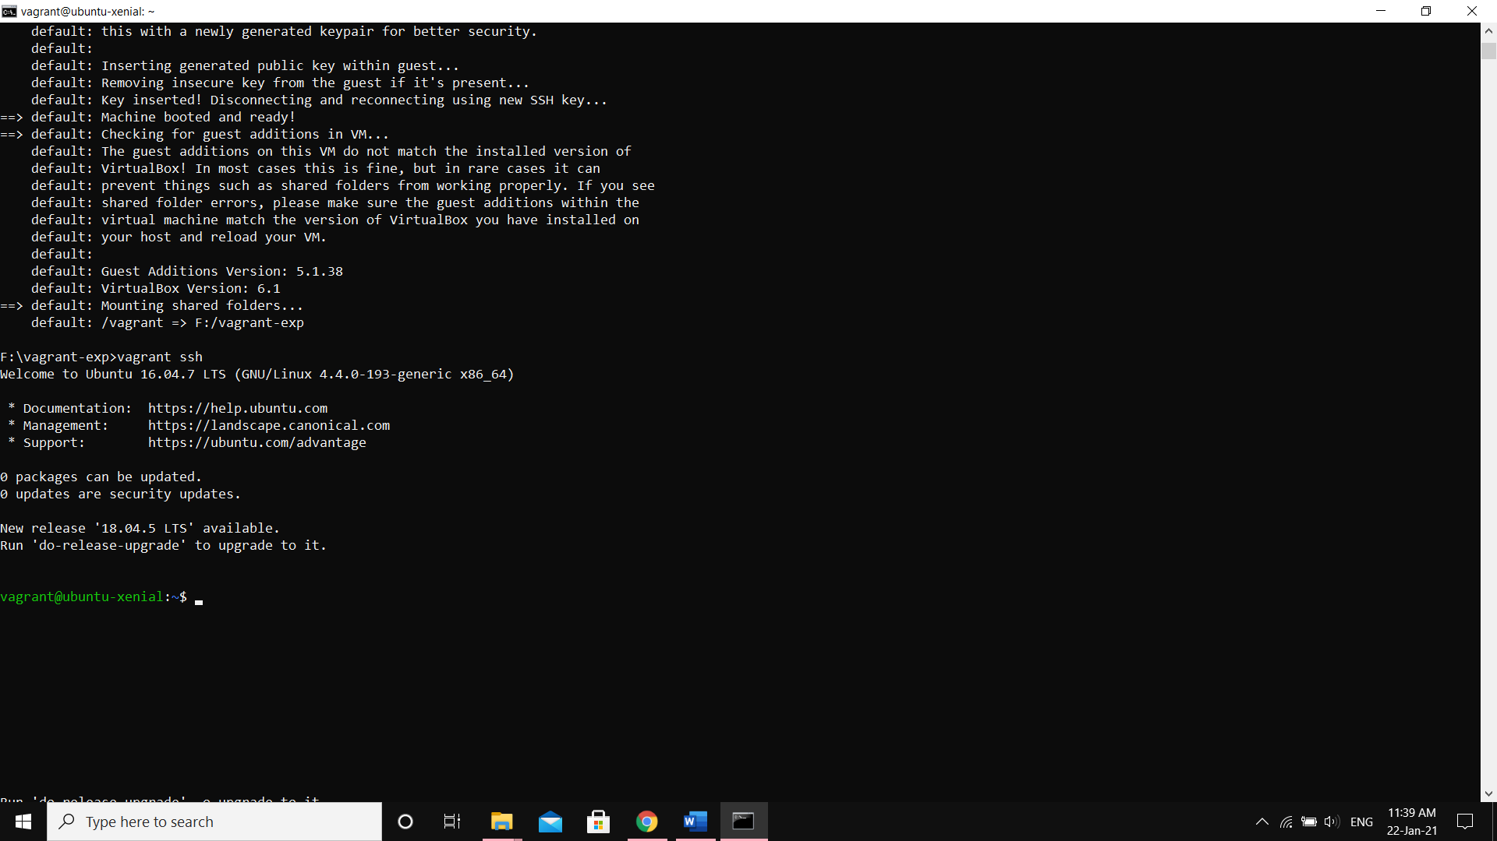

Exiting the Virtual Machine

