Application Containerization Lab

**Name: ABHISHEK SHARMA**

**Roll No: R171218005**

Experiment – 2

(Docker Volumes)

Starting VM

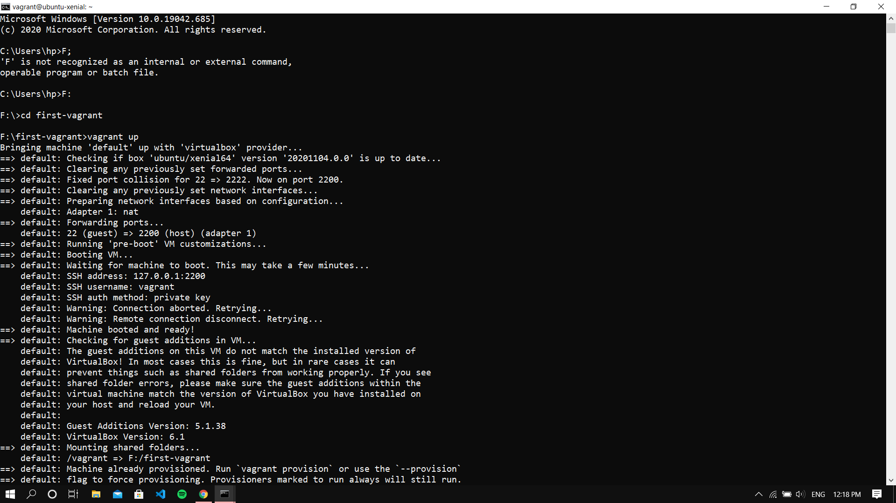

Listing all the volumes in docker and inspecting a volume

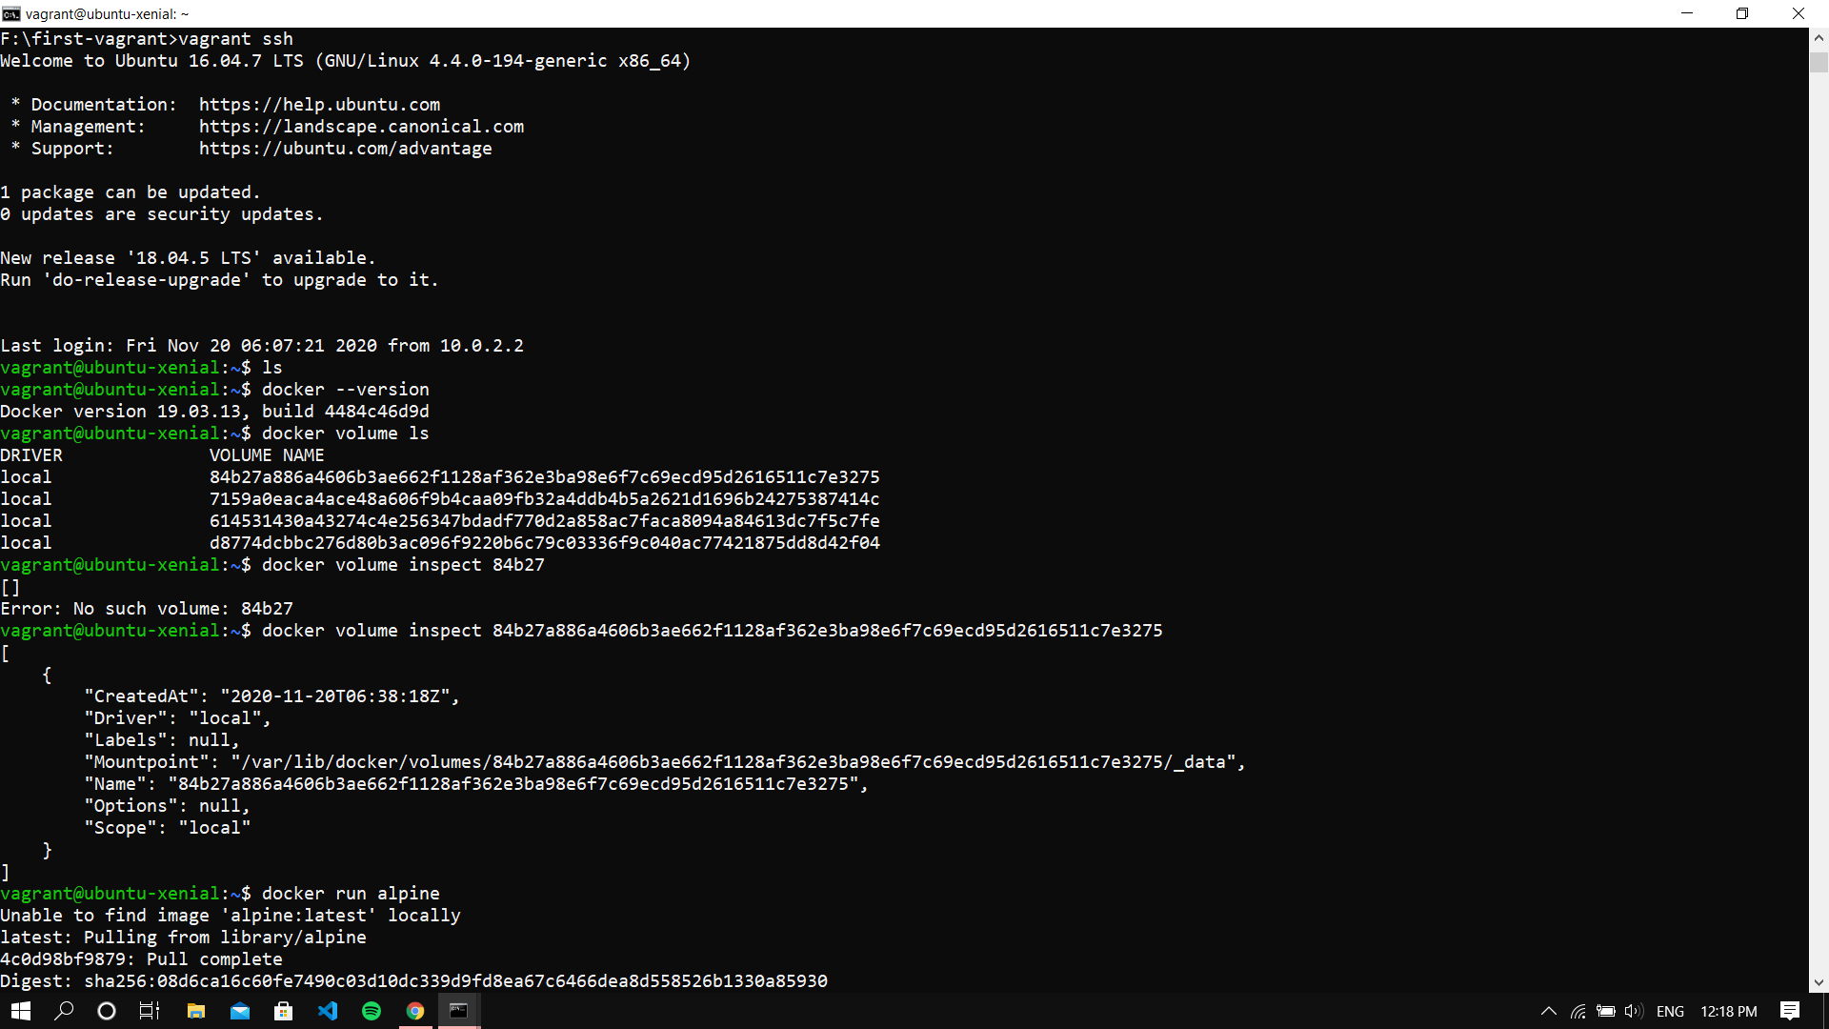

Running an Alpine Image

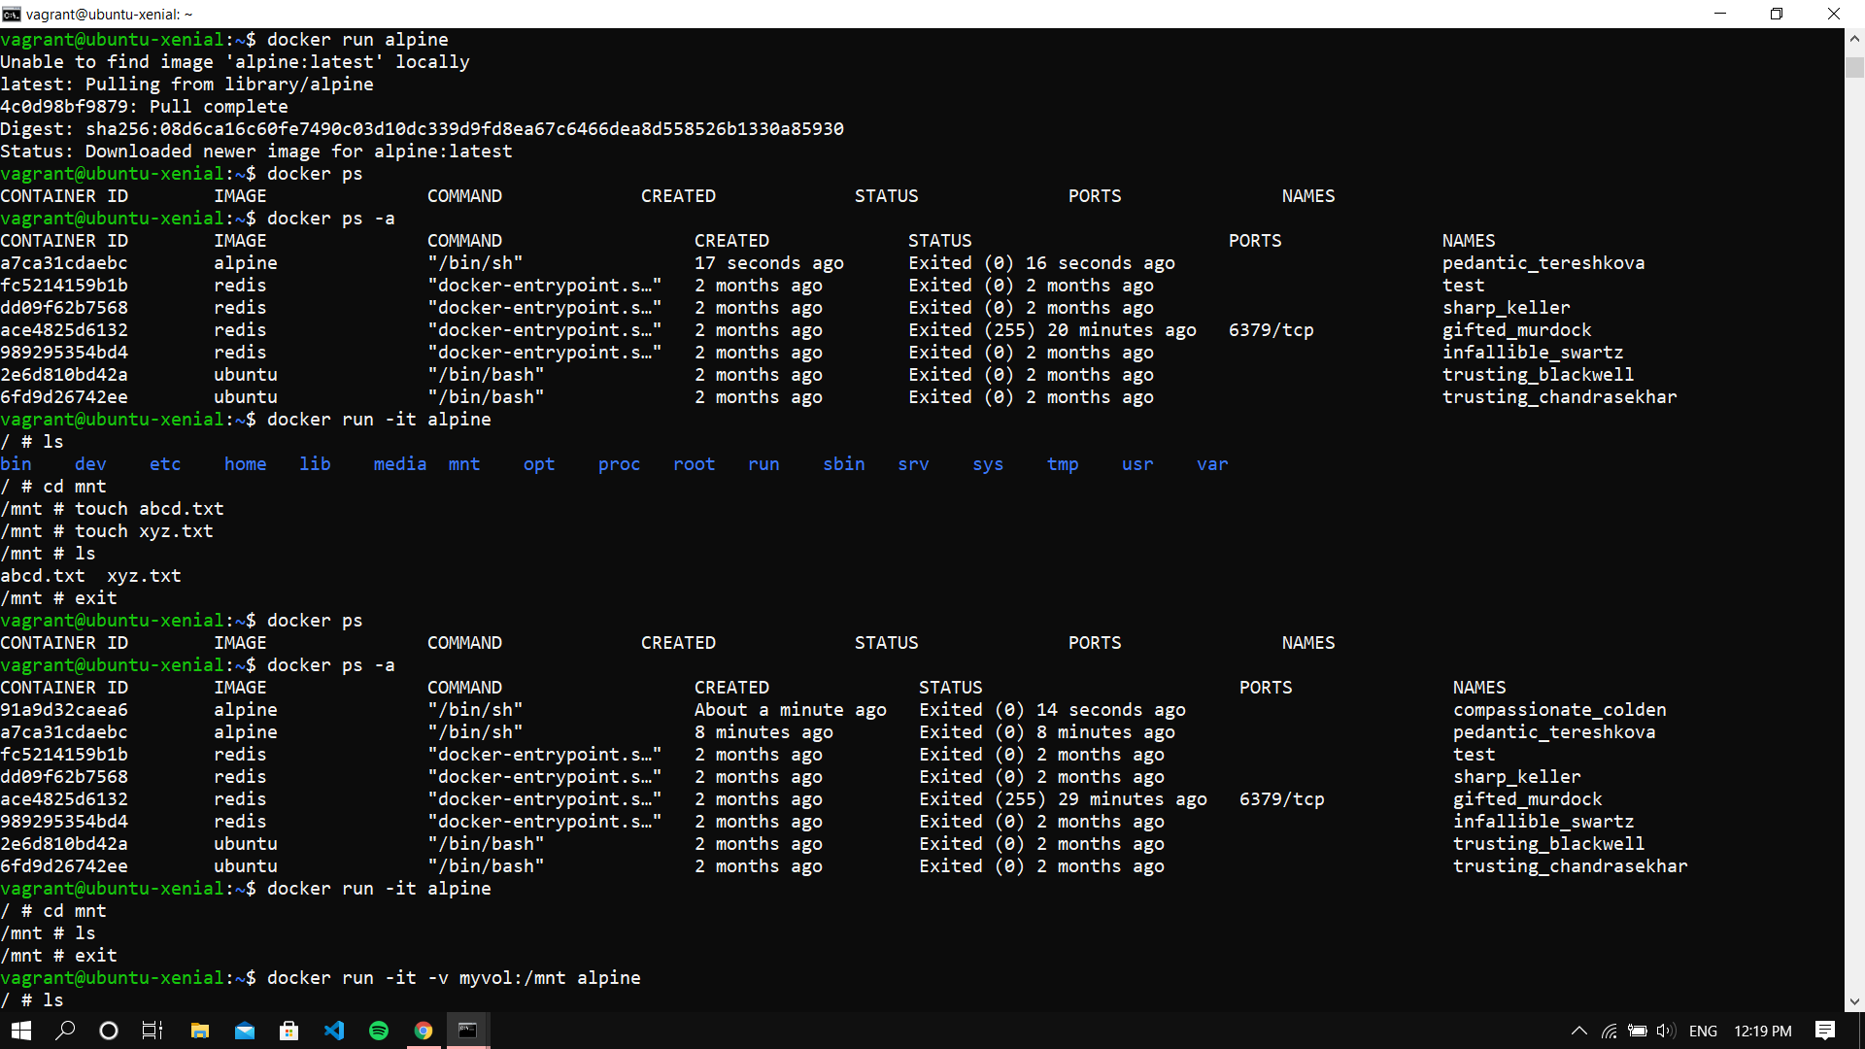

Creating some files in that alpine cont.

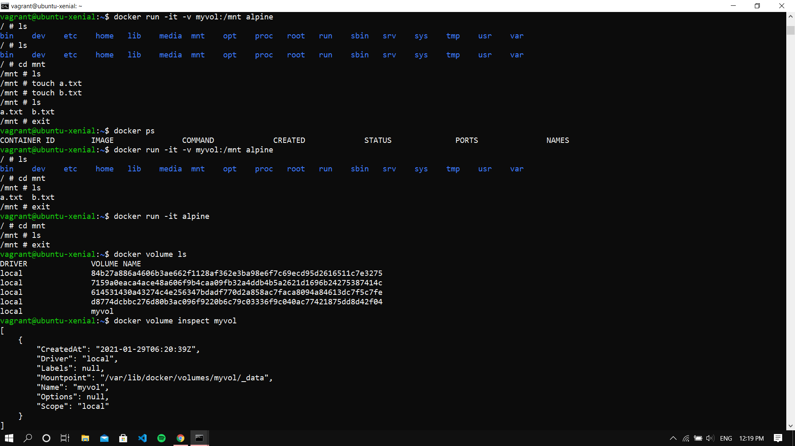

Creating Container with Volume

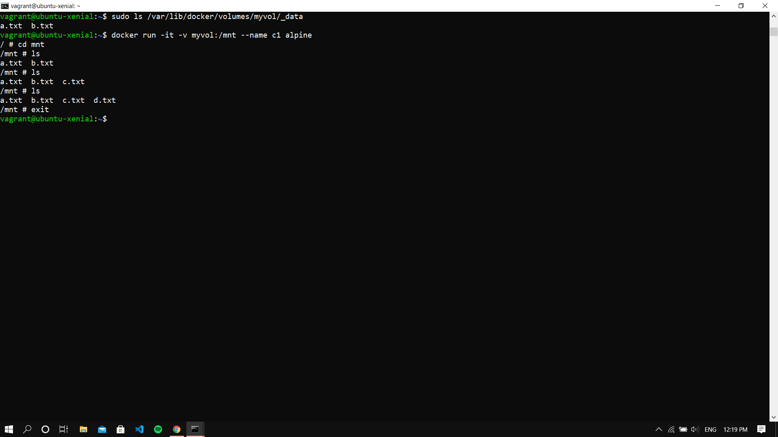

In another instance of terminal, starting a VM and running docker in that

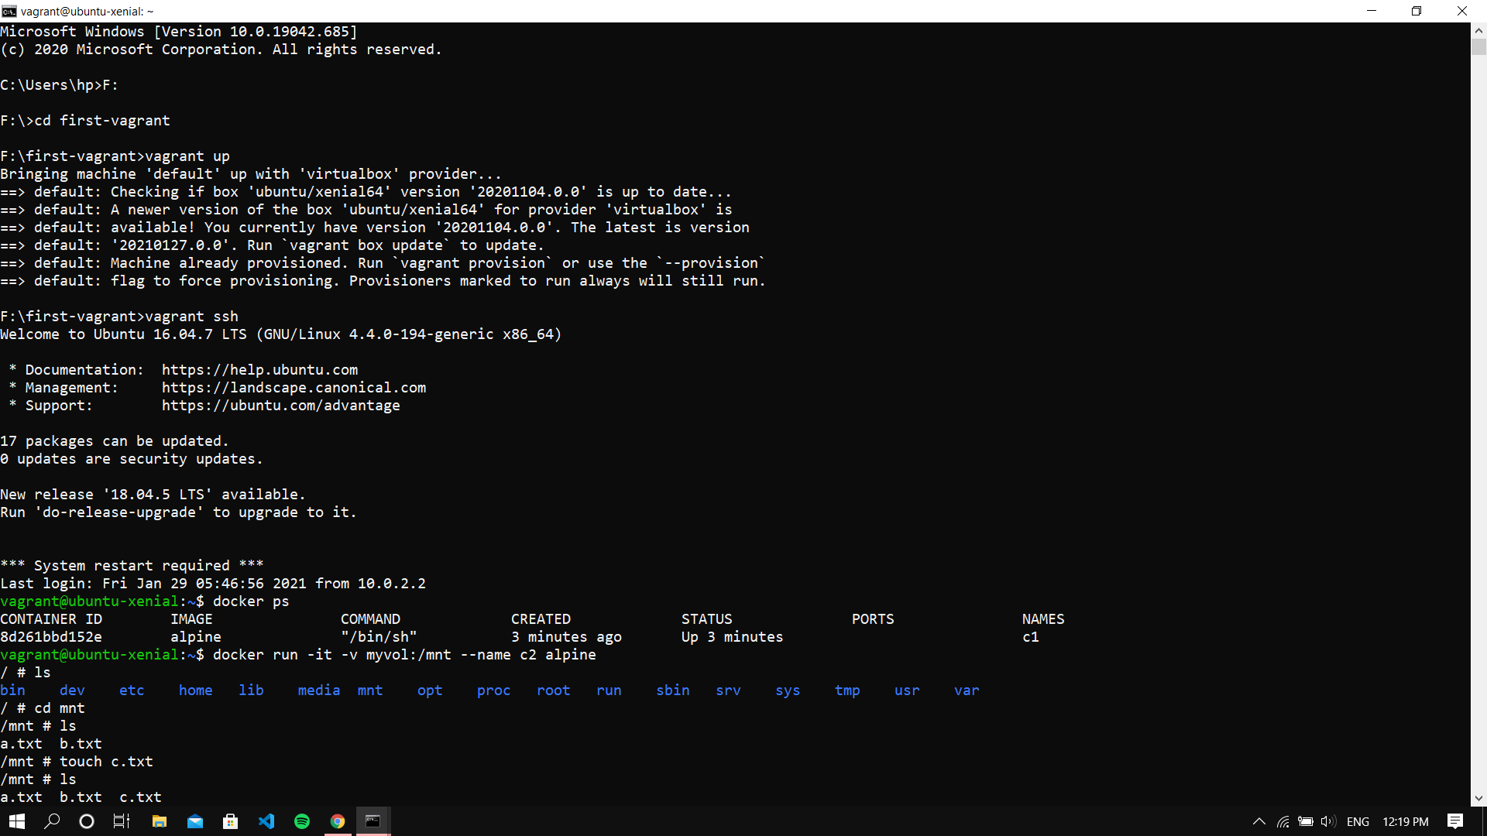

All the files show synced up

