Application Containerization Lab

**Name: ABHISHEK SHARMA**

**Roll No: R171218005**

Experiment – 3

(Docker Networks)

Starting VM

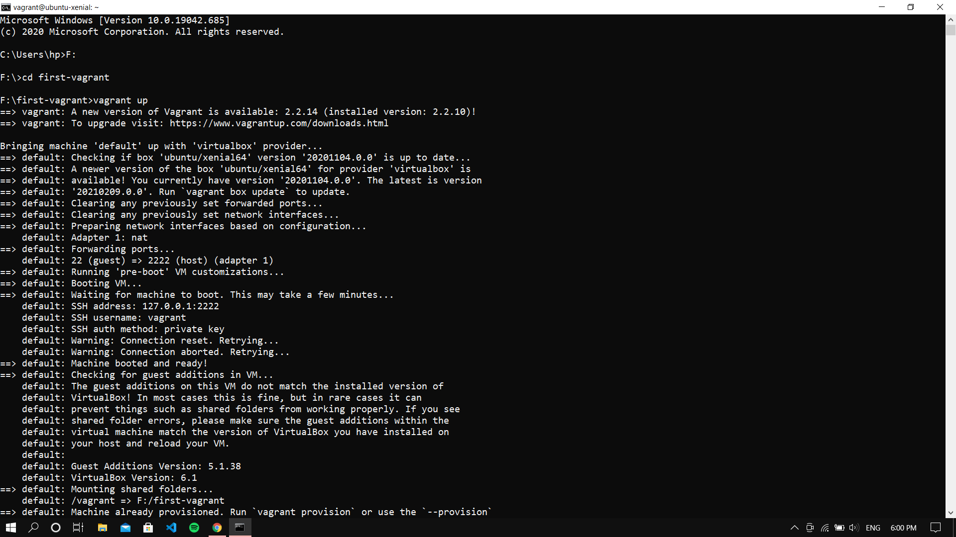

Creating a Network **nw1** and creating a Redis container cr1

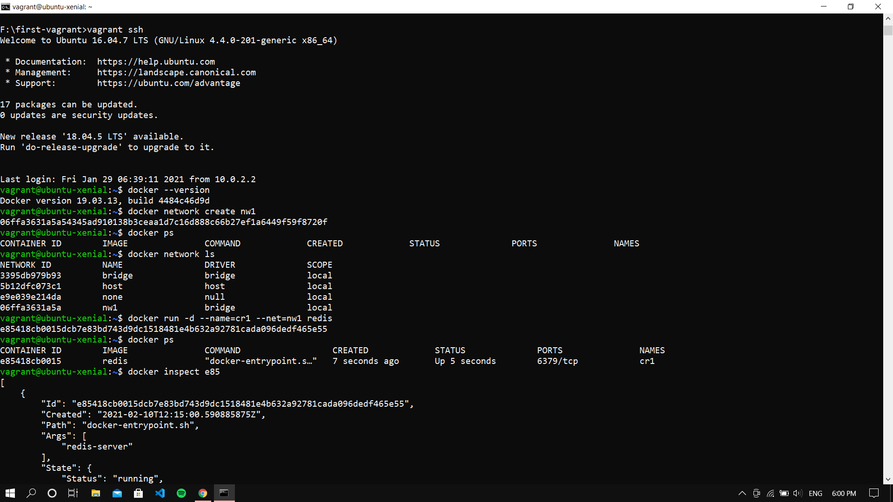

Inspecting the image

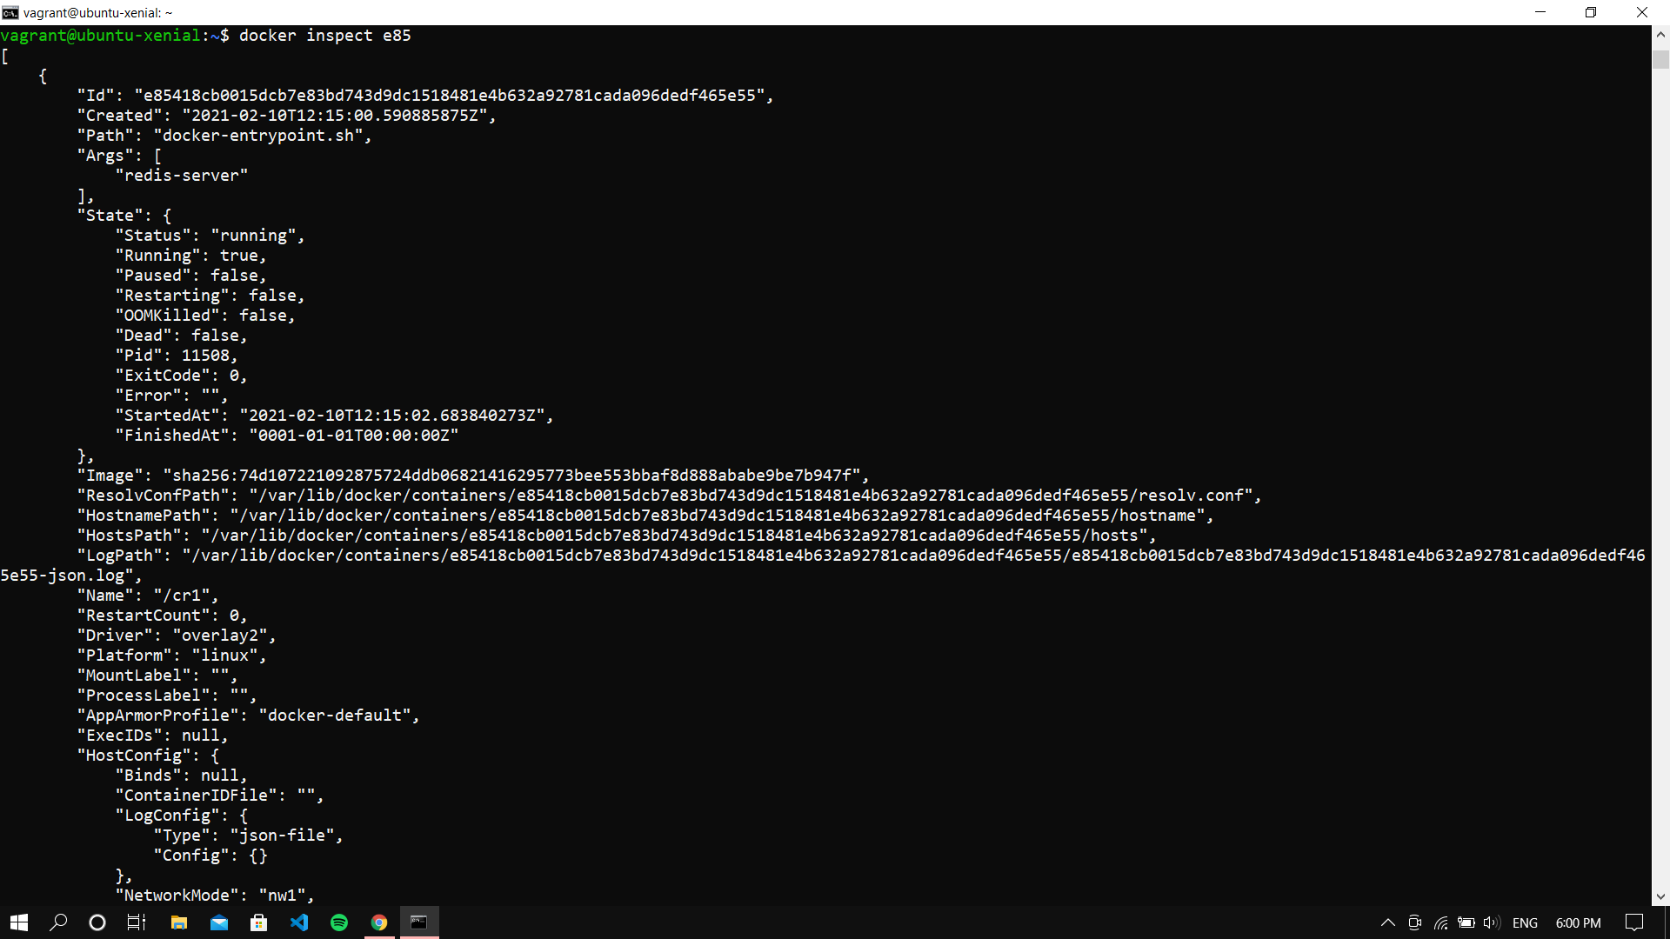

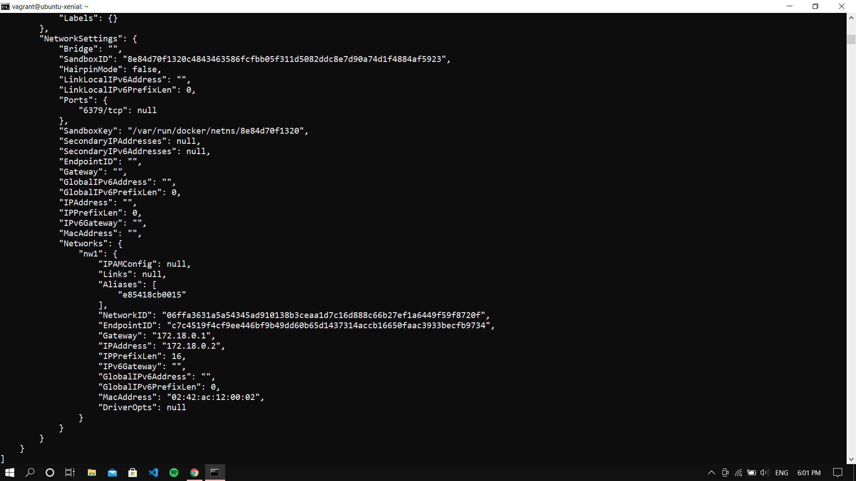

Creating container cr2 in network nw1

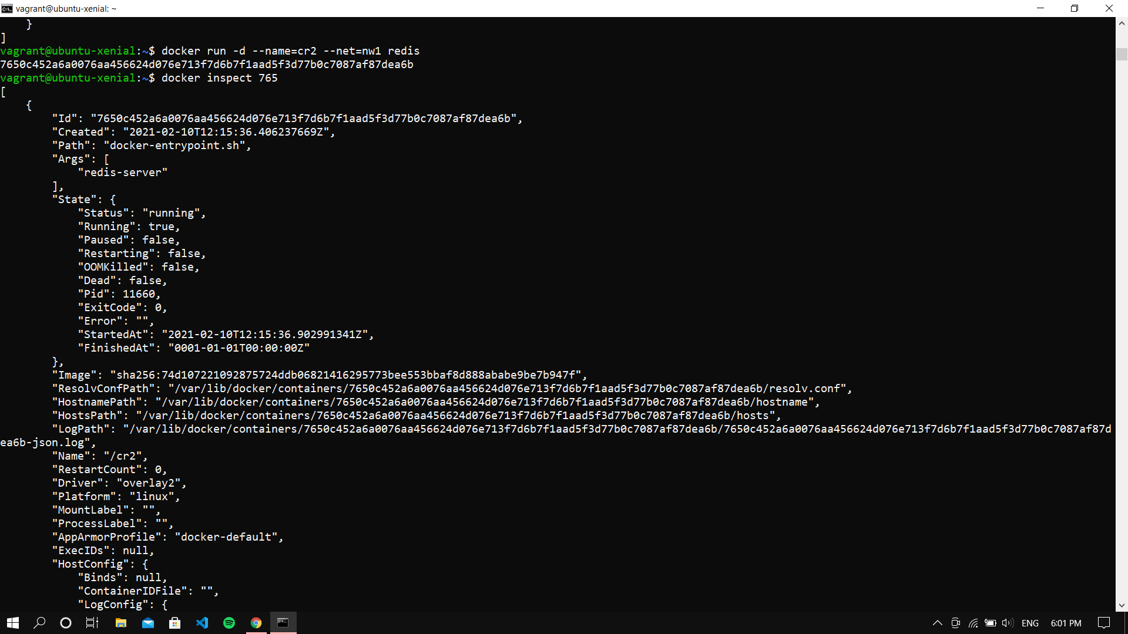

Inspecting the cr2 container

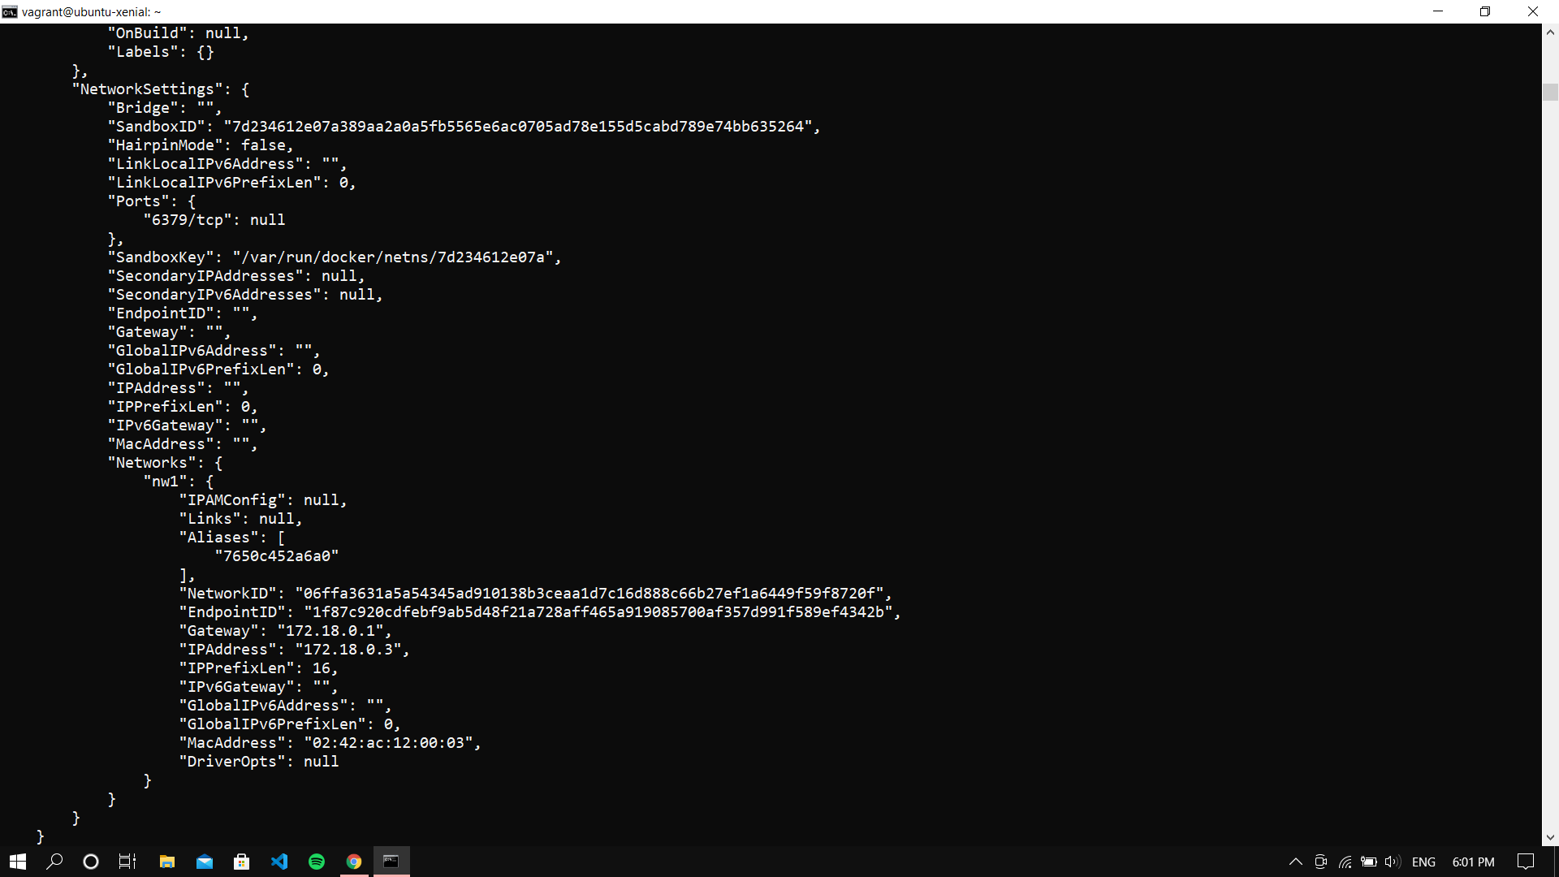

Making a cr4 container in nw1 and pinging it with cr1

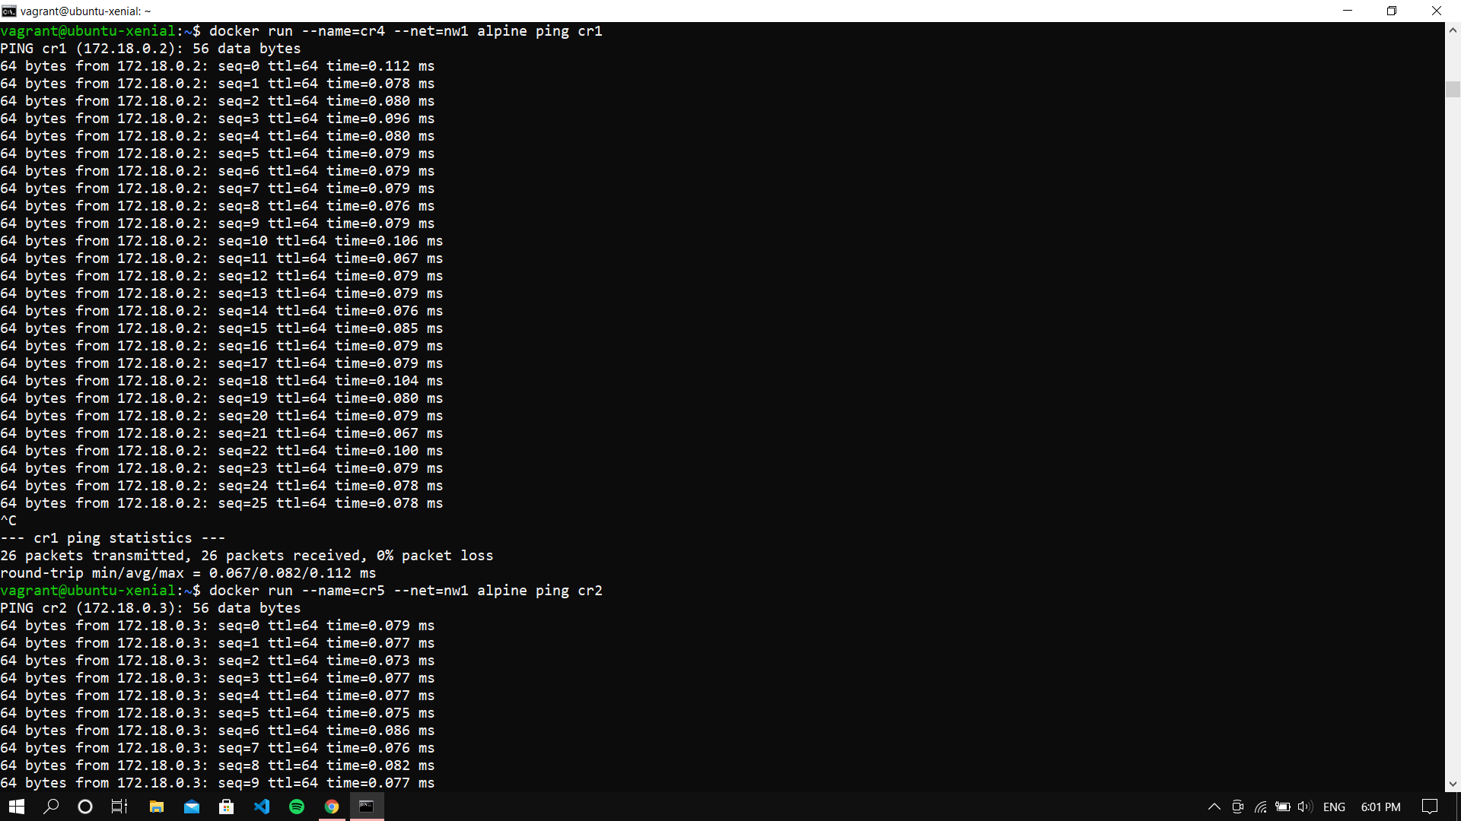

Making a cr5 container in nw1 and pinging it with cr2

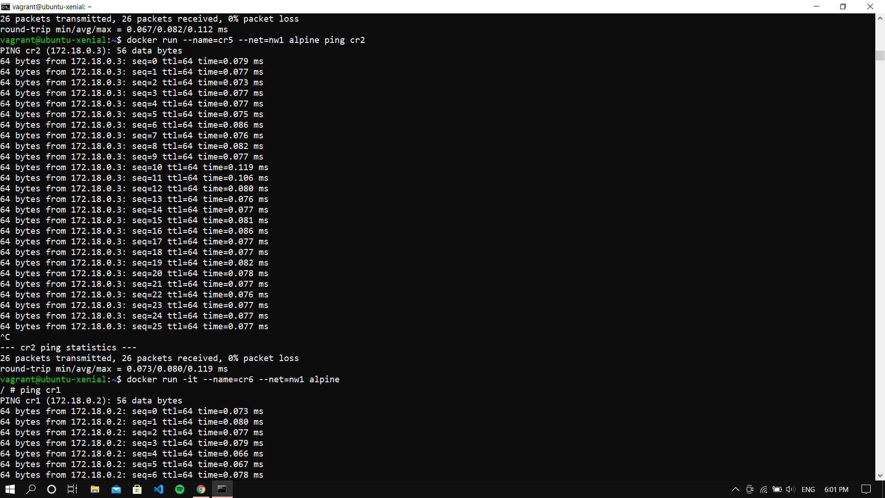

Running container cr6 with interactive terminal and then ping cr1 and creating another network nw2

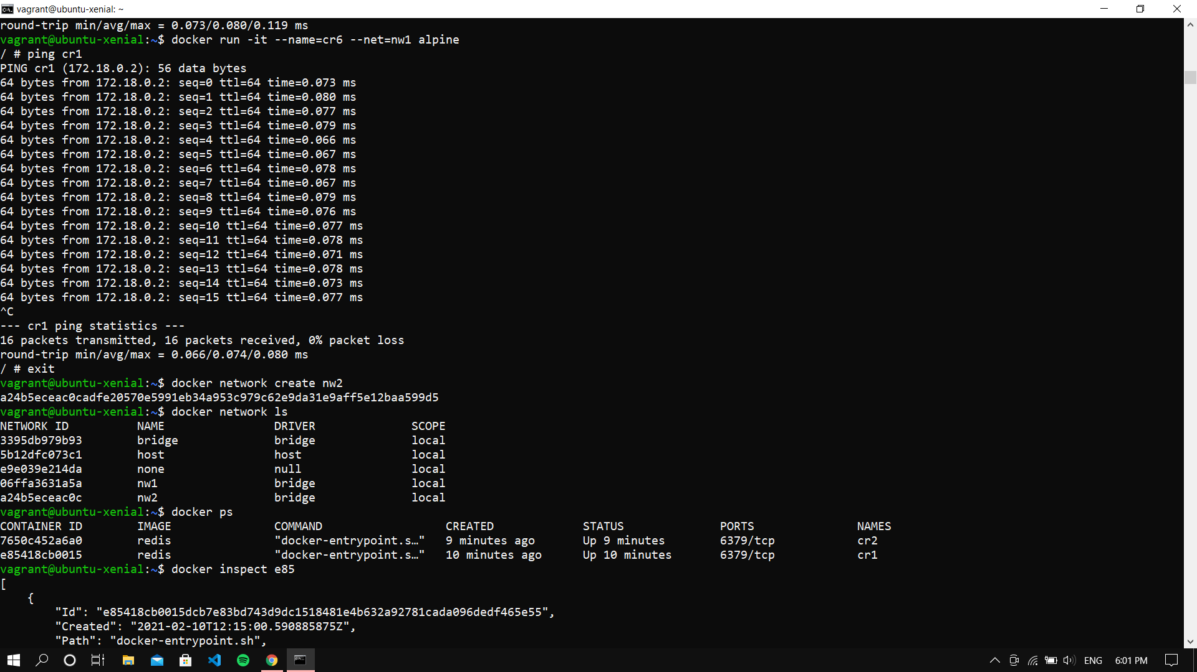

Inspecting the cr1 container

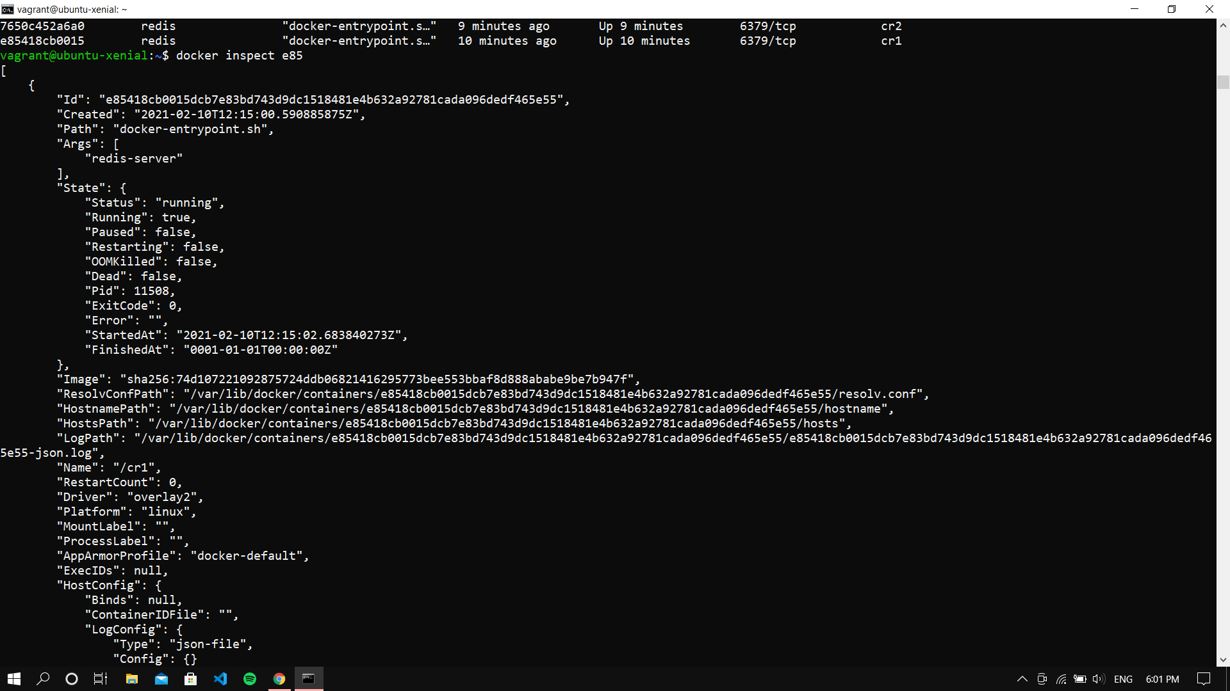

Making cr8 in nw2 and pinging cr1 with it but it gives bad address error as cr1 is in nw1 and not in nw2, so connecting cr1 with nw2

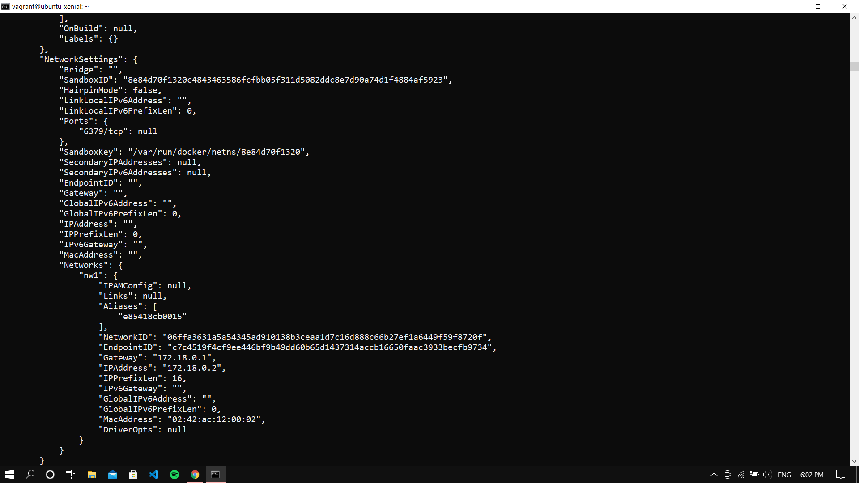

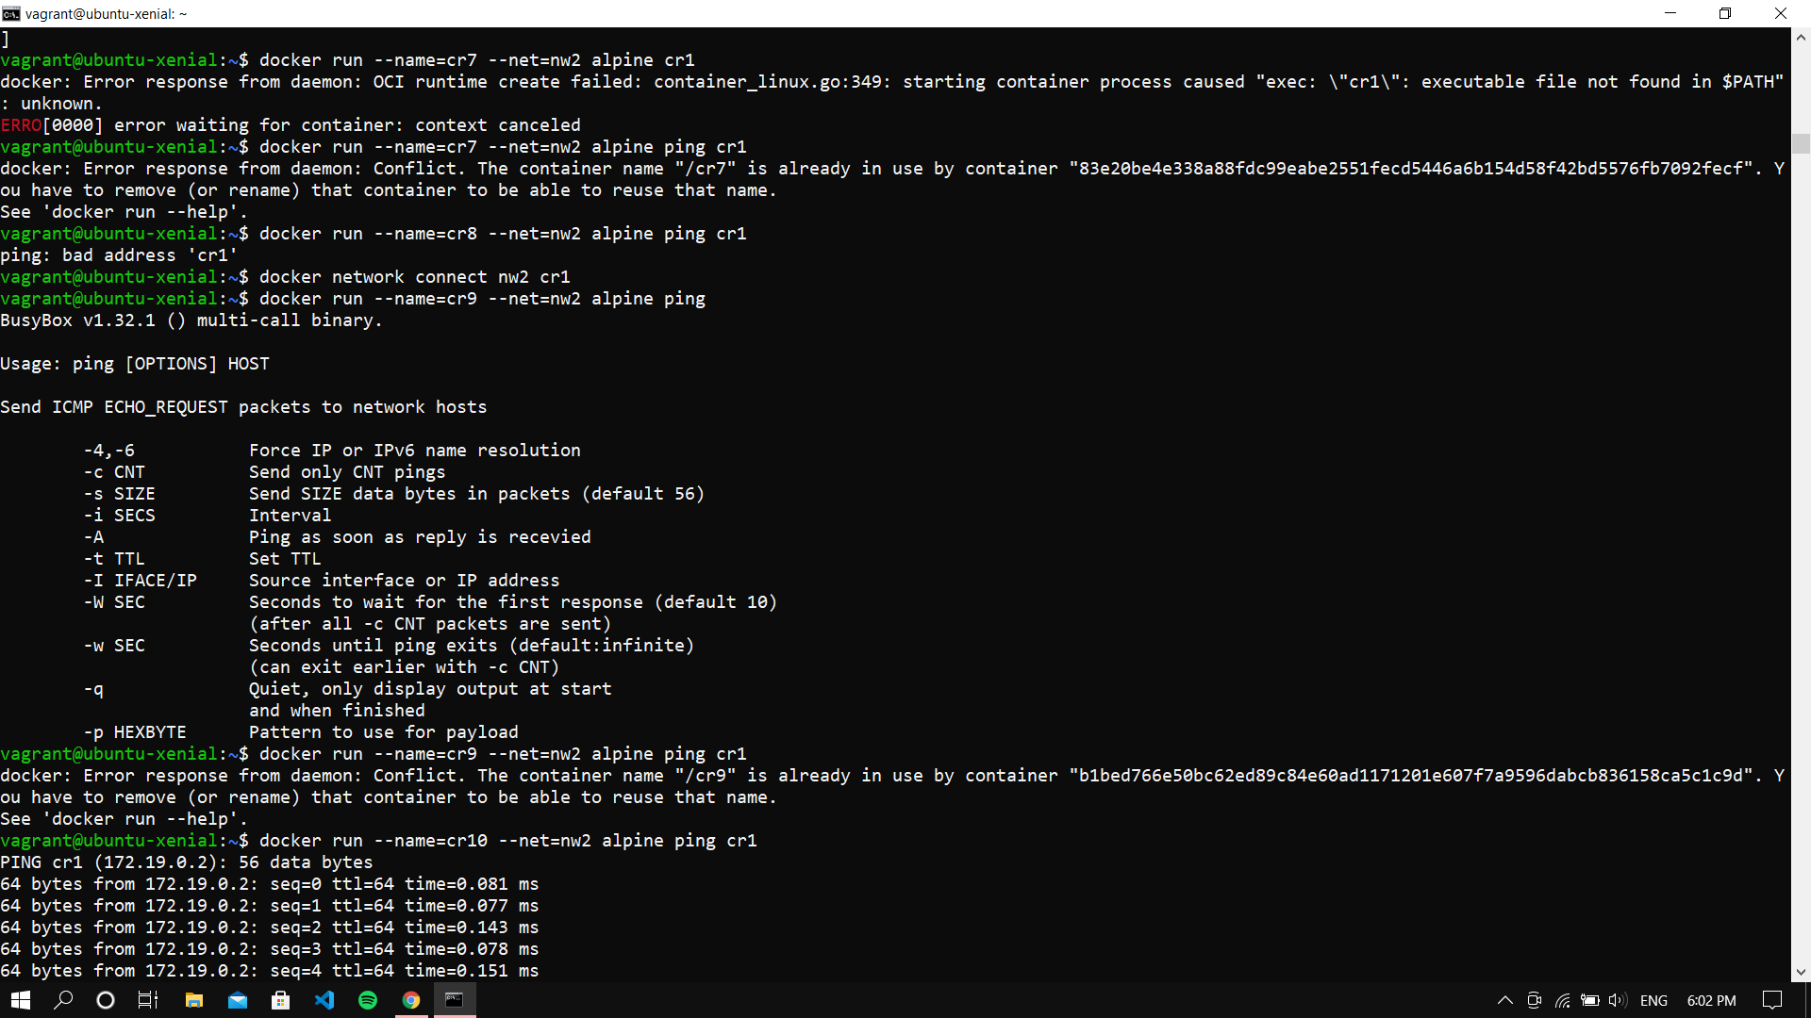

Running cr10 in nw2 and pinging with cr1 (after connecting)

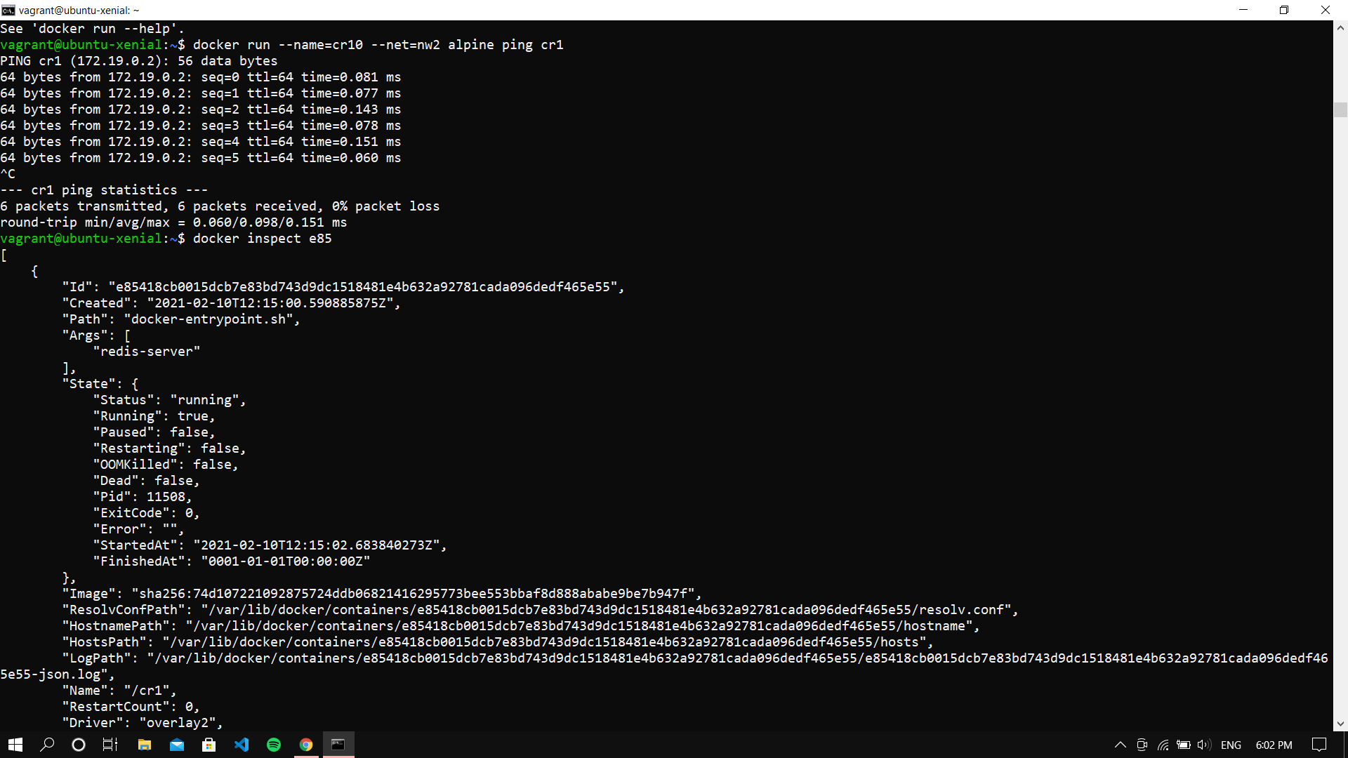

Inspecting the container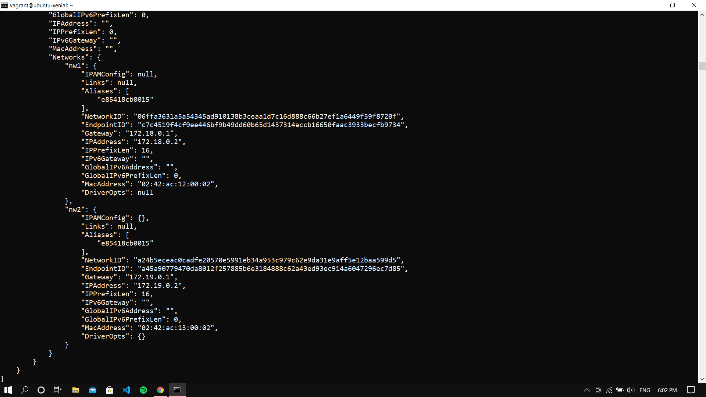

Exiting the VM and shutting it down

