

**UNIVERSITY OF PETROLEUM & ENERGY STUDIES**

**Dehradun**

[**Application Containerization Lab**](https://learn.upes.ac.in/webapps/blackboard/execute/launcher?type=Course&id=_49490_1&url=)

**Experiment-4**

**Name: Abhishek Sharma**

**Course: B. TECH CSE DevOps (2018-22)**

**Roll no.: R171218005**

**Sapid: 500067644**

**EXPERIMENT-4**

Create a Dockerfile

$ touch Dockerfile

Open Dockerfile and type FROM ubuntu

RUN apt-get update

ENV DEBIAN_FRONTEND noninteractive RUN apt-get install nginx -y

RUN echo "daemon off;" >> /etc/nginx/nginx.conf COPY index.html /var/www/html/

EXPOSE 80

CMD ["nginx"]

Create a index.html file and type

$ touch index.html

<html>

<h1>Level Up In Tech</h1>

<p> Learning it. Labbing it. Leveling Up</p>

<p>This is a simple static website, built and deliver from a docker container</p>

<p>Visit us here: <a href="levelupintech.com">Level Up In Tech</a></p>

</html>

Now run command

$ docker build –t nginx:1.0 .

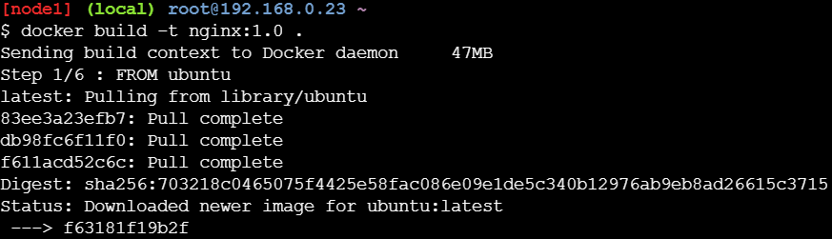

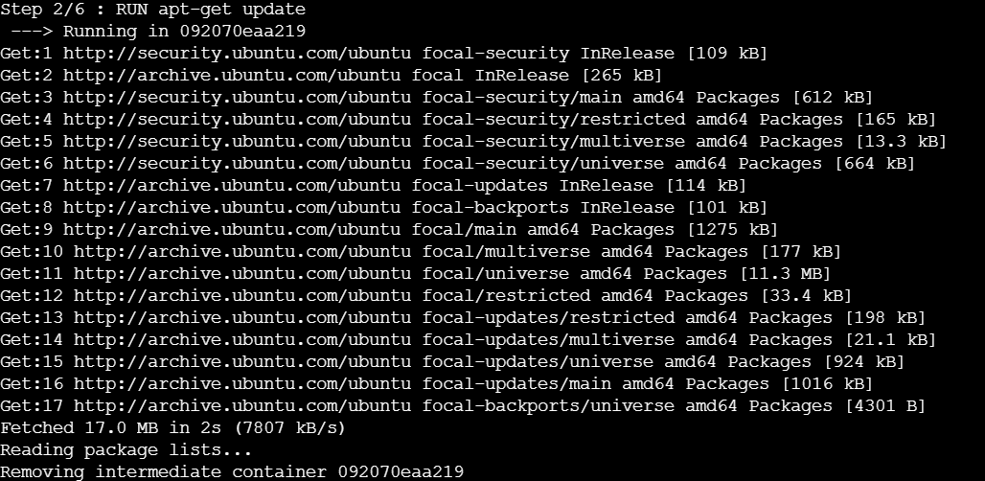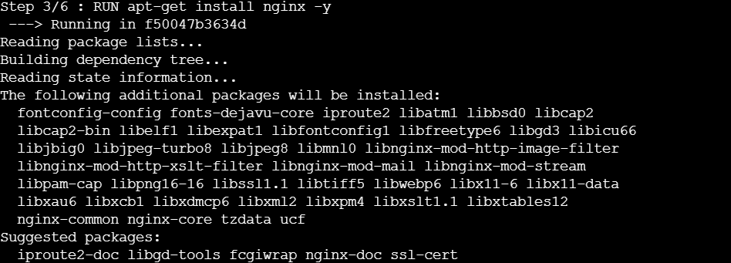

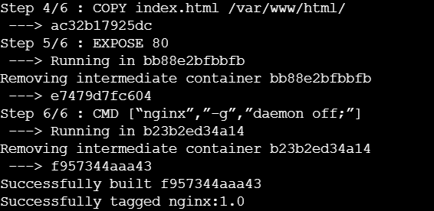

To check images

$ docker images

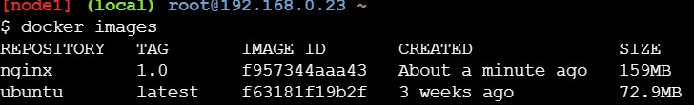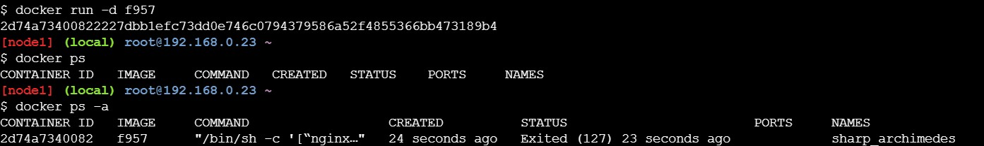

Login to docker

$ docker login

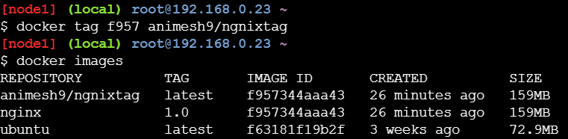Change tag name and version

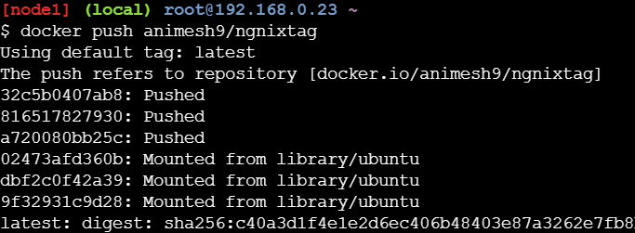Push to docker repository

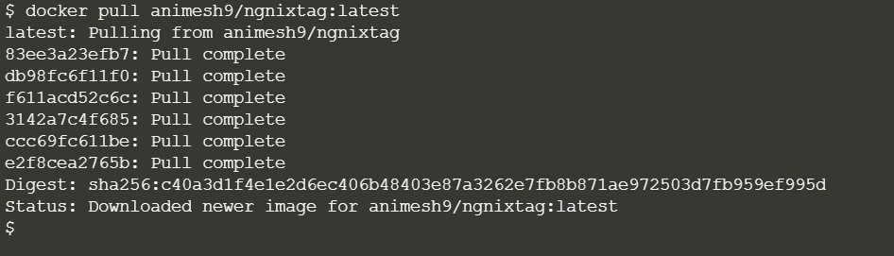Pull this repository to your local machine.

Run the container

