

**UNIVERSITY OF PETROLEUM & ENERGY STUDIES**

**Dehradun**

**APPLICATION CONTAINERIZATION**

**Name: Aman Gera**

**Course: B. TECH CSE DevOps (2018-22)**

**Roll no.: R171218015 Sapid: 500069145**

**Experiment-5**

**Docker Compose**

**Step-1:** Install docker-compose.

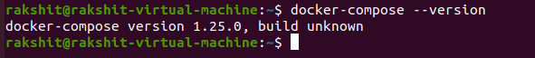

**Step-2:** Use docker-compose version 3 to create docker-compose.yaml file.Create a service named "databases". Use image named "mysql" Map container 3306 port to host machine 3306 port. Add environment variables named "MYSQL_ROOT_PASSWORD", "MYSQL_DATABASE", "MYSQL_USER" and "MYSQL_PASSWORD" along with corresponding values for all.

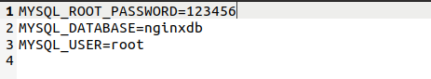

**Step-3:** Add another service named "web". Use image "nginx"

