

**UNIVERSITY OF PETROLEUM & ENERGY STUDIES**

**Dehradun**

**APPLICATION CONTAINERIZATION**

**Name: Aman Gera**

**Course: B. TECH CSE DevOps (2018-22)**

**Roll no.: R171218015**

**Sapid: 500069145**

**Experiment-6**

**Docker Linking**

**Step-1:** Run a container in detached mode with name "db" from image "training/postgres"

$ docker run -it -d --name db training/postgres

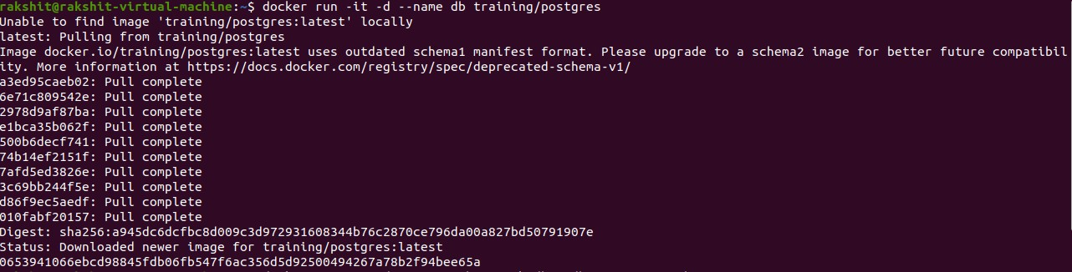

**Step-2:** Run another container in detached mode with name "web" from image "training/webapp", link container "db" with alias "mydb" to this container and finally pass an inline command "python app.py" while running container.

$ docker run -it -d -–name web -–link db:mydb training/webapp

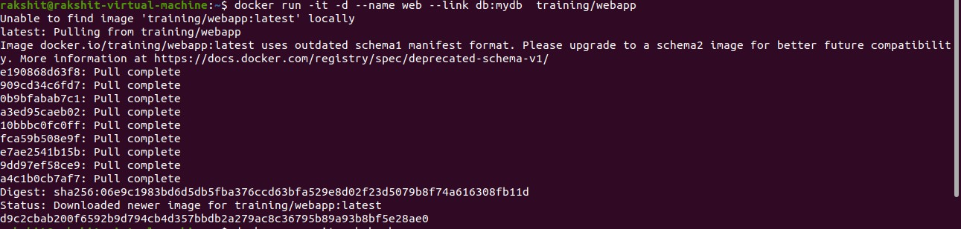

**Step-3:** Take a bash terminal in "web" container and Test container linking by doing a ping to "mydb"

$ docker exec -it web bash

And then run

# ping mydb

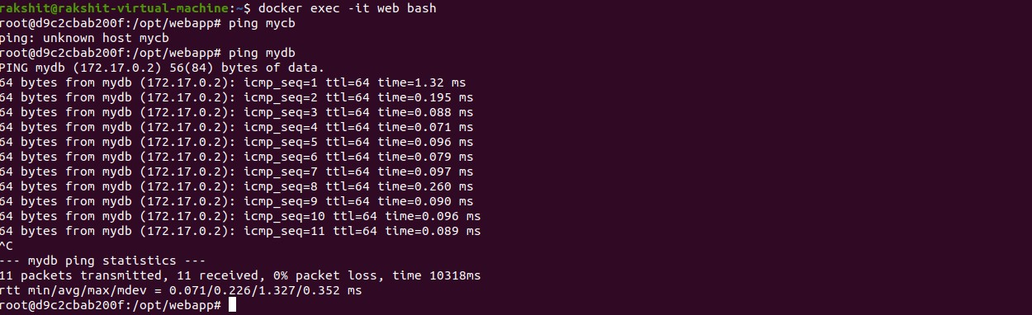

# Docker Swarm

