**EXPERIMENT-5**

**BY :AMAN TYAGI**

**AIM:** To understand networking in Docker.

STEPS:

-Creating a network

-Linking a container with the network

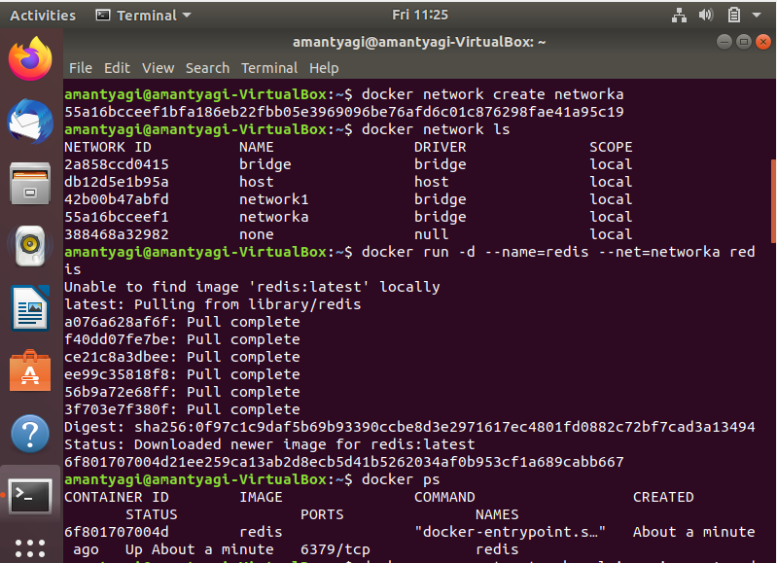

-Running ping command

-Creating second network

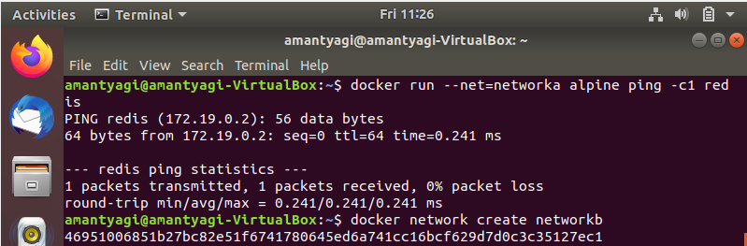

- Linking second network with another container and verify connectivity

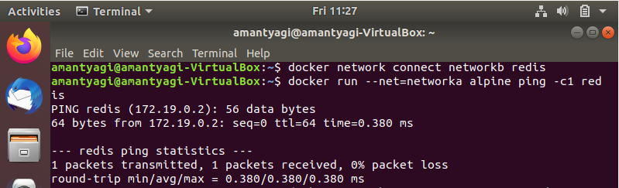

- Working with alias and inspecting the network

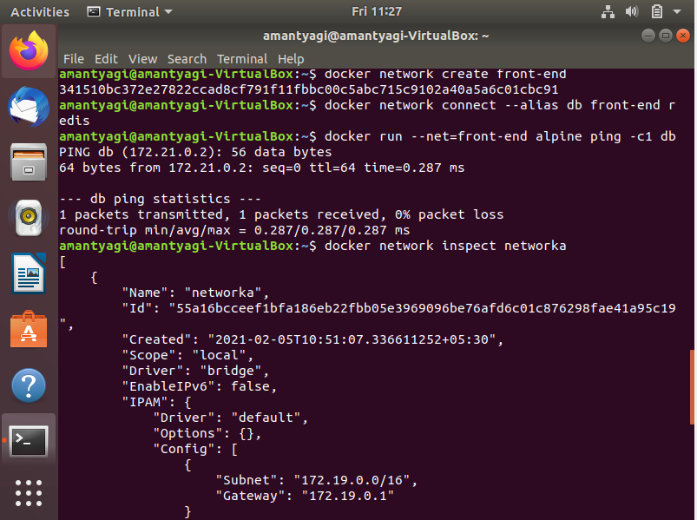

- Disconnecting a network

