Experiment-1

**Aim:** To install pre requirements.

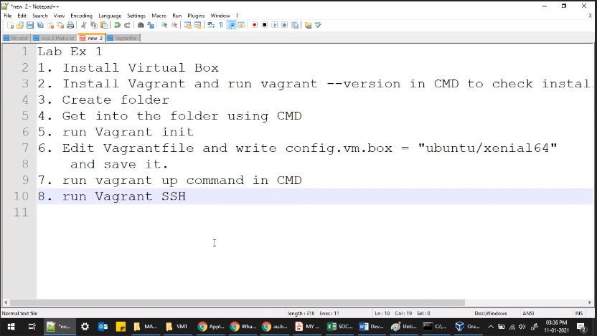

Download Virtual box from this link: <https://www.virtualbox.org/wiki/Download_Old_Builds>

As the vagrant latest version is compatible with vagrant 6.0.x and 6.1.x, so I will use one less version for better functioning.

Download and install Vagrant: <https://www.vagrantup.com/downloads.html>

The folder where I am working

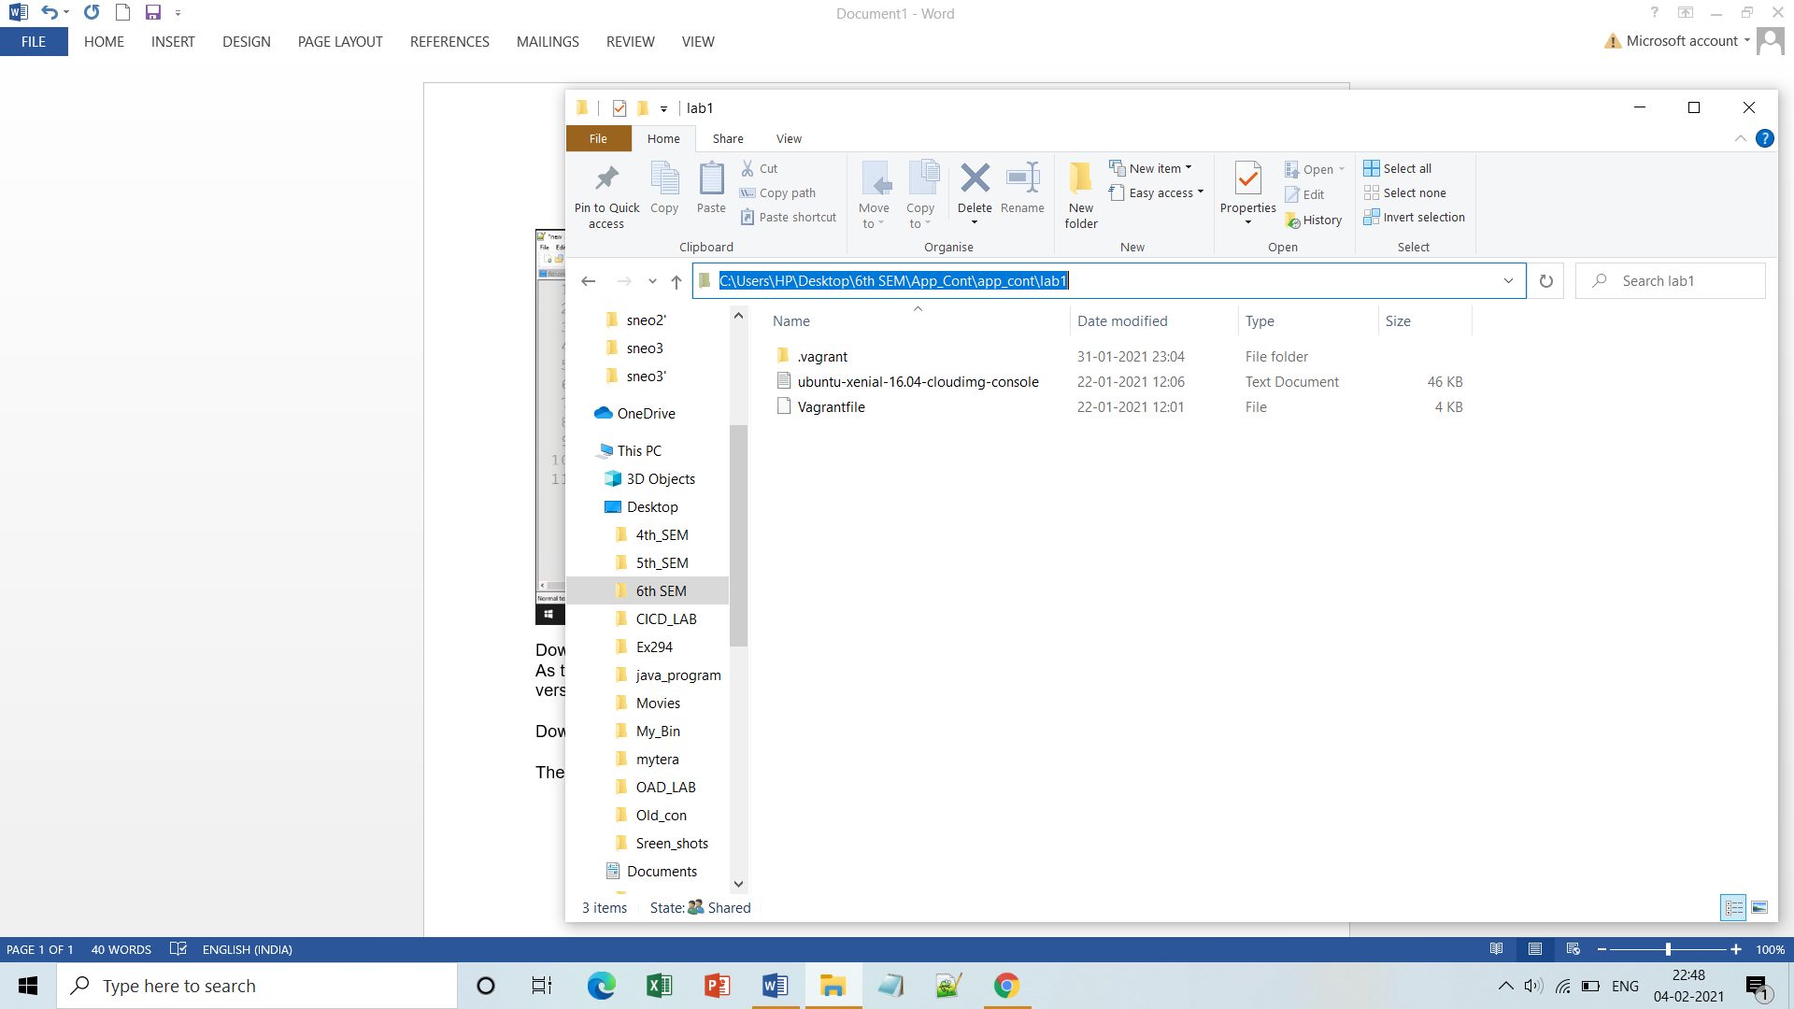

Search for VM available from:[htps://vagrantcloud.com/search](https://vagrantcloud.com/search)

I am using ubuntu/xenial64: config.vm.box = "ubuntu/xenial64"

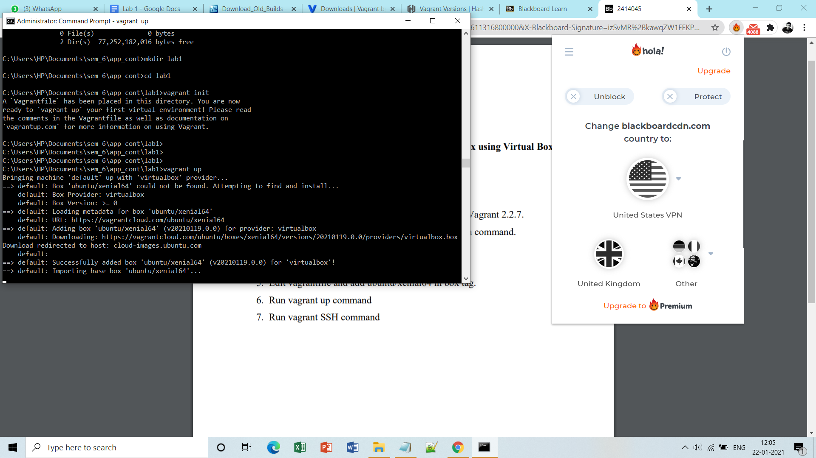

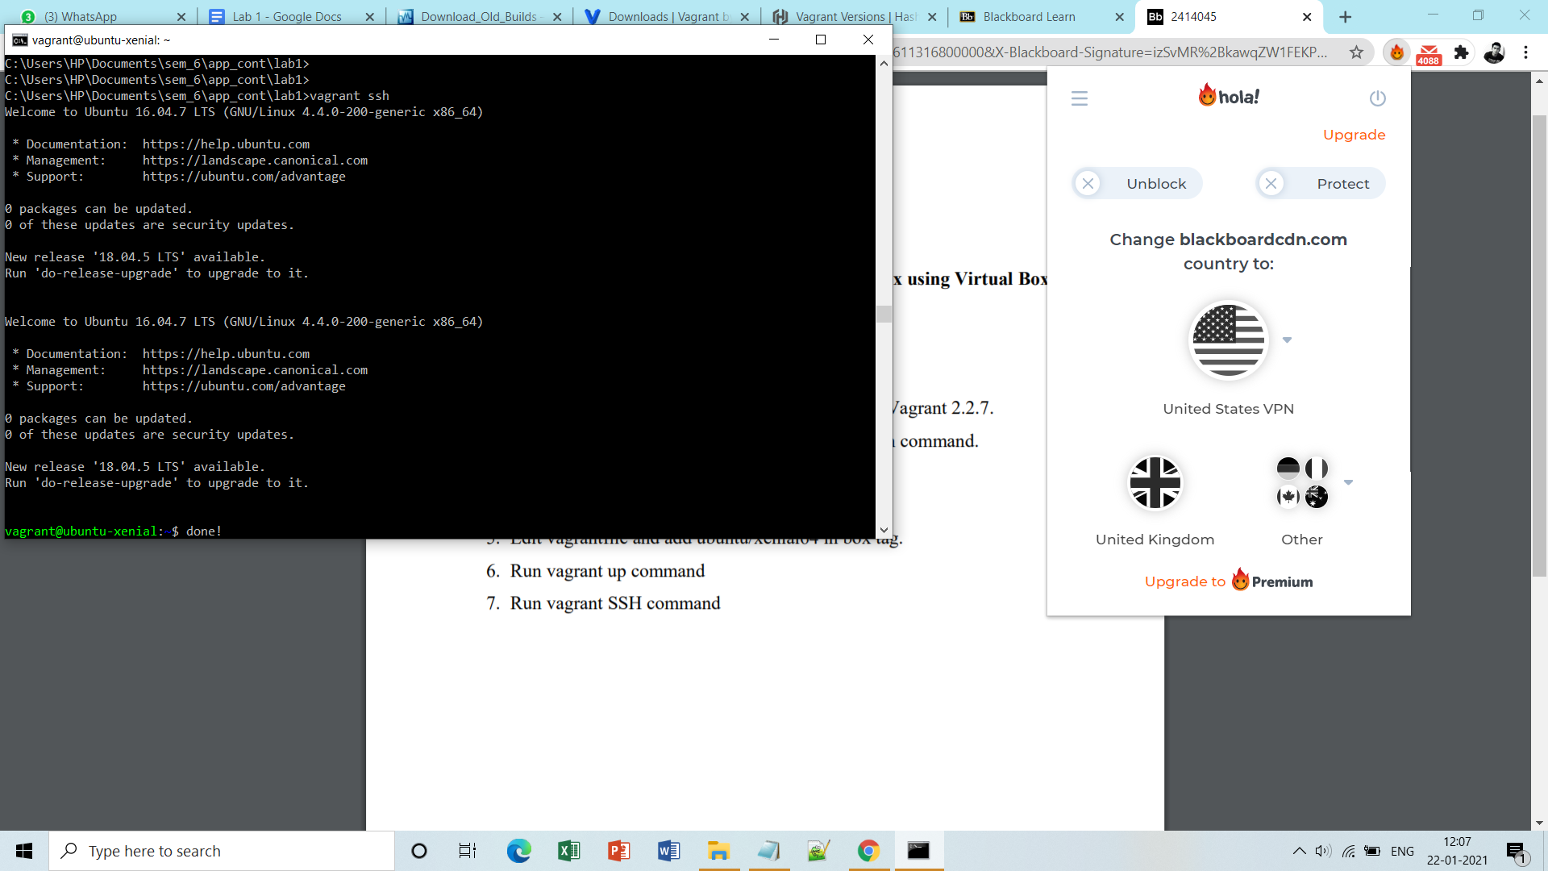

**Finally you land up here:**

