Experiment-2

**Aim:** To configure docker volume & it’s features.

**Prerequisite:** Download and install docker on your VM.

**Now follow the steps under neath.**

**Step1:** Go to command prompt and move to the directory where your vagrant file is there and run the **vagrant up** command.

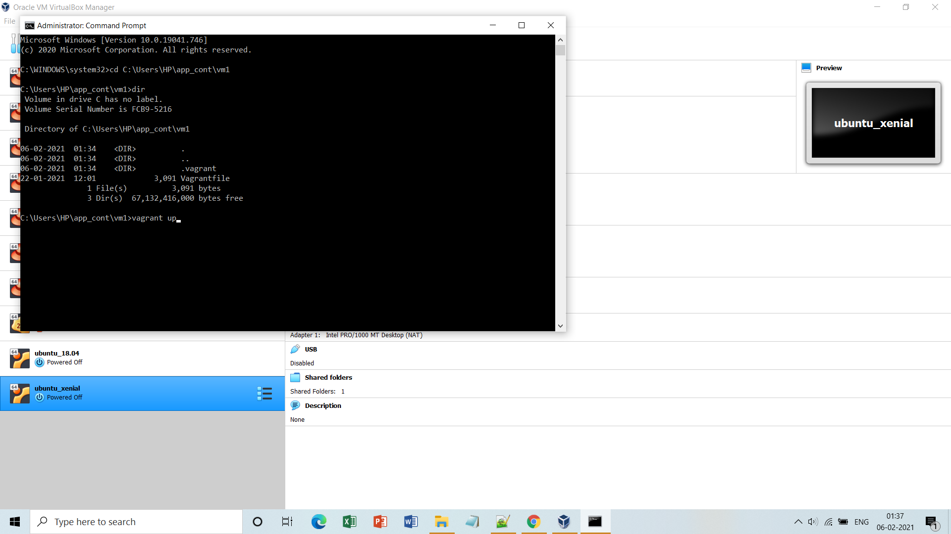

**Step2:** Run **vagrant ssh** command and enter into the terminal of your VM.

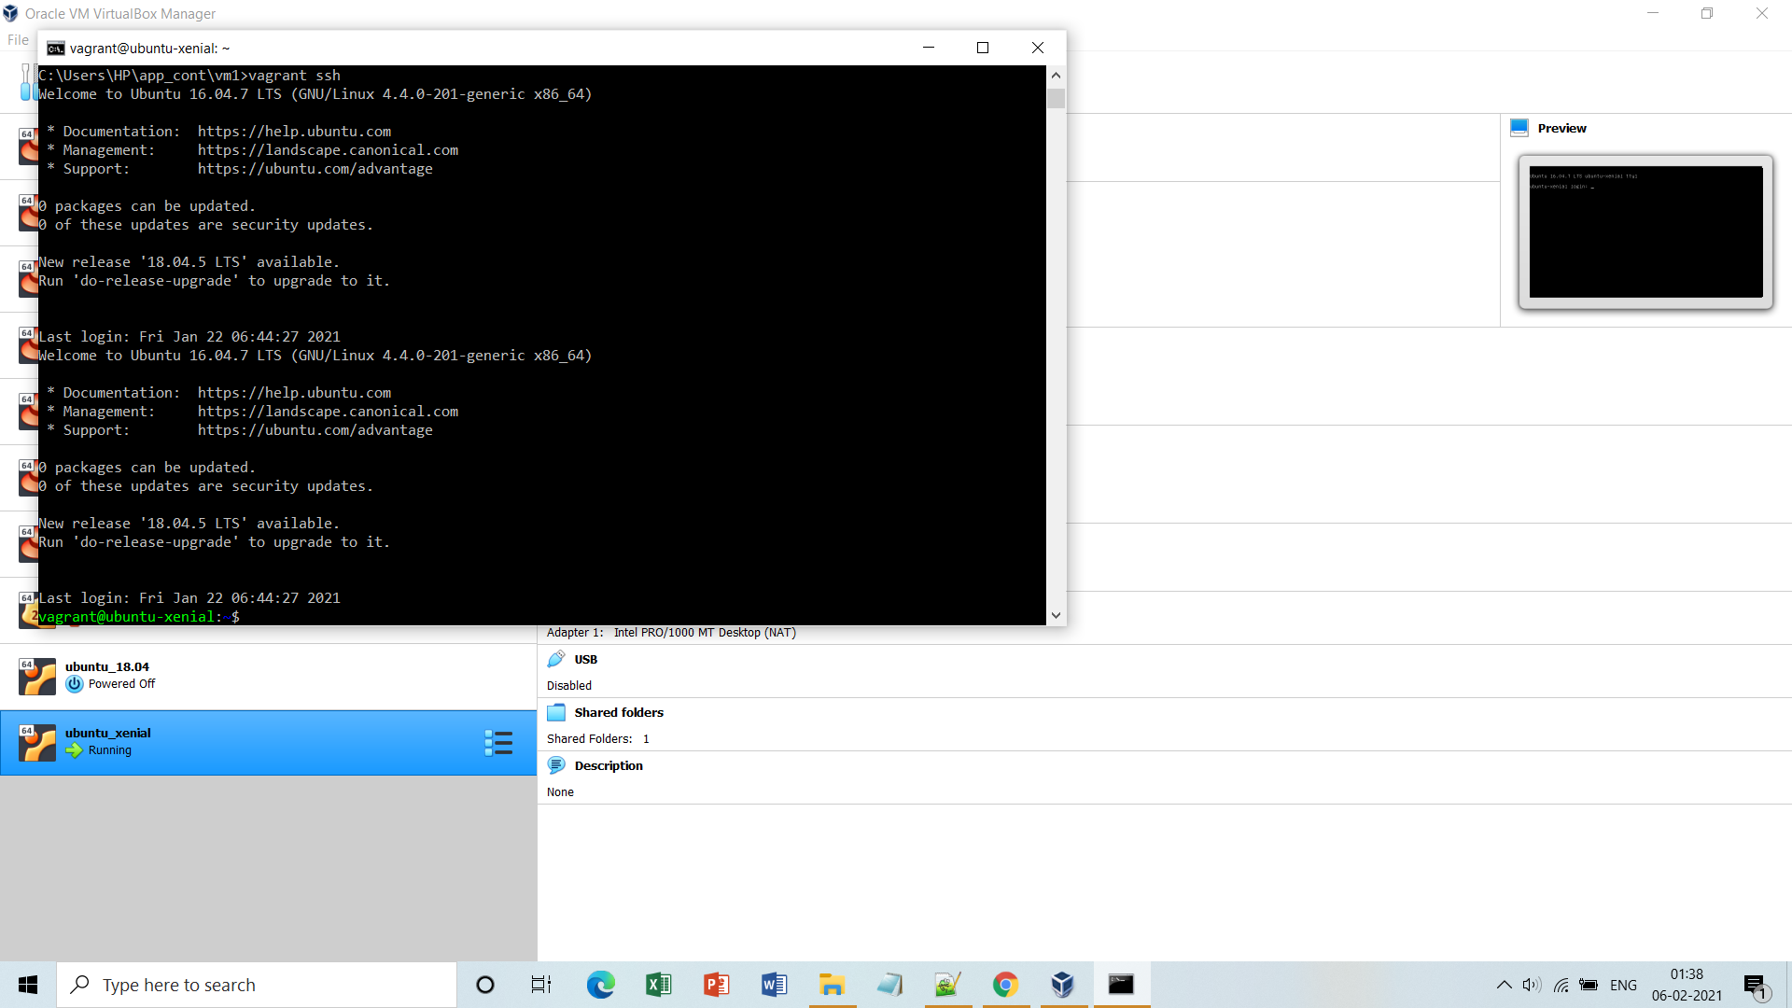

**Step3:** Make a docker container of **alpine image** or any of your choice.

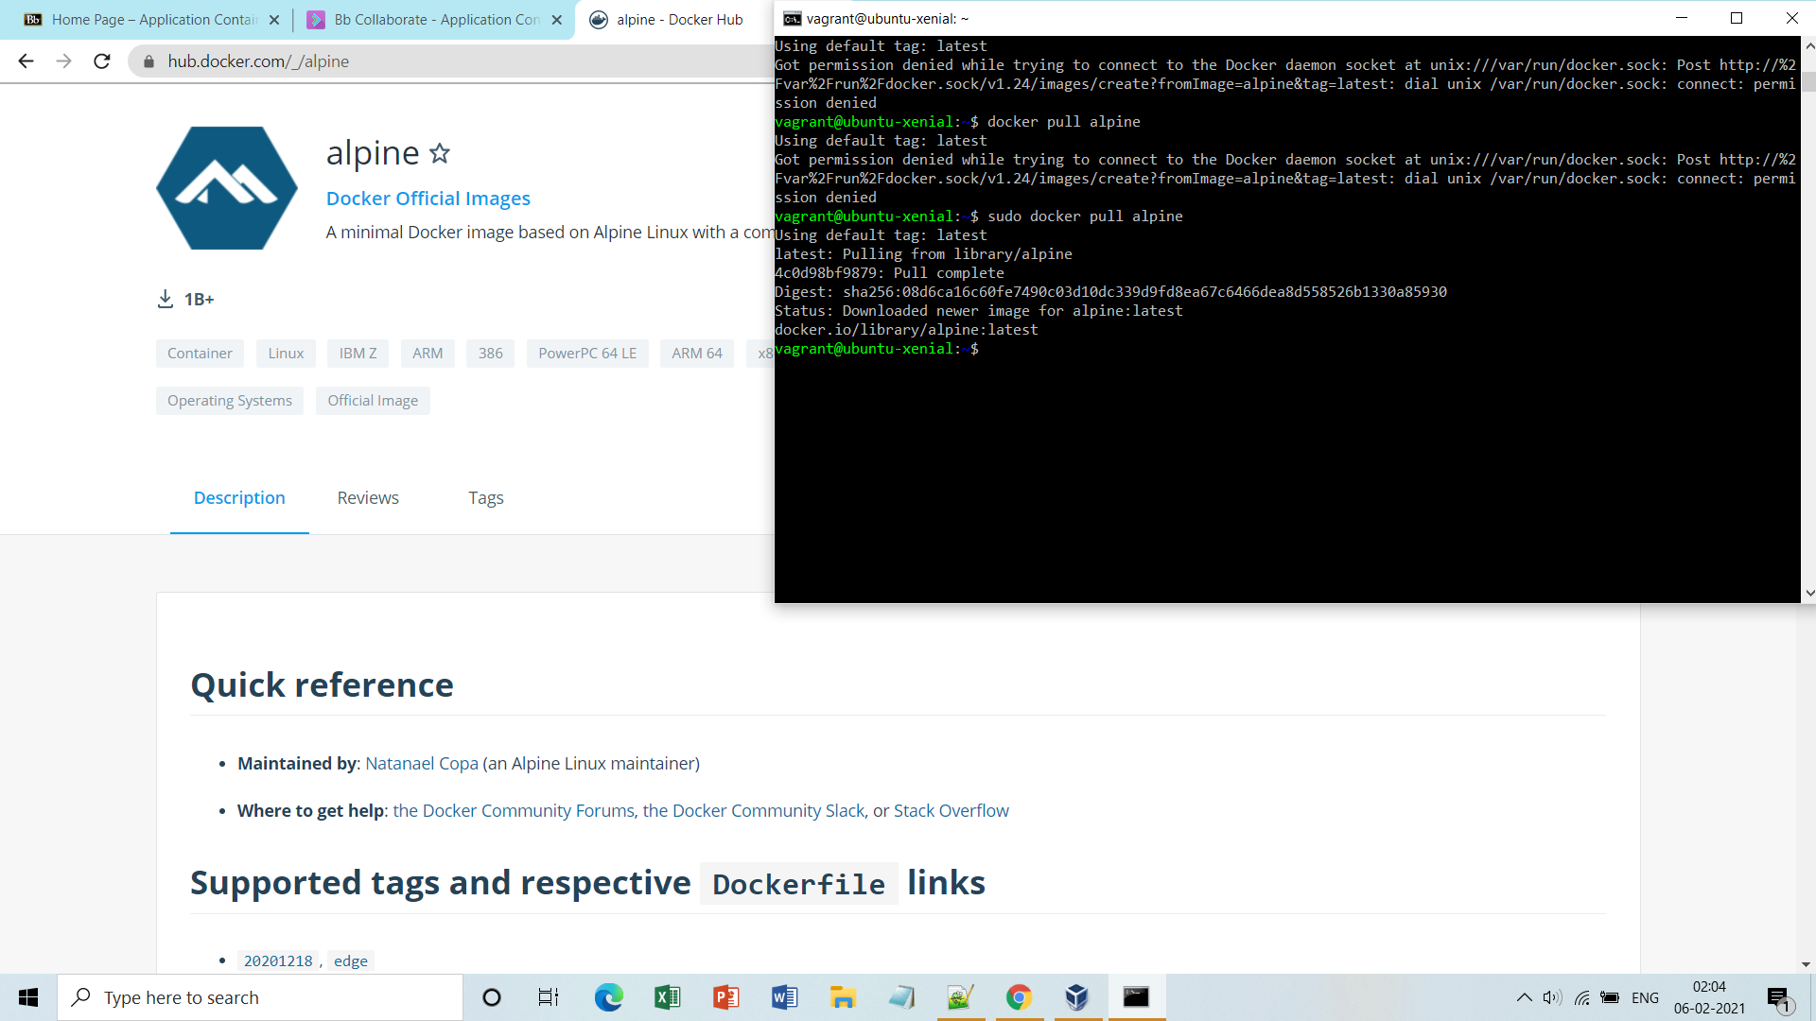

**Step4:** Just to check run the container and list them via **docker ps**(running) or **docker ps –a**(all) command.

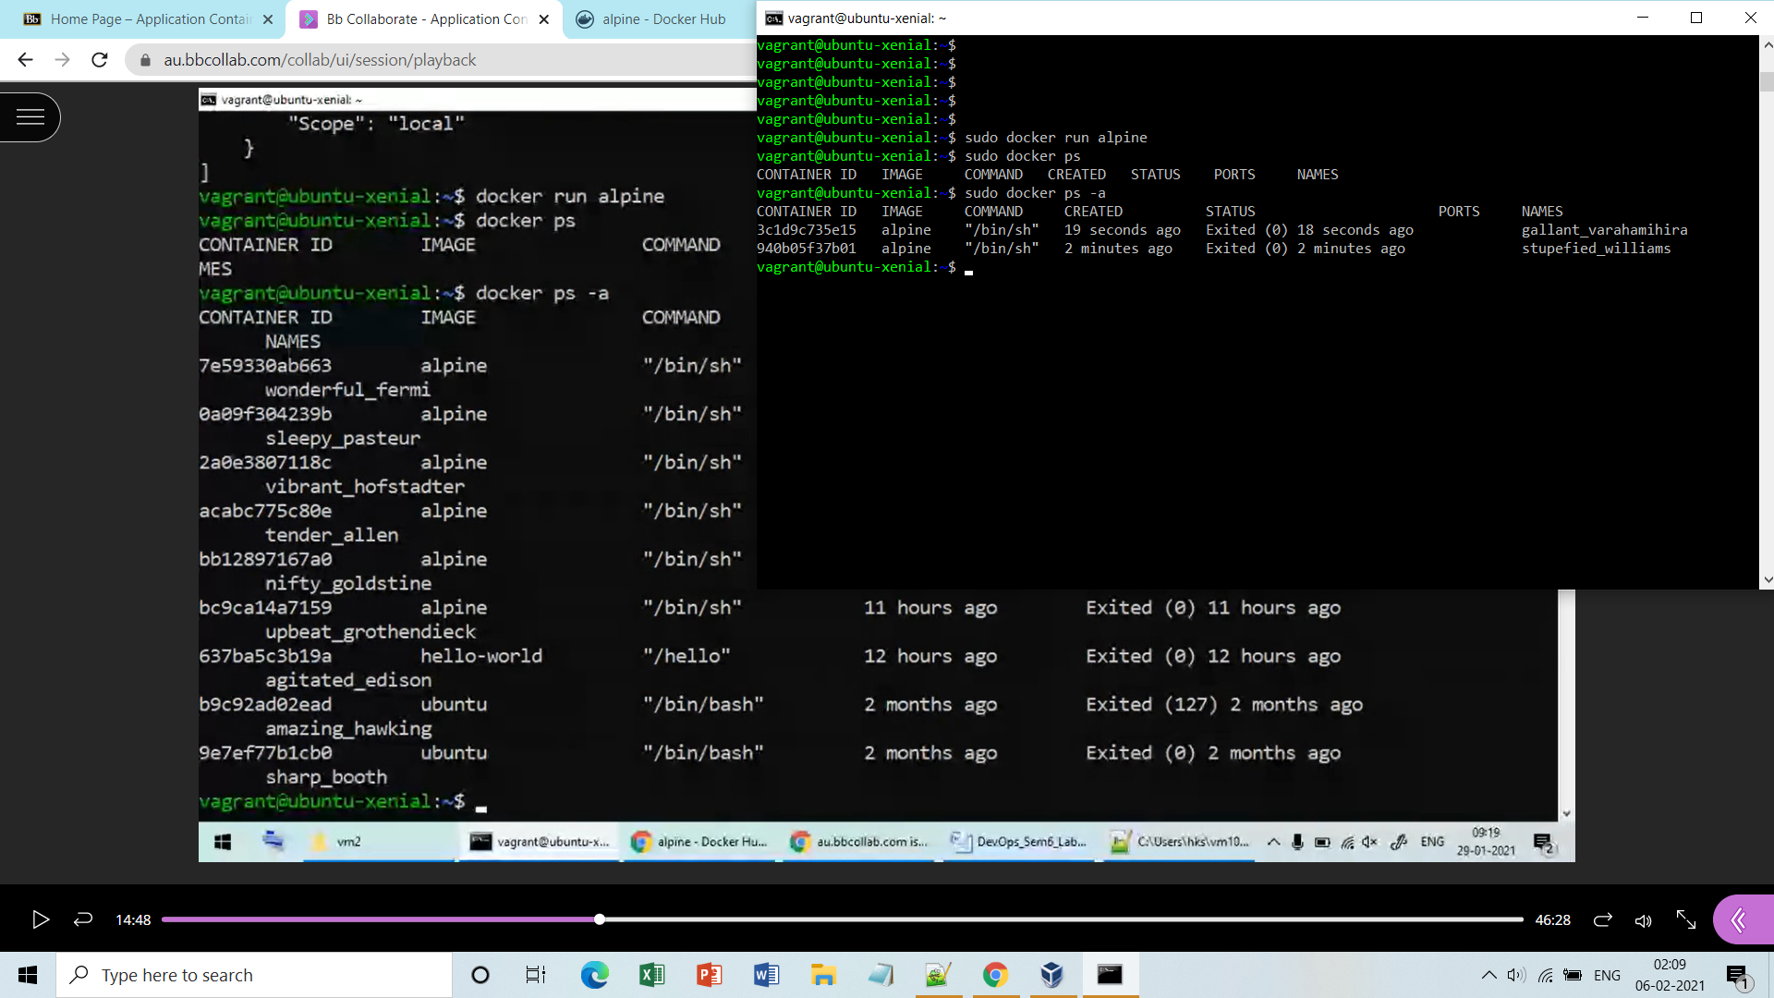

**Step5:** Enter into it’s terminal, move to **mnt** directory, make some files here and list them.

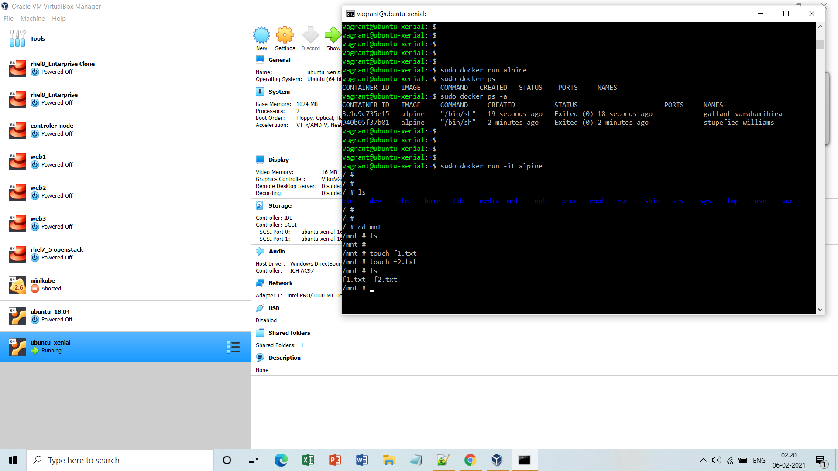

**Step6:** Now the moment you exit from the container the files are gone because they are not stored in **persistent volume**(docker volume).

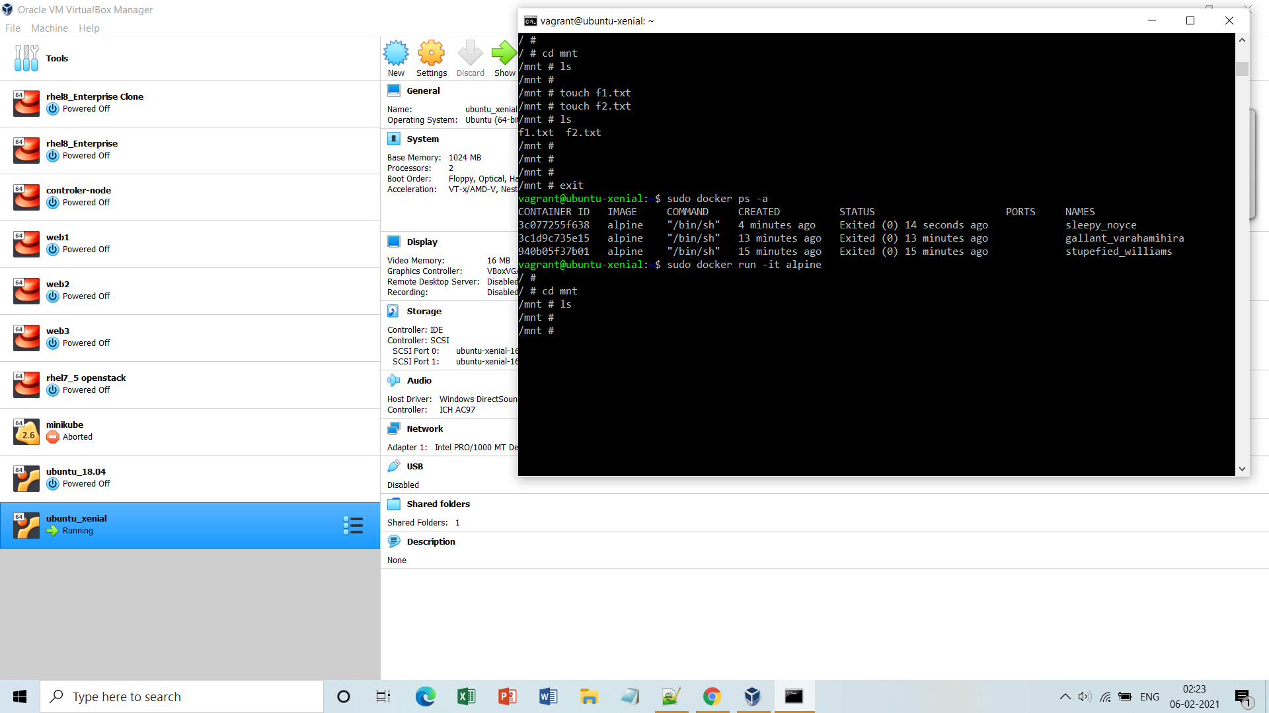

kdc

**Step7:** Now create a **docker volume**(eg. Myvol1) and map it to the mnt folder or any your root VM while running the container. And then again make some files under it , exit from container and if you again enter into it, you would still find those files as they are stored into a persistent volume(eg. myvol1).

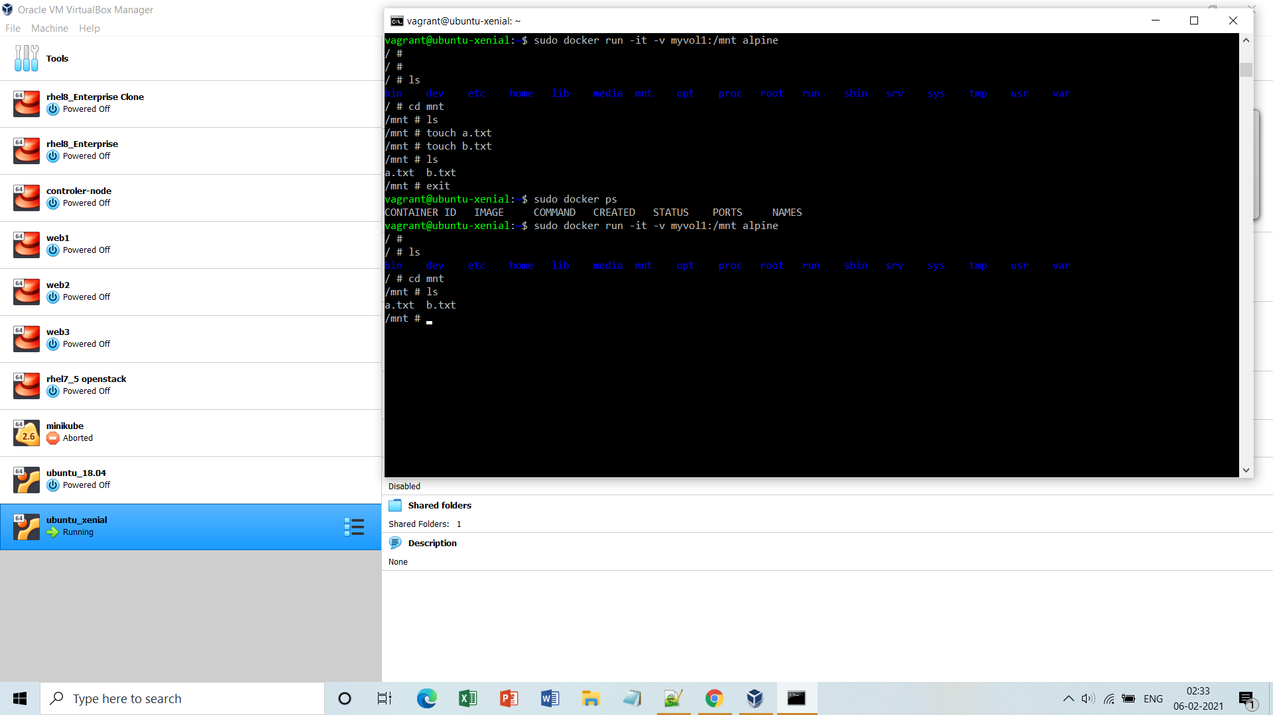

**Note:-** If you run the container without mapping it to the volume you will not find those files under mnt folder even if the volume is created.

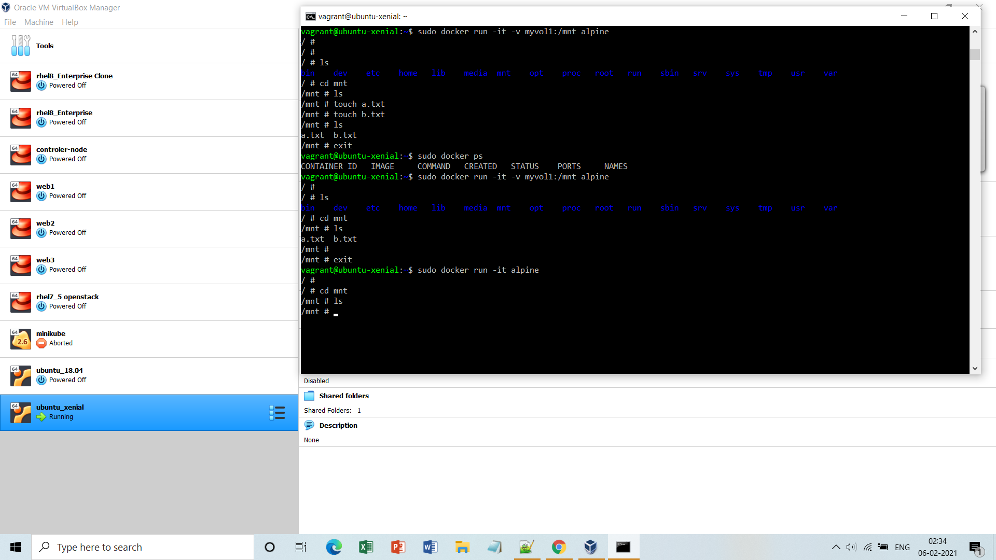

**Step8:** Now inspect the volume and locate the files inside it.

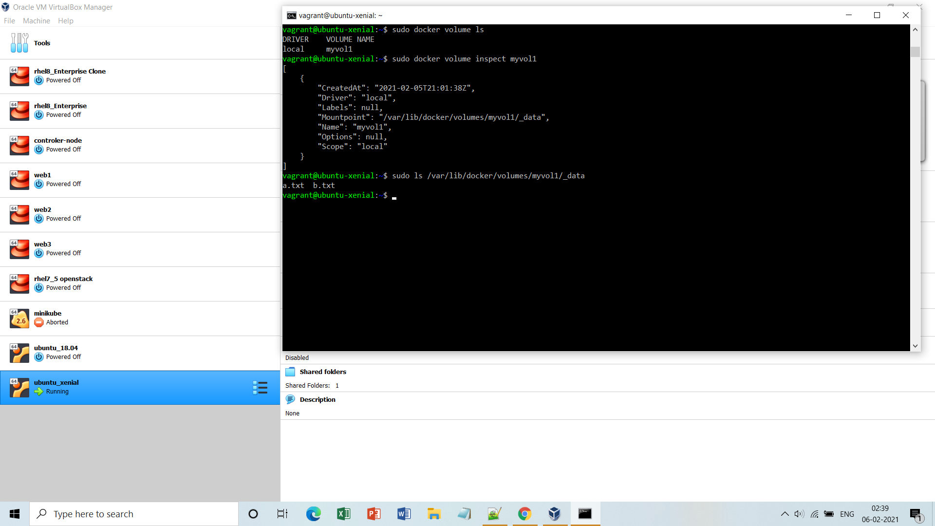

**Step9:** You can map the already created volume to multiple containers and they all will have the same content as they **sync** to each other.(b/w volume-container)

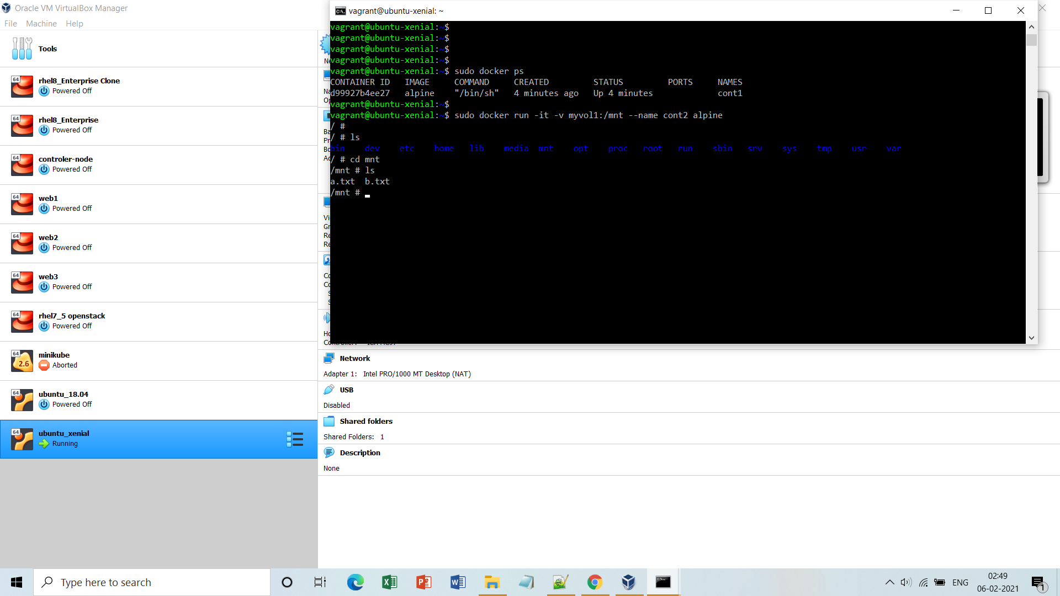

**Step10:** Now add some more files inside the sme mnt folder under **cont1** and it will be reflected in **cont2** also.(b/w container-container)

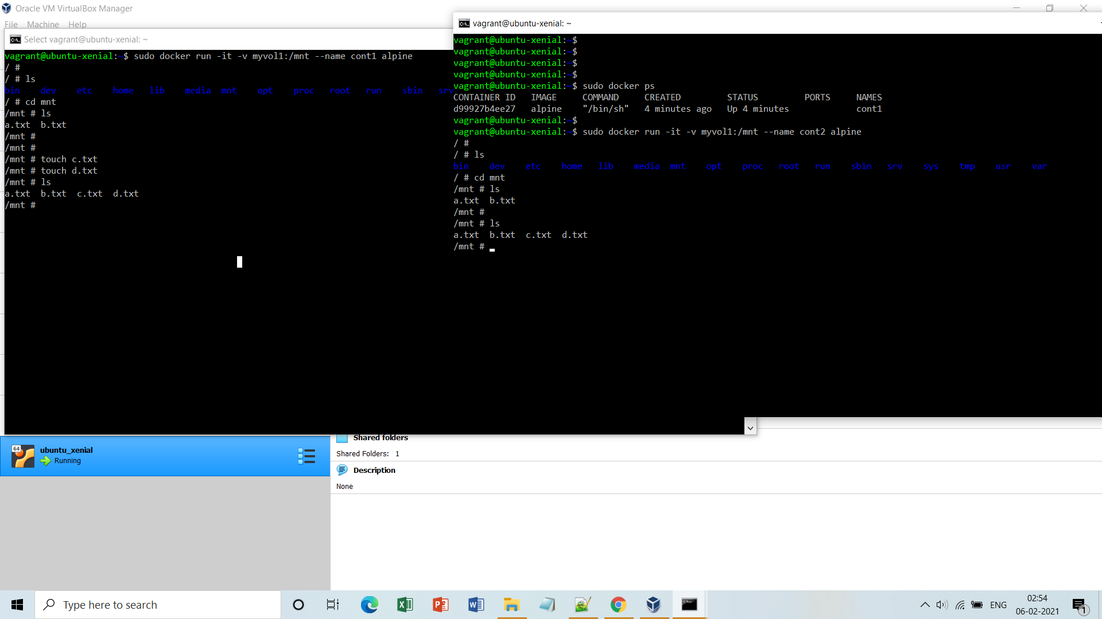

**Step11:** You can map the **existing volume** to any other folder also and still it will have all the content.

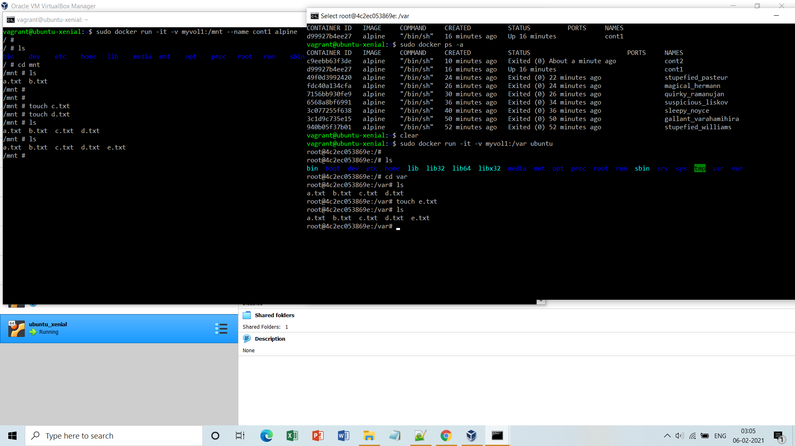

**Step12:** Now in order to delete the existing volume you need to remove all the container attached to it and the remove finally.

