**Experiment-05**

**Aim:** To create multiple containers in one go via docker-compose.

**Follow the steps below.**

**Step1:** Create two files xyz.env and docker-compose.yml files.

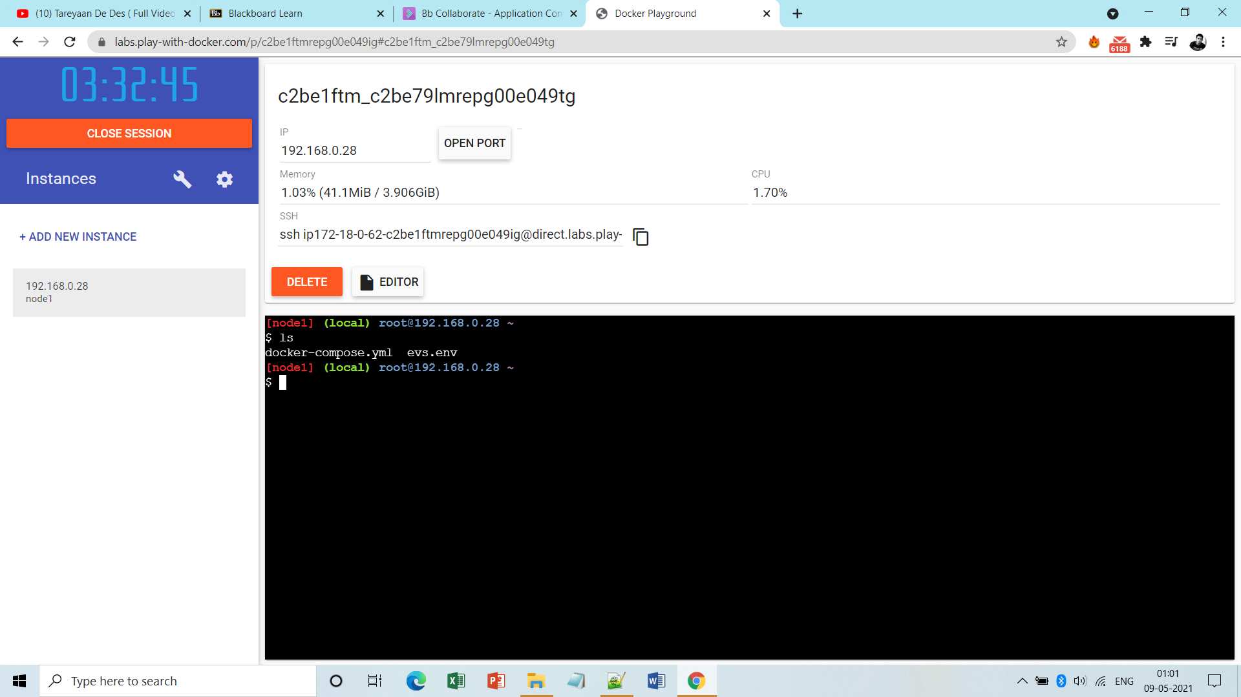

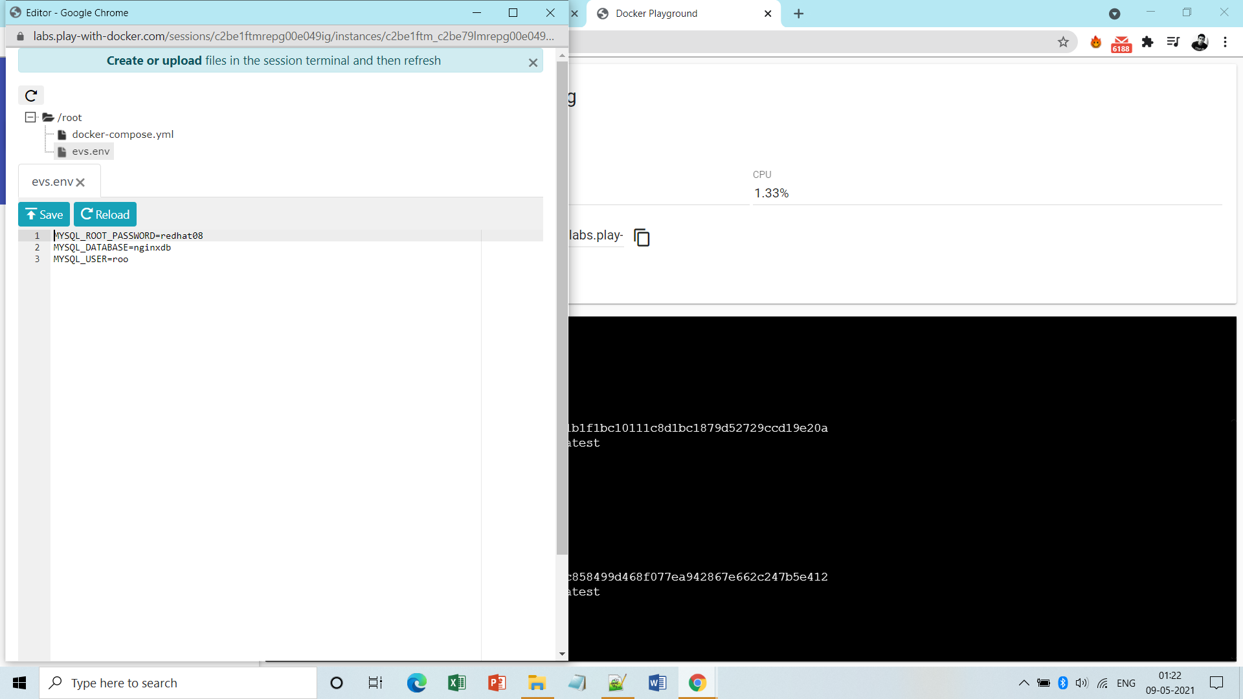

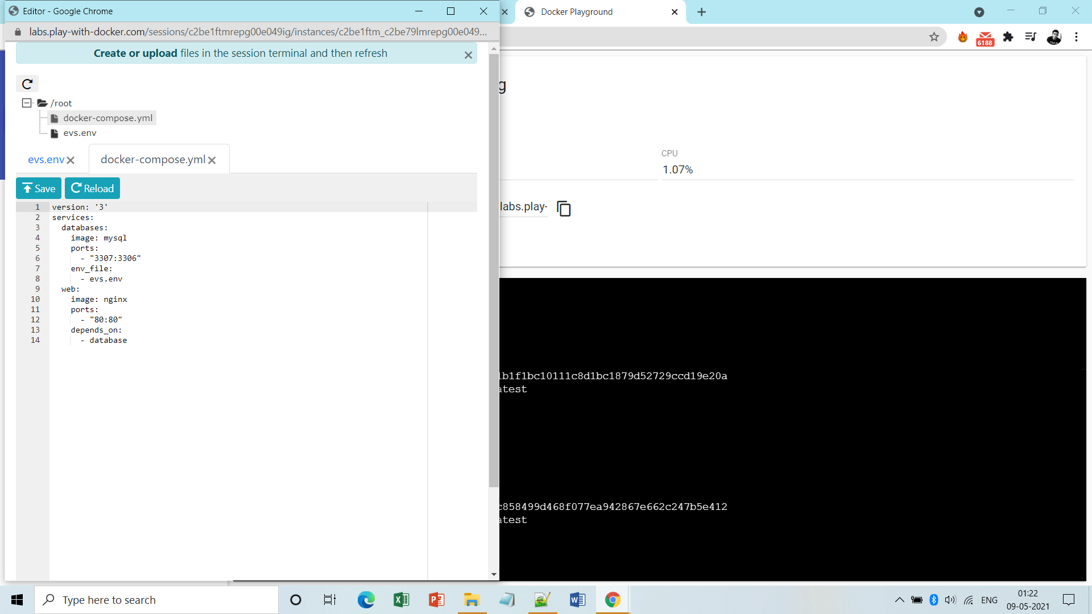

**Note:** Initially there is no containers created. 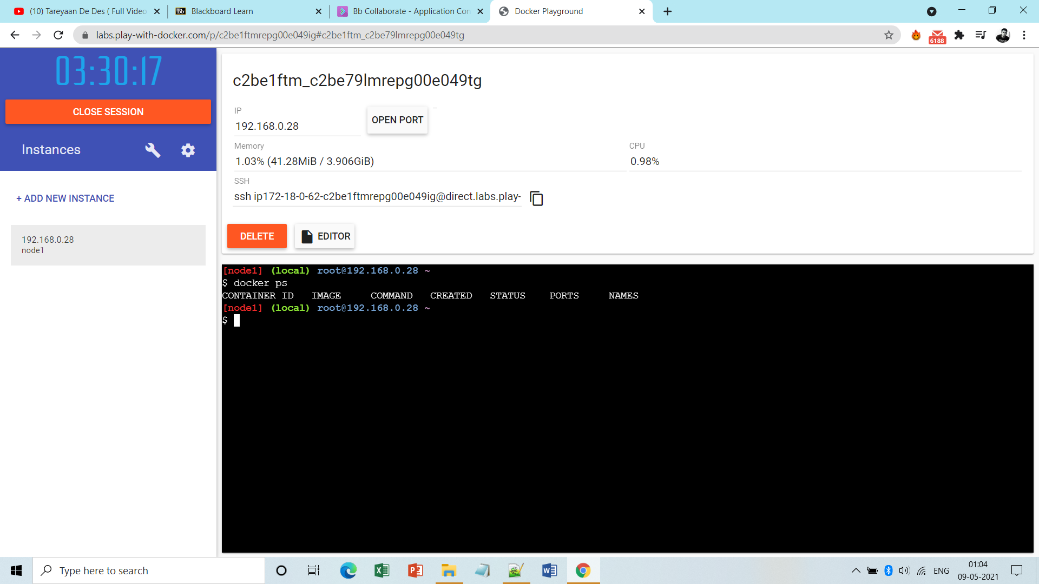

**Step2:** Now run the docker-compose.yml file.

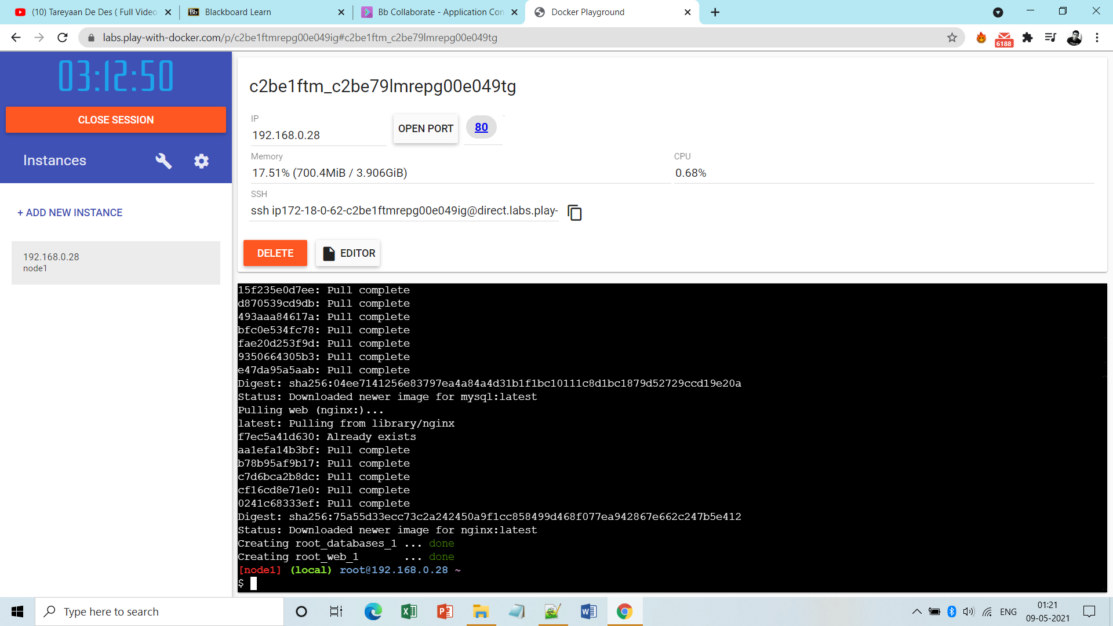

**Step3:** Now check the no. of containers created, running, etc.

