Experiment-7

**Aim:** To create swarm cluster and scale up the containers/instances for a specific service.

**Perform the following steps to do the same.**

**Step1:** Check the nodes.

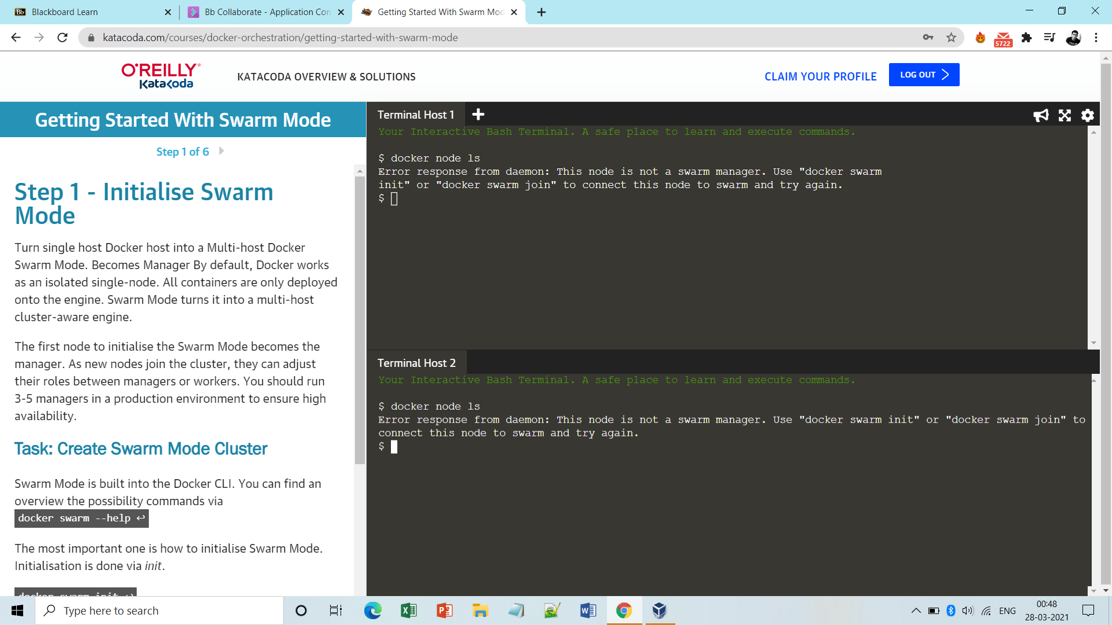

**Step2:** Initialize a node to make it master. 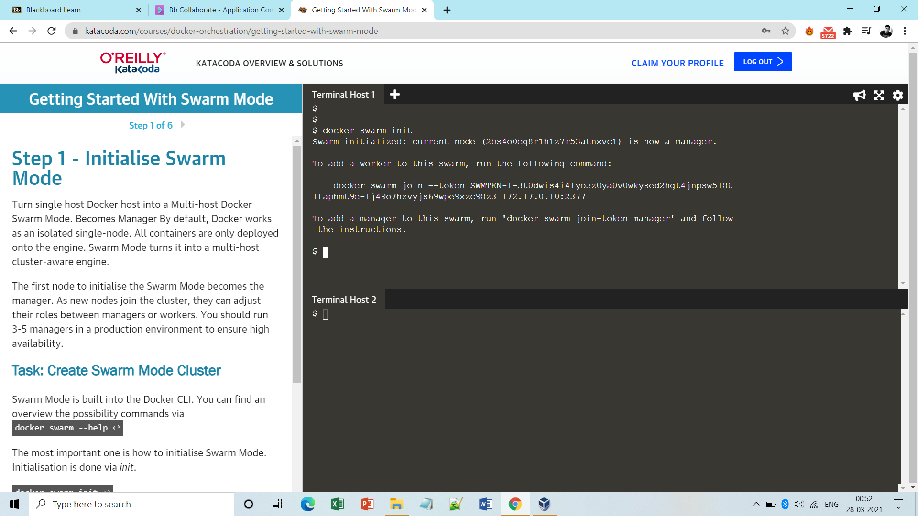

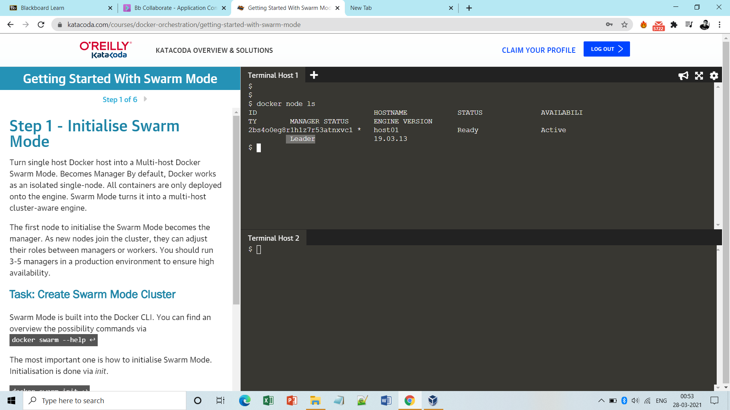

**Step3**: Join the worker node to the swarm cluster.

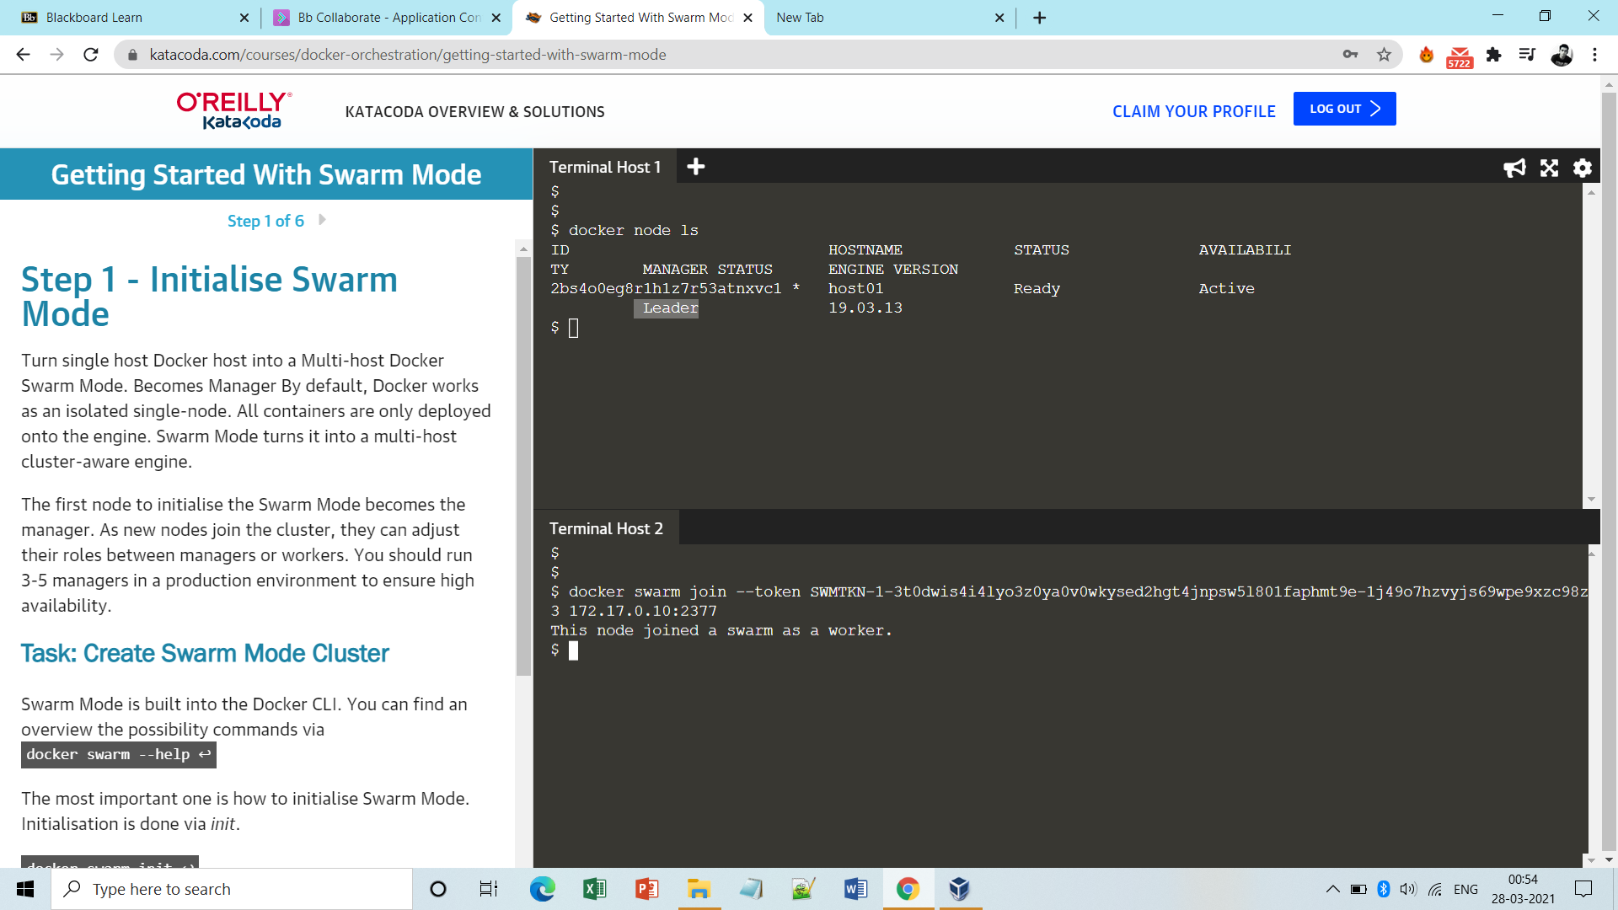

**Note:** Worker node has no authority to list the nodes or services.

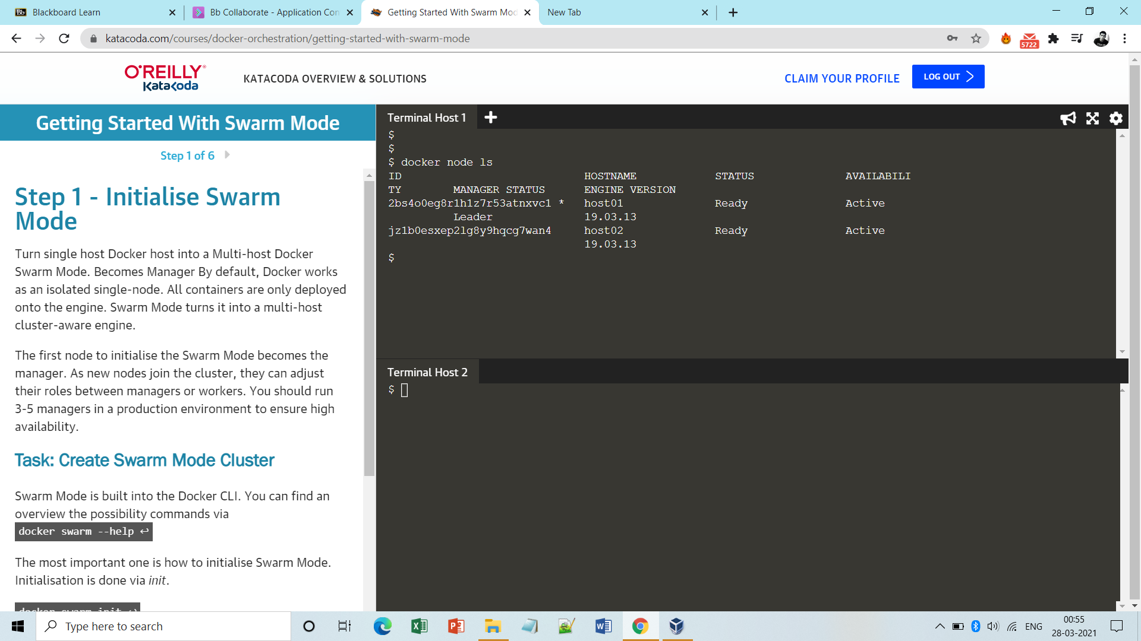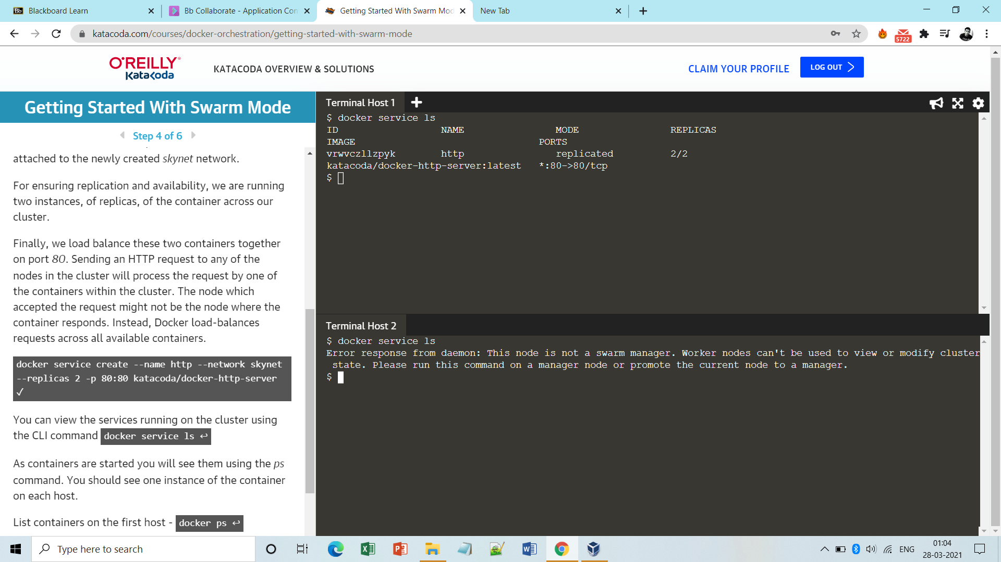

**Step4:** Check whether any instance is running on both the nodes.

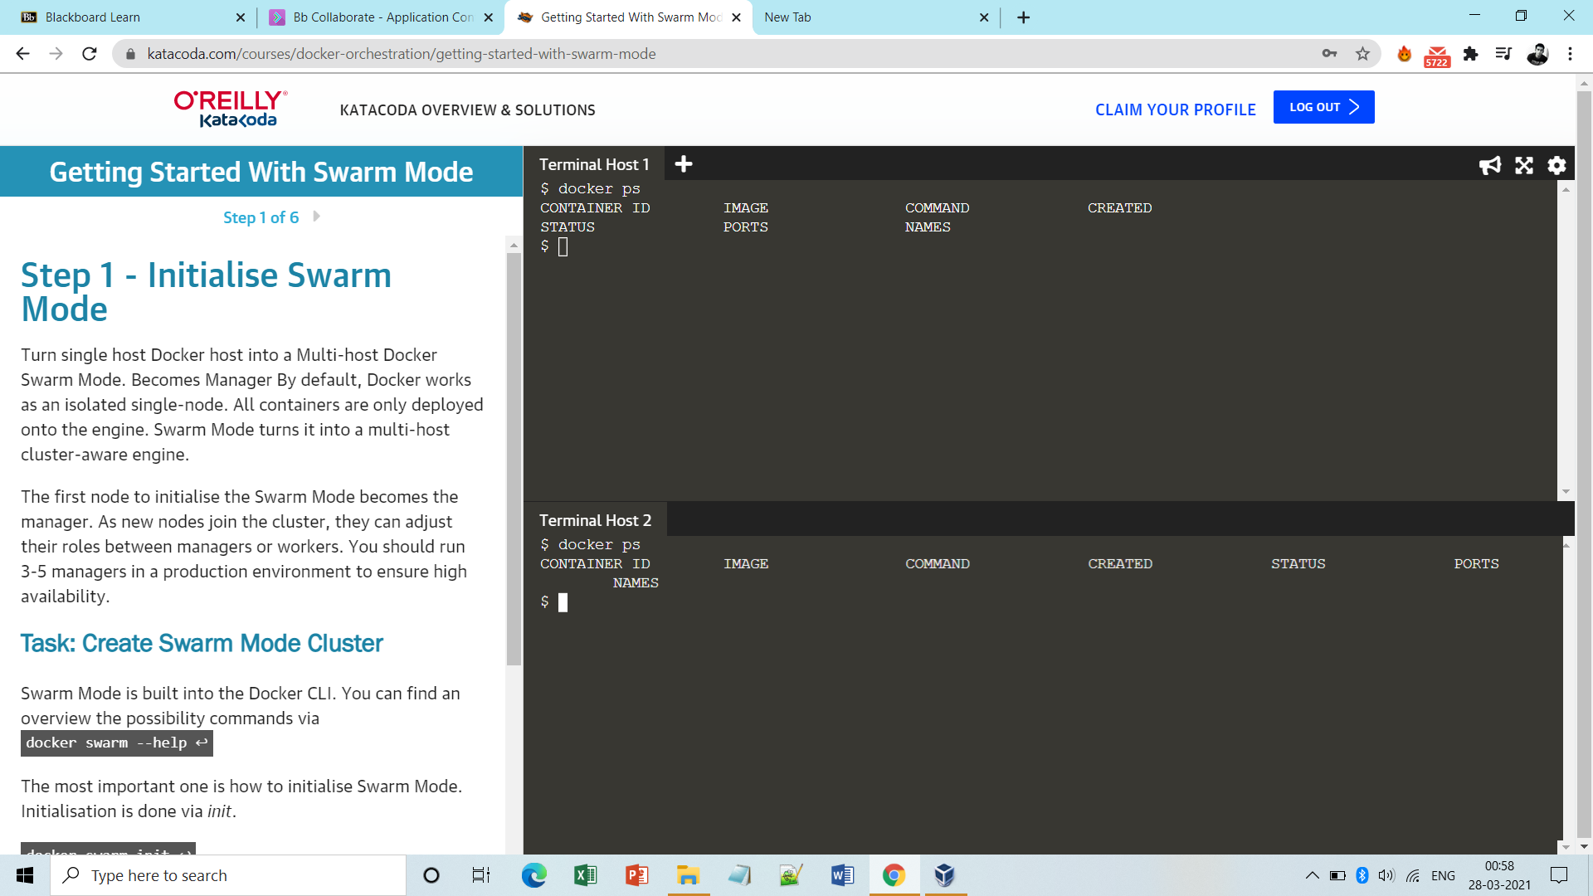

**Step5:** Create an overlay network via which nodes can communicate.

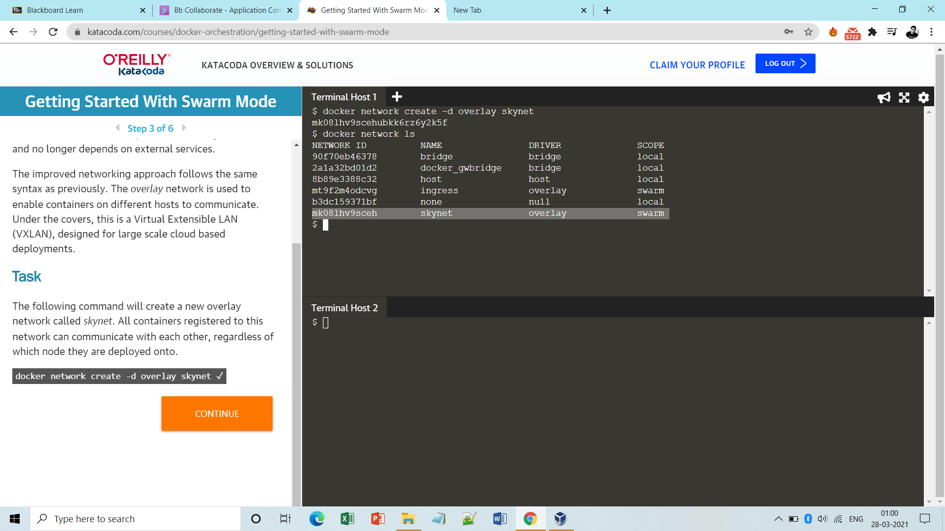

**Step6:** Initially run just 2 replicas of any service on the managed node.

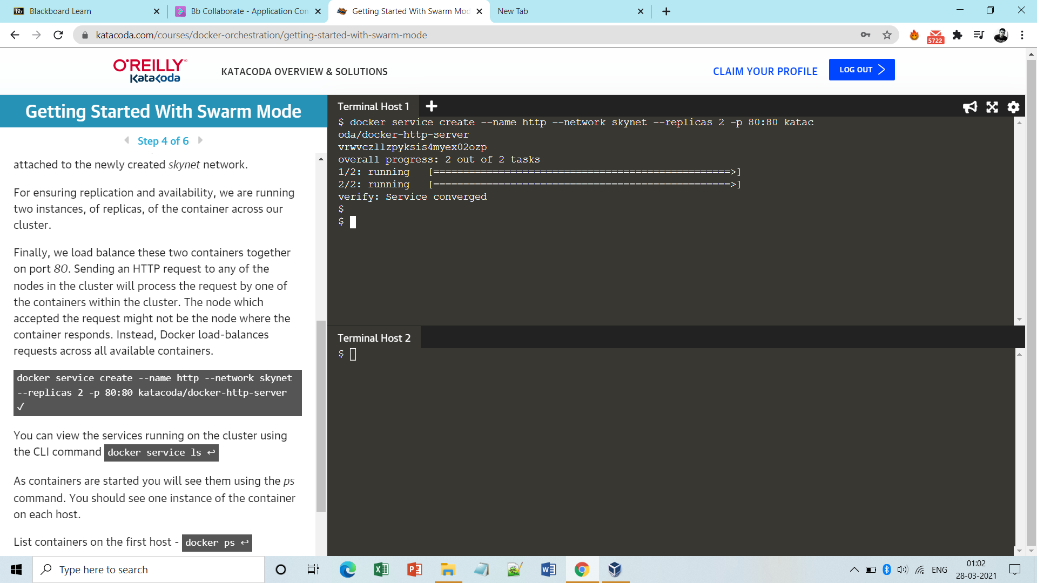

**Step7**: See the distribution of the replicas on the manager and work nodes.

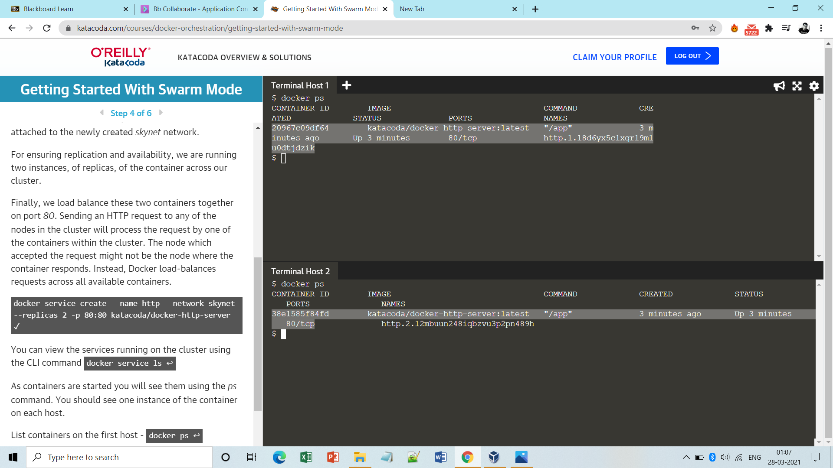

**Note:** To get state of a service:

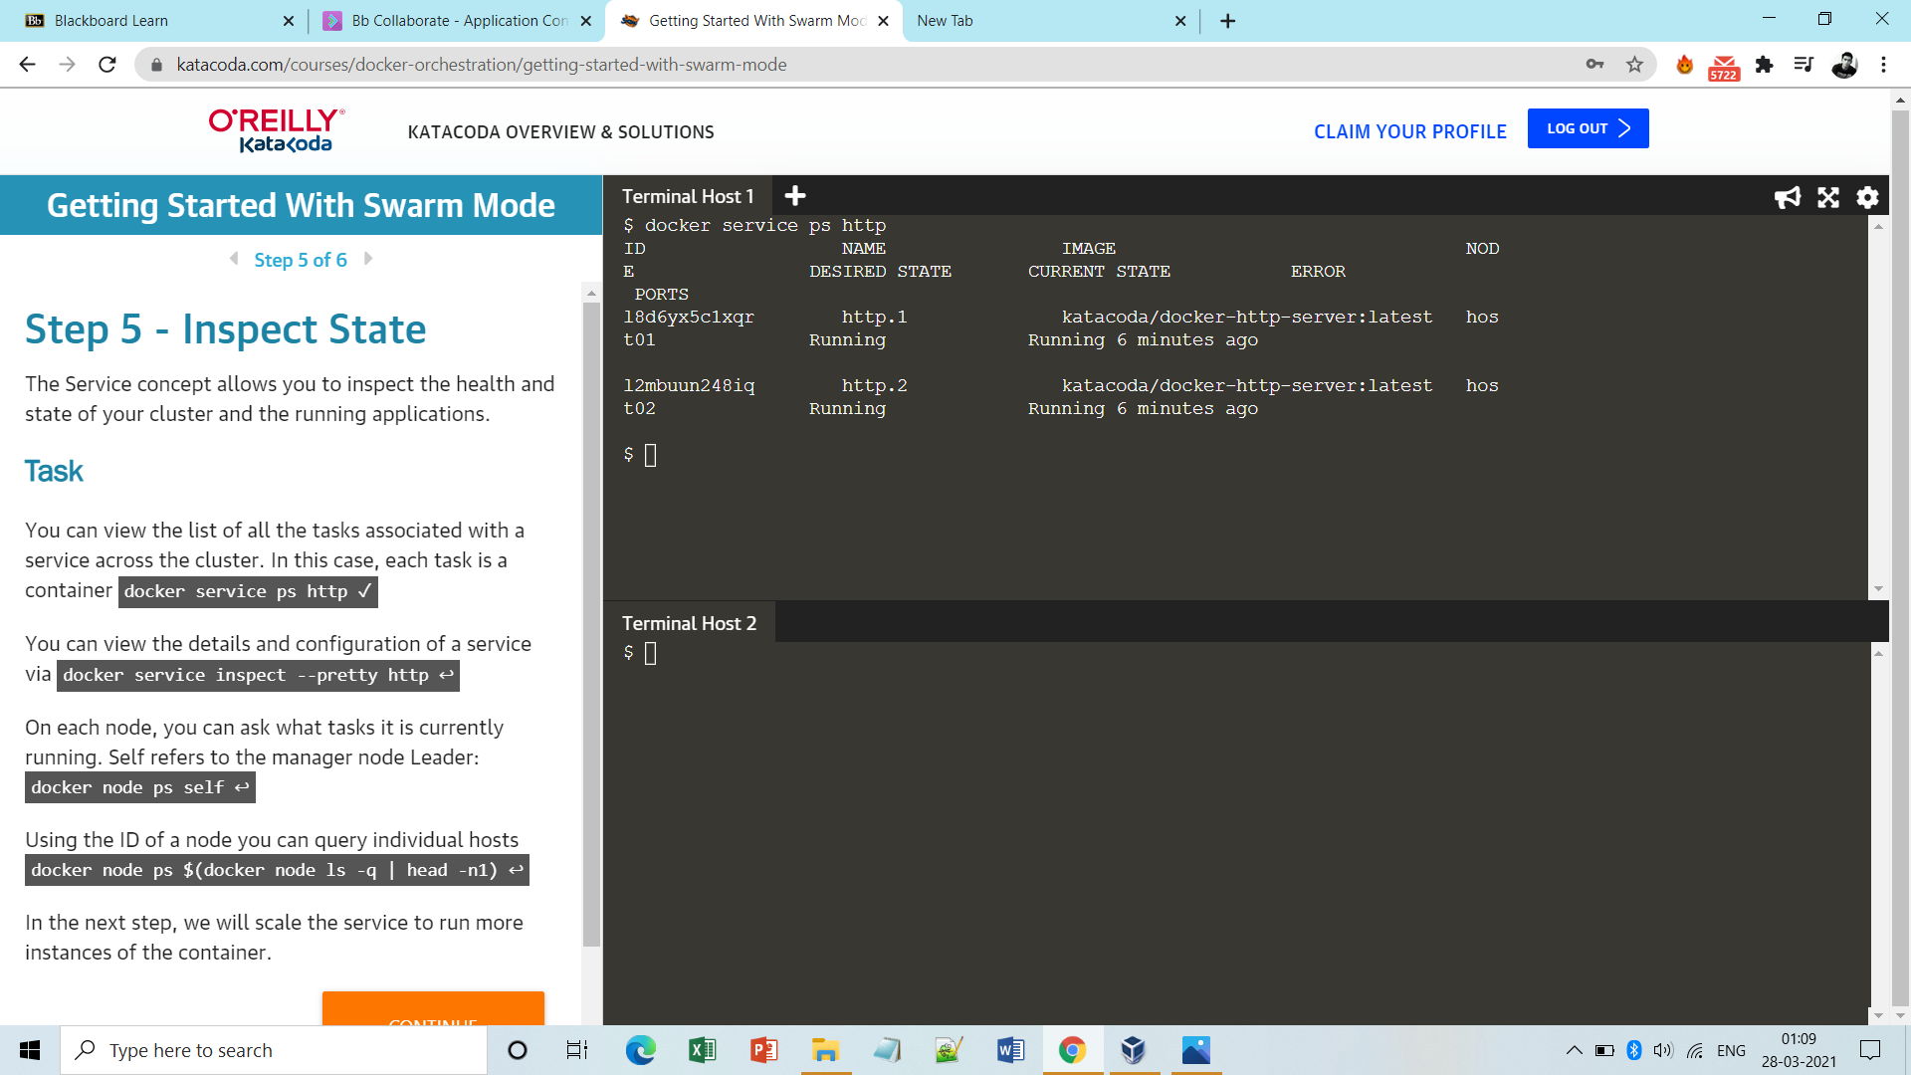

**Note:** To get the details of a service:

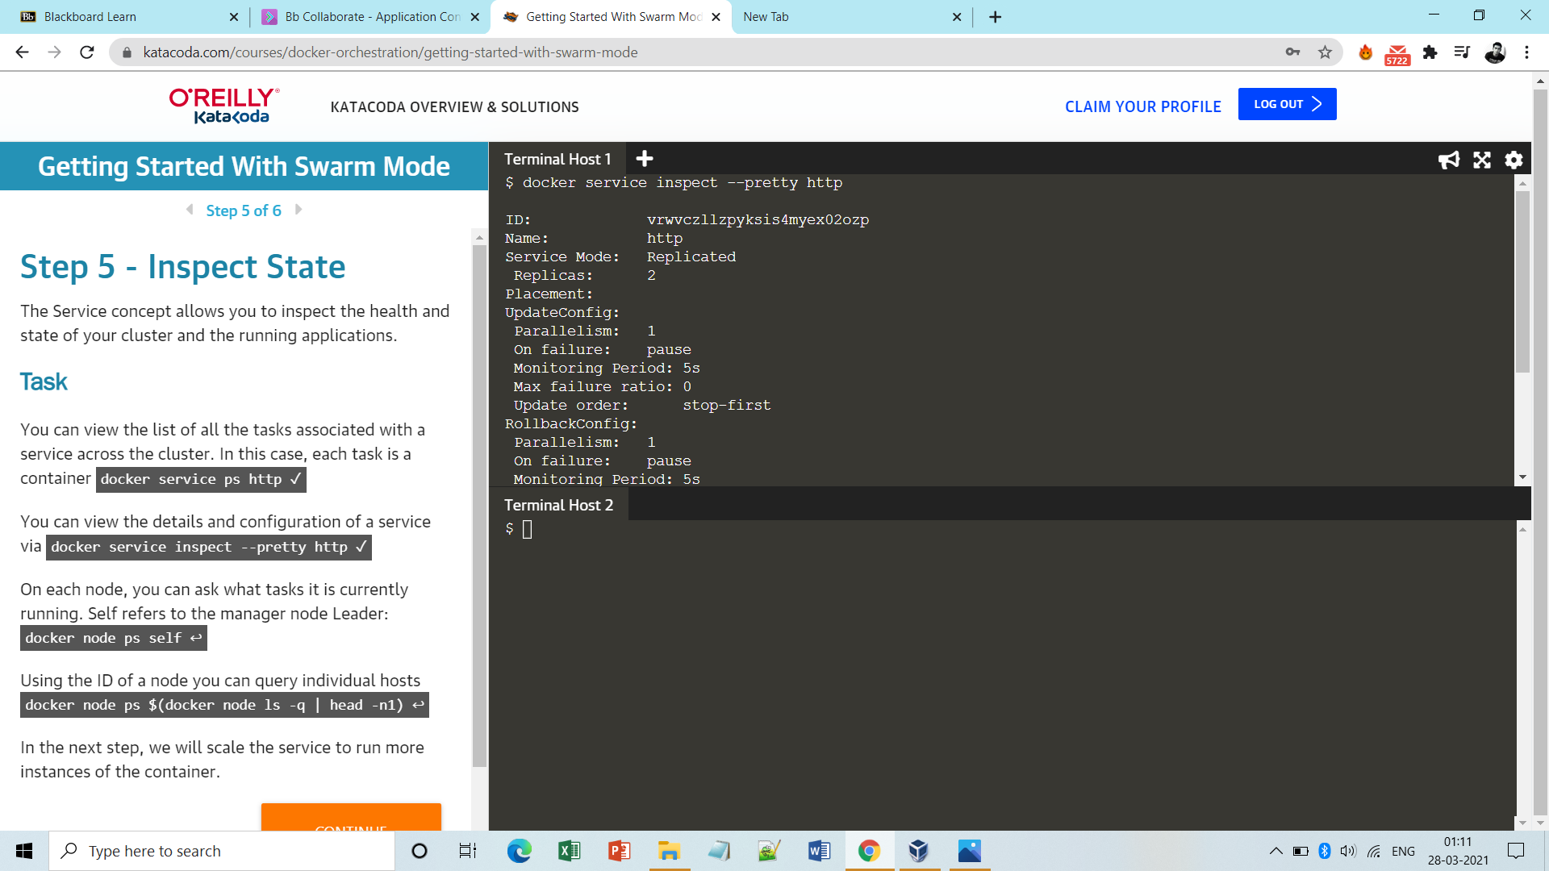

**Step8:** Now scale up to 5 and see it’s distribution.

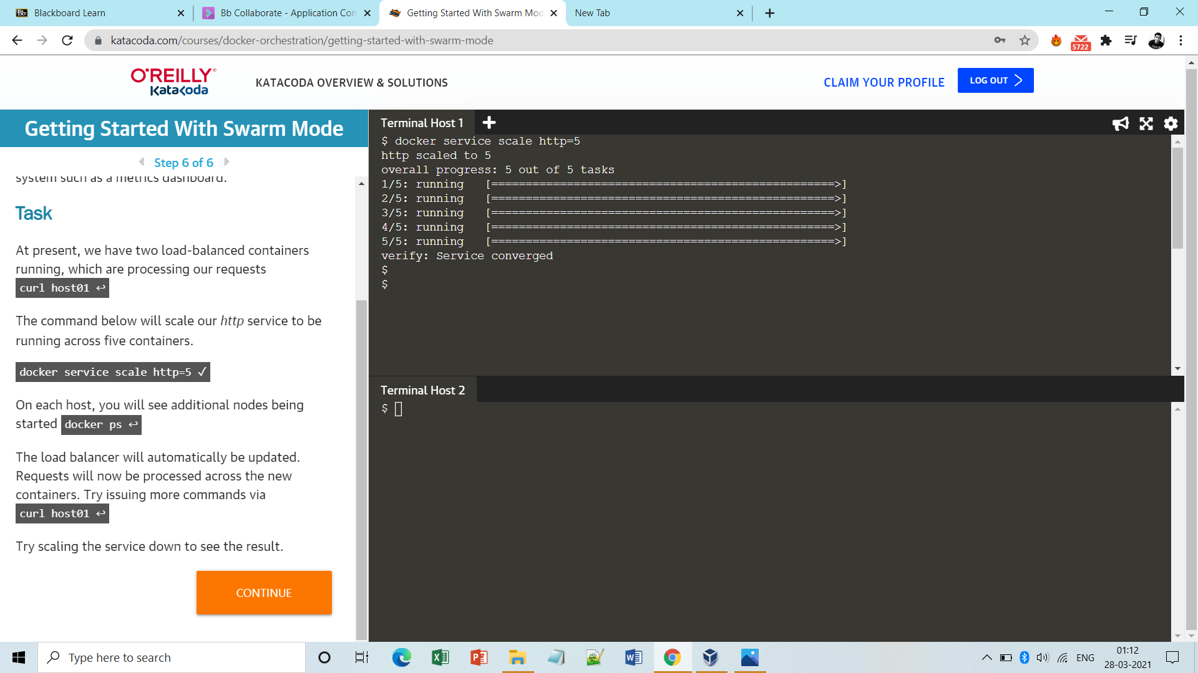

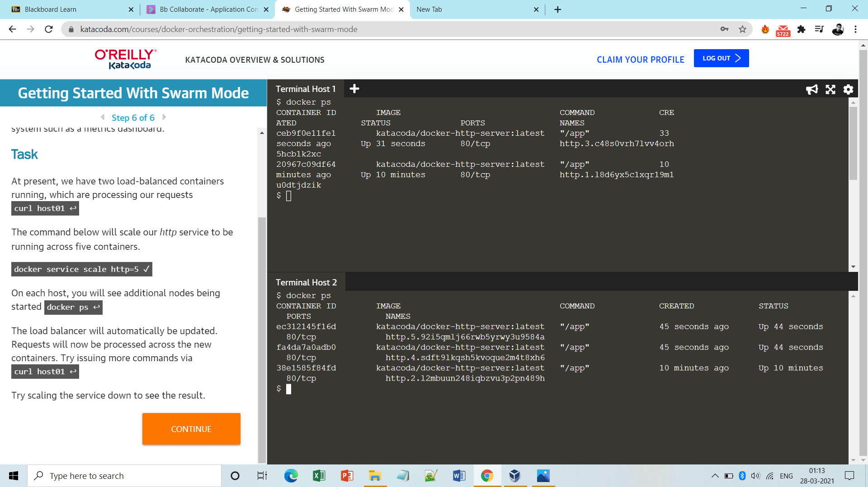

**S** **tep9:** To access the service:

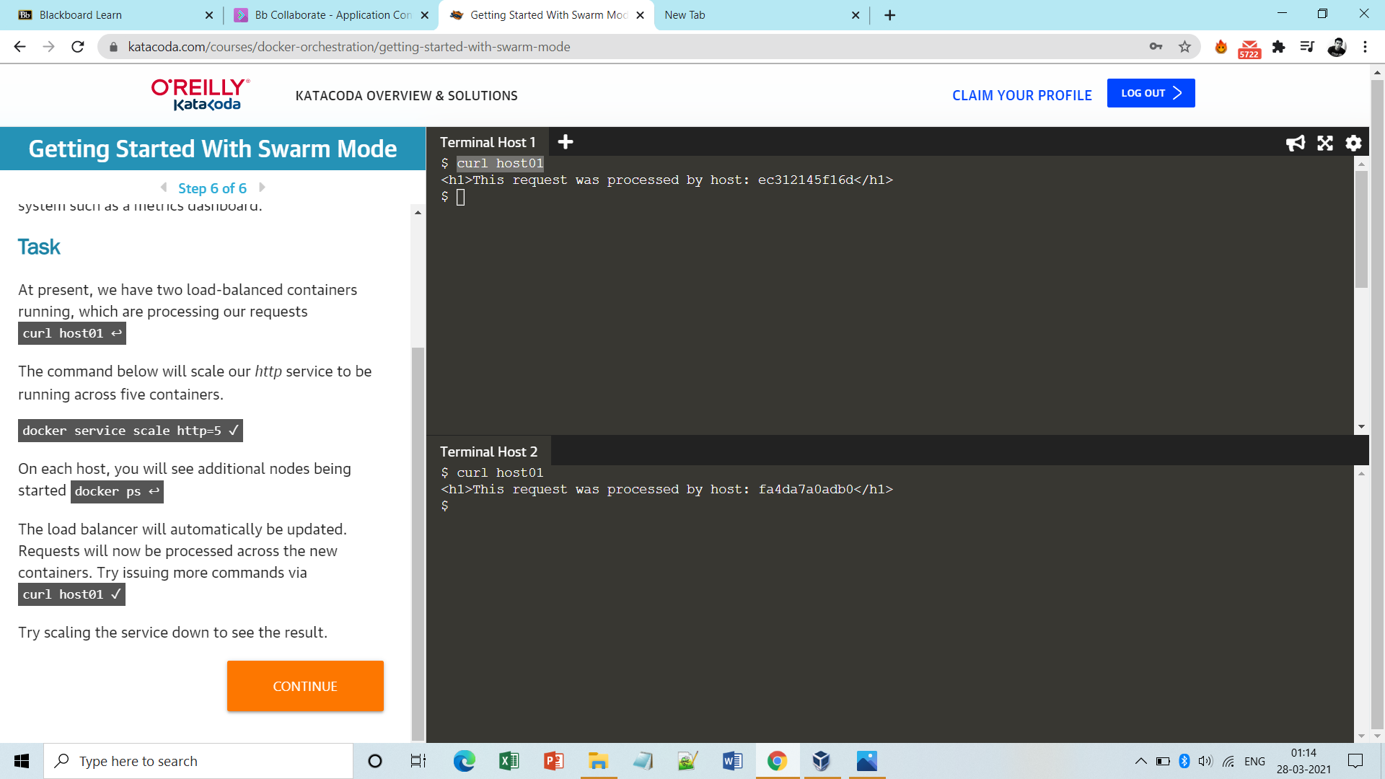

**Step10:** To leave swarm cluster for a node:

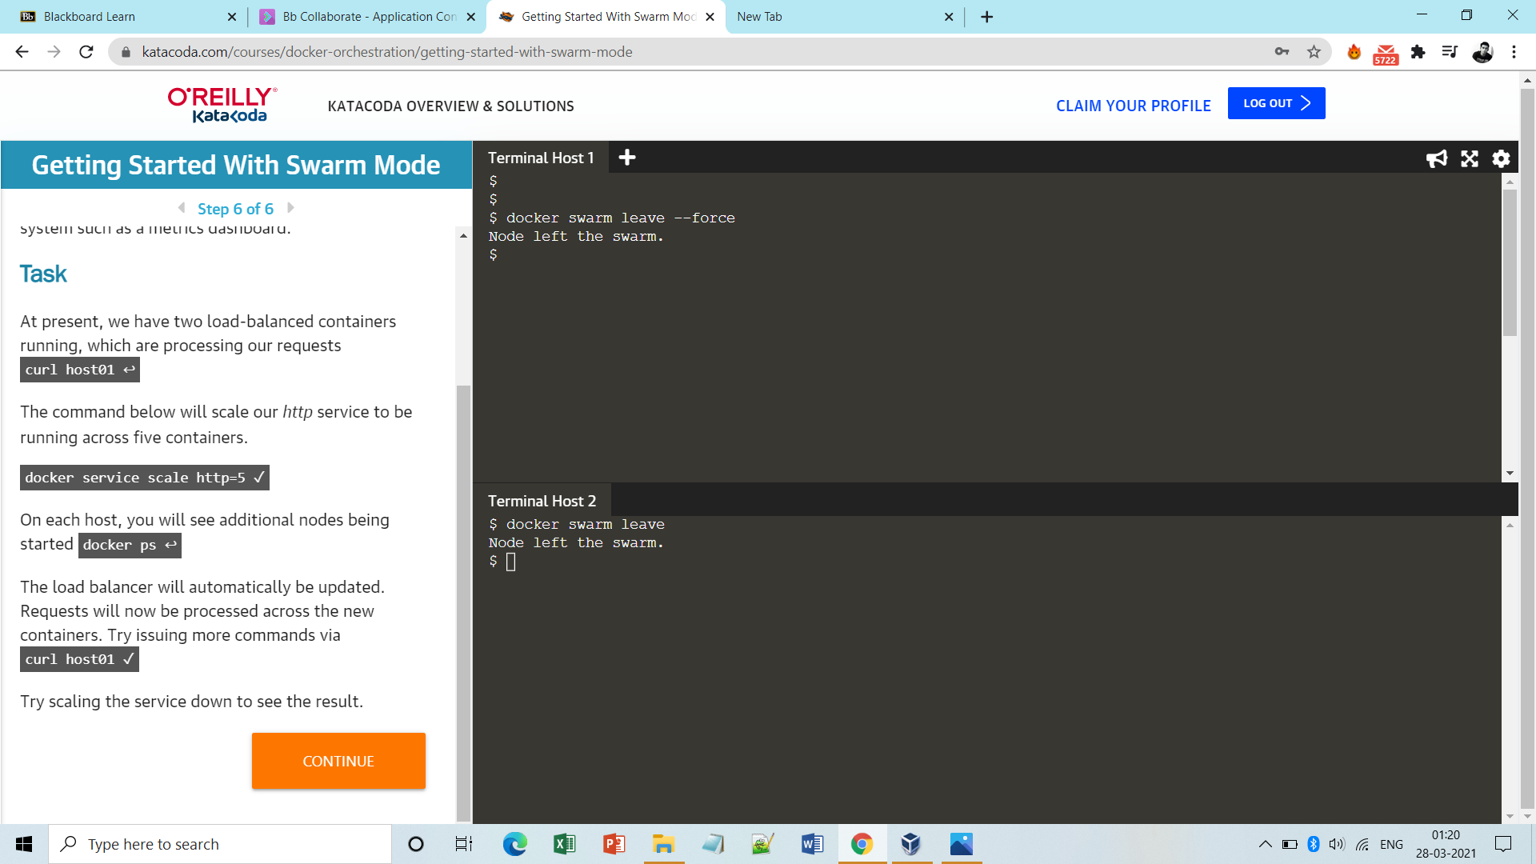

**Note: Leaving the cluster by manager node is not a good idea as the data would be lost, but to do so we need to use ‘- -force’ option.**

**Done!!**