Experiment-8

**Aim:** To ignore files in Docker.

As we know that Dockerfiles copies the working directory into the docker image. As a result this include potentially sensitive information such as password files which we would want to keep in separate file and manage out side the image.

**Now follow the following steps to resolve it.**

**Step1:** View the Dockerfile to know what all sensitive files it contain.

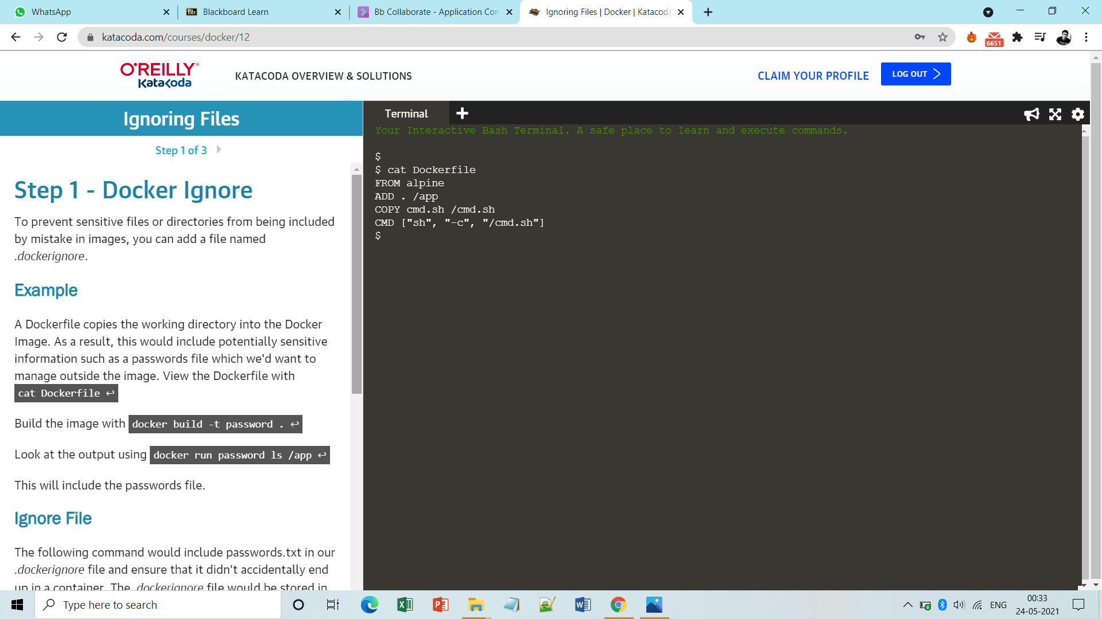

**Step2:** Now build the image with a name ‘password’ and list it.

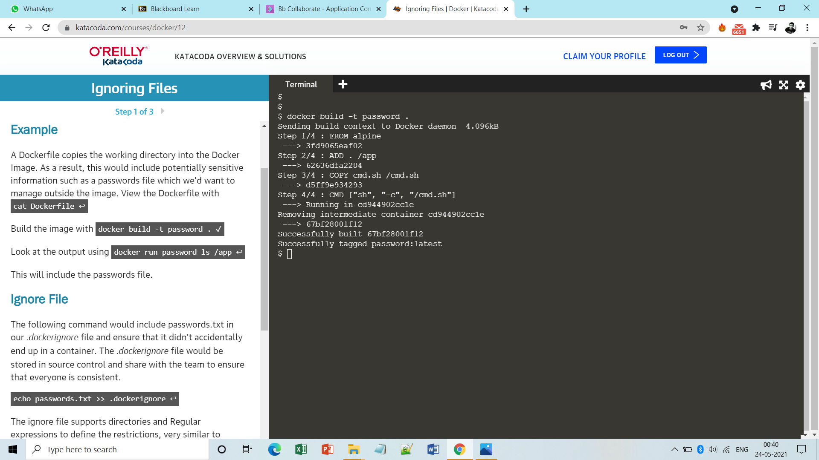

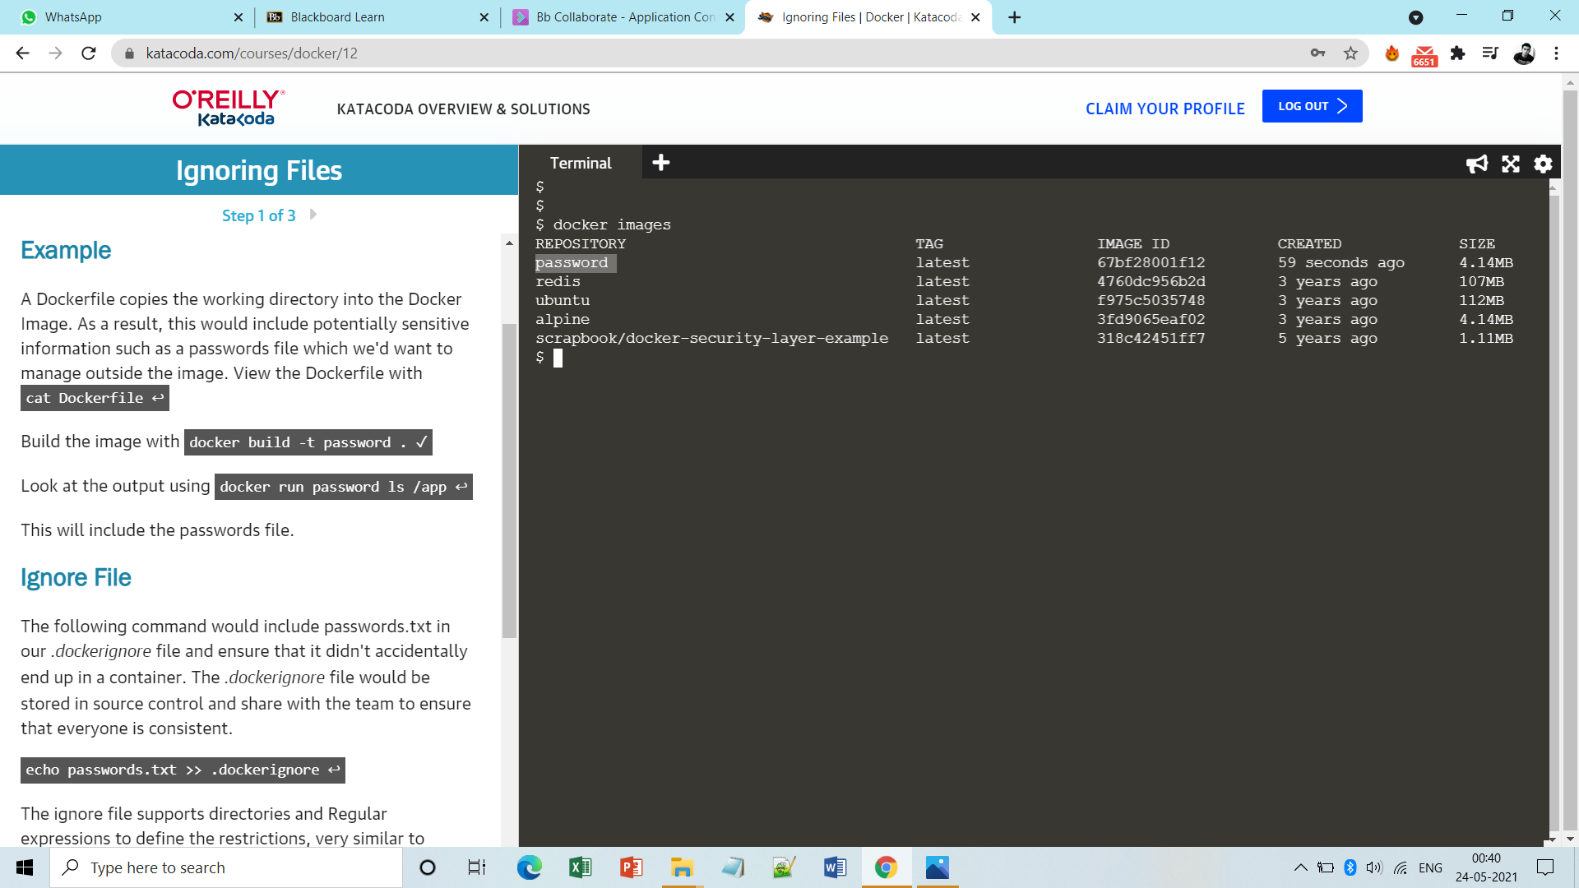

**Step3:** Now run this image and list to see what all sensitive files it contains.

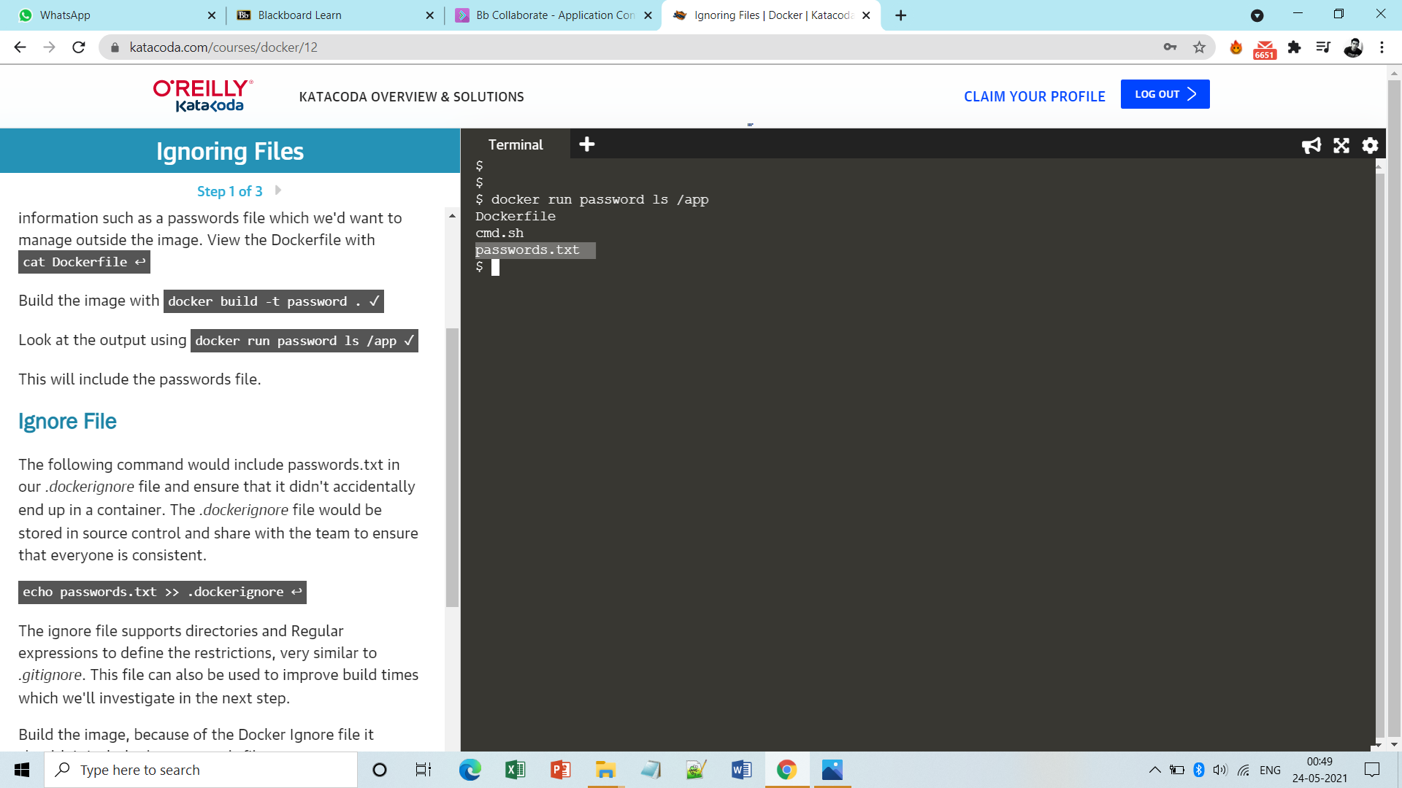

**Step4:** Now we want to ignore the password.txt file and manage it outside the image by including it in .dockerignore file.

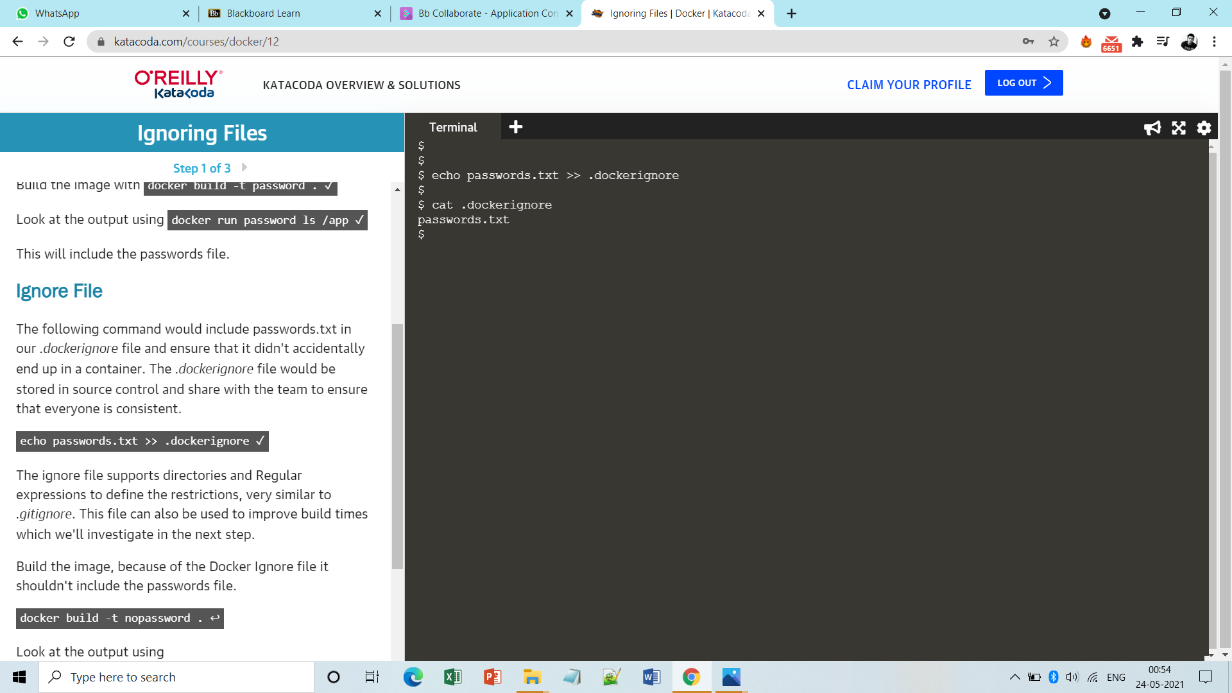

**Step5:** Now build the image again with some name like ‘nopassword’.

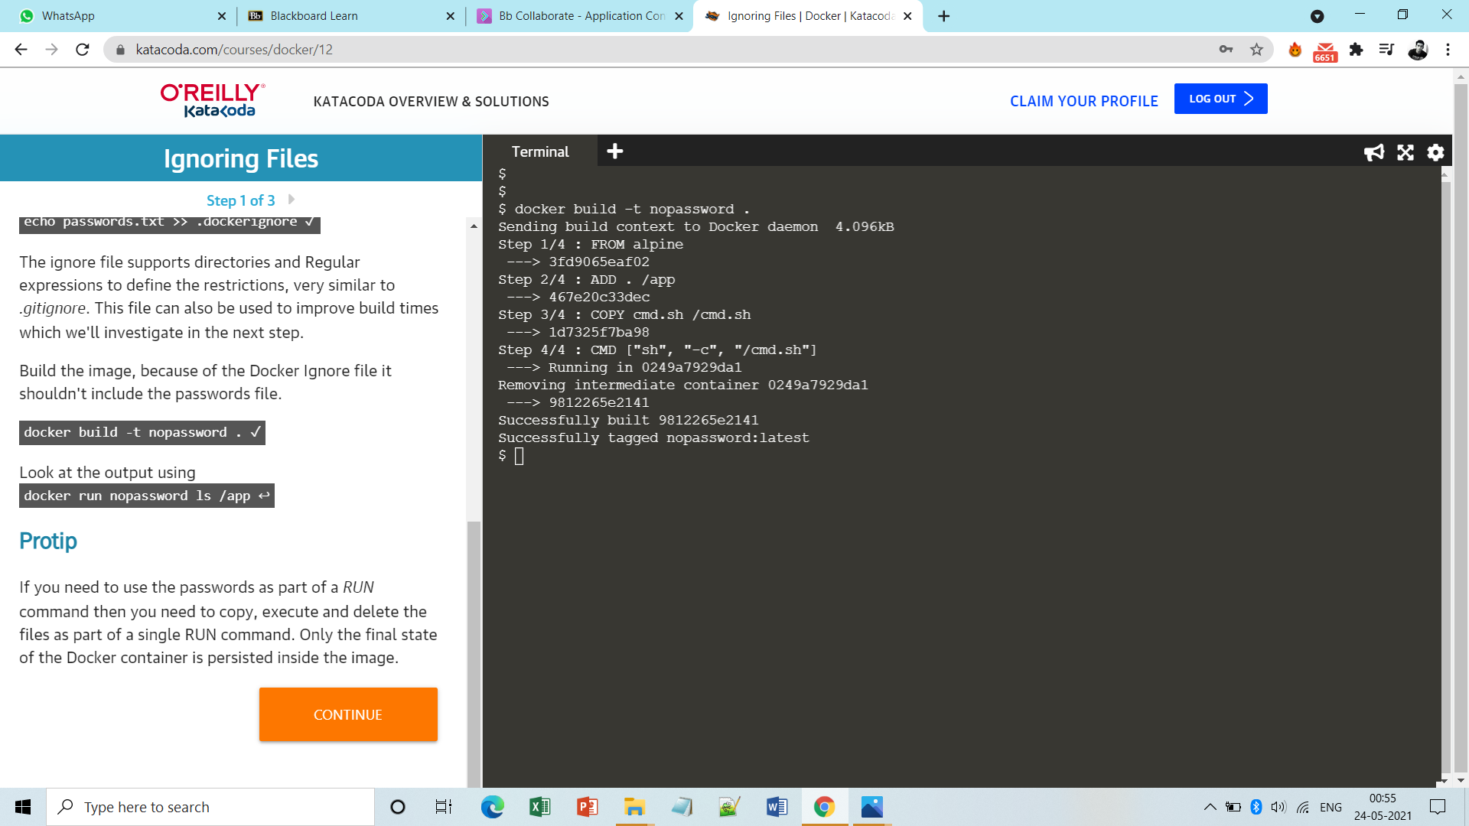

**Step6:** Now list the files to see whether the sensitive files like password.txt are ignored/excluded from the image or not.

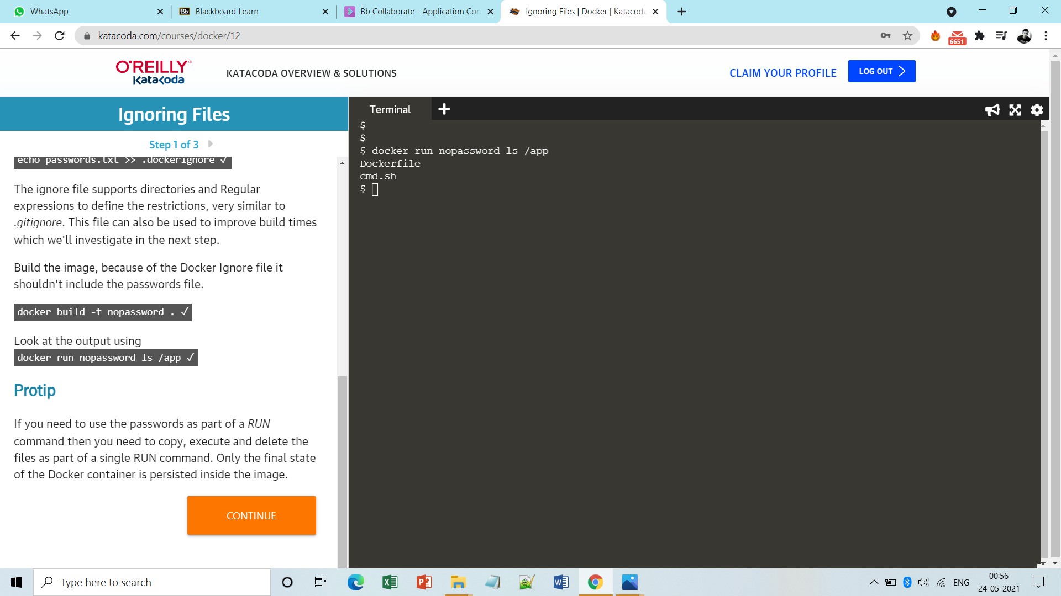

**Note:-Now similarly in order to ignore large files from getting included in the image do the following.**

**Step1:** Build the image and notice what all large files are there.

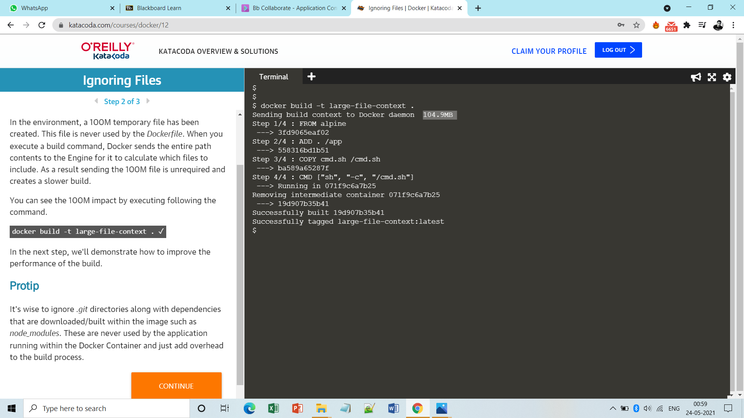

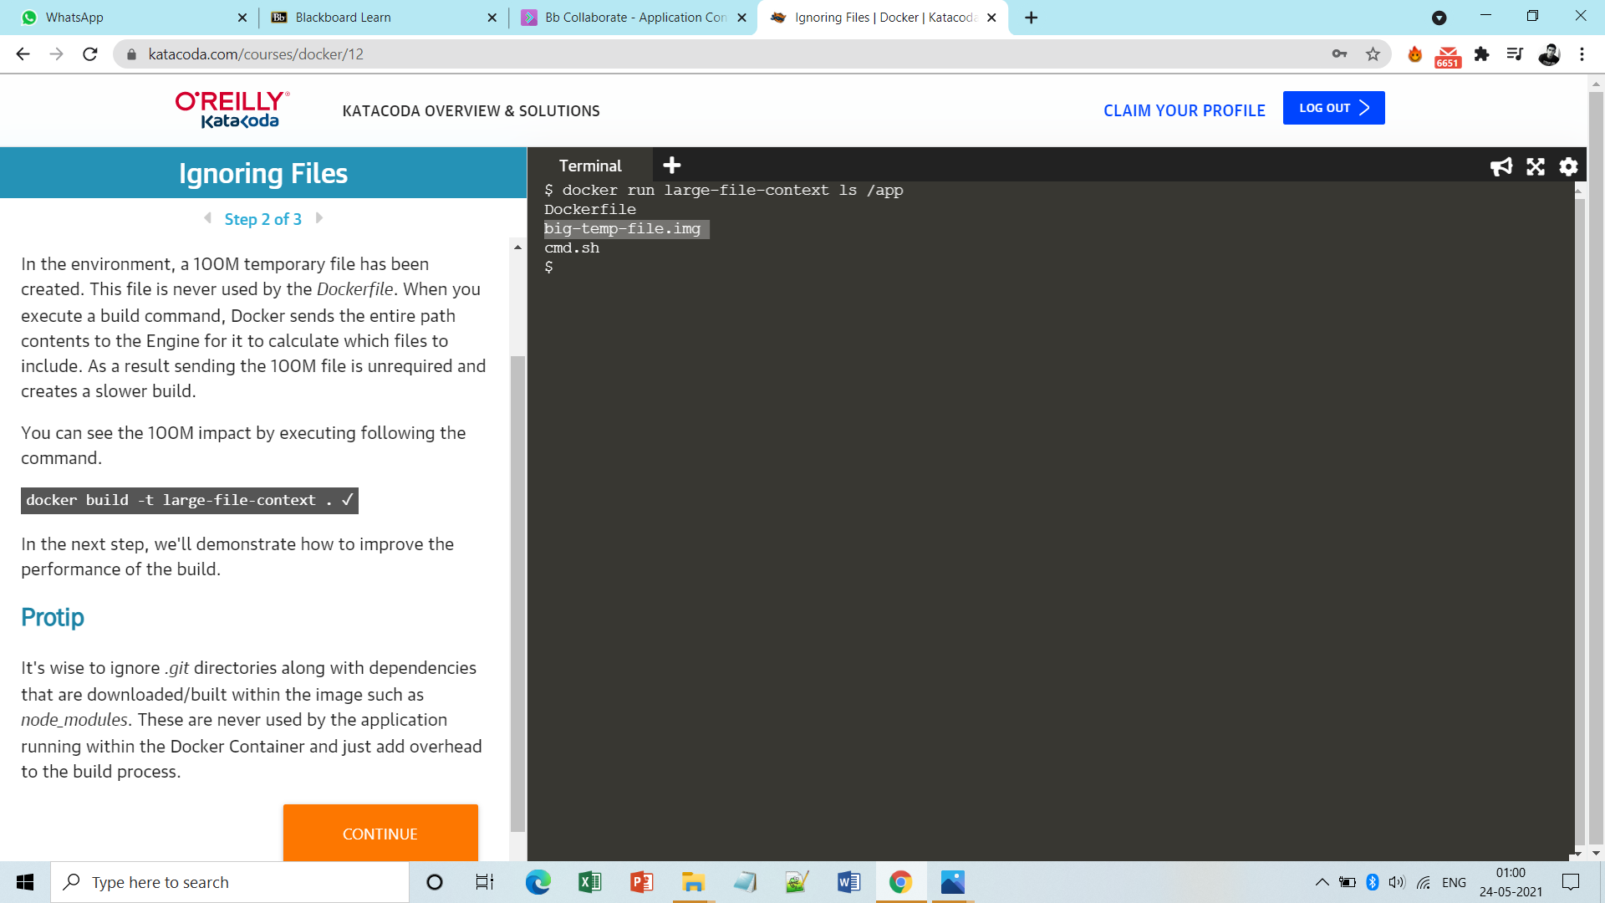

**Step2:** Now in order to ignore the big-temp-file file and manage it outside the image by include it in .dockerignore file.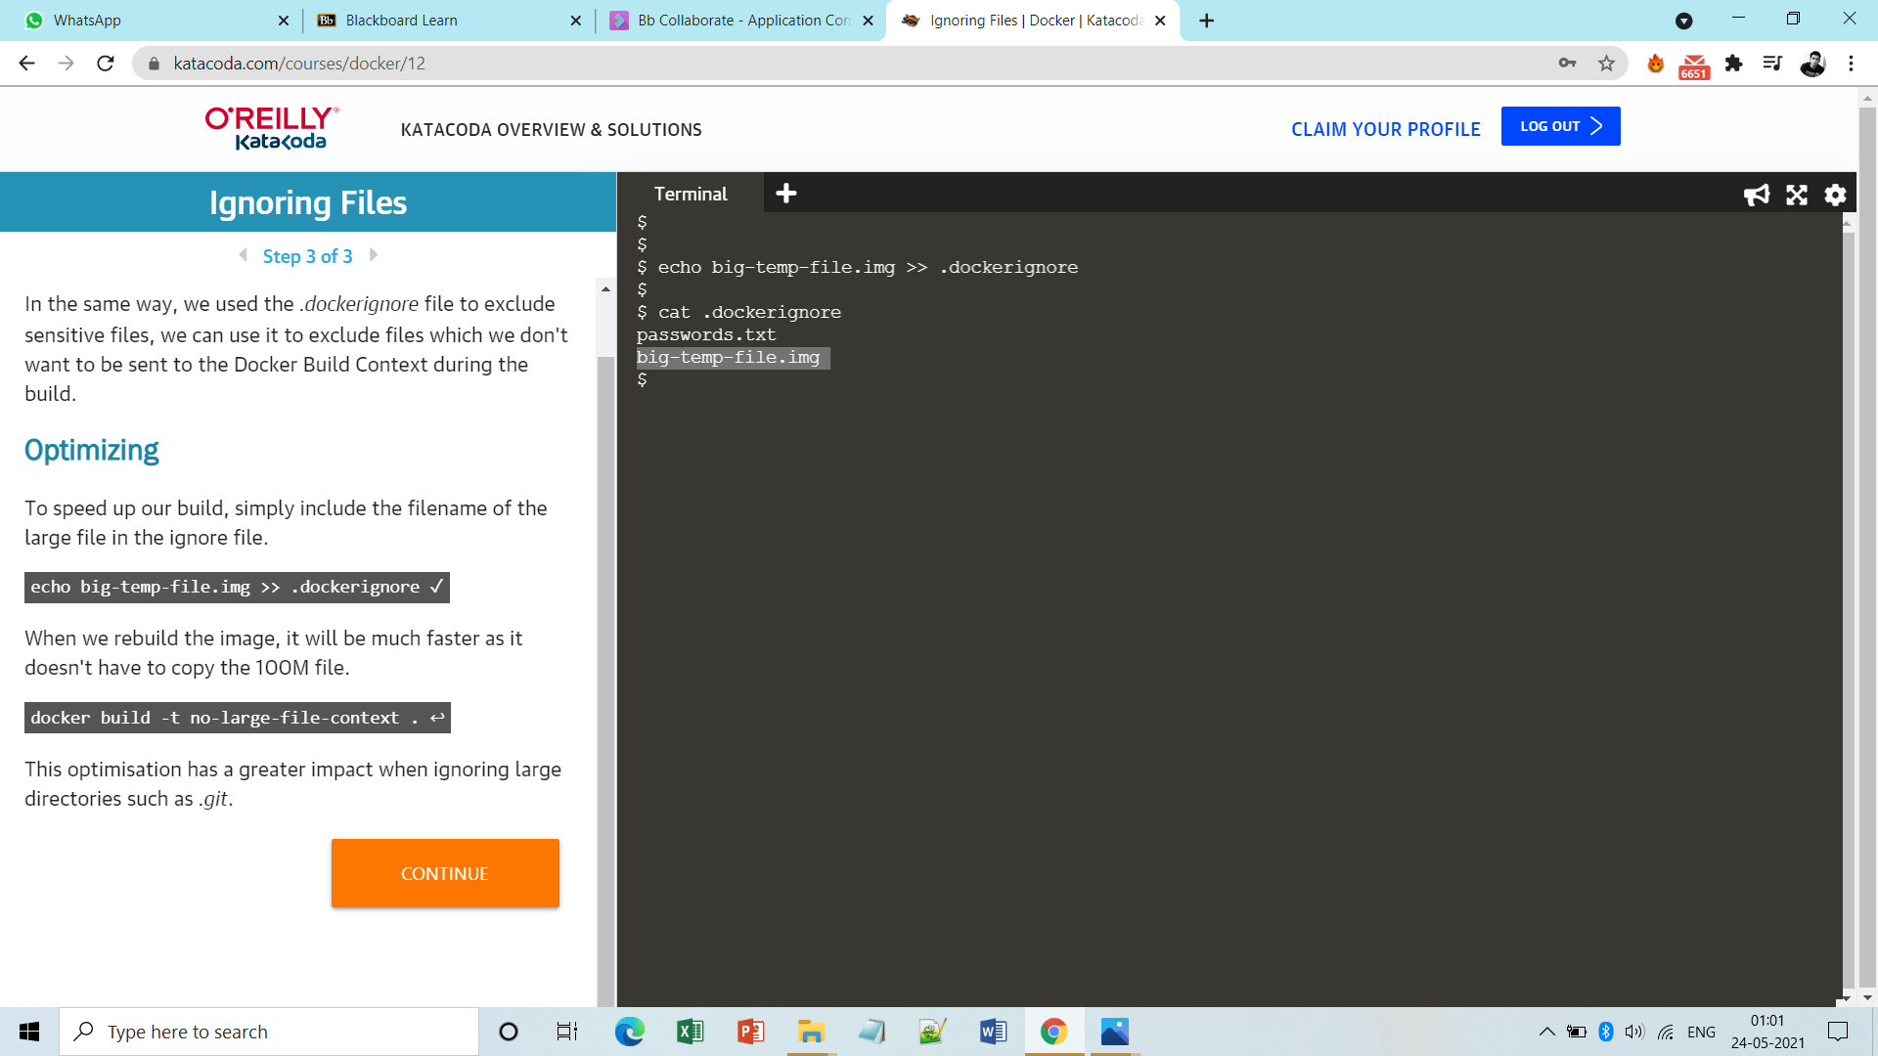

**Step4:** Now build the image again with some new name and see whether the large files are excluded from image or not.

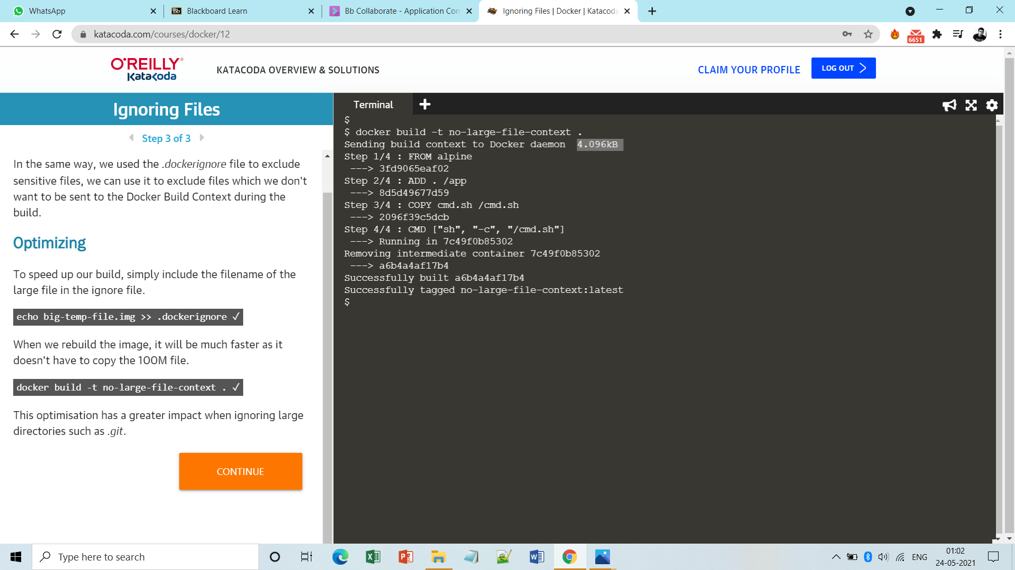

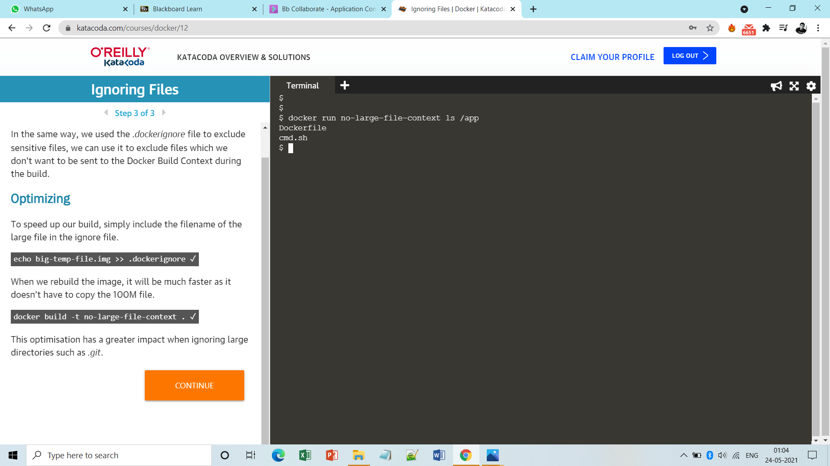

**Done!**