Experiment-9

**Aim:** To manage Docker Metadata and Labels.

**Single Label:**

**Step1:** Run a container with a single label as a reference.

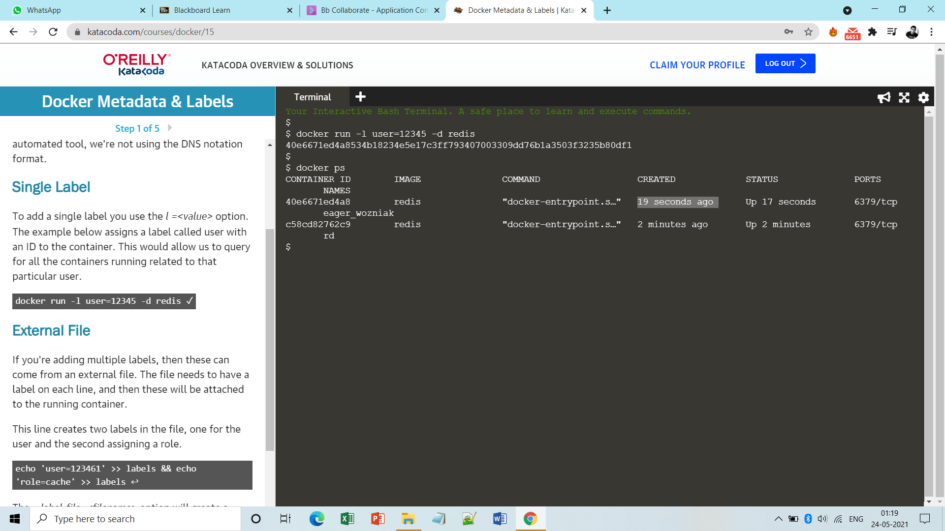

**Step2:** Run docker inspect container_id to see the labels.

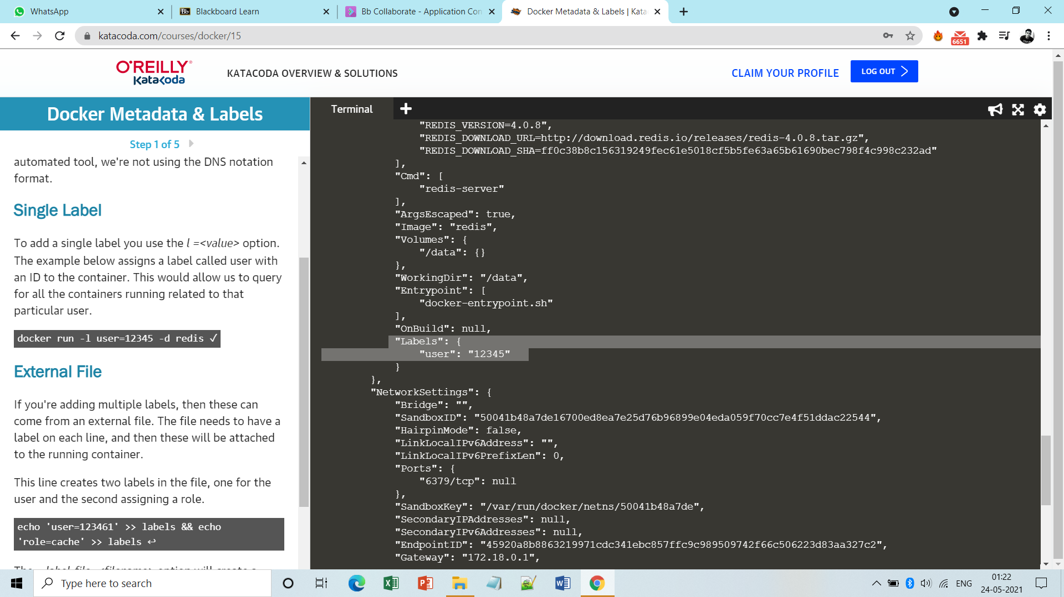

**Step3:** If we want to add multiple labels then these can come from an external file.

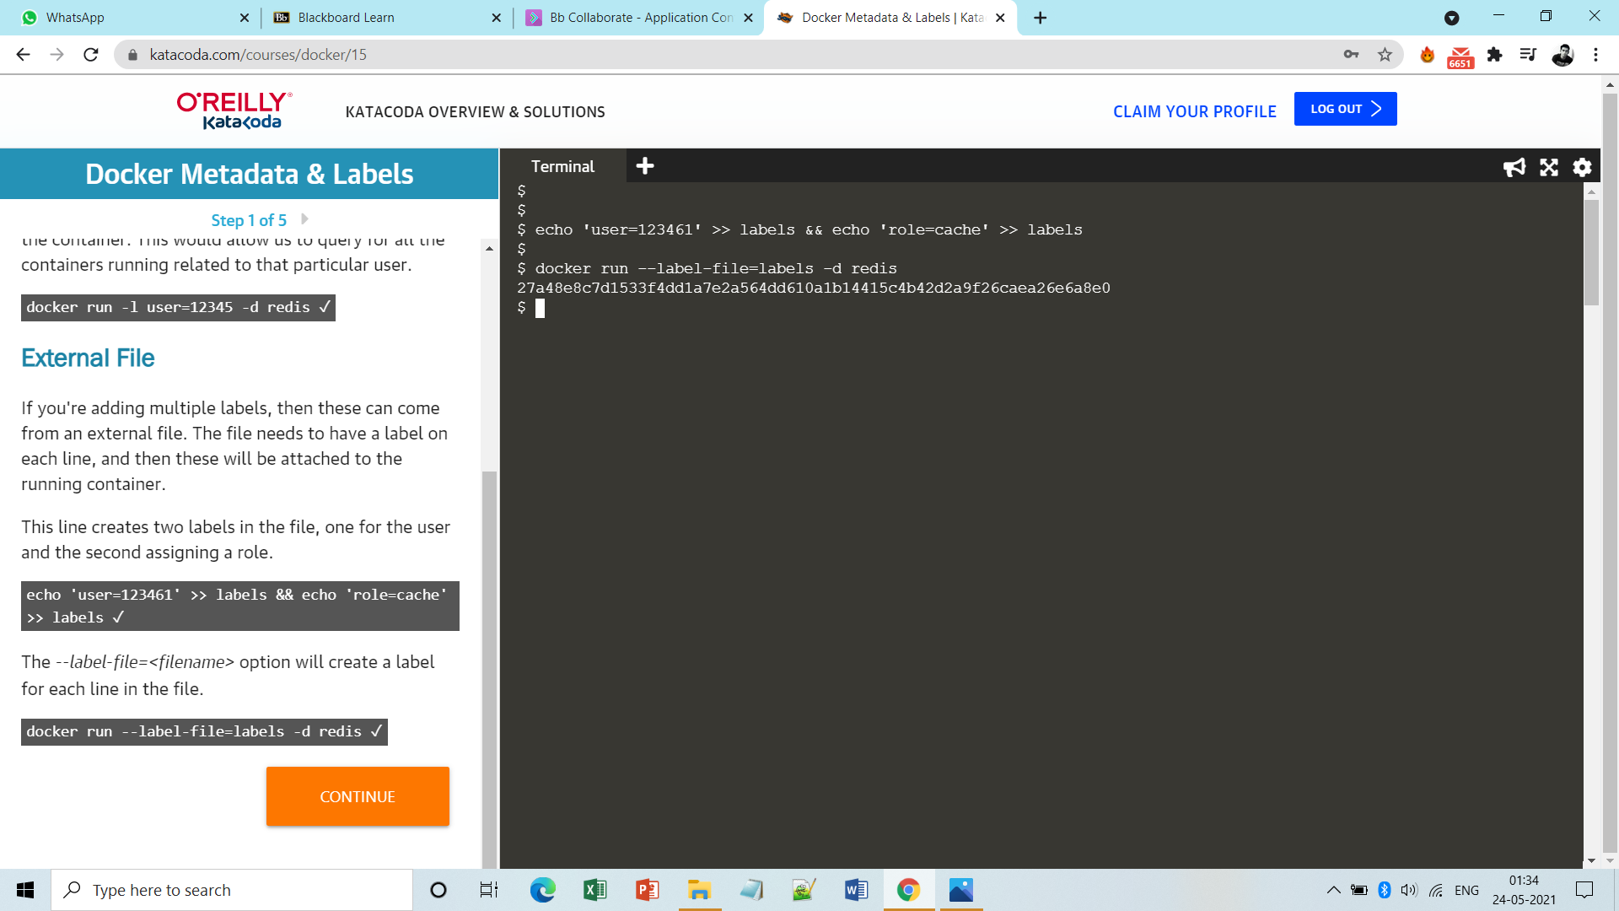

**Note:-** **Here the labels is just a file name, it can be anything.**

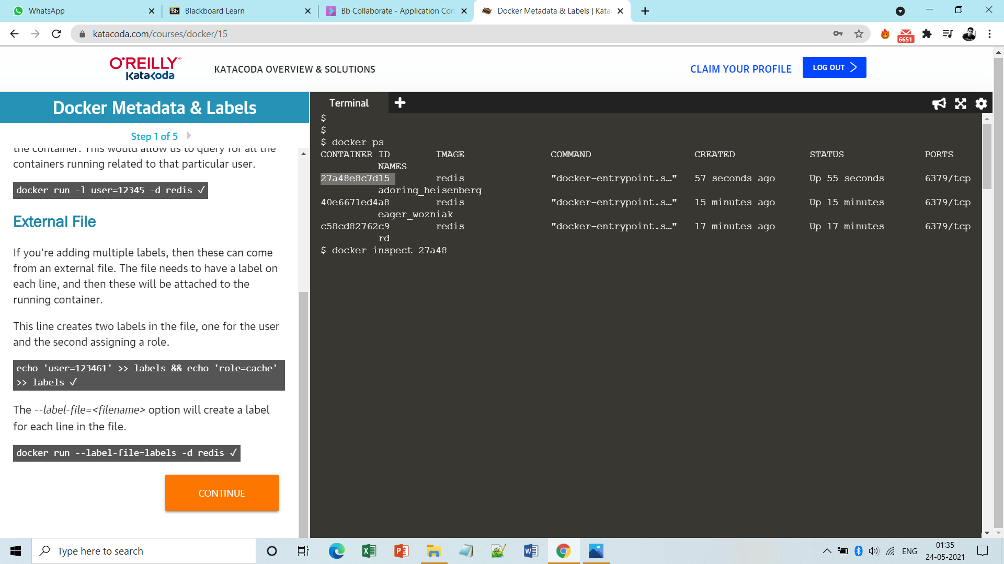

**Step4:** Again run docker inspect to see the labels. 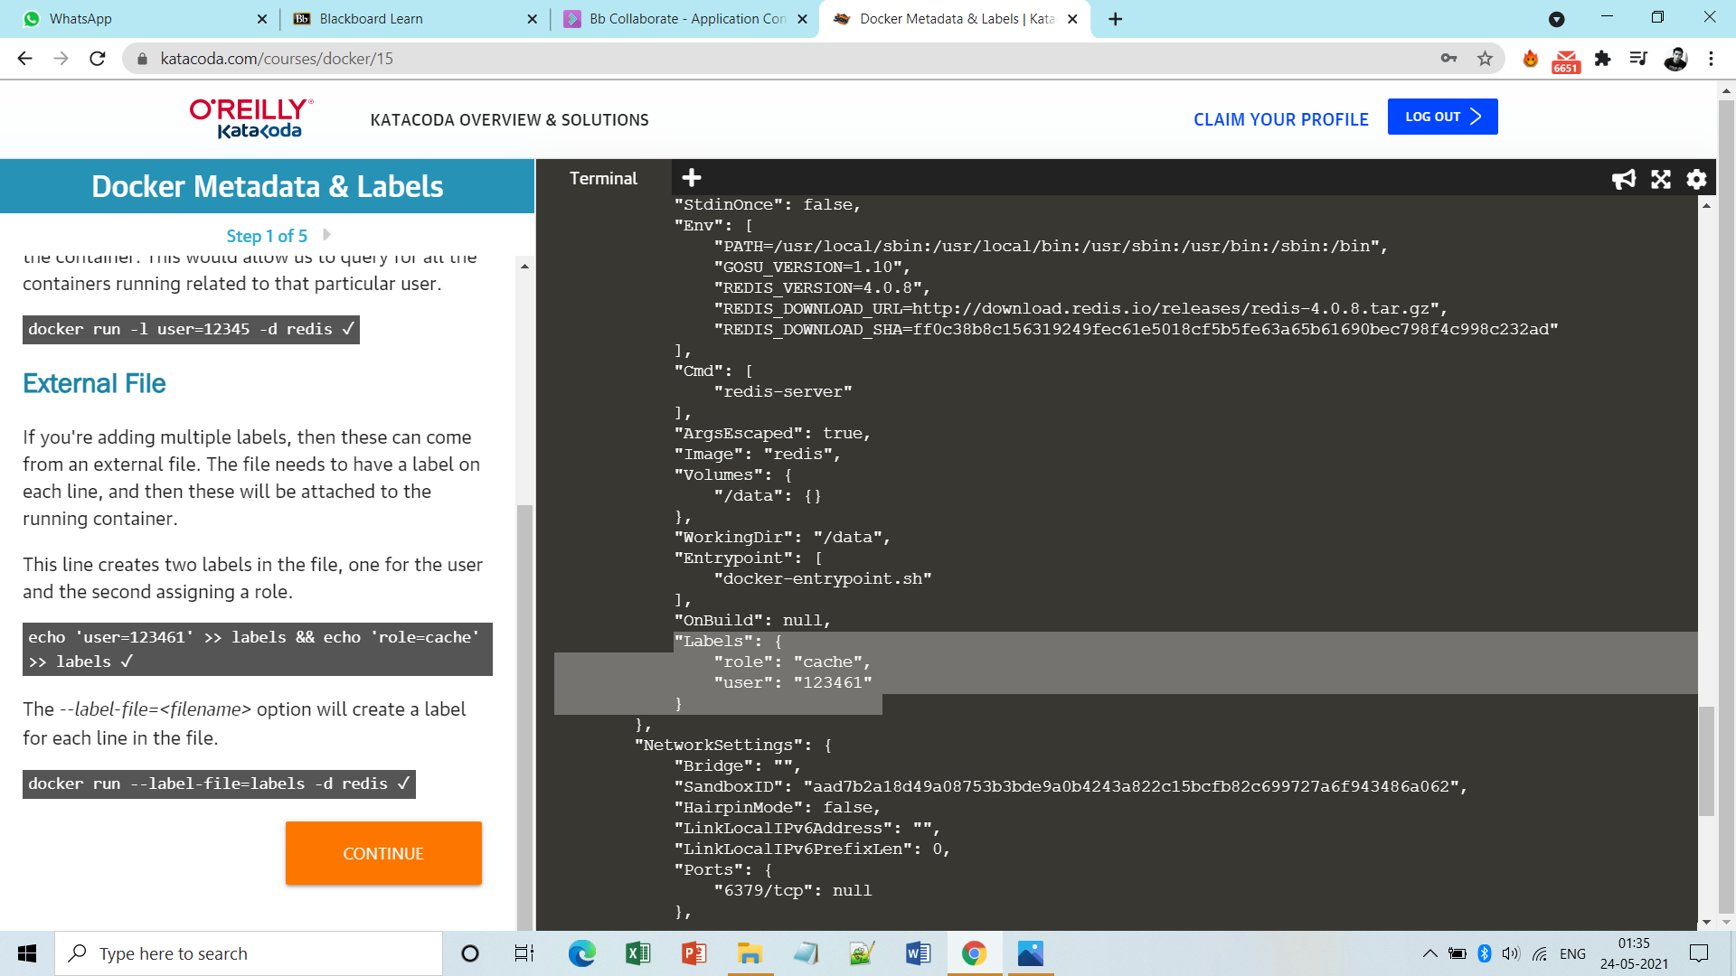

**Or we can do via following.**

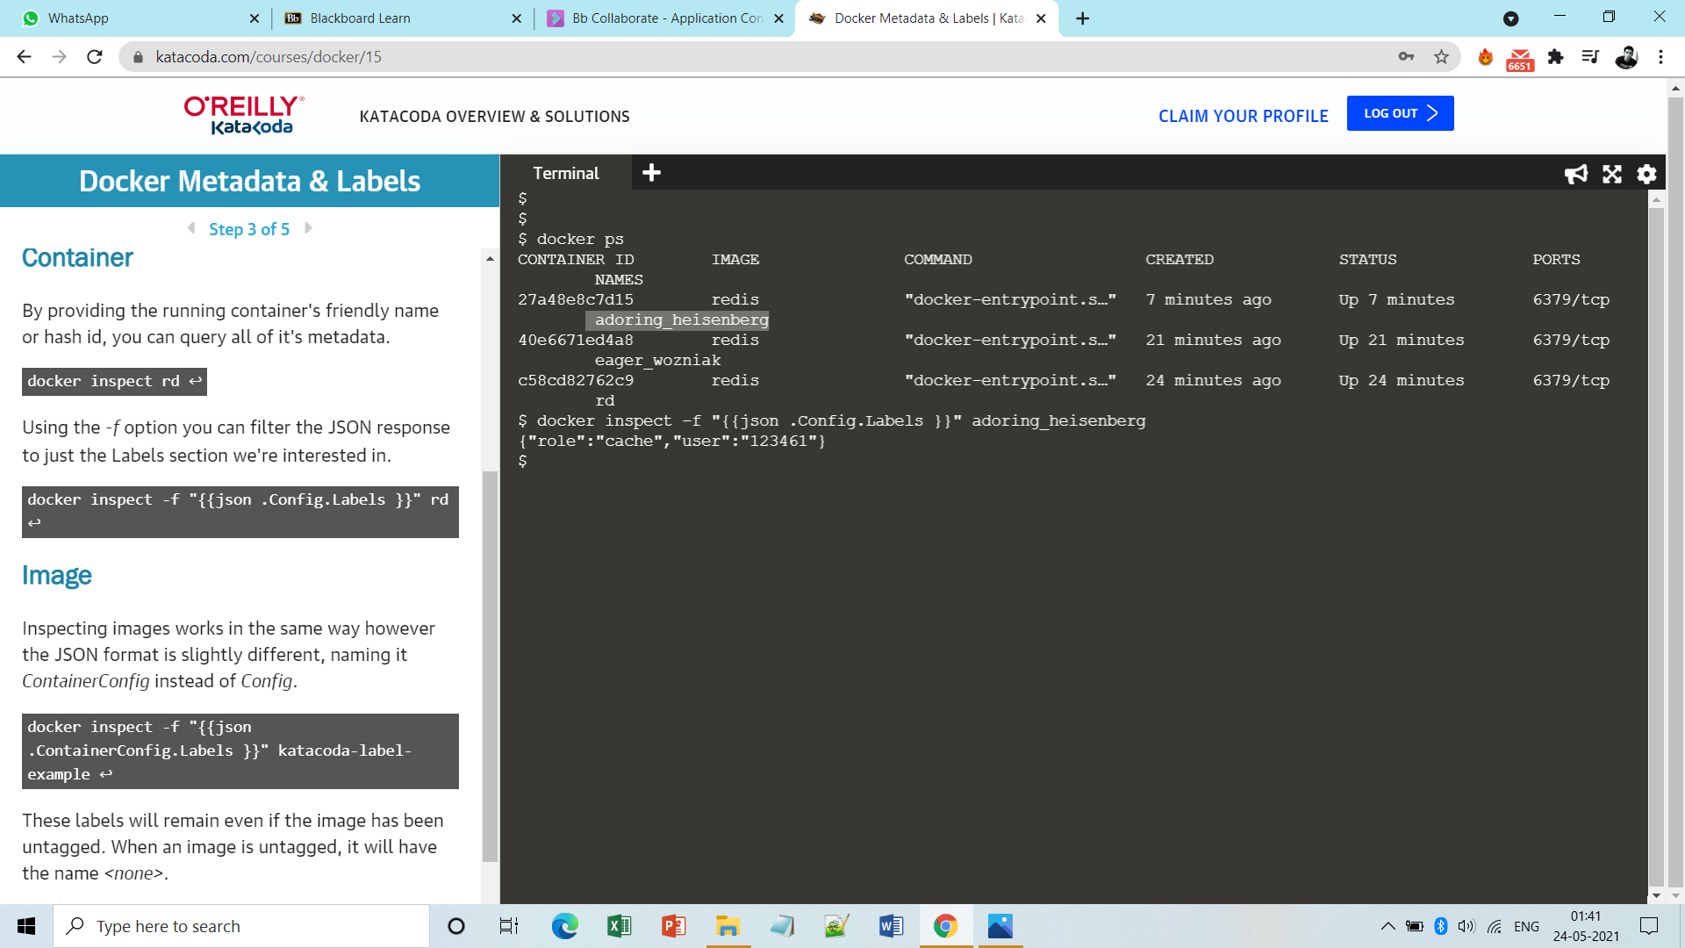

**Multiple Labels:**

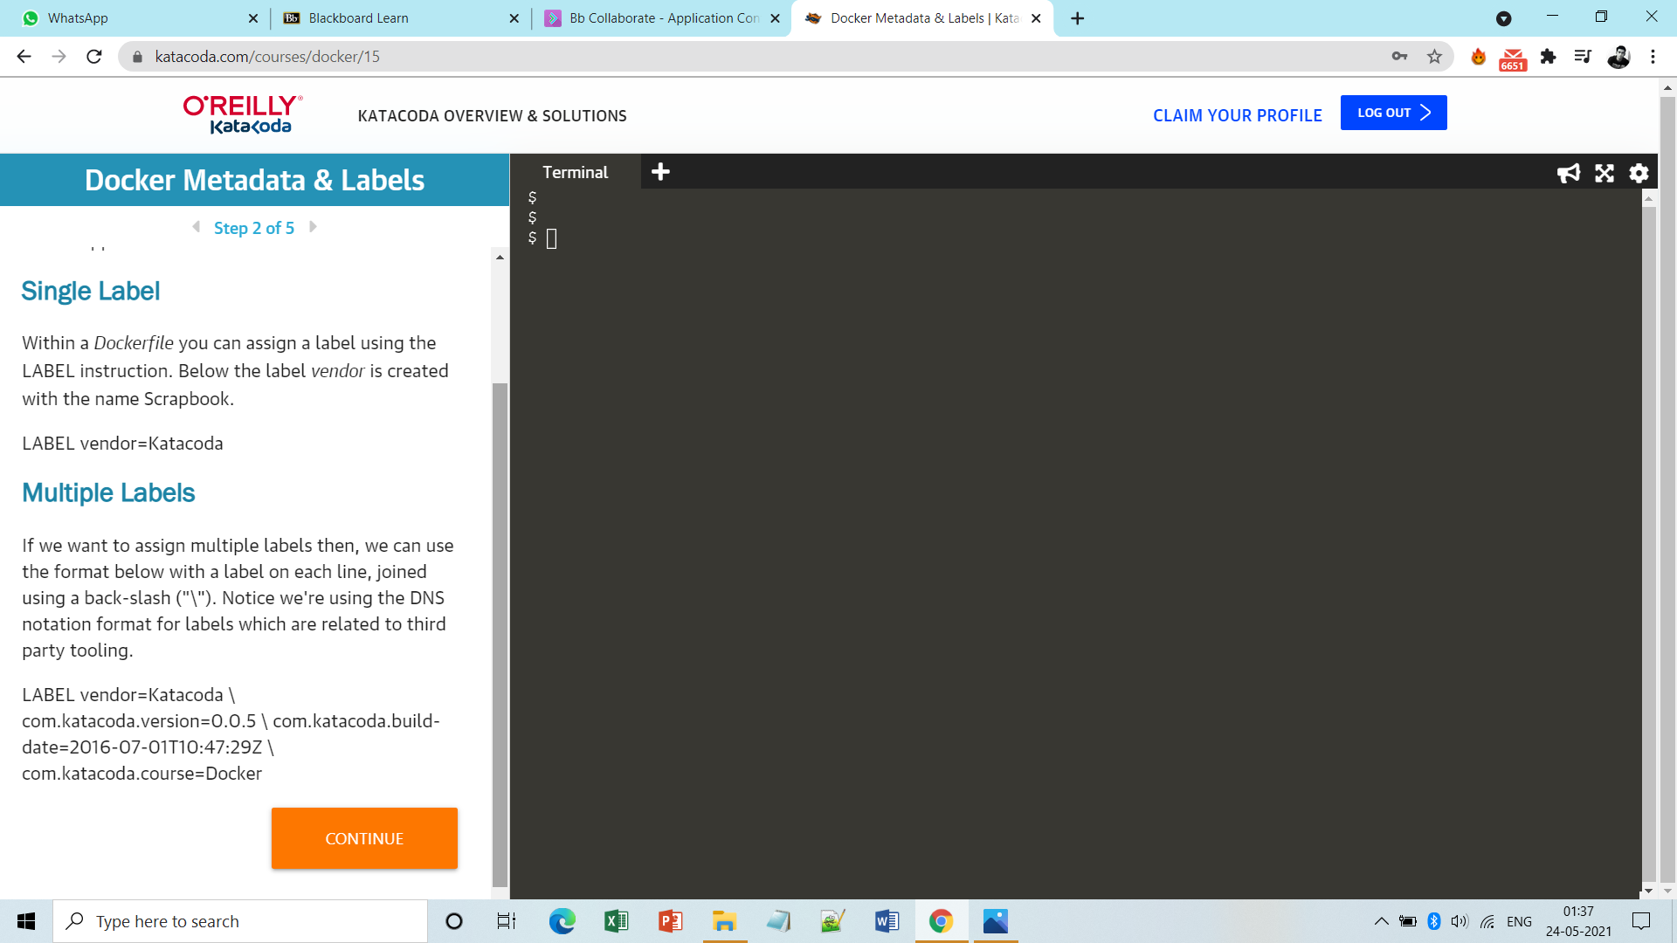

**Note:-** **Here also inspecting images works in similar fashion.**

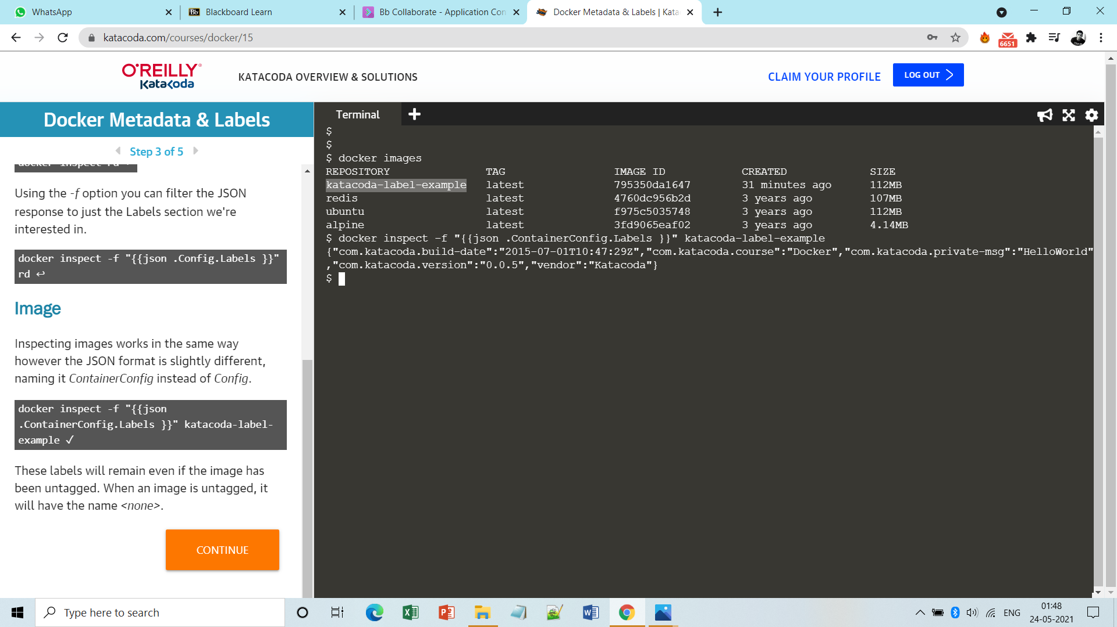

**Filtering Containers:**

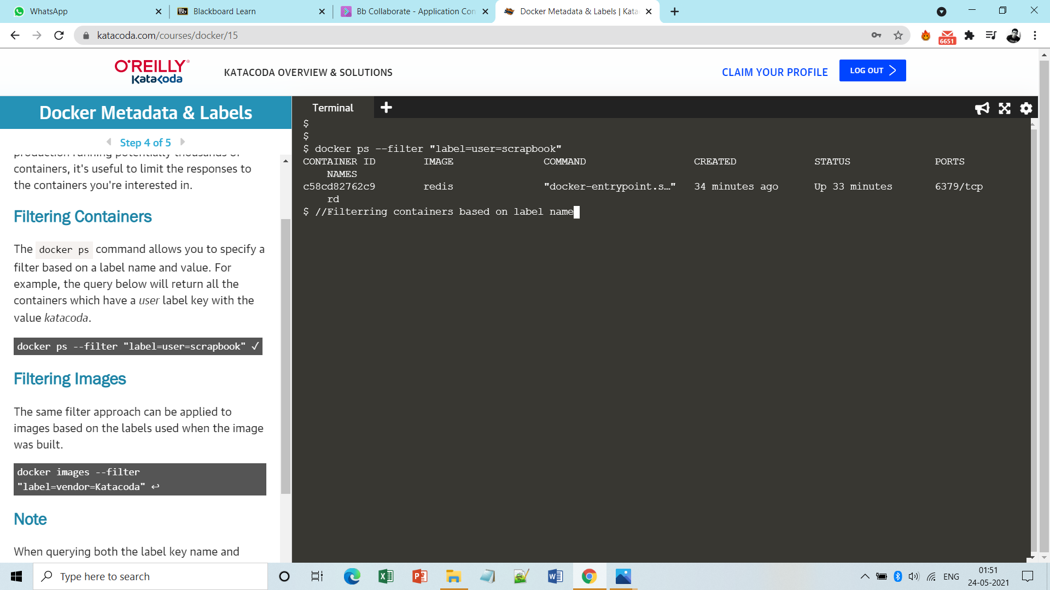

**Filtering Images:**

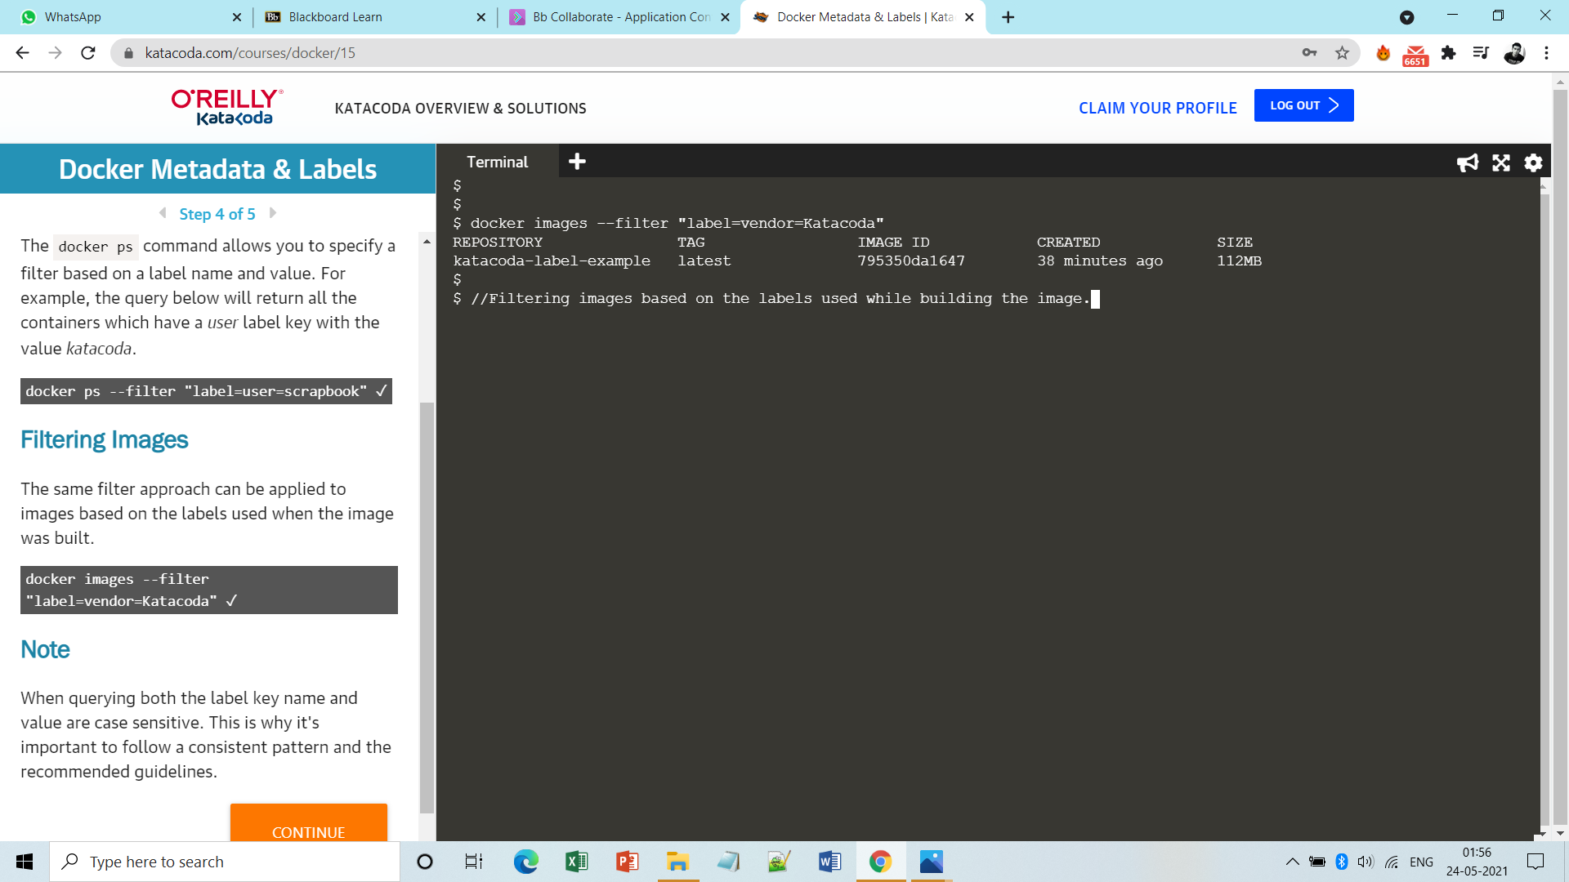

**Done!!**