**EXPERIMENT-2**

Name: Anubhav Deshwal

Roll No: R171218002

Branch :DevOps

**Aim-** To create Docker volume and attach it with Containers for persistent storage.

1. To create persistent volume in Docker, use command **docker volume create <volume-name>**. After creating volume we can see all the Docker volumes with the help of command **docker volume ls**. 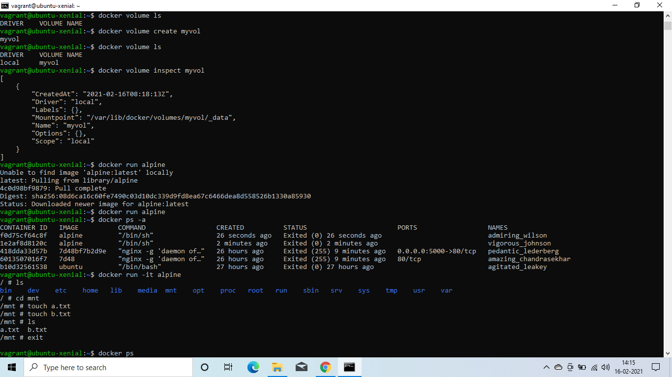
2. Now while launching container use option **-v** to attach volume to any directory inside the container. Inside the container, store any file or data in the directory attached to volume.

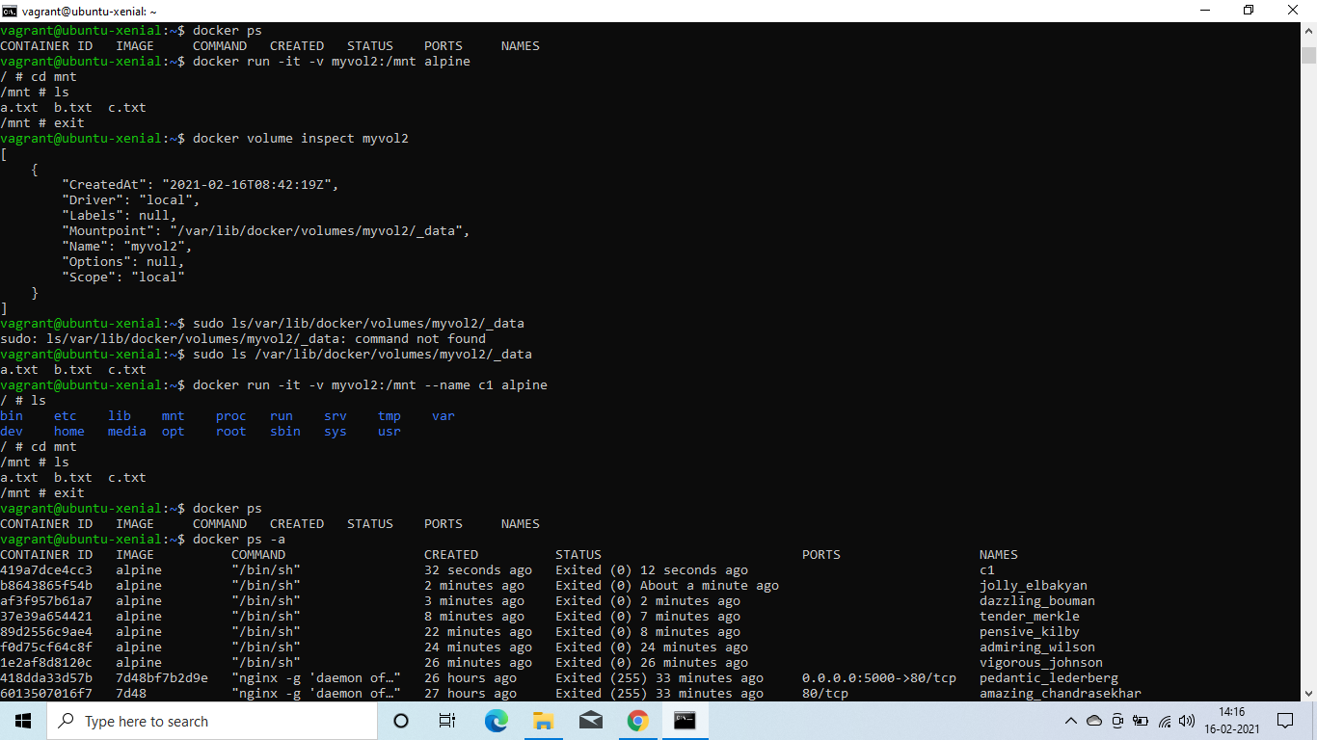

1. Now launch another container and attach the same volume with any directory inside the container. Inside the container, we can see same file and data that we stored on another container.

