**EXPERIMENT-3**

Name: Anubhav Deshwal

Roll No: R171218024

Branch: DevOps

**Aim-** To create Docker network and attach it with Containers for connectivity.

To create your own network use command **docker network create <network-name>**. To see all the existed network use command **docker network ls**.

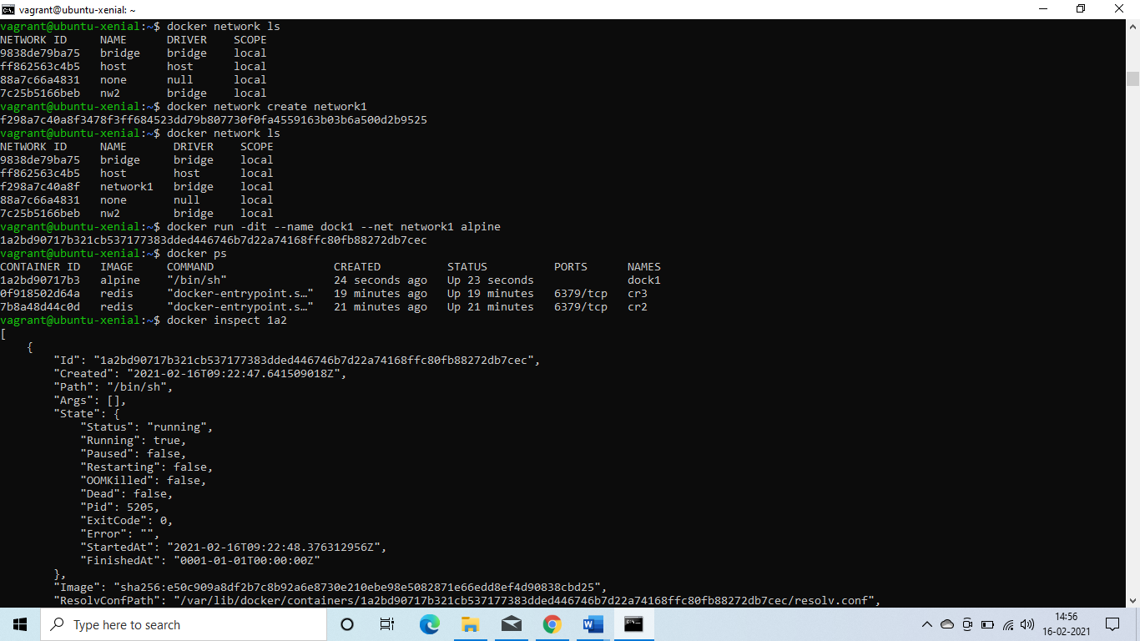

To launch a container inside a network use option  
**--net=<network-name>** while launching a container.



To see the network details of the container and check if it is inside the specified network use command **docker inspect**. 