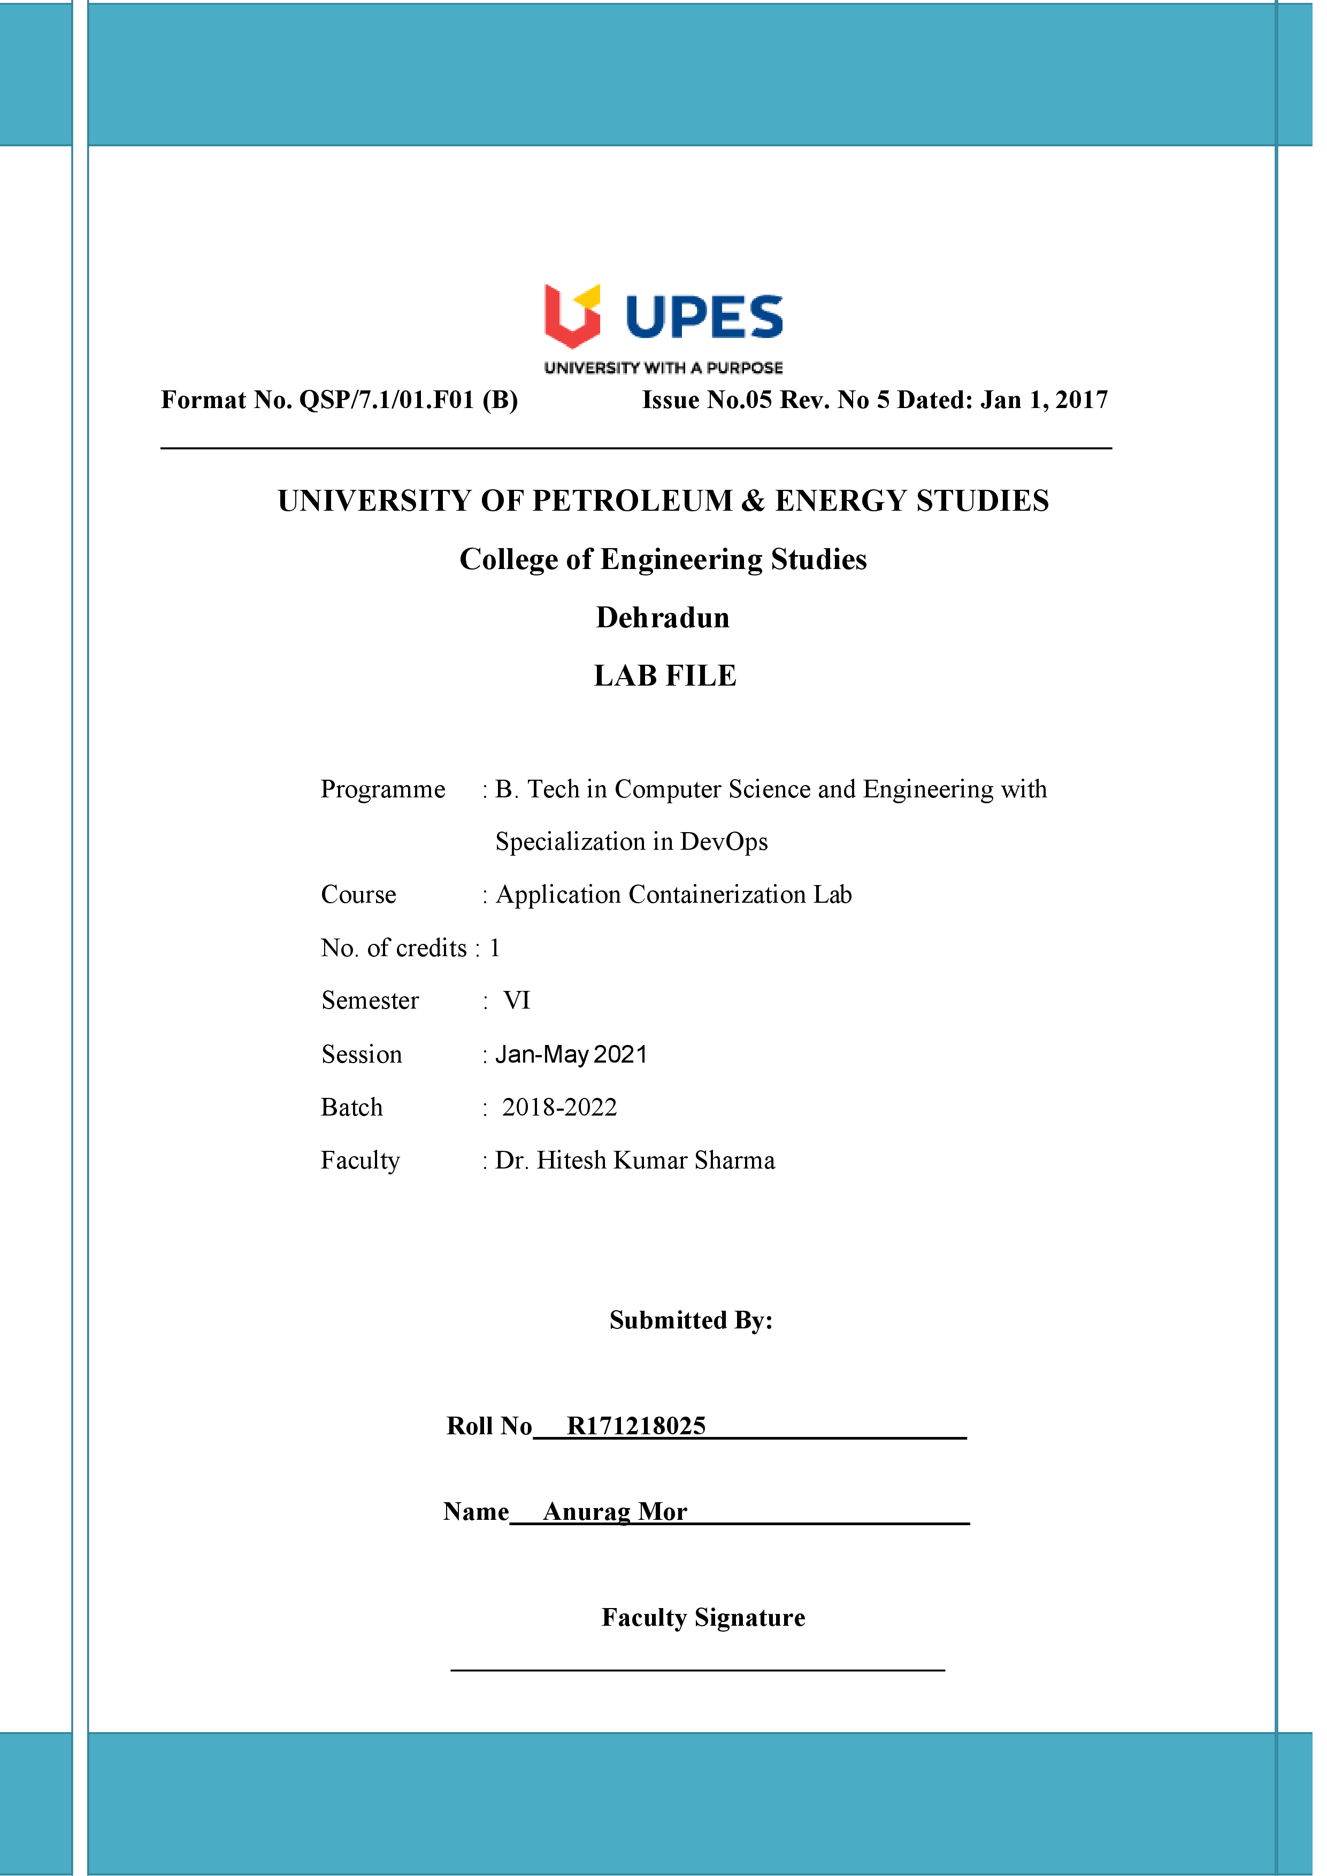

**Experiment 10 05-04-2021**

**Aim: - Working with Metadata , Log File using docker.**

**Solution: -**

1. This command assigns a label called user with an ID to the container. This would allow us to query for all the containers running related to that particular user

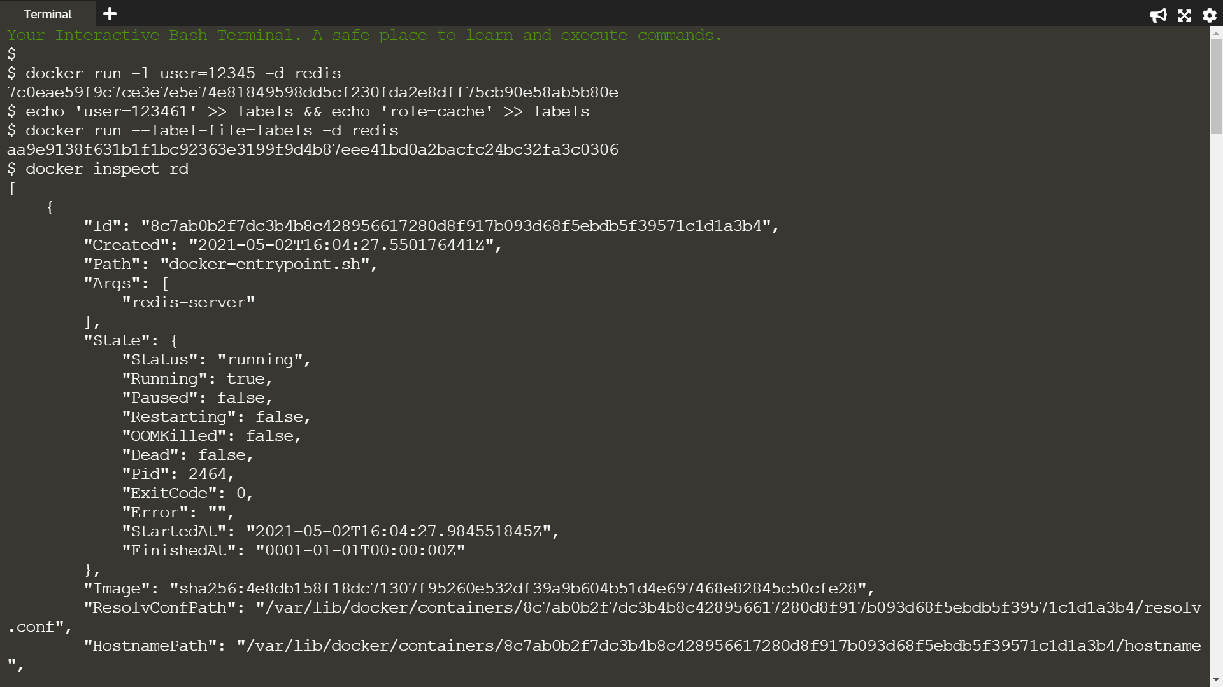

1. 1st command creates two labels in the file, one for the user and the second assigning a role and in 2nd command, the --label-file=<filename> option will create a label for each line in the file



1. Providing the running container's friendly name or hash id and querying all of its metadata



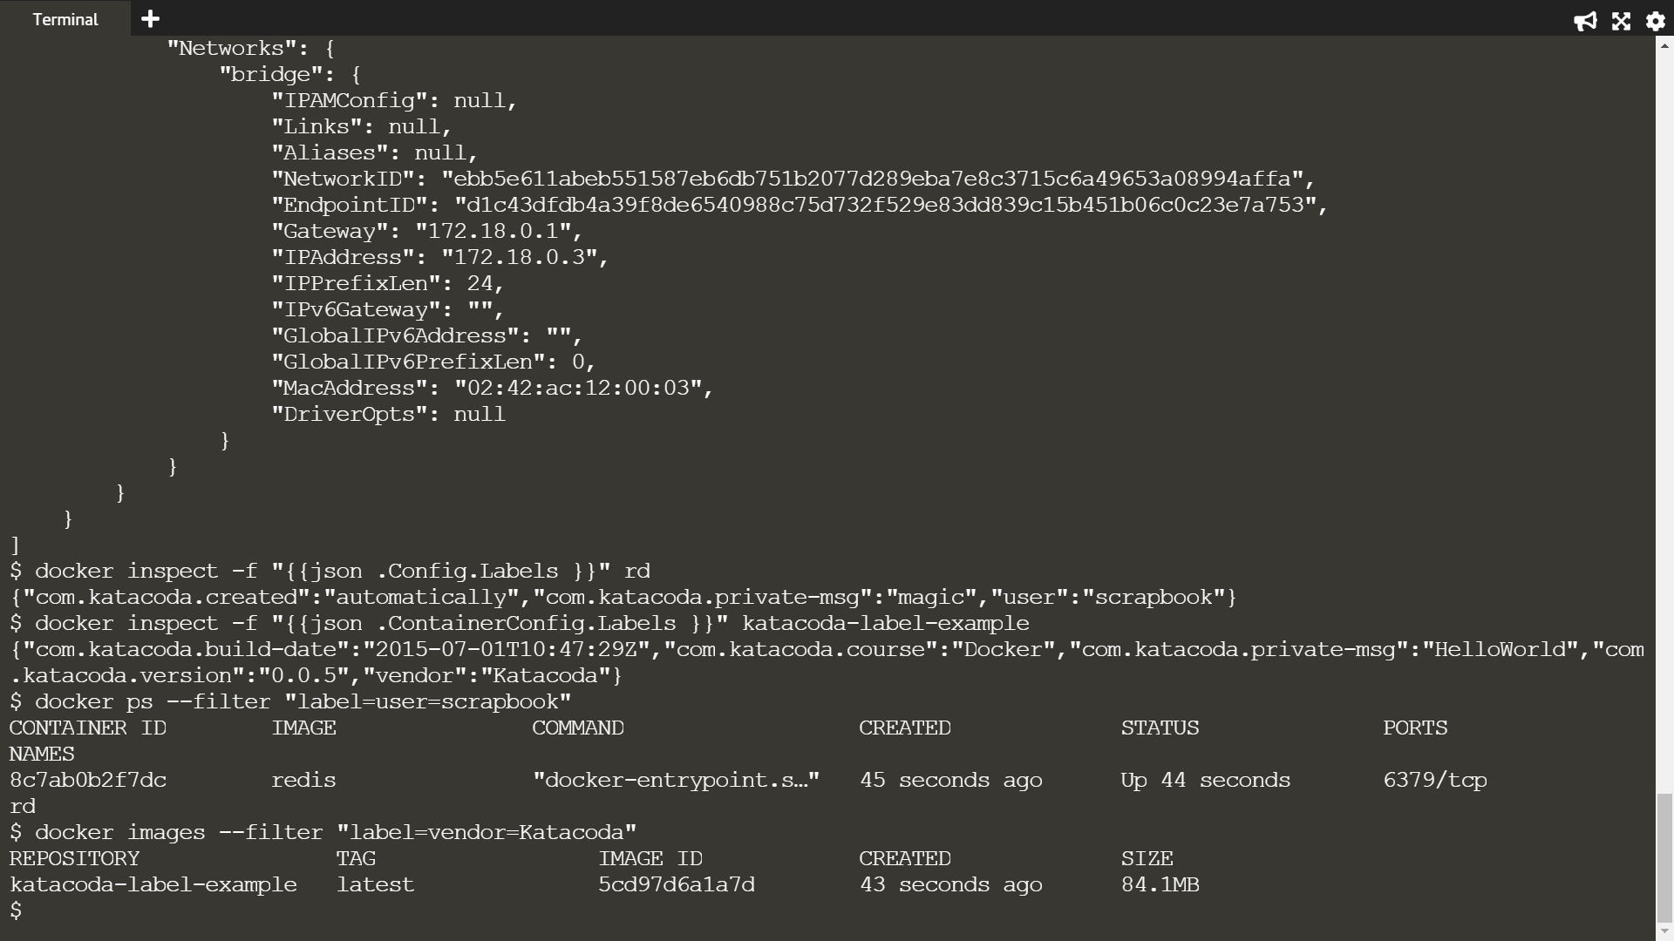

1. Using the -f option filtering the JSON response to just the labels section we're interested in



1. Inspecting images works in the same way however the JSON format is slightly different, naming it ContainerConfig instead of Config



1. The query below will return all the containers which have a user label key with the value katacoda.



1. The same filter approach can be applied to images based on the labels used when the image was built.

