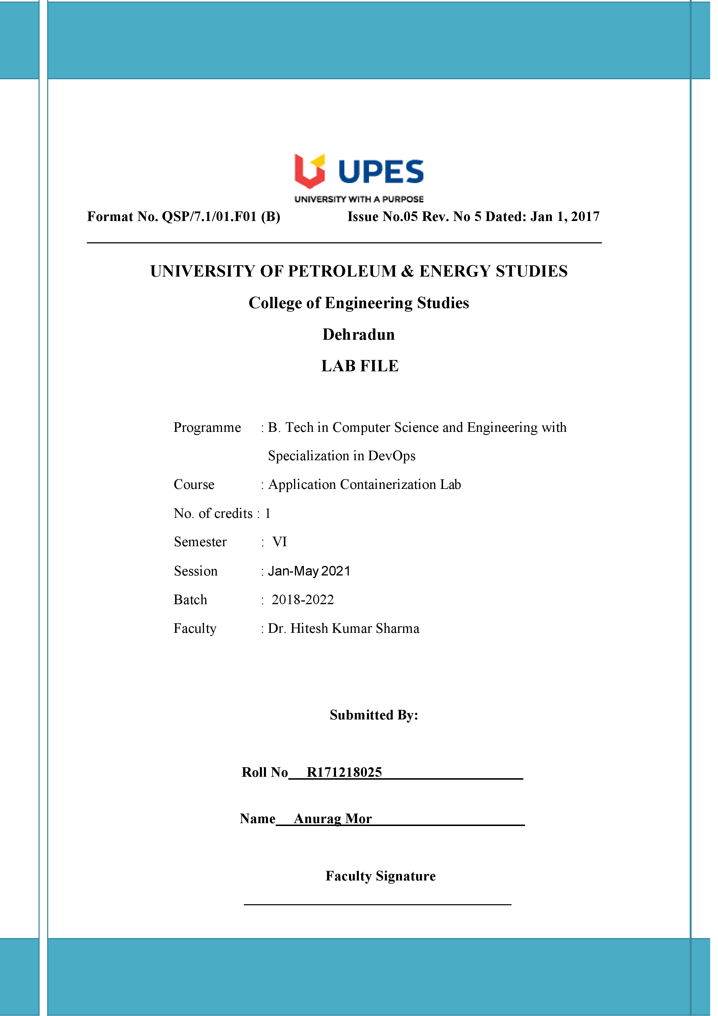

**Experiment 11 05-04-2021**

**Aim: - Managing Log Files using Docker**

**Solution: -**

1. In the background, there is an instance of Redis running with the name redis-server. Using the Docker client, we can access the standard out and standard error outputs using the following command

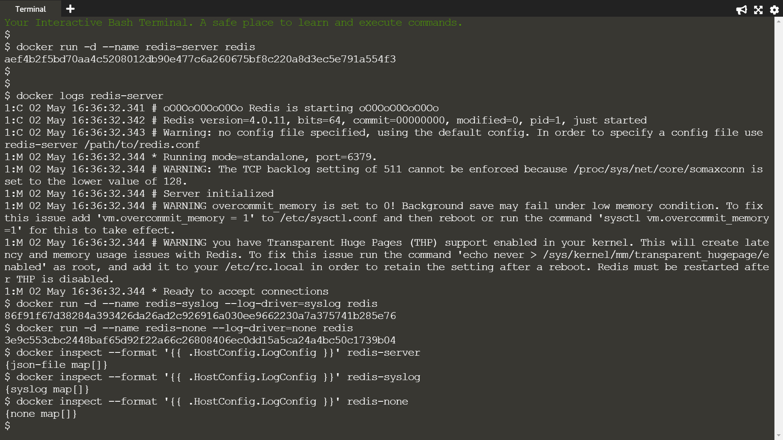

1. The command below will redirect the redis logs to syslog



1. When the container is launched, no output will be logged when we set log-driver to none



1. The commands below will output the LogConfig section for each of the containers.





