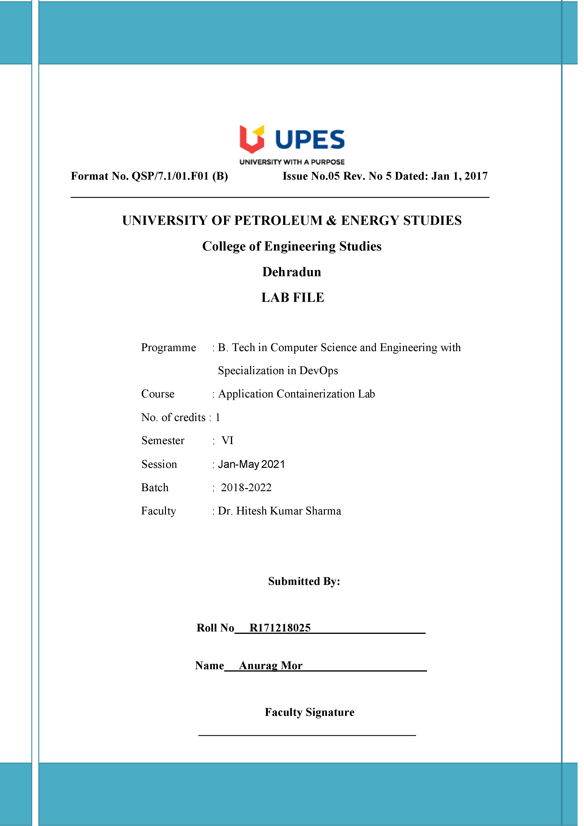

**Experiment 12 05-04-2021**

**Aim: - Prepare and Implement Docker Container Restart Policy**

**Solution: -**

1. Here it is a special container that outputs a message and then exits with code 1 to simulate a crash. Launching an instance using the following command

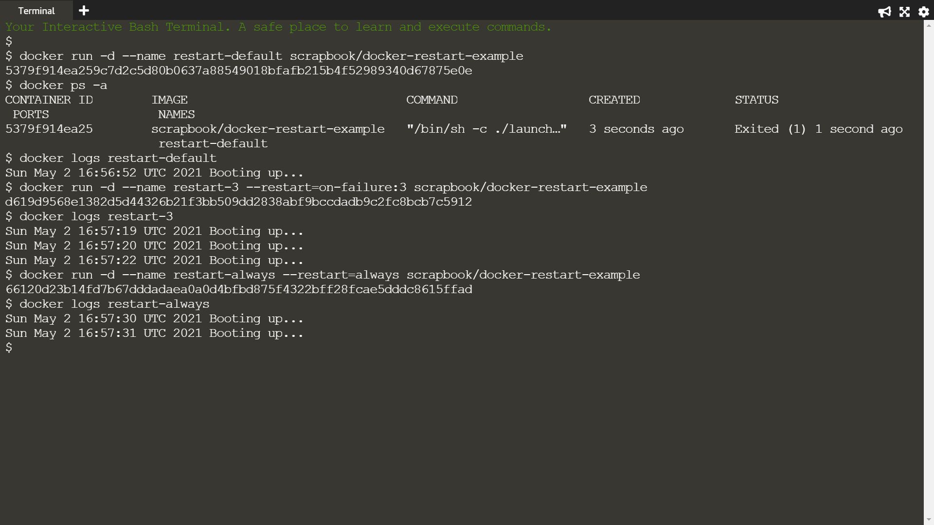

1. List all the containers, including stopped, to see the container has crashed



1. The logs will output a message, which indicates information to diagnose the issue.



1. In the example below, Docker will restart the container three times before stopping.



1. Using the always flag to automatically restart the container when it crashes

