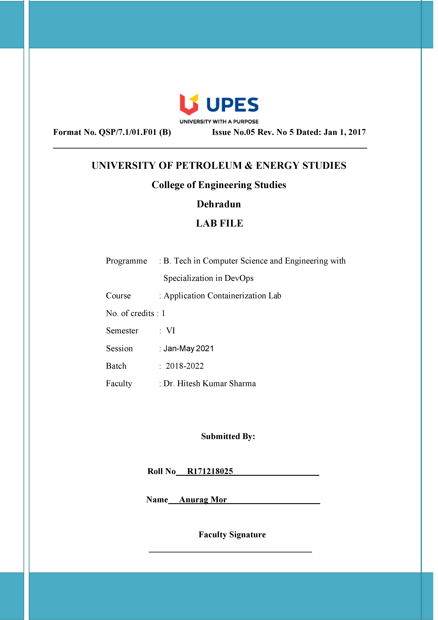**Experiment 1 22-01-2021**

**Aim:** Installation and execution of vagrant

**Solution: -**

**1)** Download vagrant from the official website of HashiCorp.

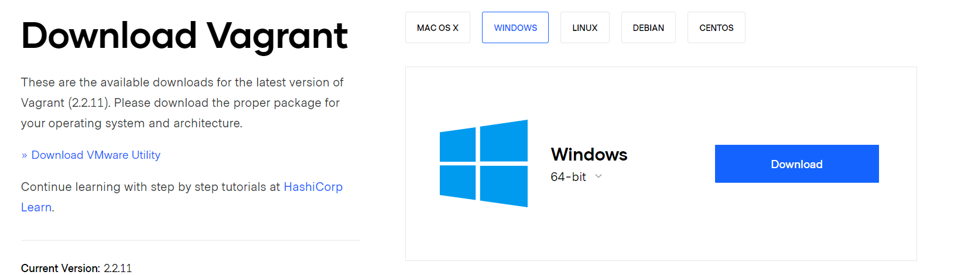

**2)** Run the exe file to install vagrant.

**3)** Open the command prompt and create a directory and initialise it using the ‘vagrant init’ command.

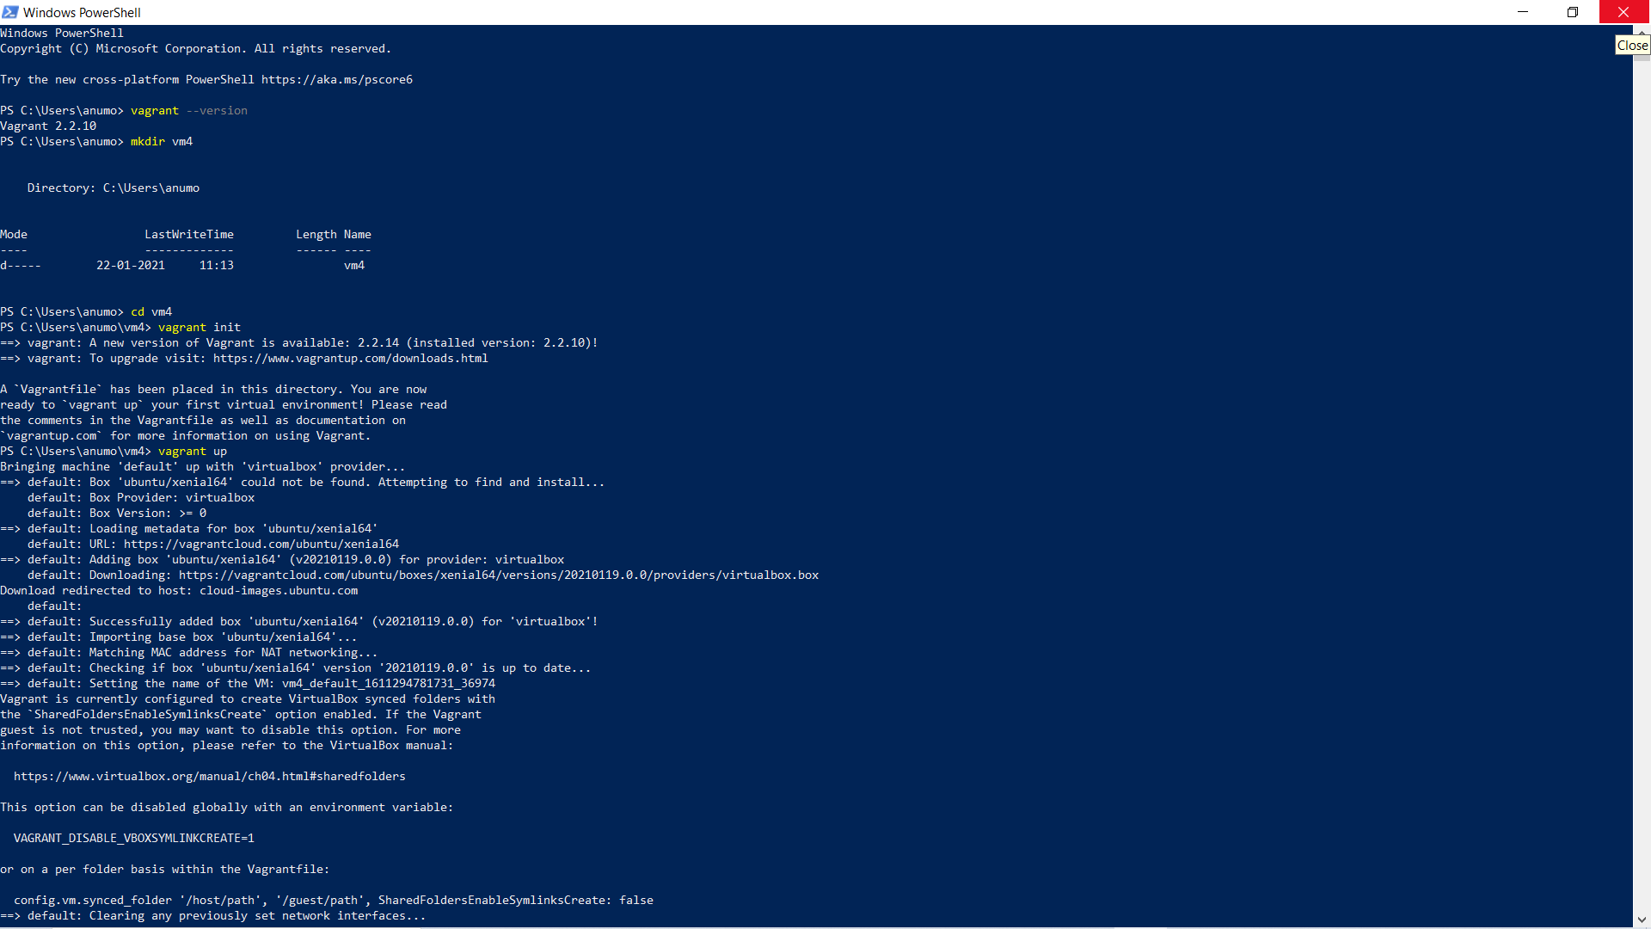

**4)** After the end of step 3 a vagrant file is created and by editing this file, we will decide the configuration of the vms that will be created by vagrant. Here we have made the following changes:

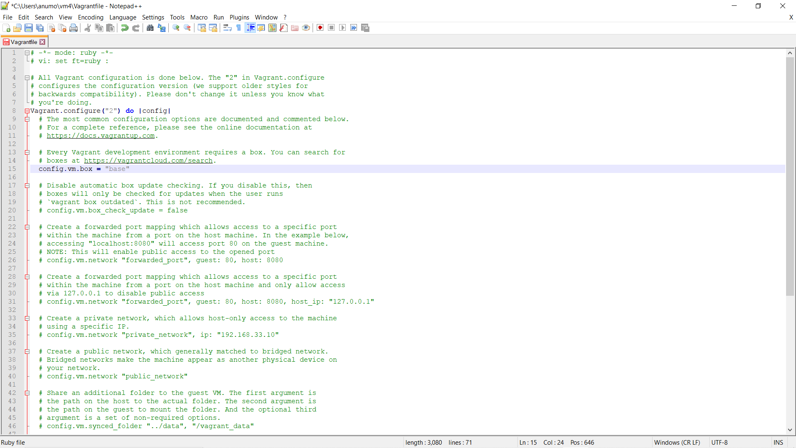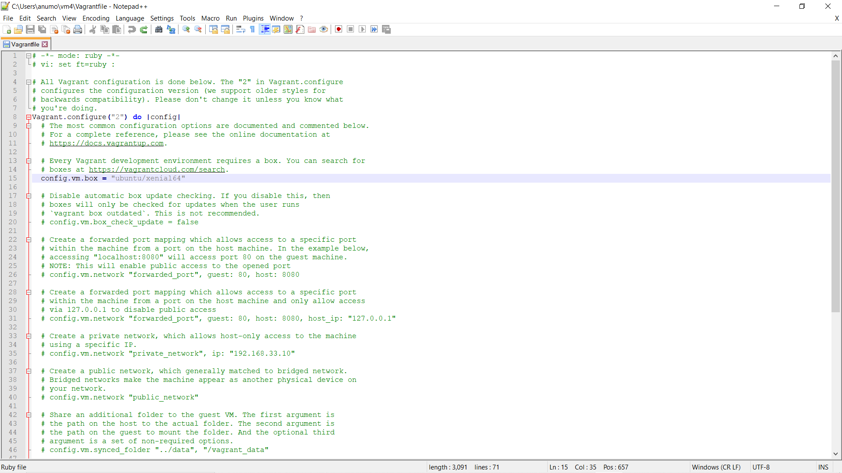

**5)** Run the ‘vagrant up’ command to create the vm. Here first the Ubuntu is downloaded and then the vm is created. At the end of this step a vm has been created.

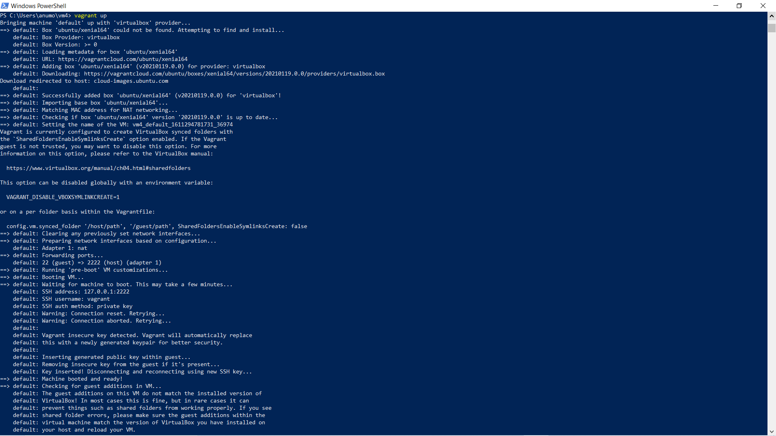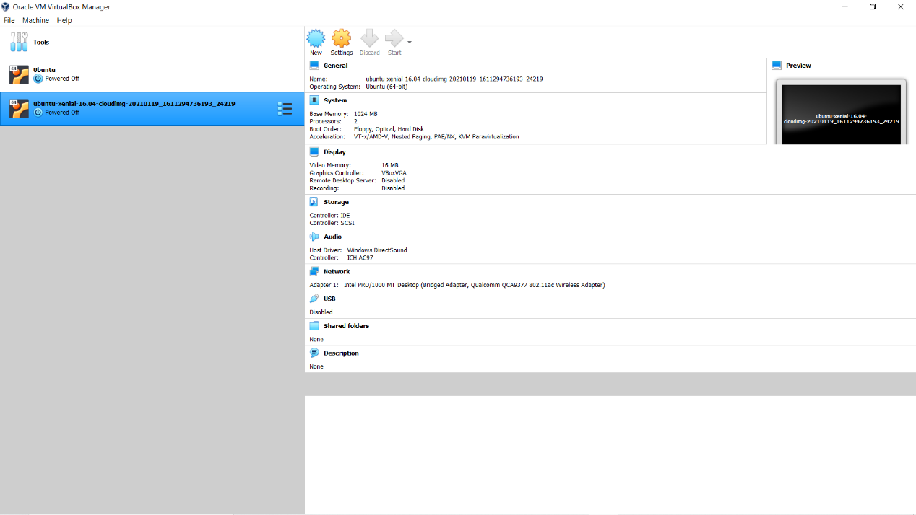

**6)** Run the ‘vagrant ssh’ command to a attach the vm created to the windows command line. Now a command line of Ubuntu has opened.

