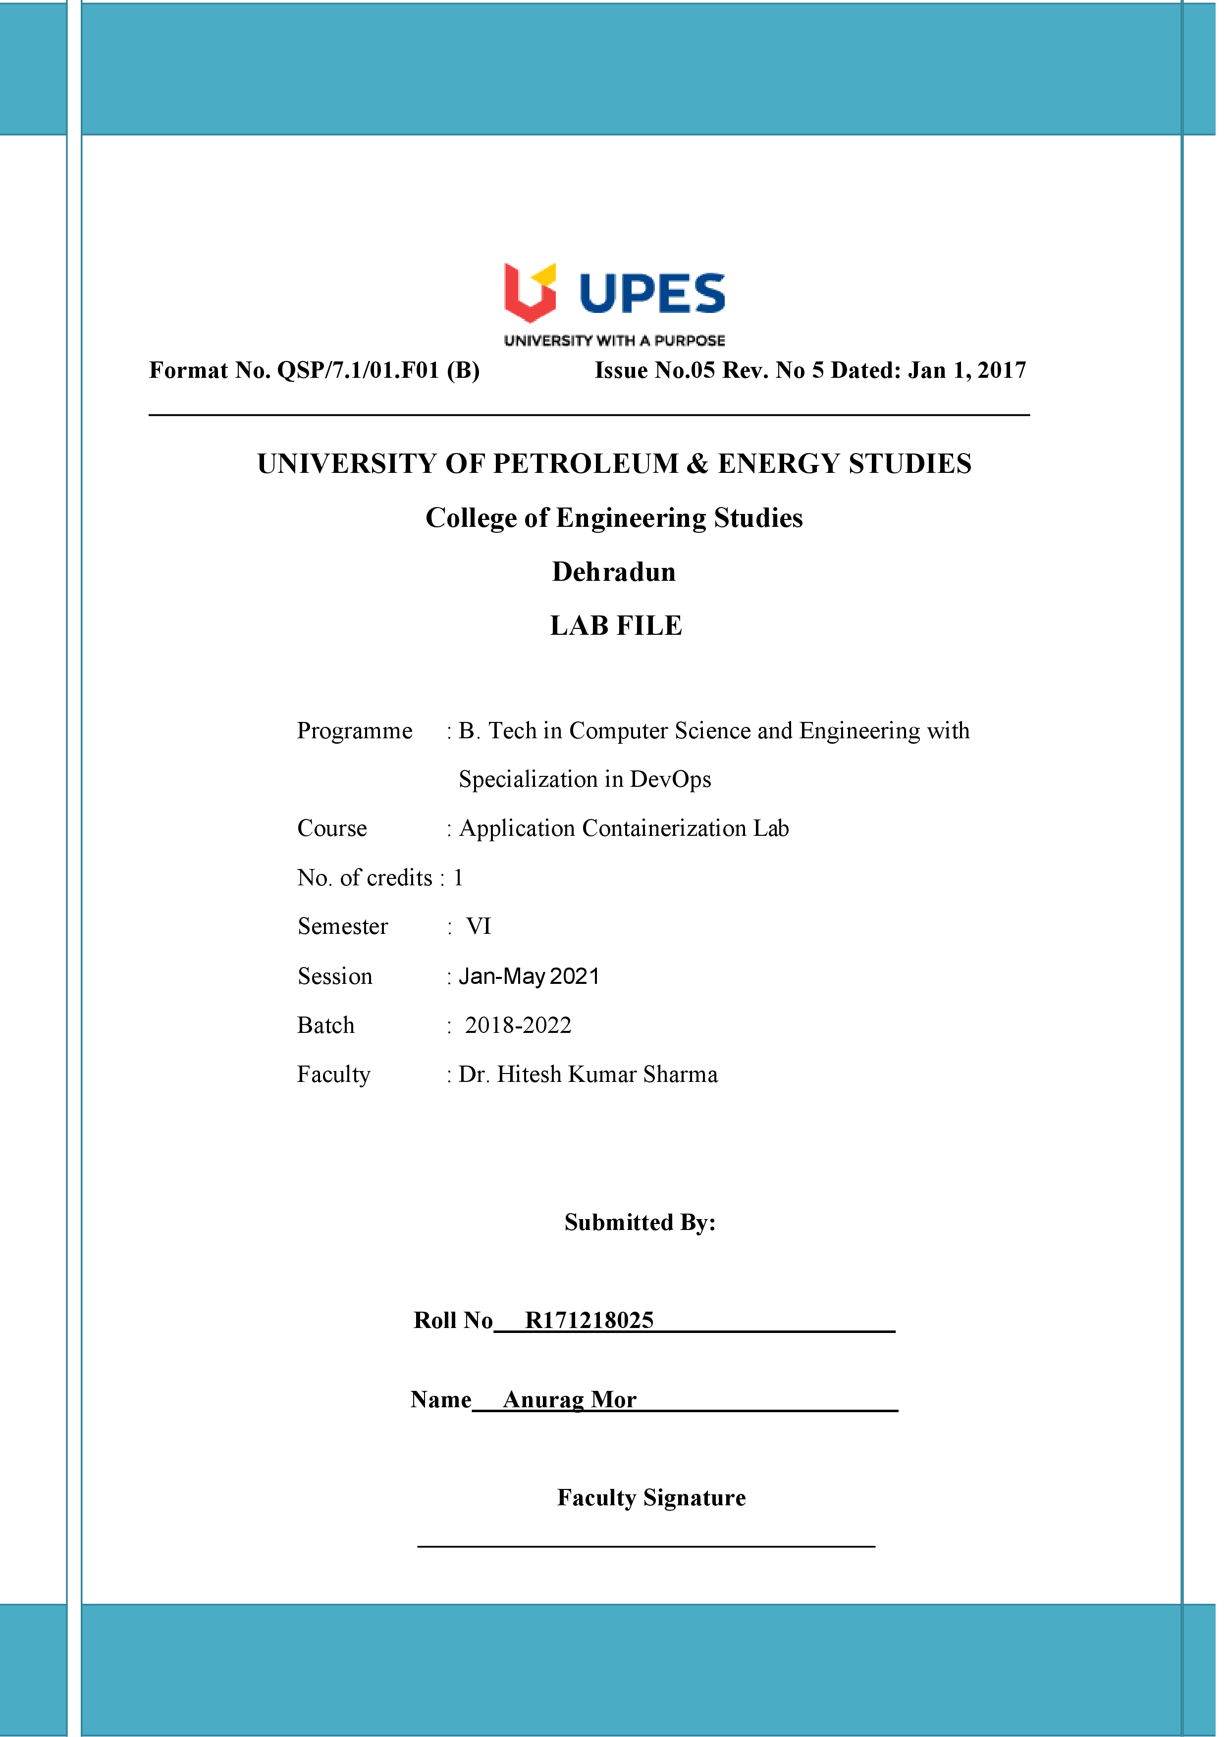**Experiment 4 12-02-2021**

**Aim :-** To create a docker image using docker file, change tag and push it to DockerHub.

**Solution:-**

**1)**Create a Dockerfile in any directory using vim Dockerfile and write the following command in it:-

FROM ubuntu

RUN apt-get update

ENV DEBIAN_FRONTEND noninteractive

RUN apt-get install nginx -y

RUN echo "daemon off;" >> /etc/nginx/nginx.conf

COPY index.html /var/www/html/

EXPOSE 80

CMD ["nginx"]

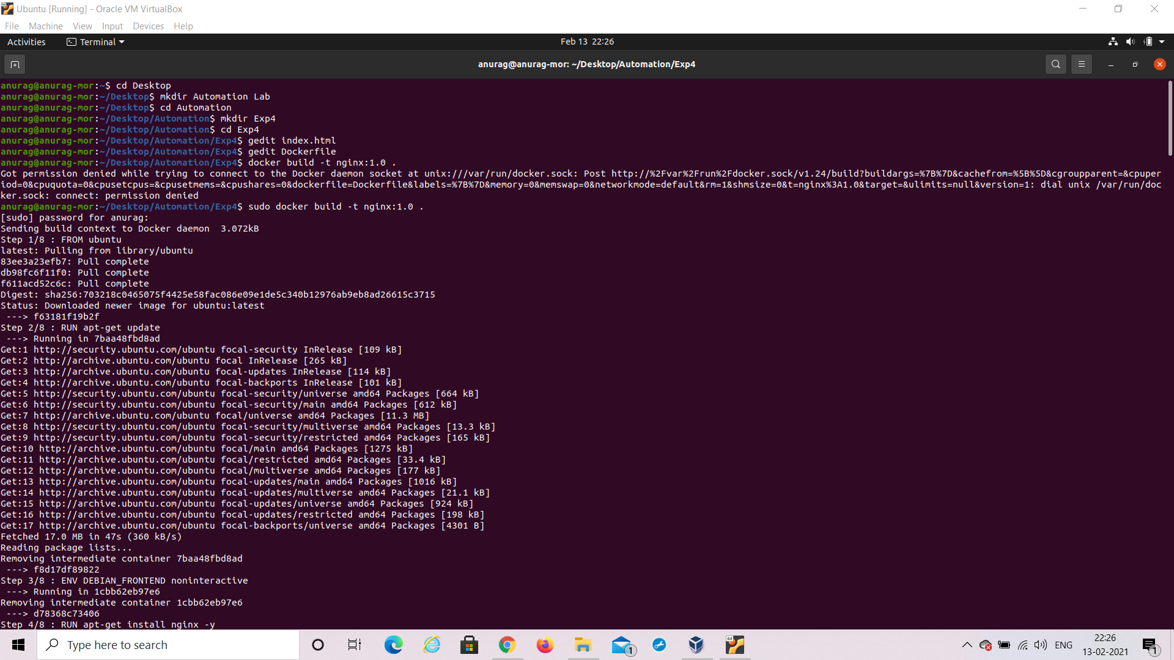

2) Create a index.html file and write a html code in it.



3) To build the image run the following command:-

 sudo docker build -t nginx:1.0 .



1. To verify that the image is build or not , run the following command:-

sudo docker images

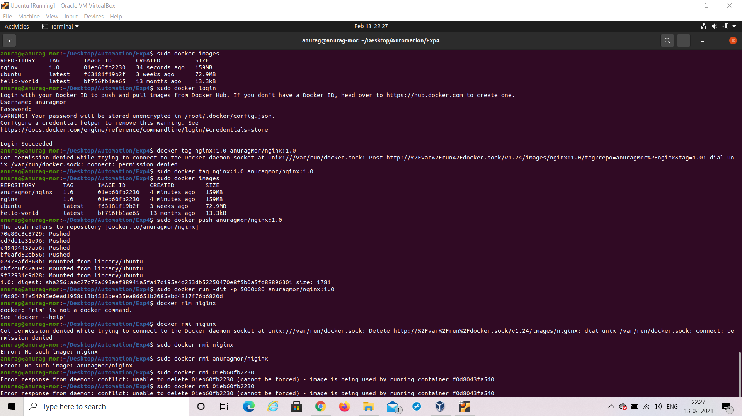

1. Now to push the created image to docker hub we need to login and run several commands :- rum them in the order as same follow:-

sudo docker login



sudo docker tag {old_name} {username}/{new_name}



sudo docker images



sudo docker push {username}/{image_name}



1. Now go and check at the Docker Hub whether the image is there or not:-

[DockerHub](https://hub.docker.com/)

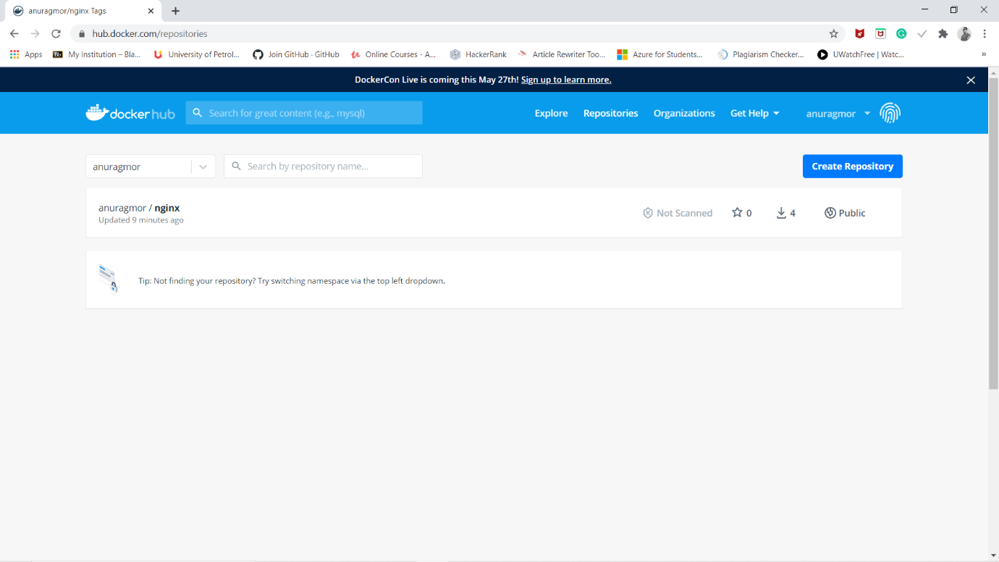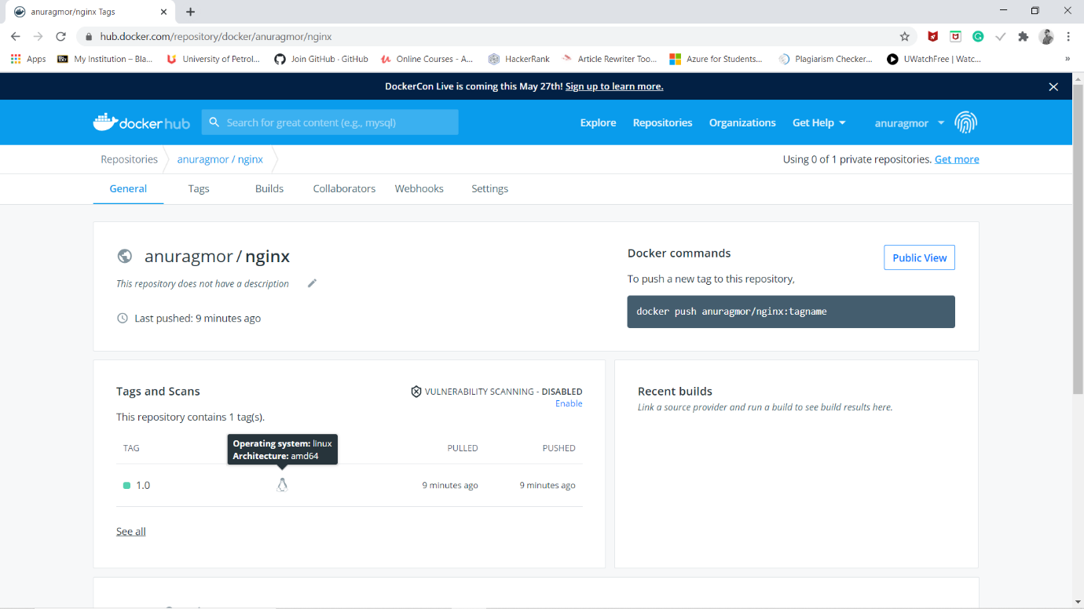

1. Now to see the niginx server is working and the html file is working use the command:-

 sudo docker run -dit -p 5000:80 {username}/{image_name}:{tag}



1. Goto [http://localhost:5000](http://localhost:5000/) to verify running.