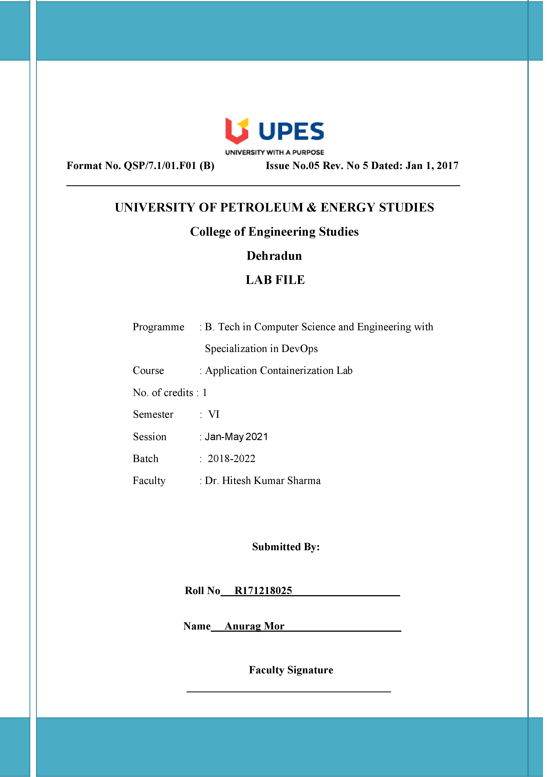

**Experiment 6 Date:- 12-03-2021**

**Aim:- Creating docker-link and docker swarm.**

**Solution:-**

Docker Linking:-

1. Run a container in detached mode with name "db" from image "training/postgres"

$ docker run -it -d --name db training/postgres

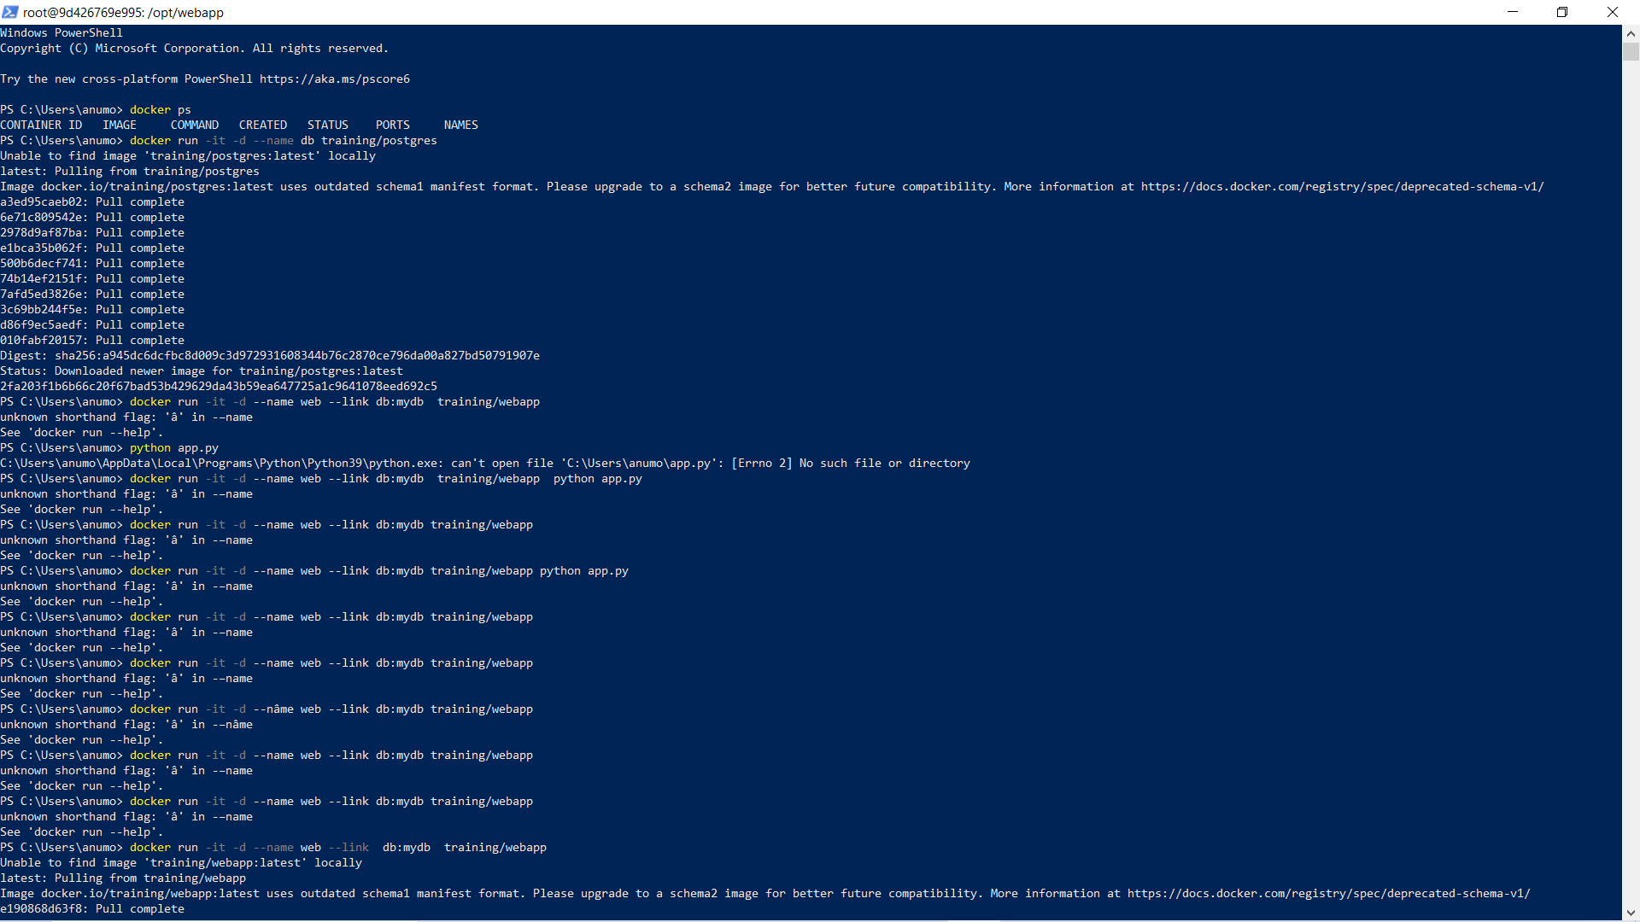

1. Run another container in detached mode with name "web" from image "training/webapp", link container "db" with alias "mydb" to this container and finally pass an inline command "python app.py" while running container.

$ docker run -it -d -–name web -–link db:mydb training/webapp   
python app.py

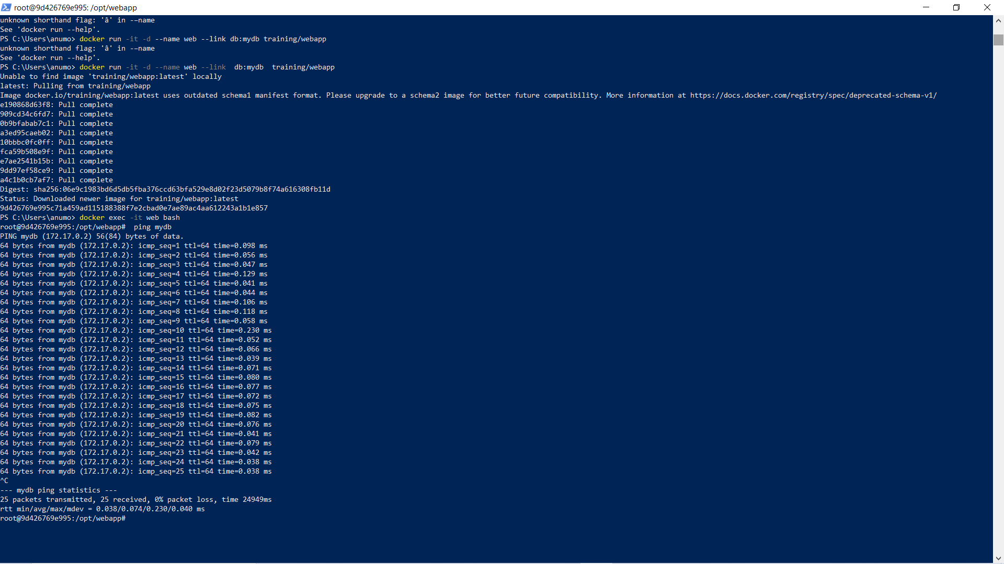

1. Take a bash terminal in "web" container and Test container linking by doing a ping to "mydb"

$ docker exec -it web bash



1. And then run  
   # ping mydb



Docker Swarm:-

1. Run the following command to create a new swarm:

$ docker swarm init

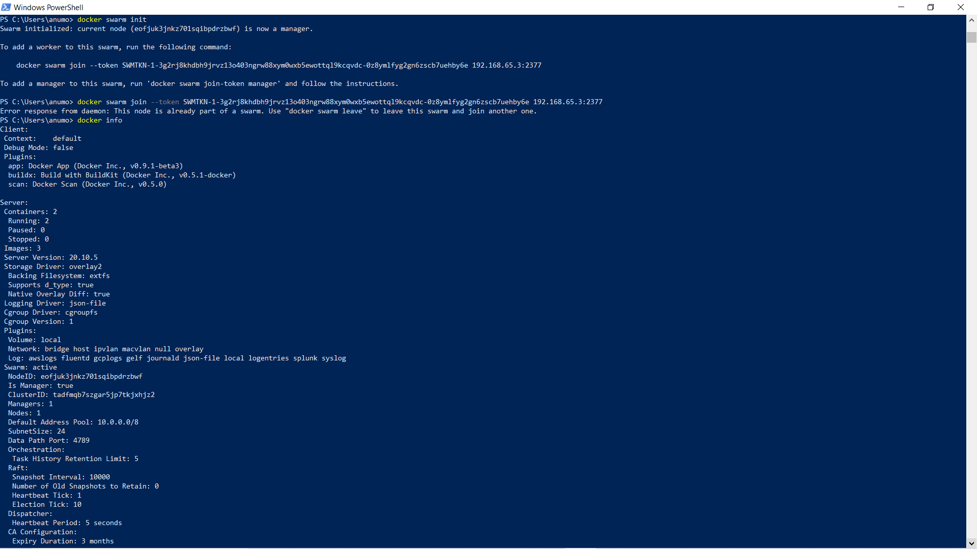

1. To add a worker to this swarm, run the following command:

$ docker swarm join \--token SWMTKN49nj1cmql0jkz5s954yi3oex3nedyz0fb0xx14ie39trti4wxv-8vxv8rssmk743ojnwacrr2e7c \192.168.99.100:2377



1. Run docker info to view the current state of the swarm:

$ docker info



1. Run the docker node ls command to view information about nodes:

$ docker node ls

