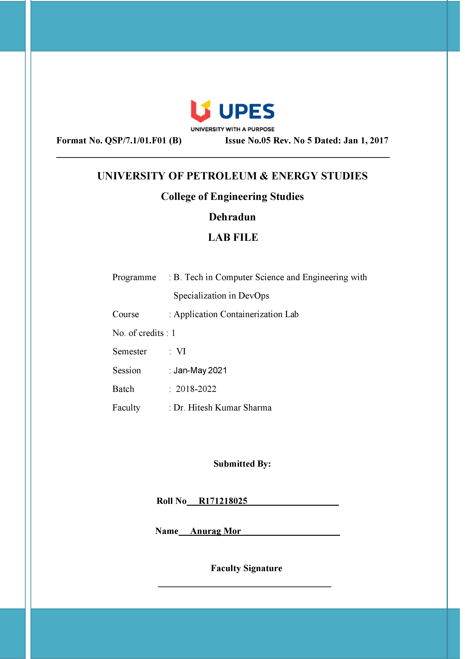

**Experiment 8 Date: - 05-05-2021**

**Aim: - Kubernetes – Minikube installation and fundamentals**

**Solution: -**

Launch Cluster

minikube start --wait=false

kubectl get nodes

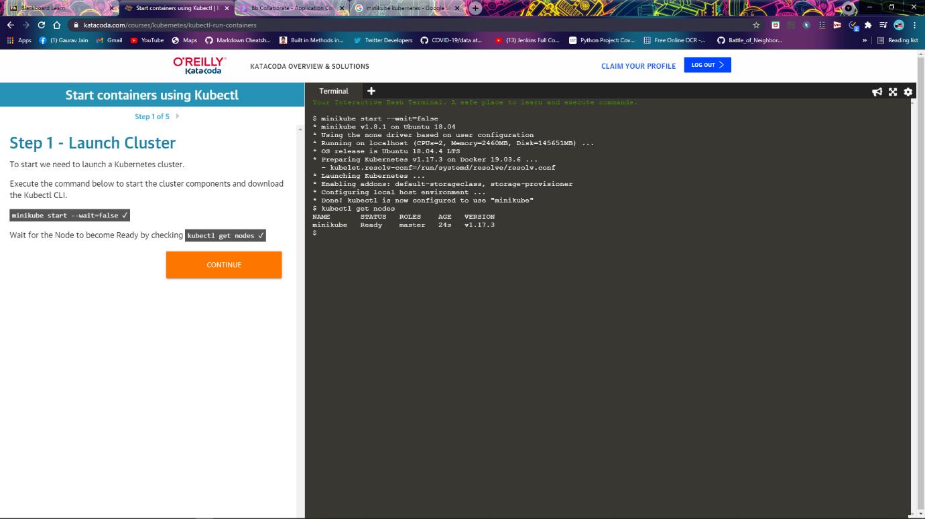

Kubectl run

kubectl run http --image=katacoda/docker-http-server:latest --replicas=1

kubectl get deployments

kubectl describe deployment http

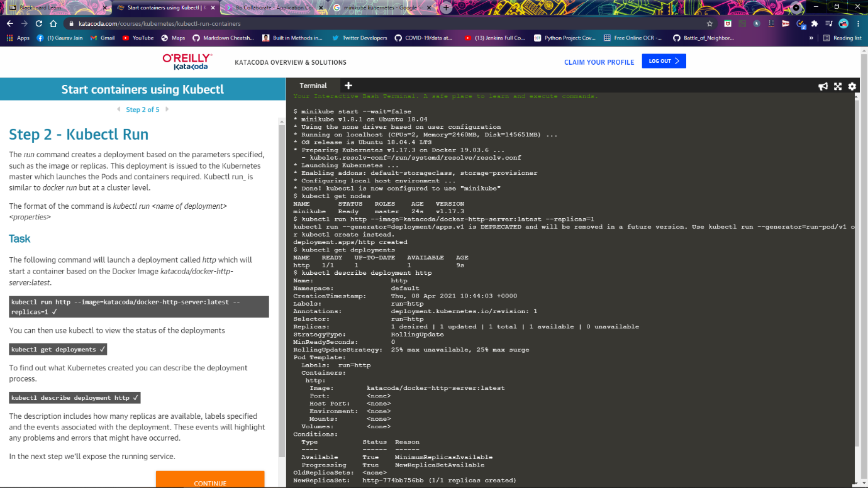

Kubectl Expose

kubectl expose deployment http --external-ip="172.17.0.40" --port=8000 --target-port=80

curl <http://172.17.0.40:8000>

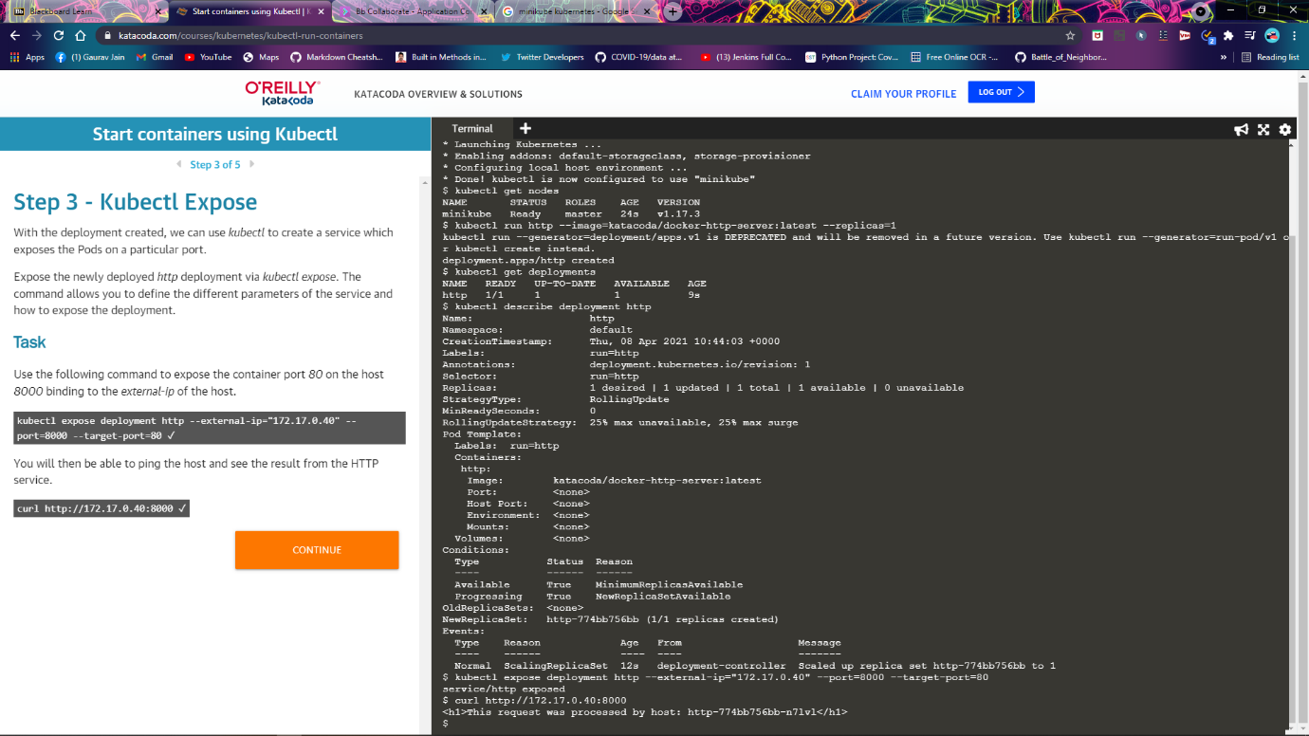

Kubectl Expose

kubectl run httpexposed --image=katacoda/docker-http-server:latest --replicas=1 --port=80 --hostport=8001

curl http://172.17.0.40:8001

docker ps | grep httpexposed

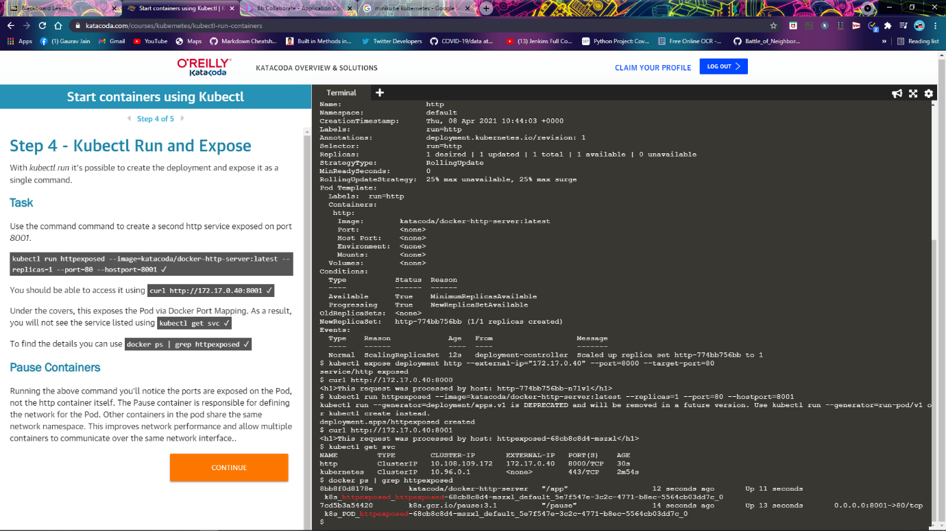

Scale Containers

kubectl scale --replicas=3 deployment http

 kubectl get pods

curl http://172.17.0.40:8000

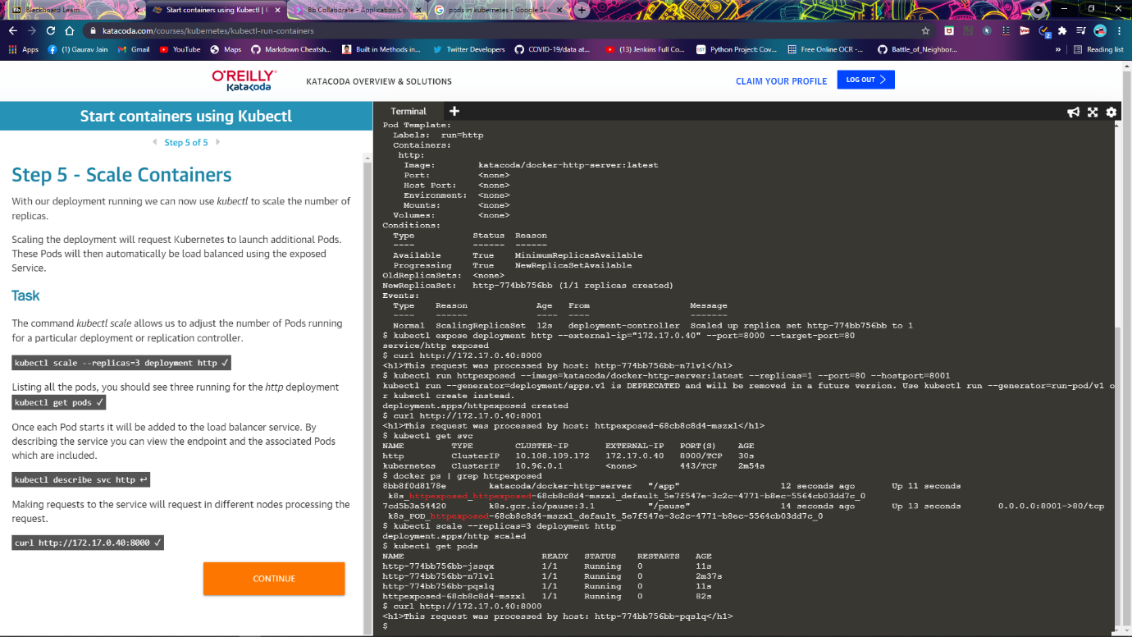

Launch Single Node Kubernetes Cluster

Start Minikube

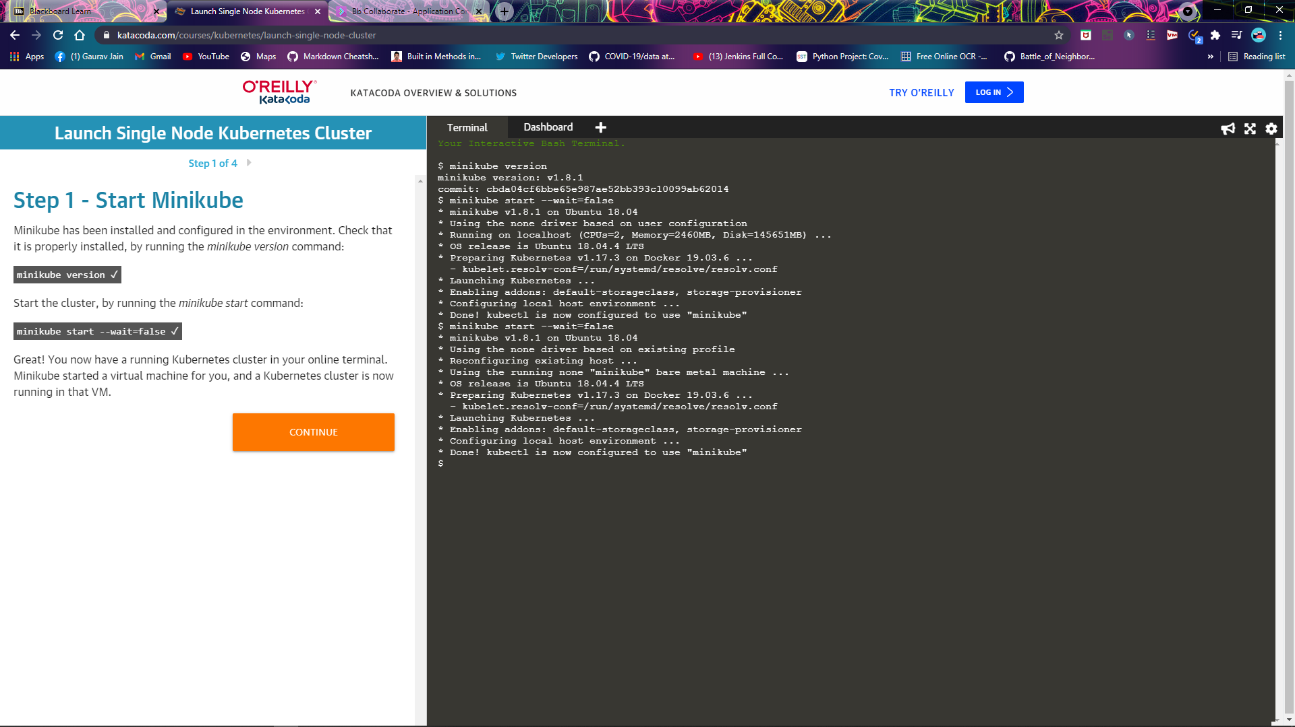

Cluster info

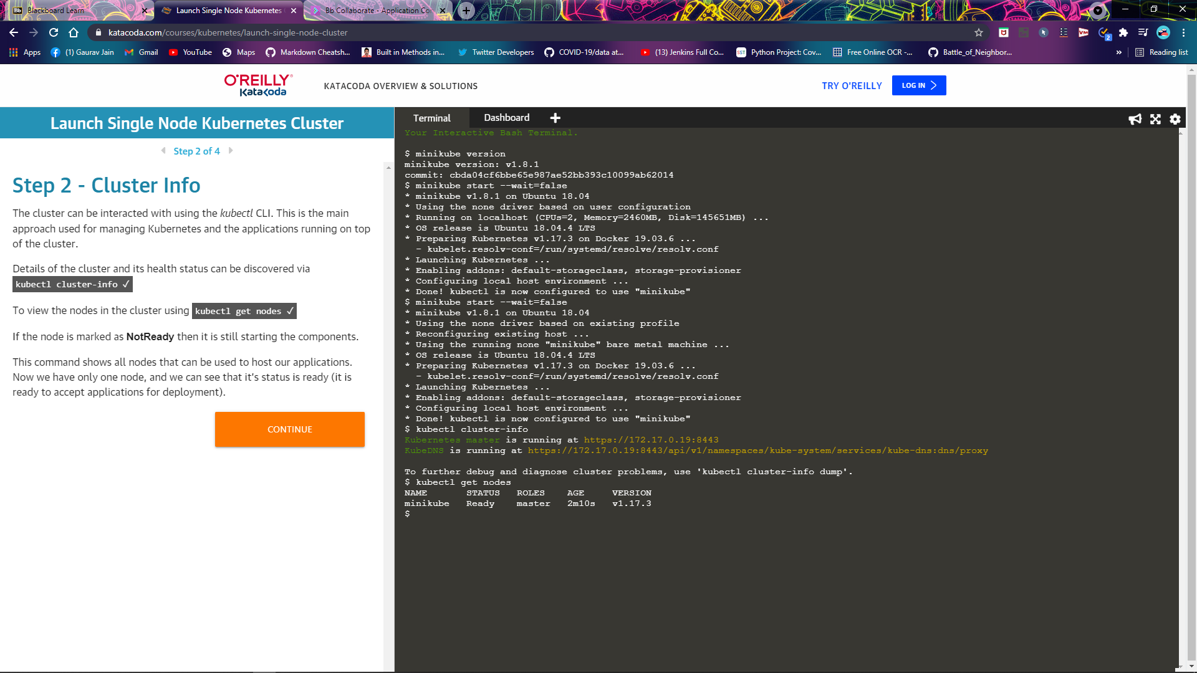

Deploy Containers

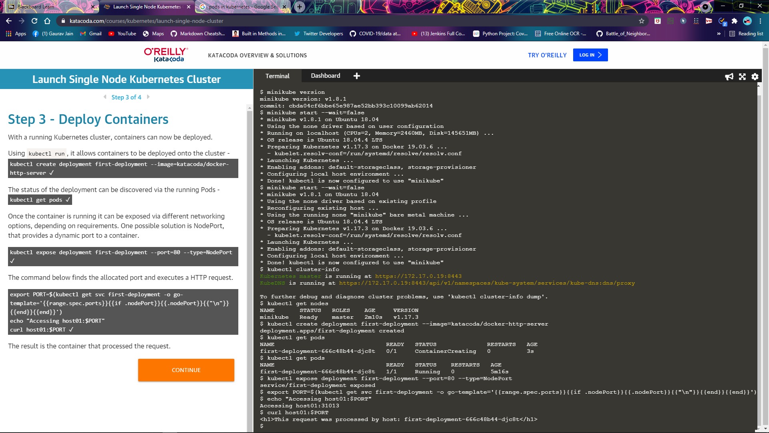

Dashboard

