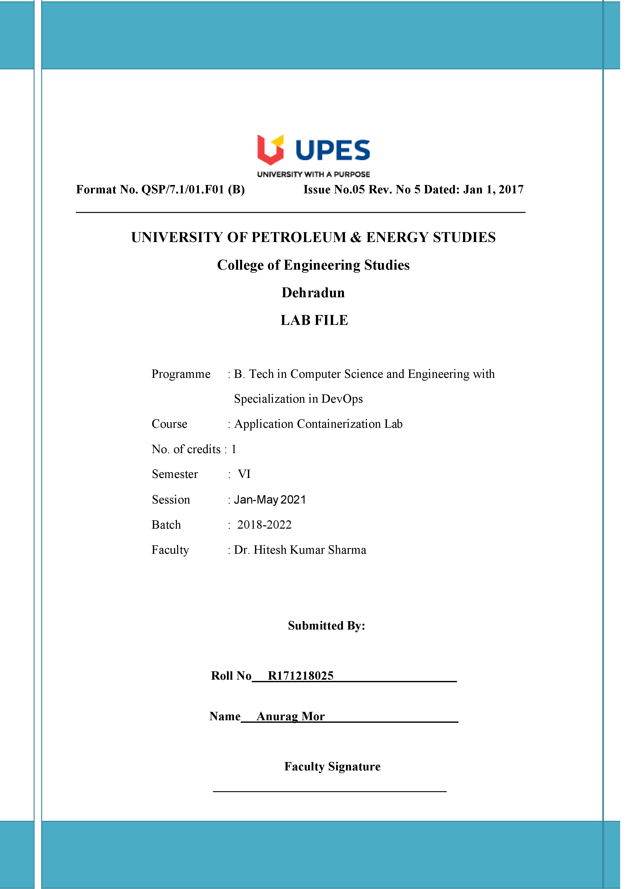

**Experiment 9 05-04-2021**

**Aim:- Build Docker Image using .Dockerignore file**

**Solution: -**

