**EXPERIMENT-1**

AIM => Running Virtual Machine into a window command prompt using VAGRANT.

1. Open Command prompt and create a folder “vm2” .

Go to folder and type command => vagrant init

* This will configure the current directory to be a Vagrant environment by generating an initial Vagrant file if one does not already exist.

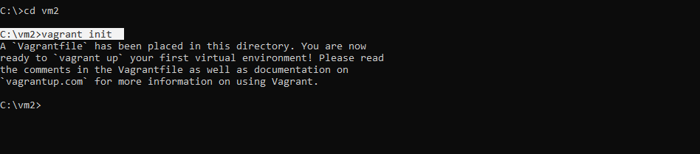

1. Configure your Vagrantfile which is just initialized at your directory vm2.

Write => ***config.vm.box = "ubuntu/xenial64*** [ Cloud-image of the ubuntu ]

OR

You can directly use: “vagrant init ubuntu/xenial64” in first step. Using this we did need to configure the vagrant file.

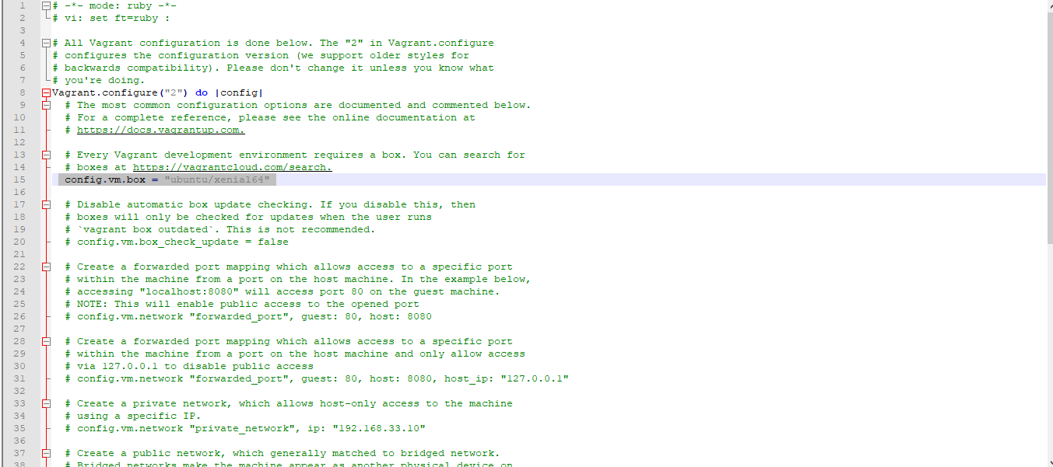

1. After configuring the file, Create the guest machine using

“Vagrant up”

=> This command creates and configures guest machines according to your [Vagrantfile](https://www.vagrantup.com/docs/vagrantfile/).

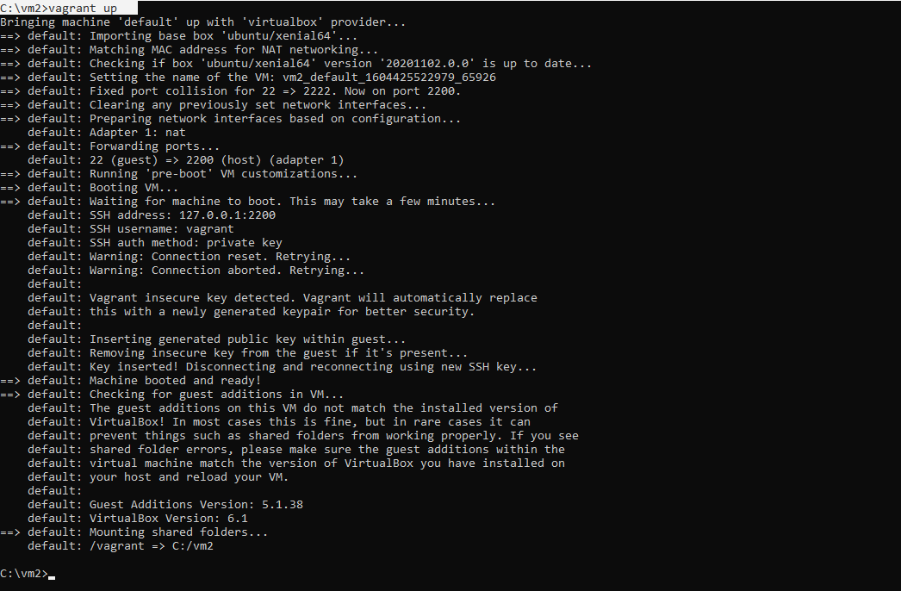

1. Lets enter into our machine.

Command : “vagrant ssh”.

This will SSH into a running Vagrant machine and give you access to a shell.

