### **DockerHub and It's working**

How to push docker image in docker hub

**Step-1:**

Create a container say ubuntu

Command:

Docker run –it ubuntu /bin/bash

ls

You will see many files and directory already exists. Create more files here.

Command:

Touch file file2 test test2 xyz

Also, additionally, install the apache server and files inside tmp/ directory using the command

apt-get install apache2 –y

To see an HTML webpage go to “cd var/www/ ”

Go to tmp directory

cd /tmp

touch file1 file2

ls

Now, create an image of this updated container.

Command:

docker commit <Container_name> <new_container_name>

docker commit practical_mclean newimageuser

docker images

You will see the image is created with a name newimageuser.

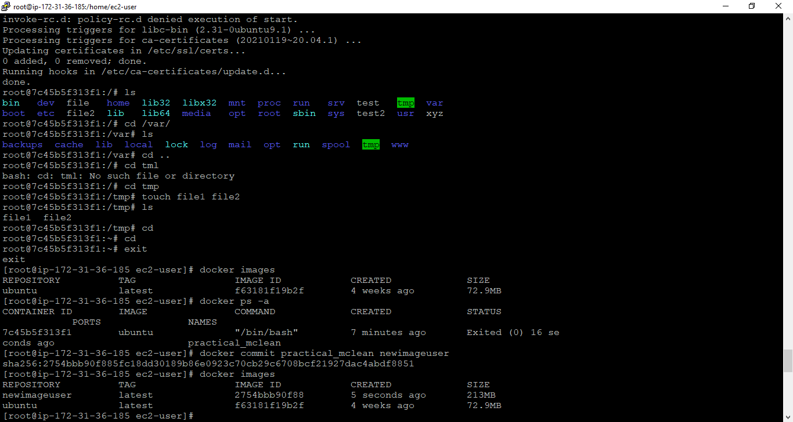

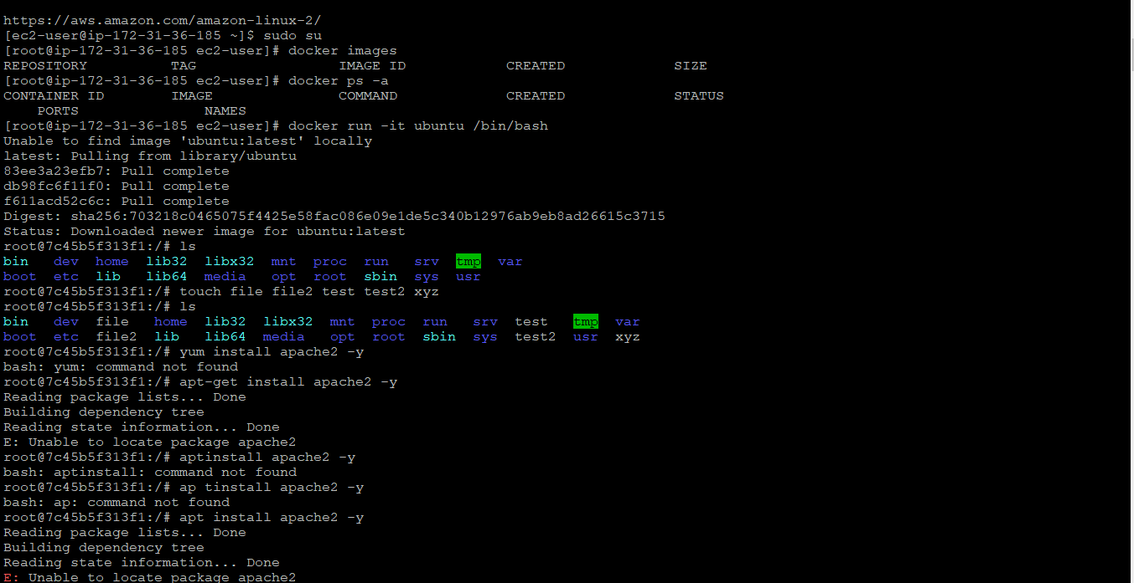

**Step-2:** login into the docker hub account

Command:

 Docker login

Add credentials when asked carefully.

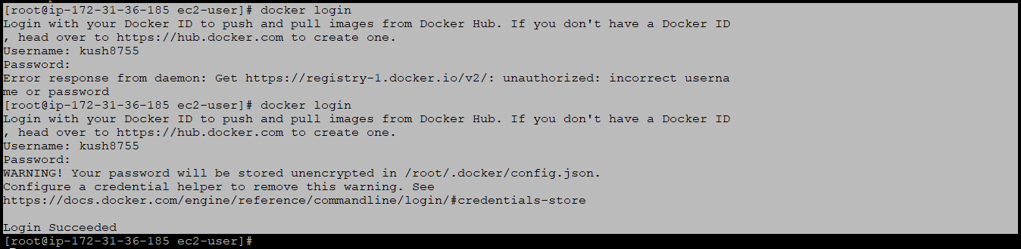

**Step-3:**

Now, push it into the docker hub using the following command

Command:

Docker tag <image_name_to_be_pushed> <New_i mage_name>

Docker tag newimageuser kush8755/imagebychitranshiubuntu

Docker push chitranshi8755/imagebychitranshibuntu

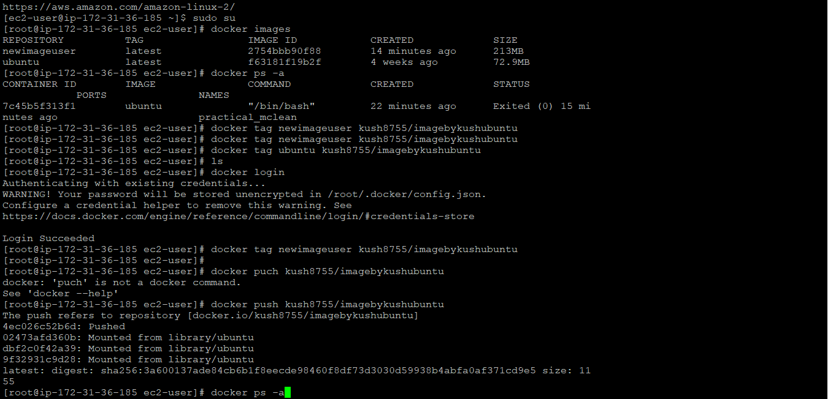

**Step-4:** To verify the software we installed, The files we created will come pre-install when another user uses our image.

Create an AWS ec2 instance [see the previous blog how to create]

Command-1:

sudo su

Redirect to root directory

Command-2:

 Yum update –y

Update the Linux machine

Command-3:

Yum install docker –y

Install docker on Linux machine

Command-4:

Service docker start

Start the Docker Daemon

Command-5:

docker images

Show the image available

Command-6:

docker ps –a

Show containers status

Command-7:

docker pull chitranshi8755/imagebychitranshiubuntu

Pull the image of the name “imagebychitranshiubuntu” from the docker hub of username “chitranshi8755”.

Command-8:

docker images

Shows the image available, now it shows the above image we pull.

Command-9: docker run –it –name chitranshicontainer kush8755/imagebychitranshiubuntu /bin/bash

Create a container name chitranshicontainer using the image we pull.

Command-10:

 cd tmp

ls

It will verify that folder and software conf files are pre-installed in the new user account

Command-11:

 cd var/www/

ls

It will verify that folder and software conf files are pre-installed in the new user account.

