**Experiment–3**

Aim: Creating Networks Between Containers using Networks

## To start with we create the network with our predefined name.

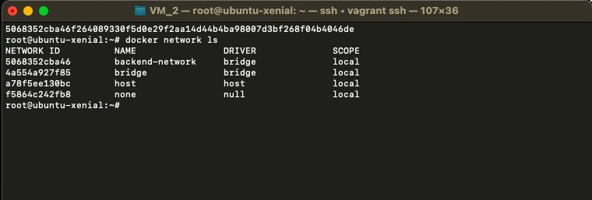

$ docker network create backend-network

## When we launch new containers, we can use the “***--net****”* attribute to assign which network they should be connected to.

$ docker run -d --name=redis --net=backend-network redis

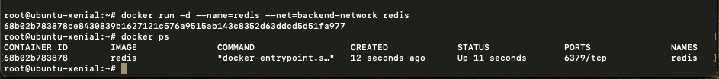

* Create another redis container with name “***redis_1***” under the “***backend-network***” network.

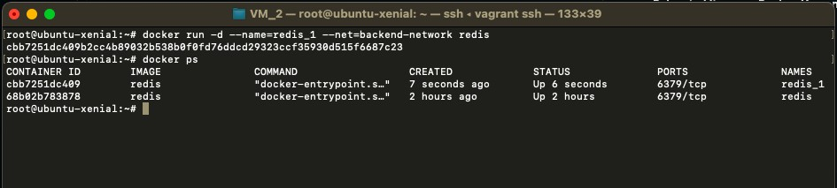

$ docker run -d --name=redis_1 --net=backend-network redis

* Now ping the redis (***redis_1***) container from the newly created alpine (***alpine_1***) container with in the same network (***backend-network***).

$ docker run –-name=alpine_1 --net=backend-network alpine ping redis_1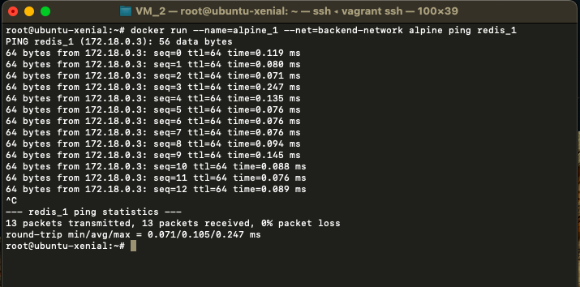

### Create another network (frontend-network) and connect the redis (***redis_1***) container with is network.

$ docker network connect frontend-network redis_1

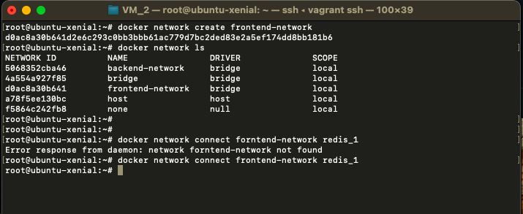

### Now inspect the “***redis_1***” container to check the network connectivity.

$ docker inspect redis_1

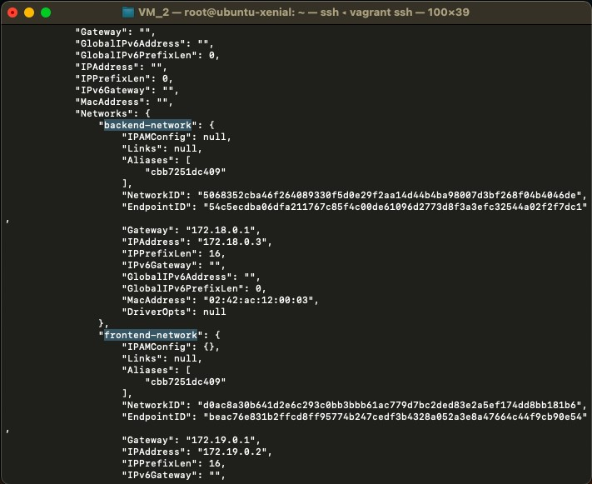

* Now disconnect the “***redis_1***” container from the “***backend-network***” network.

$ docker network disconnect backend-network redis_1

$ docker inspect redis_1

