**APPLICATION CONTAINERIZATION LAB**

**Experiment No. 4**

**Docker Hub: Creating Images and pushing/publishing them to Docker Hub**

**Submitted by:**

Devansh Markan

Roll Number: R171218036

SAP ID: 500069794

Semester: VI – Batch 1

In this experiment, we will create a customized Docker image and then push it to the Docker hub repository.

**Follow these steps below:**

1. Create a Docker file with the name “Dockerfile” and write some code into it.

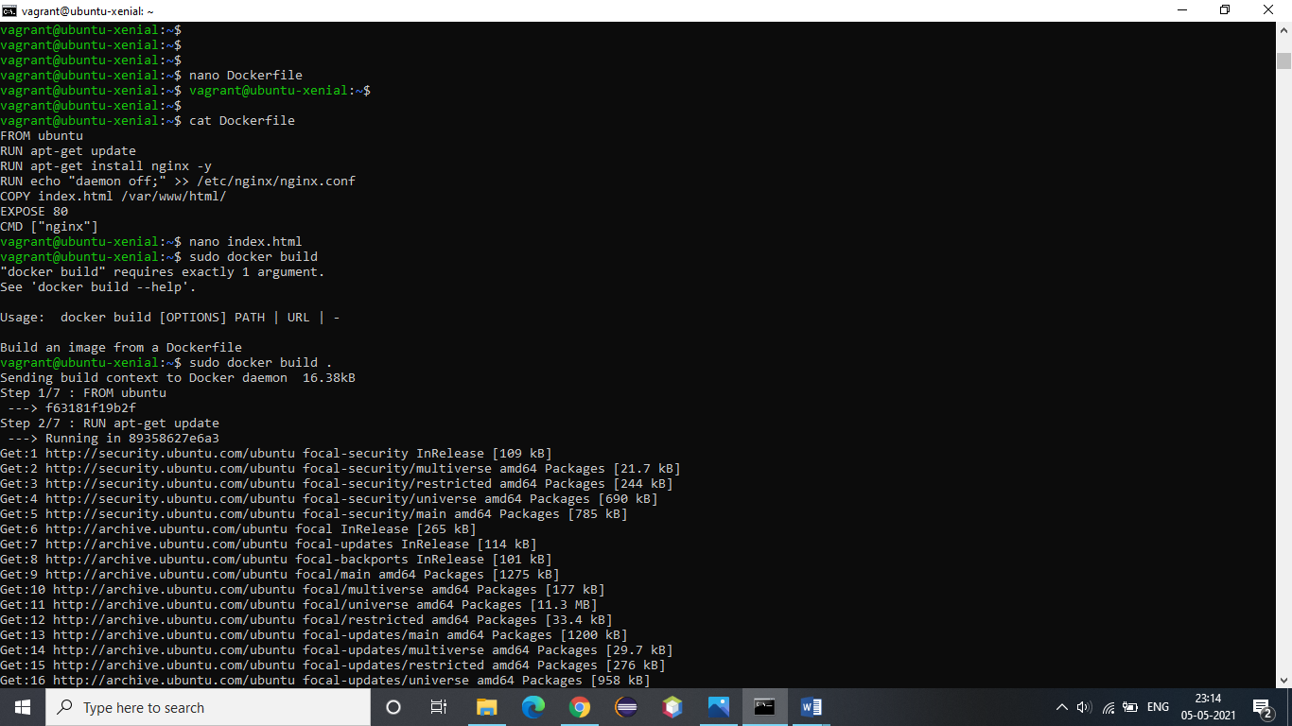

2. Create another file named index.html and add some basic webpage code in it.

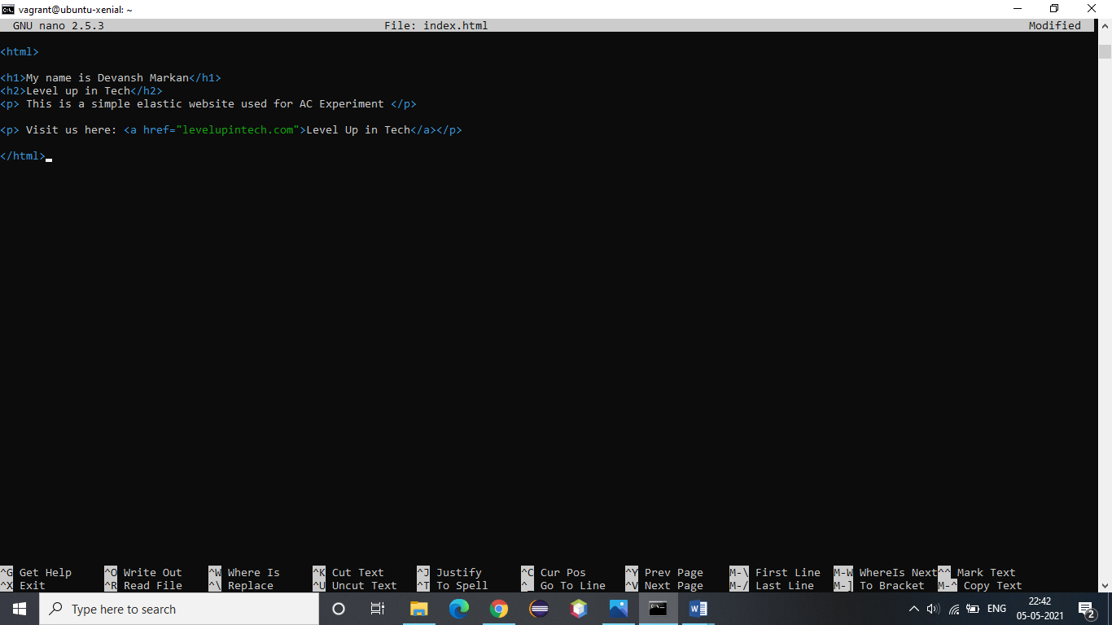

So, this code that we have written is just for this experiment and testing purpose.

3. Now, to build an image using this dockerfile.

Command: **docker build .** (Here . specifies current directory)



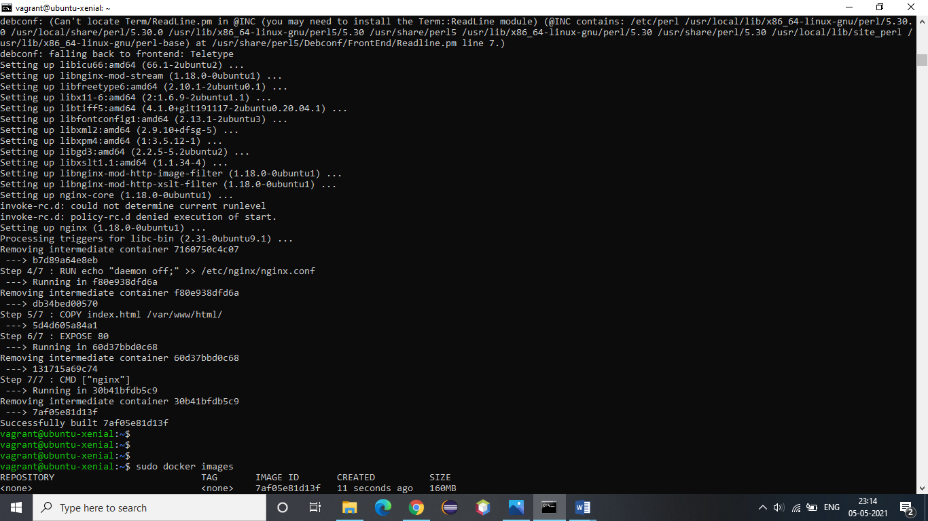

4. Now, list the newly created image using command **“docker images”**

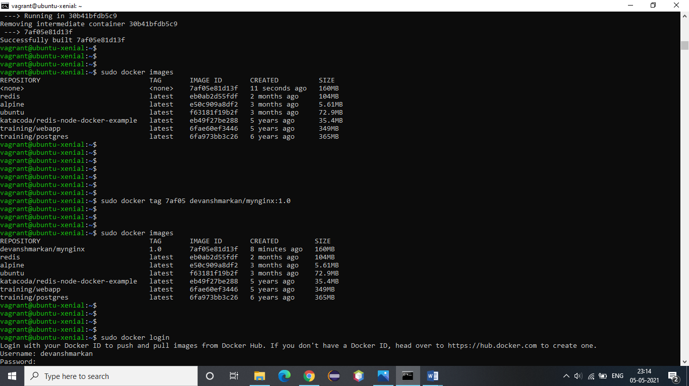

5. Now, we will create a repository on Docker hub as follows:

The following image shows how my repository looks like after it is successfully created.

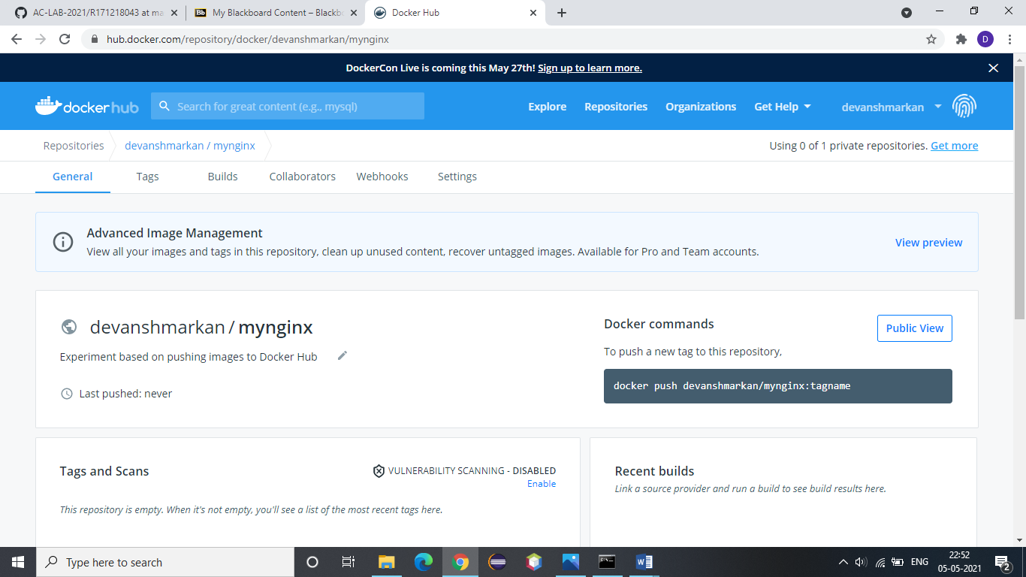

6. Now, it’s time to provide a tag to our image.

Command syntax: **docker tag <image-id> <repository-with-tag>**

**Also,** check “docker images” to check for tag.



7. Login to your docker hub account by entering your credentials.

Command: **docker login**

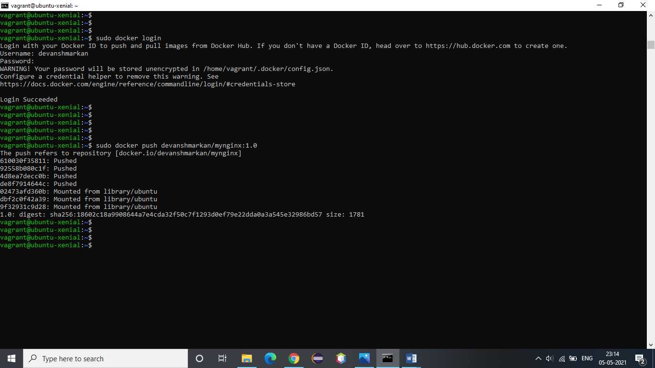

8. Now, push the image on docker hub.

Command: ***docker push devanshmarkan/mynginx:1.0***



So, our repository will look like this after the push is successfully completed.

