**APPLICATION CONTAINERIZATION LAB**

**Experiment No. 5**

**The Concept of Link in Docker: Linking two containers using Docker Link**

**Submitted by:**

Devansh Markan

Roll Number: R171218036

SAP ID: 500069794

Semester: VI – Batch 1

So, in the experiment, we are going to create two different containers and then we will link them using docker link.

Docker link feature allows containers to get aware of the presence of each other and thus, the containers are able to communicate with each other.

**Follow these steps below:**

1. So, firstly, we have to run a container in detached mode in the background mode. The container name is “db” and the image used for the container is “training/postgres”.

Command: **docker run –it –d --name db training/postgres**

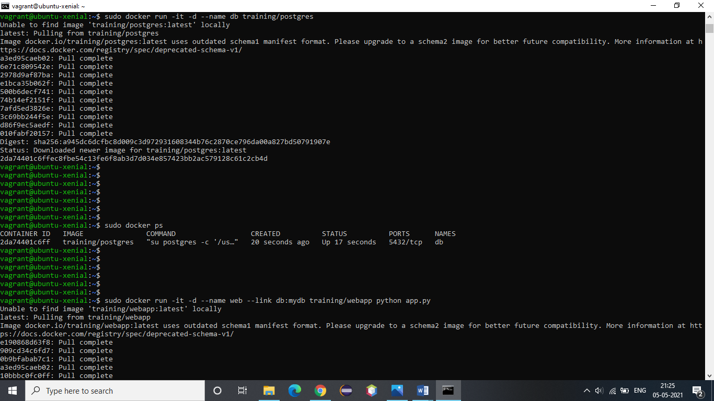

2. We can verify that the above specified container is running by using the command: **docker ps**



3. Now we will run another container in background. This container name is “web” and the image used to create this container is “training/webapp”.

We will link this container to the container db with alias mydb. We will pass an inline command “python app.py” while running this container.

Command: **docker run –it –d --name web --link db:mydb training/webapp python app.py**

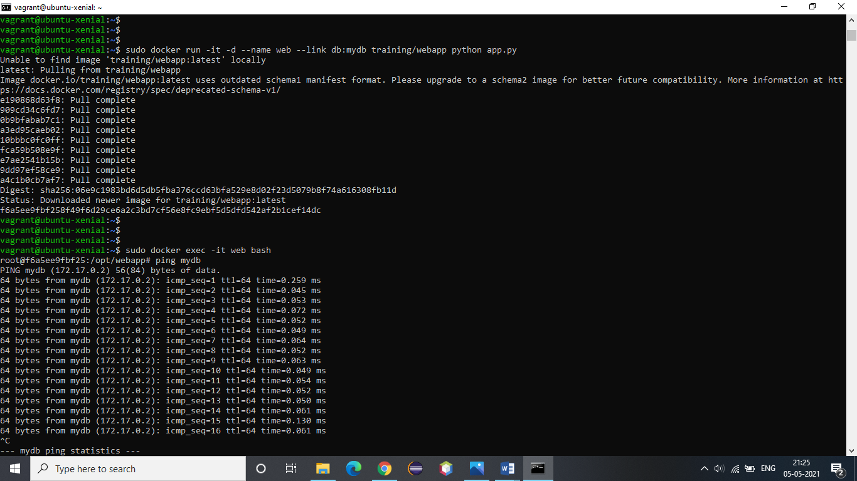

4. Now, we have to verify the connection between the containers. To do this, open the bash terminal of web container and ping mydb.

Command: **docker exec –it web bash**



5. We also have an option to see the stats of the running containers and monitor them using docker stats.

