**APPLICATION CONTAINERIZATION LAB**

**Experiment No. 2**

**Docker Volume**

**Submitted by:**

Devansh Markan

Roll Number: R171218036

SAP ID: 500069794

Semester: VI – Batch 1

Docker containers are isolated from each other but still they can share data by having a common shared volume.

Volume is a storage on local machine which can be used by containers to store data.

**1.** Create a docker container and bind any folder of the container with a volume and move to the directory /mnt and create some files.

**Command: docker run -it -v TestVolume1:/mnt alpine**

This command will open the terminal of the newly created alpine container.

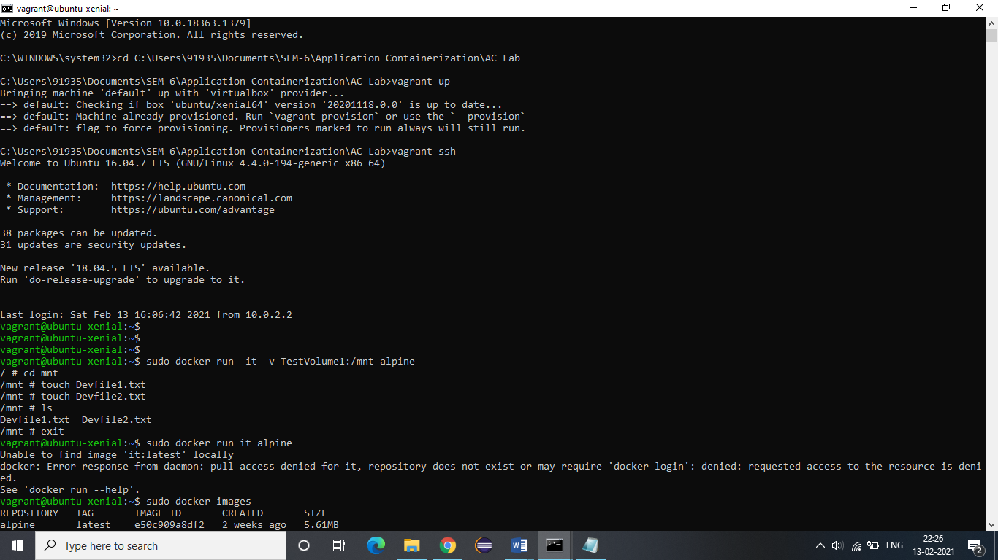

**2.** Now exit the container and create a new container without specifying any volume to check whether these files are accessible to that container or not.

**The image being used is alpine.**

**Command: docker run –it alpine**

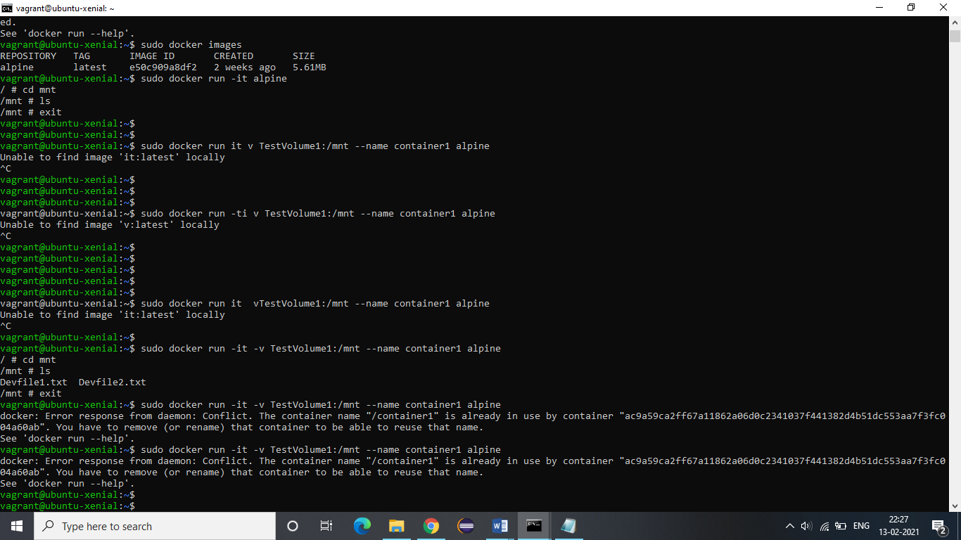

**3.** Now let us create a container named “container1” using alpine image and bind its mnt folder with TestVolume1. The files created in step-2 will be present in this container.

**Command: docker run –it –v TestVolume1:/mnt --name container1 alpine**



**4.** Now we will create another container named container2 using ubuntu image and bind var folder of the container to the same volume. The files will be present in this container as well.

**Command: docker run –it –v TestVolume1:/var --name container2 ubuntu**

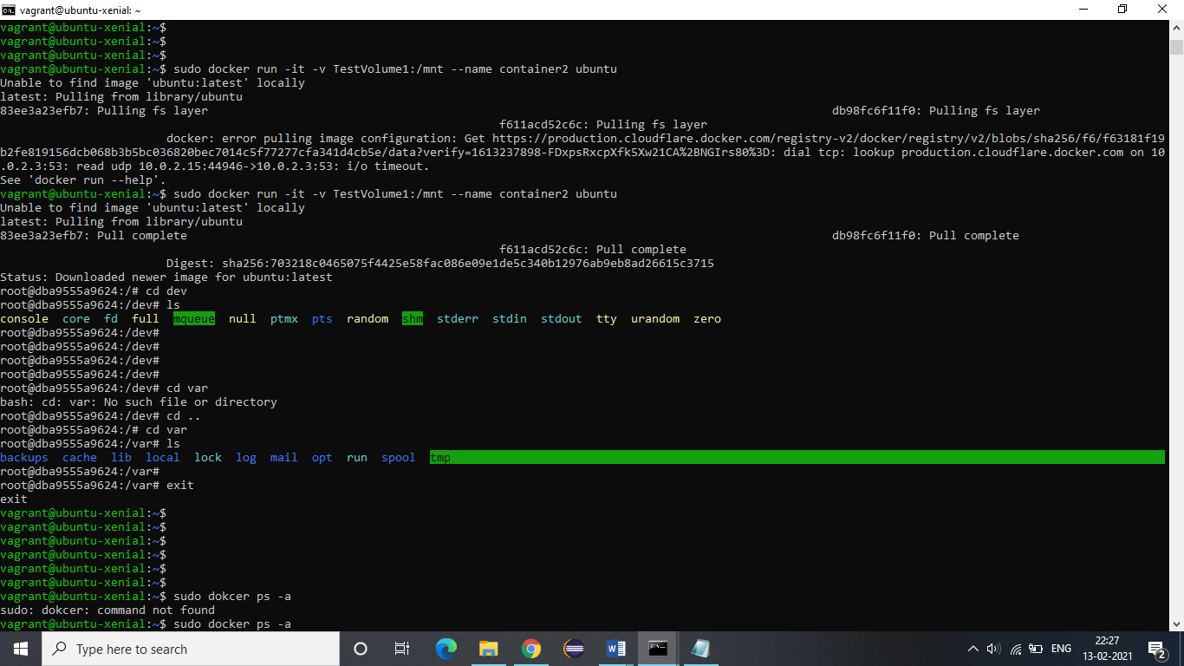

**5.** We can access the data even when the containers are stopped by directly moving to the location of volume.

First, let us verify that the containers are stopped.

**Command: docker ps –a**

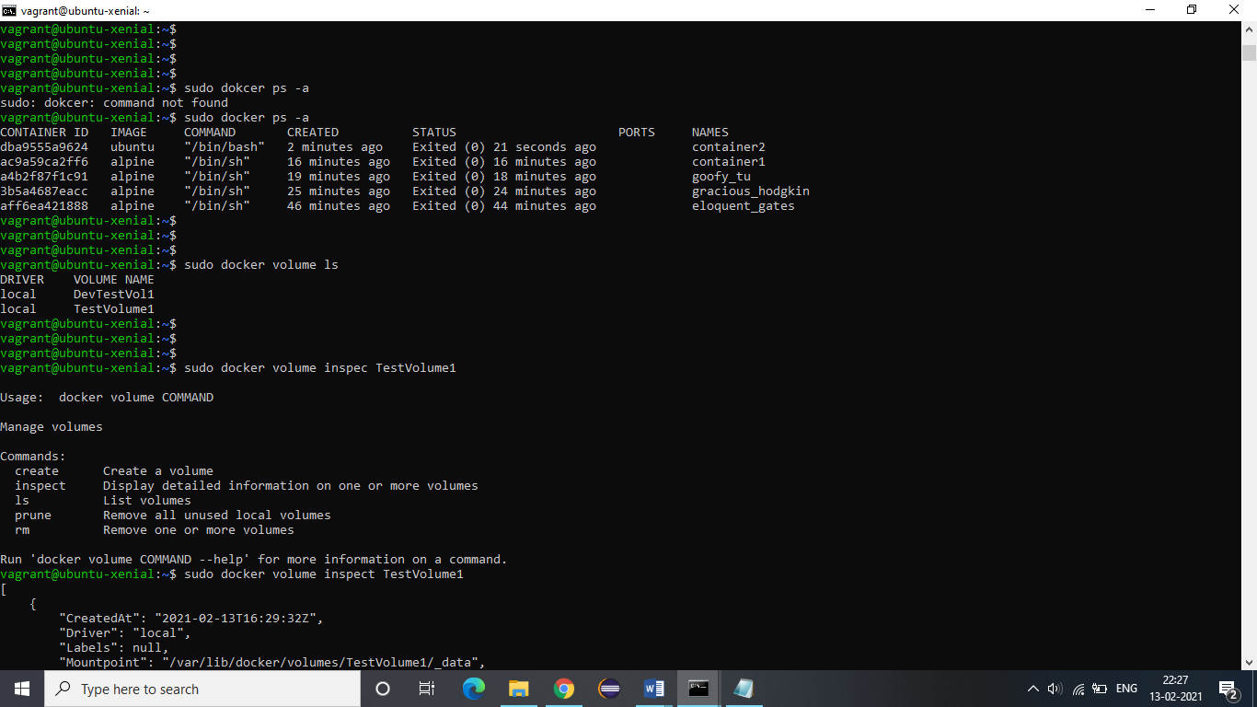

**To list the available docker volumes with their names, use the following command:**

**Command: docker volume ls**



**6.** Now we need to get the path of the TestVolume1 to access its data. The command to display the details of a volume is as follows:

**Command: docker volume inspect TestVolume1**

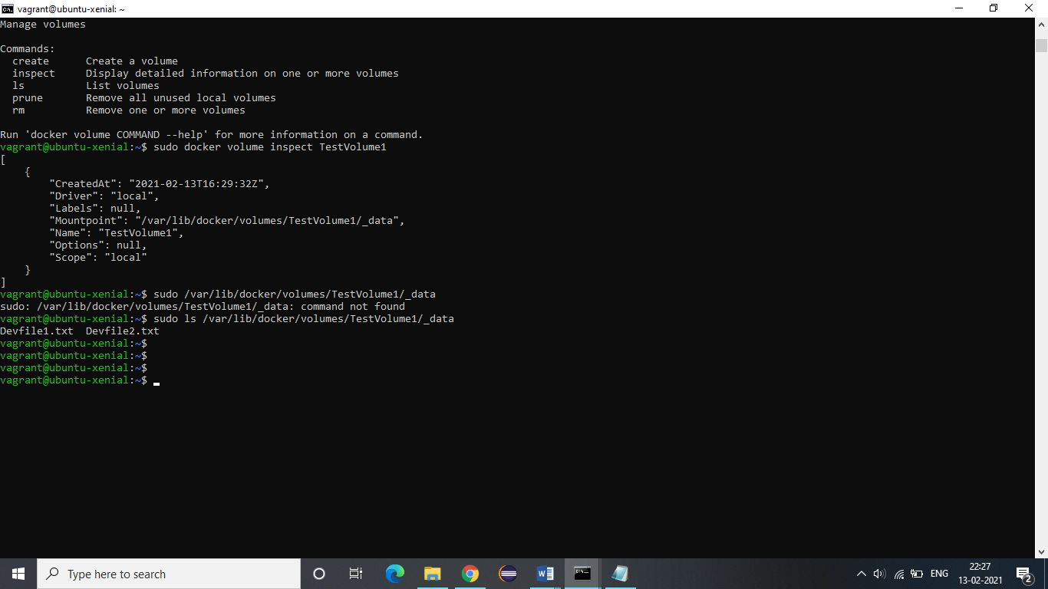

**7.** The above displayed output shows the path (mountpoint).

All created files will be present at this specified path:

