**APPLICATION CONTAINERIZATION LAB**

**Experiment No. 9**

**Running multi-container applications using Docker Compose**

**Submitted by:**

Devansh Markan

Roll Number: R171218036

SAP ID: 500069794

Semester: VI – Batch 1

Docker Compose is a tool used to create a Docker application that will run on multiple containers. A YAML configuration file is used where the configuration of the containers is given.

In this experiment, we will create a two-service configuration with MySQL as database and Nginx image as web server.

**Follow these steps below:**

1. Install docker-compose in your machine.

The commands are:

**Command1:** sudo curl -L https://github.com/docker/compose/releases/download/1.21.2/docker-compose-$(uname -s)-$(uname -m) -o /usr/local/bin/docker-compose

**Command2:** sudo chmod +x /usr/local/bin/docker-compose

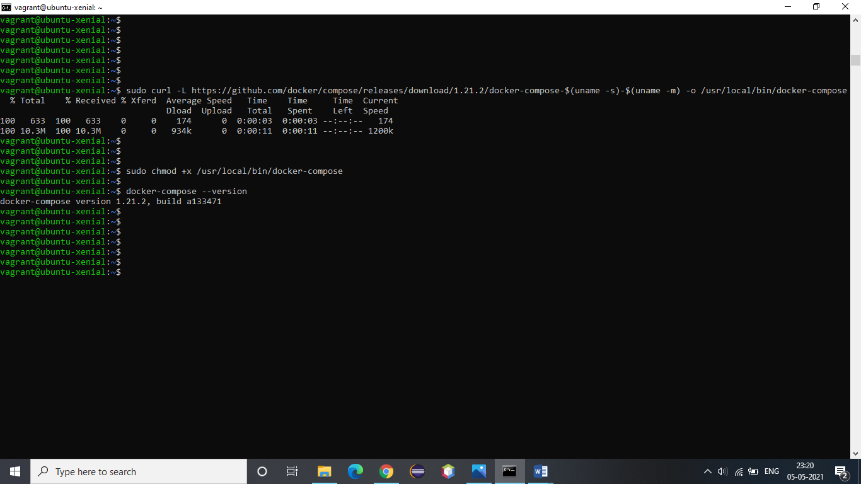

2. Verify the docker-compose installation by checking its version:



3. Write the following content in the “evs.env” file:

MYSQL_ROOT_PASSWORD=<passwd>

MYSQL_DATABASE=<database>

MYSQL_USER=<name>

This file will be used to refer to the value of specified variables.

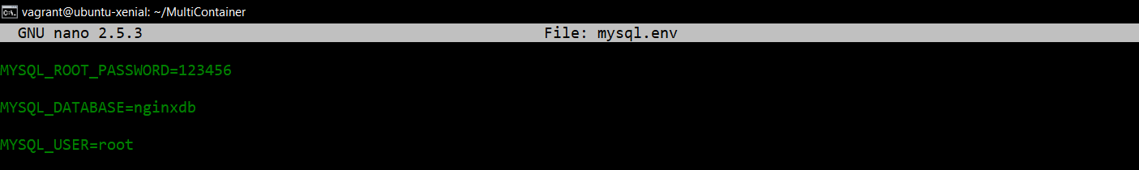

4. Make a YAML configuration file with the name “docker-compose.yml” and provide the configuration of containers in this file.

Write the following content in the file.

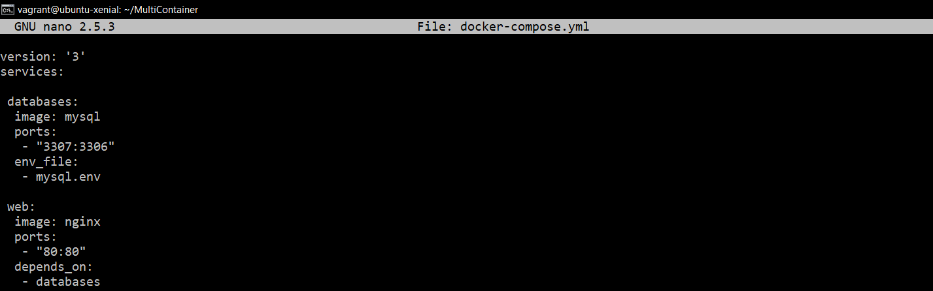

5. Use the below command to run the services specified.

Command: docker-compose up

