**APPLICATION CONTAINERIZATION LAB**

**Experiment No. 1**

**Working with Vagrant - Introduction**

**Submitted by:**

Devansh Markan

Roll Number: R171218036

SAP ID: 500069794

Semester: VI – Batch 1

Vagrant is a tool provided by HashiCorp. It is used for building and managing virtual machines environments.

This experiment is about creating a virtual machine in Virtual Box using Vagrant.

**1.** Download and install Oracle VirtualBox. The version being used here is 6.0.12.

Link to install version 6.0.12: <https://www.virtualbox.org/wiki/Download_Old_Builds_6_0>

**2.** Download Vagrant as per your operating system from its official website <https://www.vagrantup.com/downloads.html>

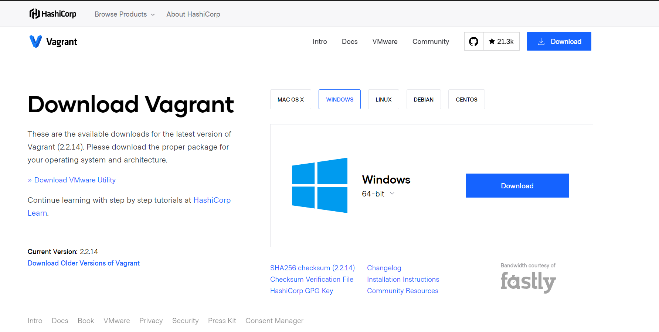

On running the setup, you will be asked to provide the desired path for the installation and proceed further to complete the installation.

Finish the installation and then restart the computer to apply the changes.

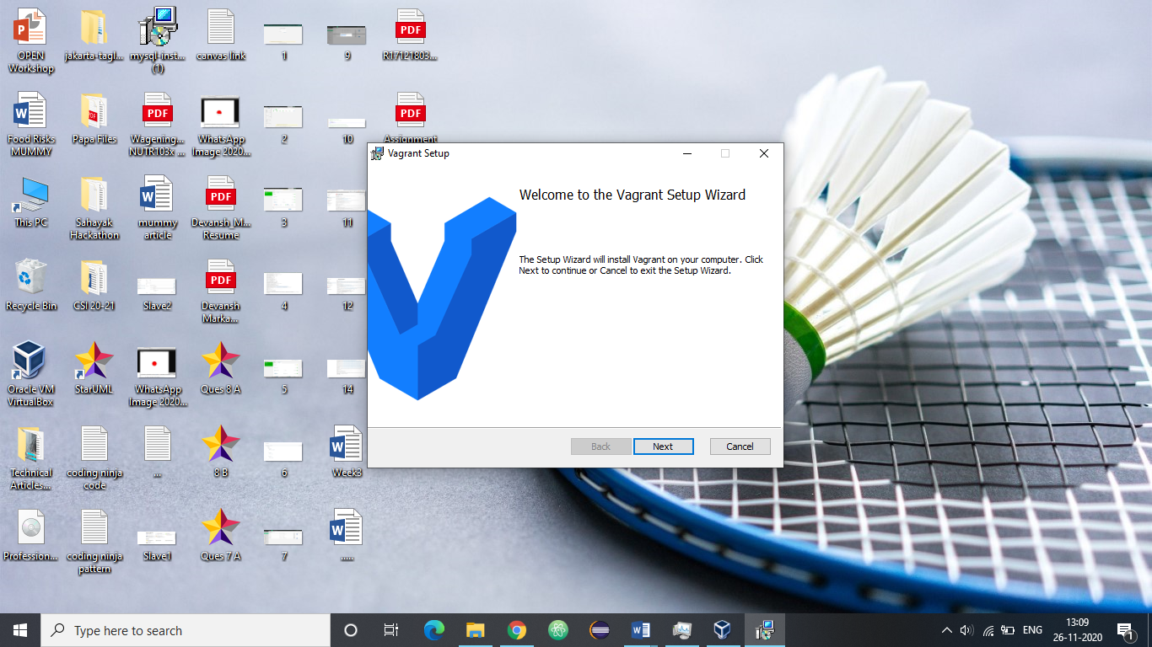

**3.** Verify that Vagrant is successfully installed on your computer. To do so, open the command prompt and type the following command:

Command: vagrant –version

The successful output verifies the installation of vagrant.

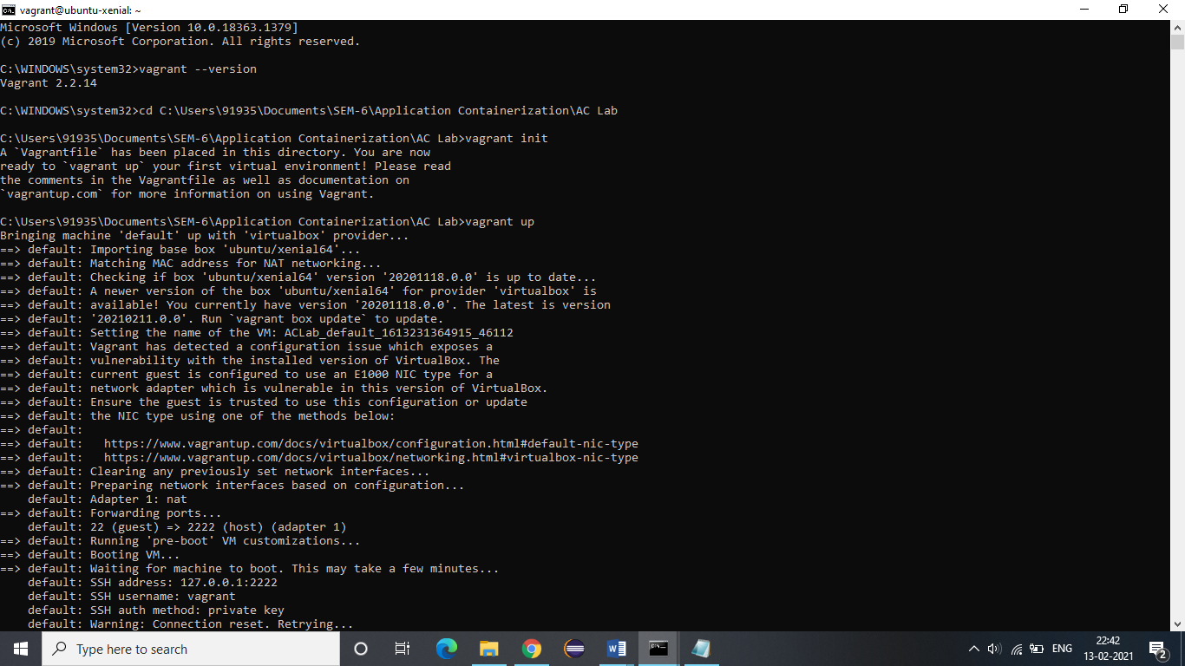

**4.** Create a new folder and switch to that folder.



**5.** Initialize this folder for Vagrant.

Command: vagrant init



You can observe that a file named Vagrantfile is created in your folder after the execution of above command.

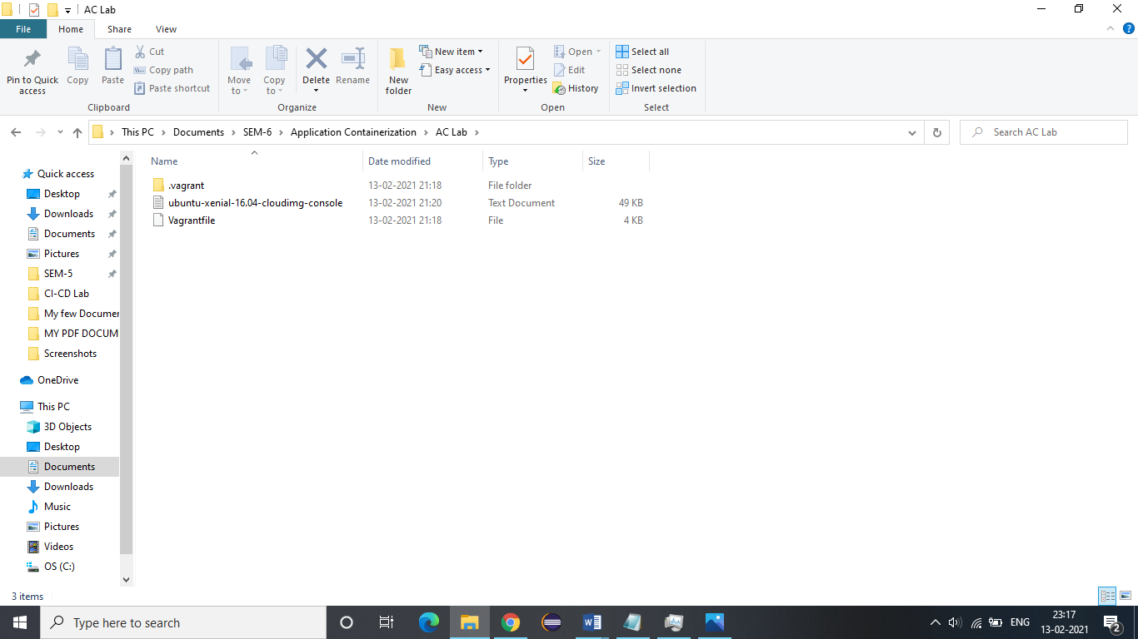

This Vagrantfile is used to describe the specifications and configuration of the machine that you want to create using Vagrant.

The commented lines of the file can be uncommented and desired specifications can be placed at appropriate places.

**6.** Open the Vagrantfile for editing and specify the image that you wish to create your virtual machine with.

Specify the base for your virtual machine.

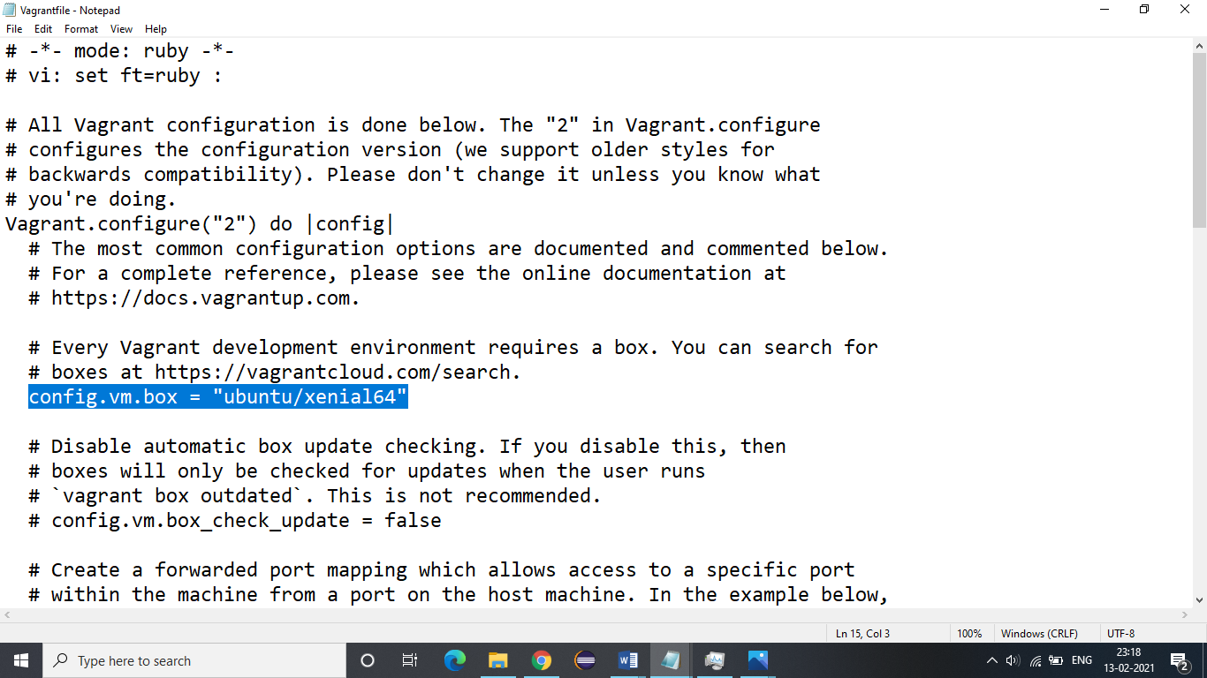

**7.** To create the virtual machine as per the specified configuration, run the following command.

Command: vagrant up



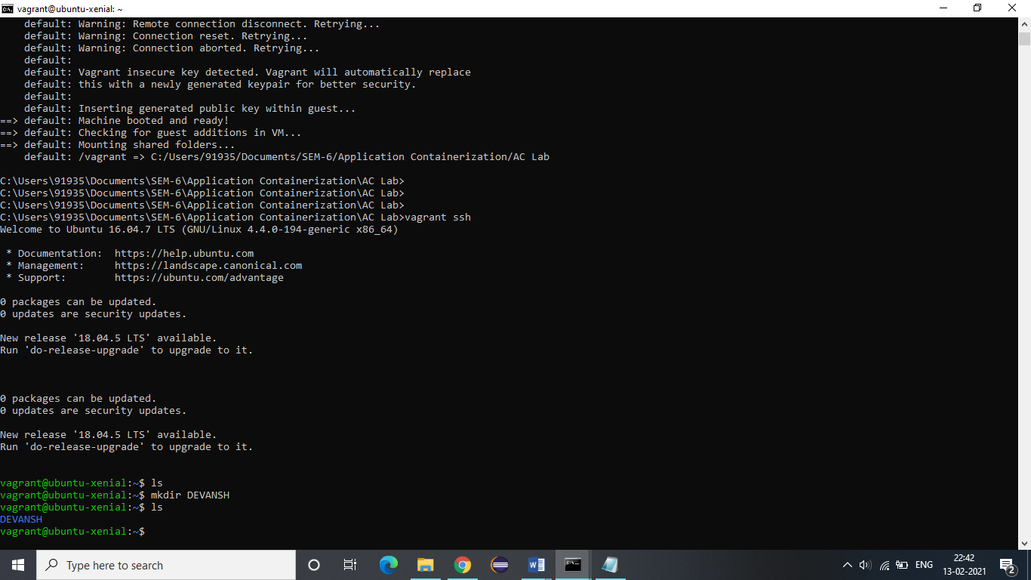

**8.** SSH into the newly created virtual machine by using the following command:

Command: vagrant ssh

