Experiment 14

(By Devmalya Bandyopadhyay)

Aim: Working with Metadata, Log File using Docker

1) Adding single label

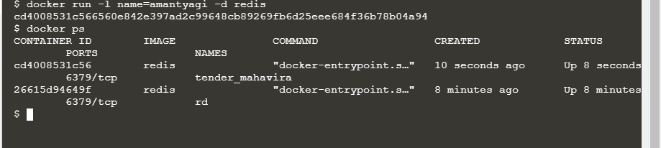

2) Filtering the search

