

**UNIVERSITY OF PETROLEUM & ENERGY STUDIES**

**Dehradun**

[**Application Containerization Lab**](https://learn.upes.ac.in/webapps/blackboard/execute/launcher?type=Course&id=_49490_1&url=)

**Experiment-7**

**Name: Devmalya Bandyopadhyay**

**Course: B. TECH CSE DevOps (2018-22)**

**Roll no.: R171218039**

**Sapid: 500069119**

**Experiment-7**

**Aim:-**Deploying a Service on Docker Swarm

**Step 1:-** Run the docker swarm init command to initialize the Cluster

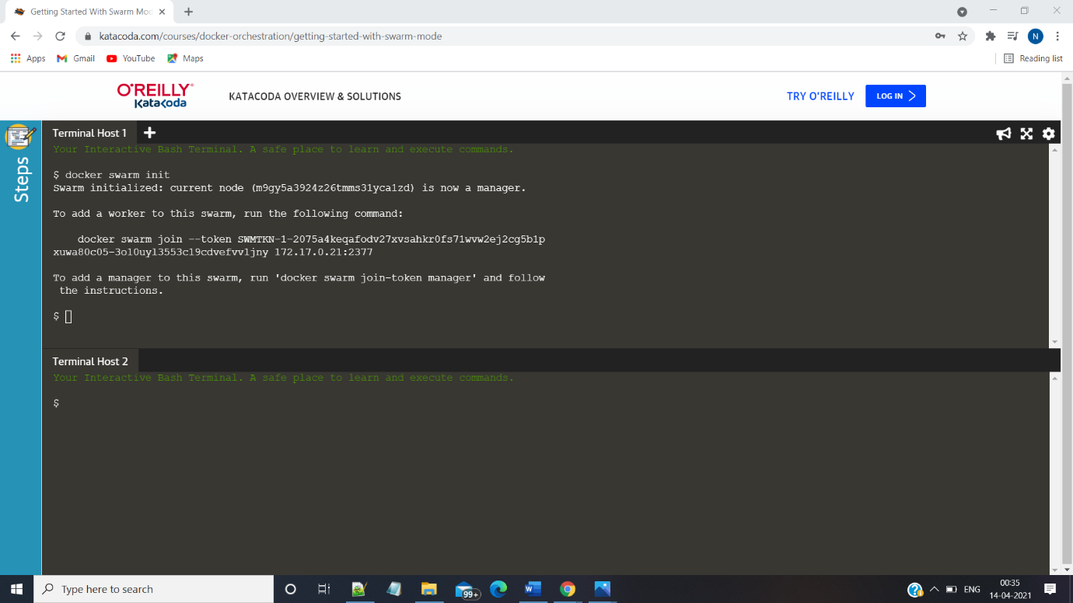

**Step2:-** Run the node ls command to list all the nodes in the cluster

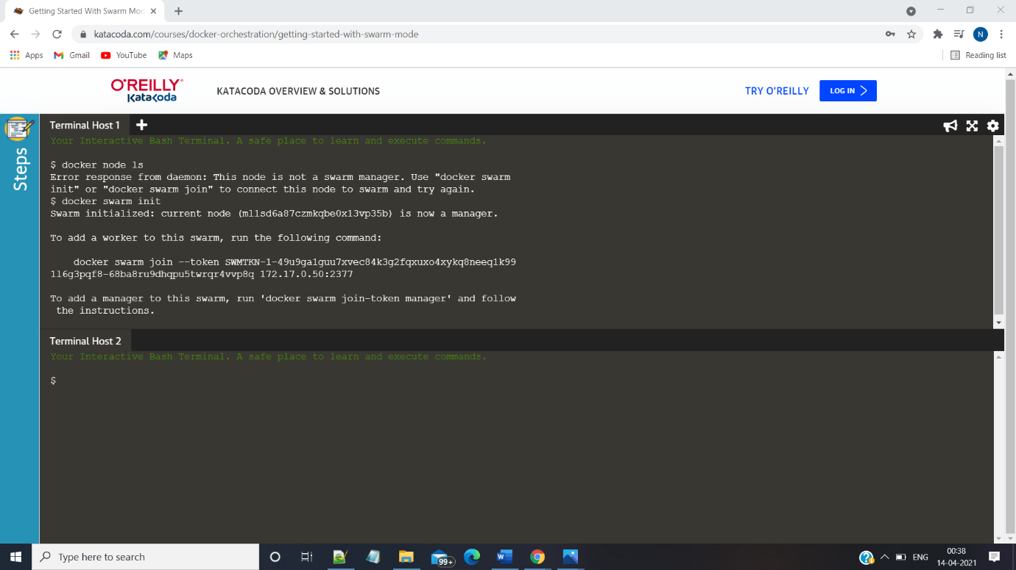

**Step3:** Run the docker swarm join –token command command on other node this makes the other node as a

Member of existing cluster

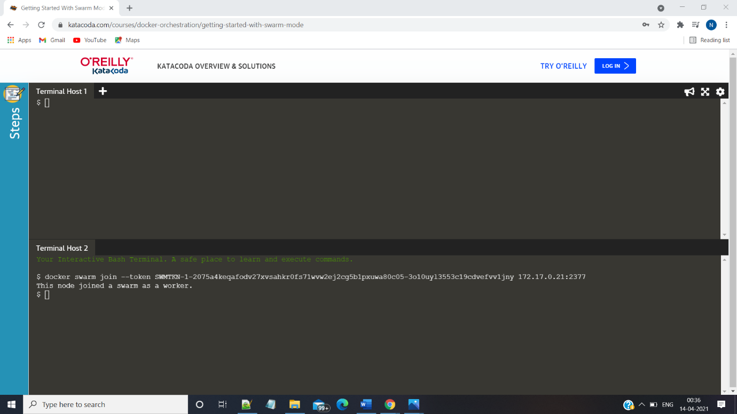

**Step4:- Create an Overlay Network using docker network create command**

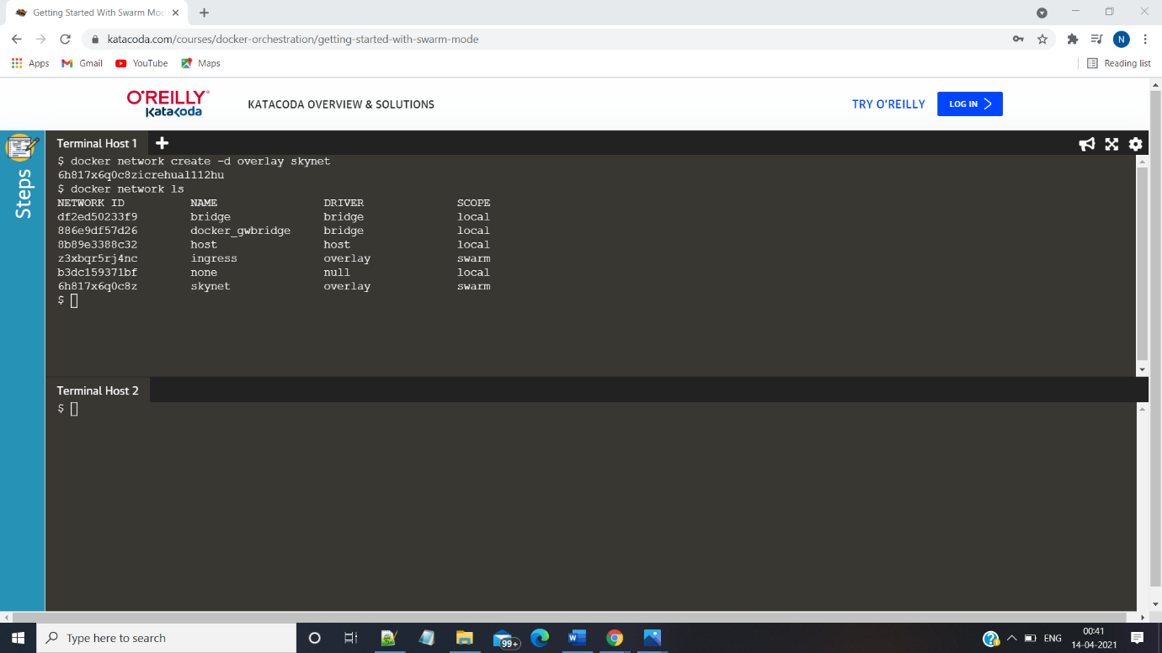

**Step 5:-** Create a service and run two replicas of the service using docker service create command

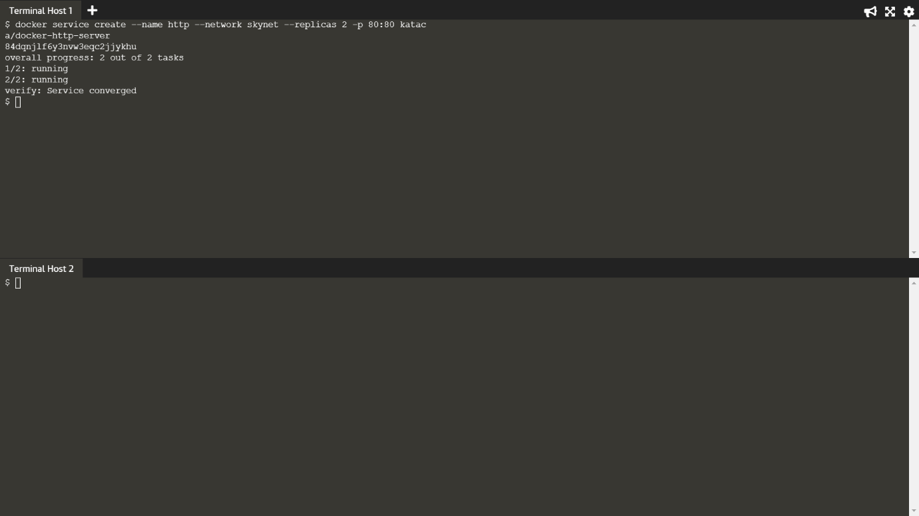

**Step 6:** Run the docker ps command on both the hosts to see the running processes on both the hosts

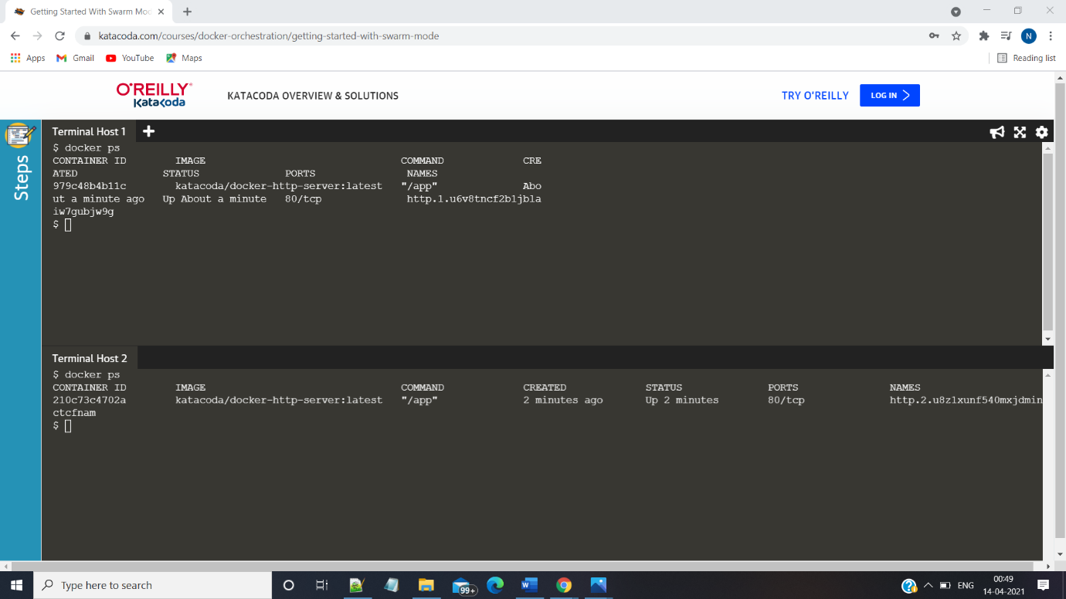

**Step 7:** run the docker swarm leave command to exit from cluster

