Application Containerization Experiment 10

**Docker - Managing Log Files**

**Name: Harivansh Mathur, Roll No: R171218043**

In the background, there is an instance of Redis running with the name redis-server. Using the Docker client, we can access the standard out and standard error outputs using the following command

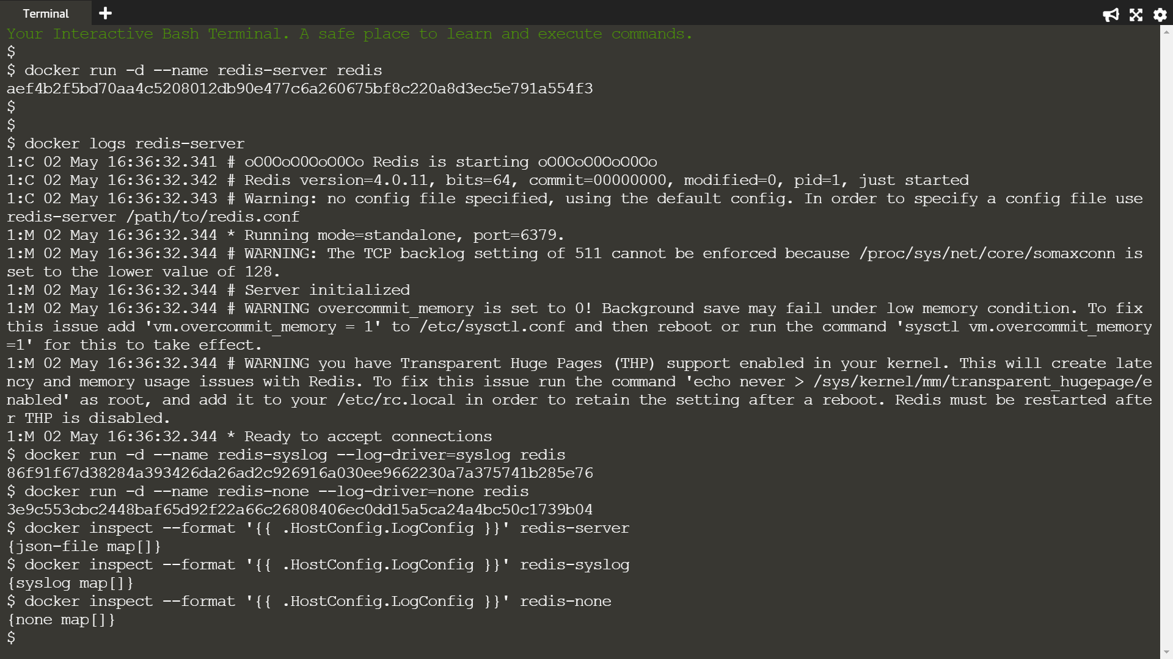

The command below will redirect the redis logs to syslog



When the container is launched, no output will be logged when we set log-driver to none



The commands below will output the LogConfig section for each of the containers.





