Application Containerization Experiment 12

**Installing Minikube**

**Name: Harivansh Mathur, Roll No: R171218043**

Installing minikube by using chocolatey package manager

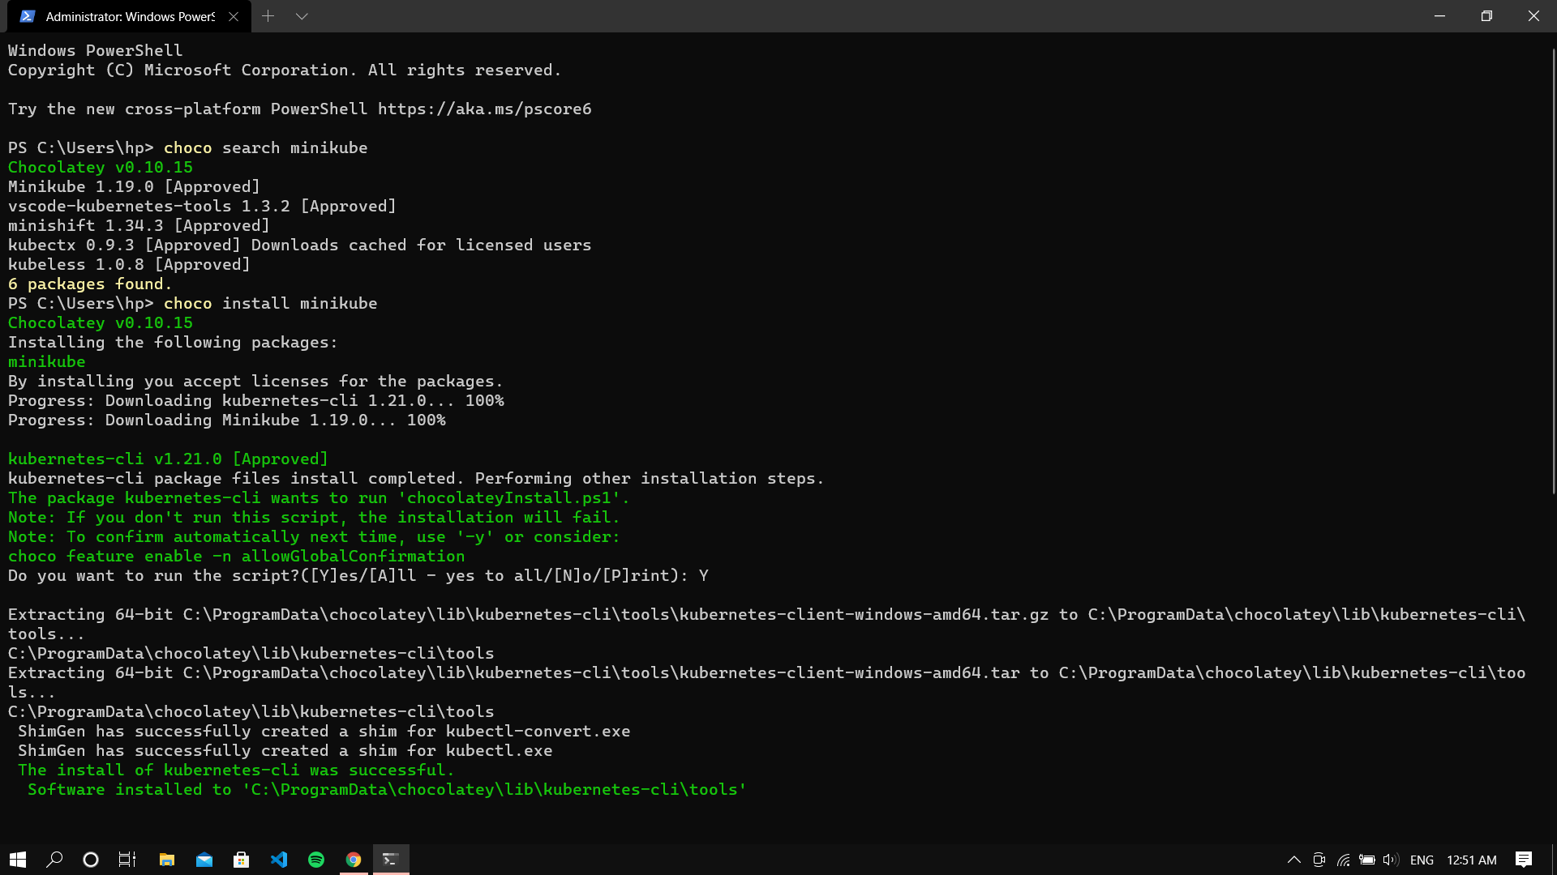

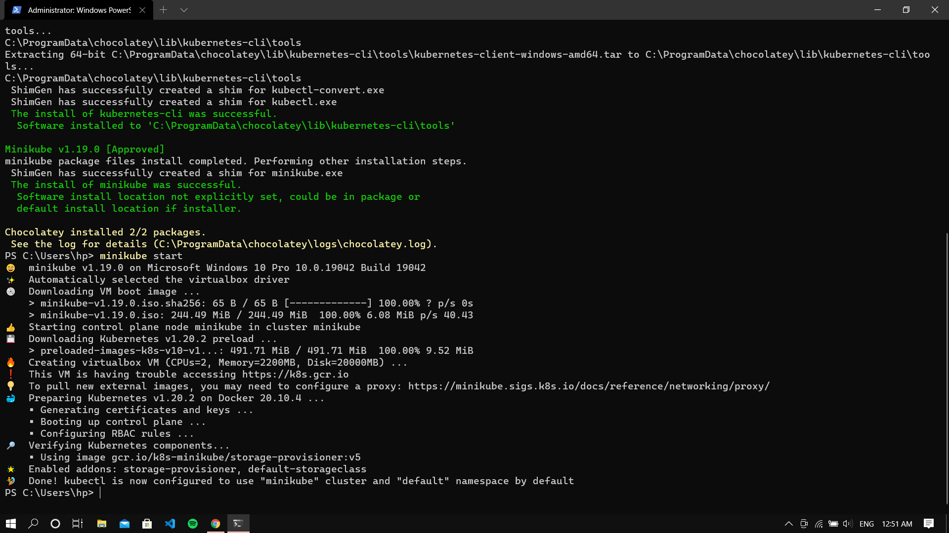

Starting minikube

