Application Containerization Experiment 13

**Deploying Pods and Services on Minikube**

**Name: Harivansh Mathur, Roll No: R171218043**

Opening Kubernetes Dashboard

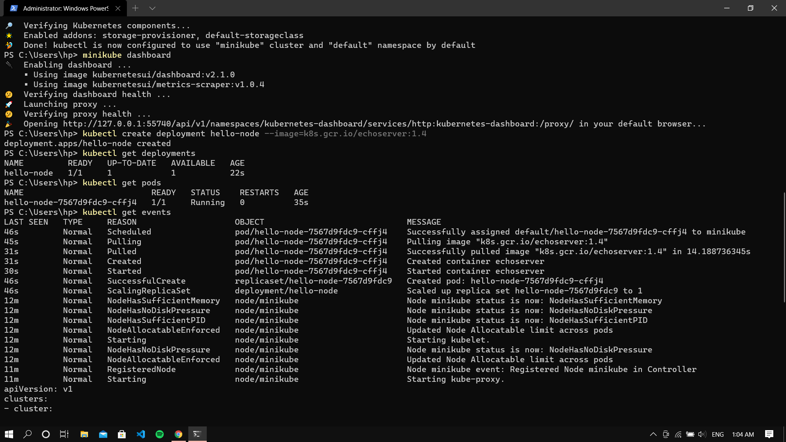

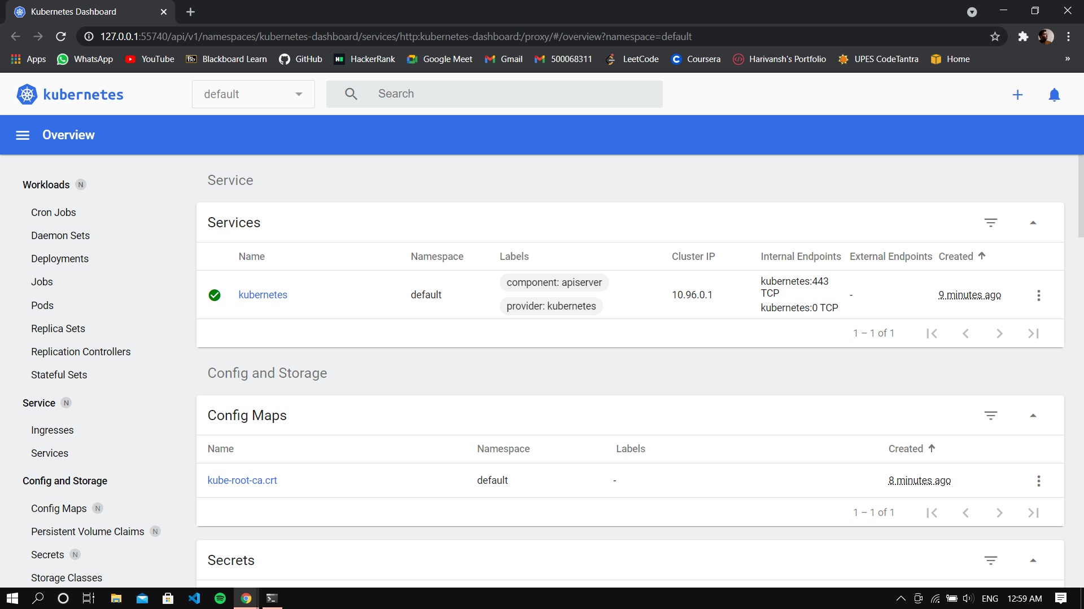

Creating a deployment, viewing the deployment and the pods



Command for viewing cluster events



Exposing the pod and creating a serivce

