Application Containerization Lab

Experiment - 5 (Docker Compose)

**Name : Harivansh Mathur**

**Roll No : R171218043**

* Installing docker-compose

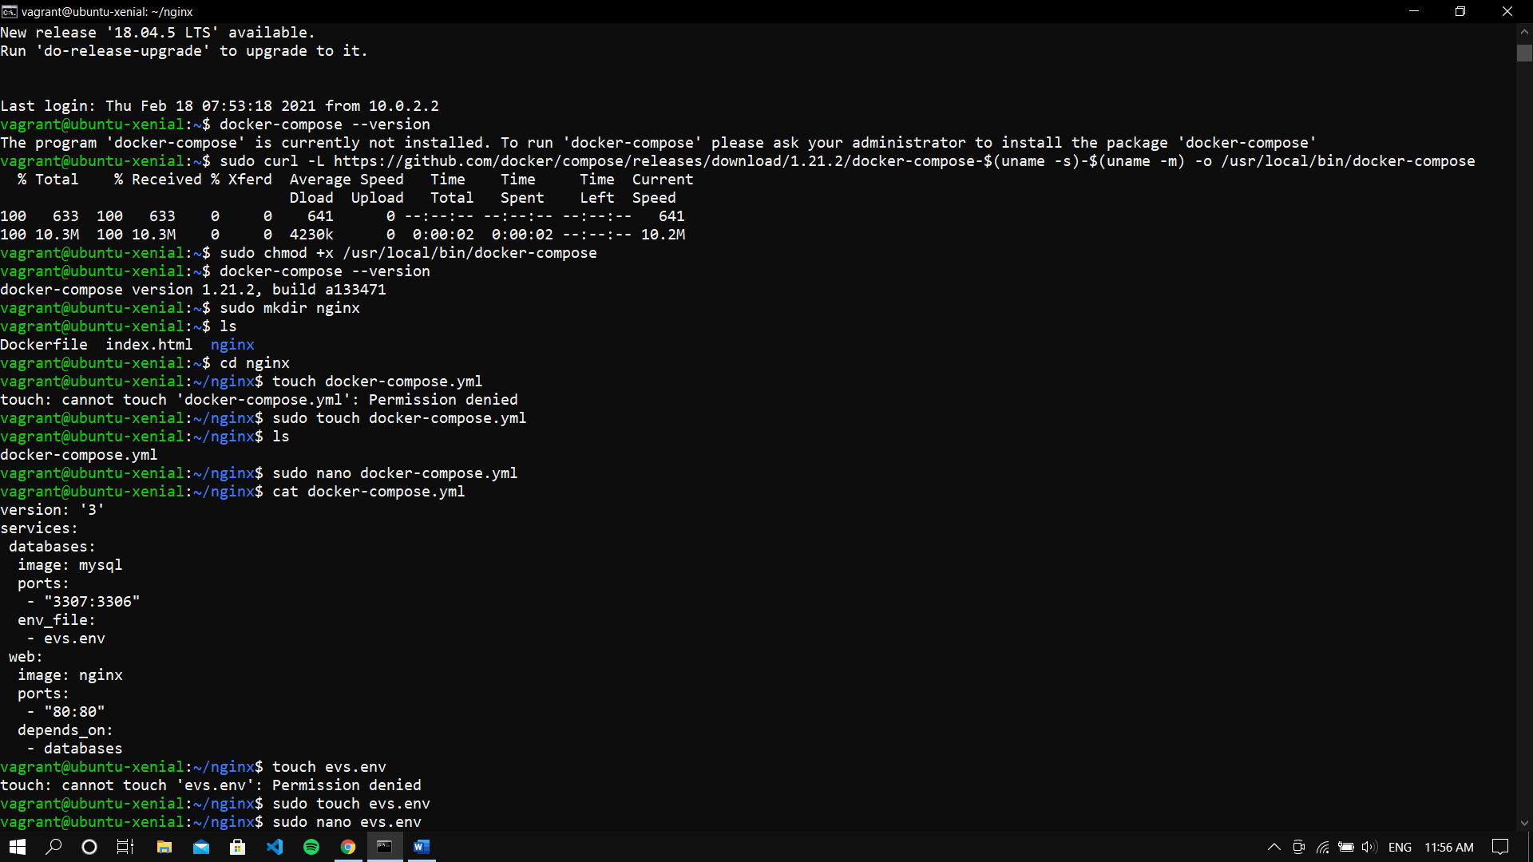

* Creating docker-compose.yml file



* Creating evs.env file

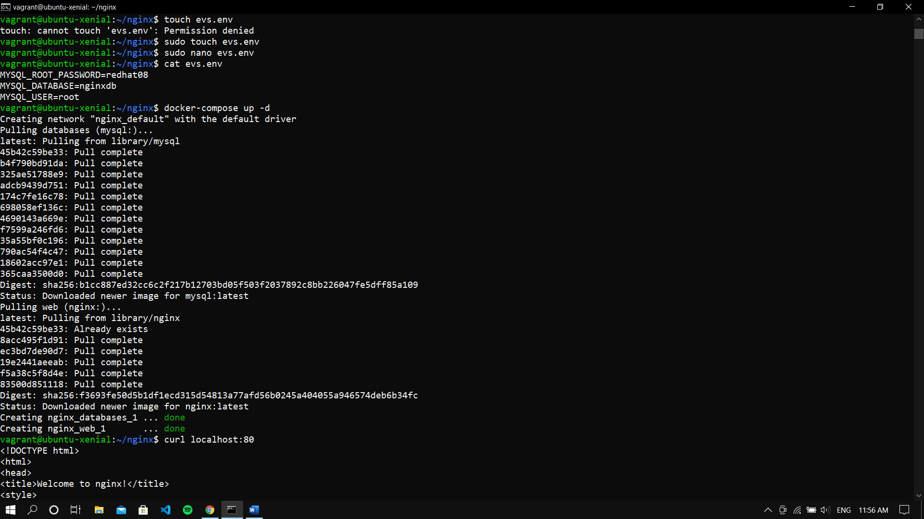

* Running “docker-compose up -d” command



* Verifying using curl, that the Nginx server is running on port 80

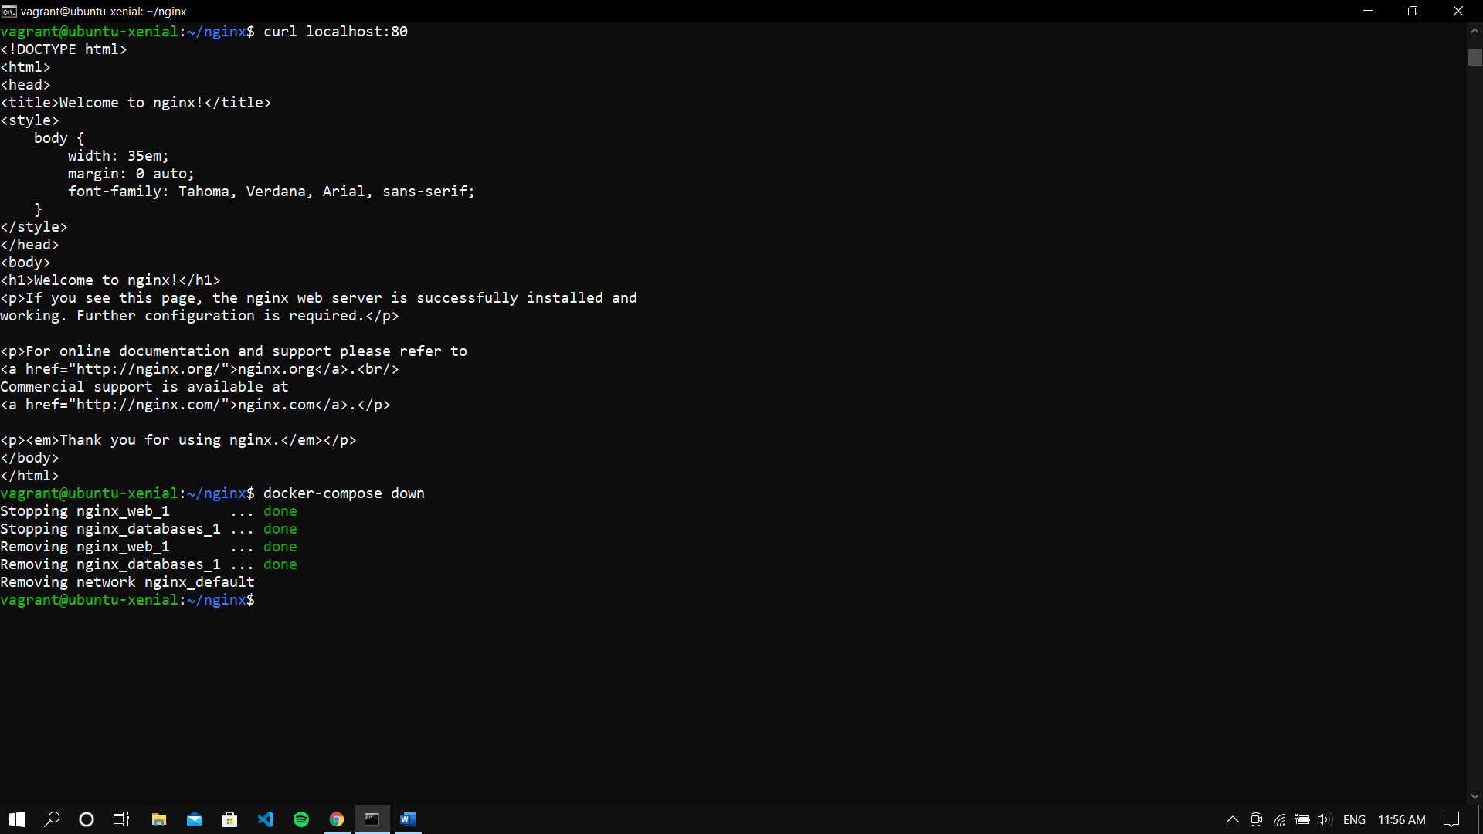

* Stopping the service with “docker-compose down” command

