Application Containerization Lab

EXPERIMENT - 6 (Docker Link)

**Name: Harivansh Mathur, Roll No: R171218043**

Open the terminal and run a postgres container by the command ‘docker run -it -d –name db training/postgres’.

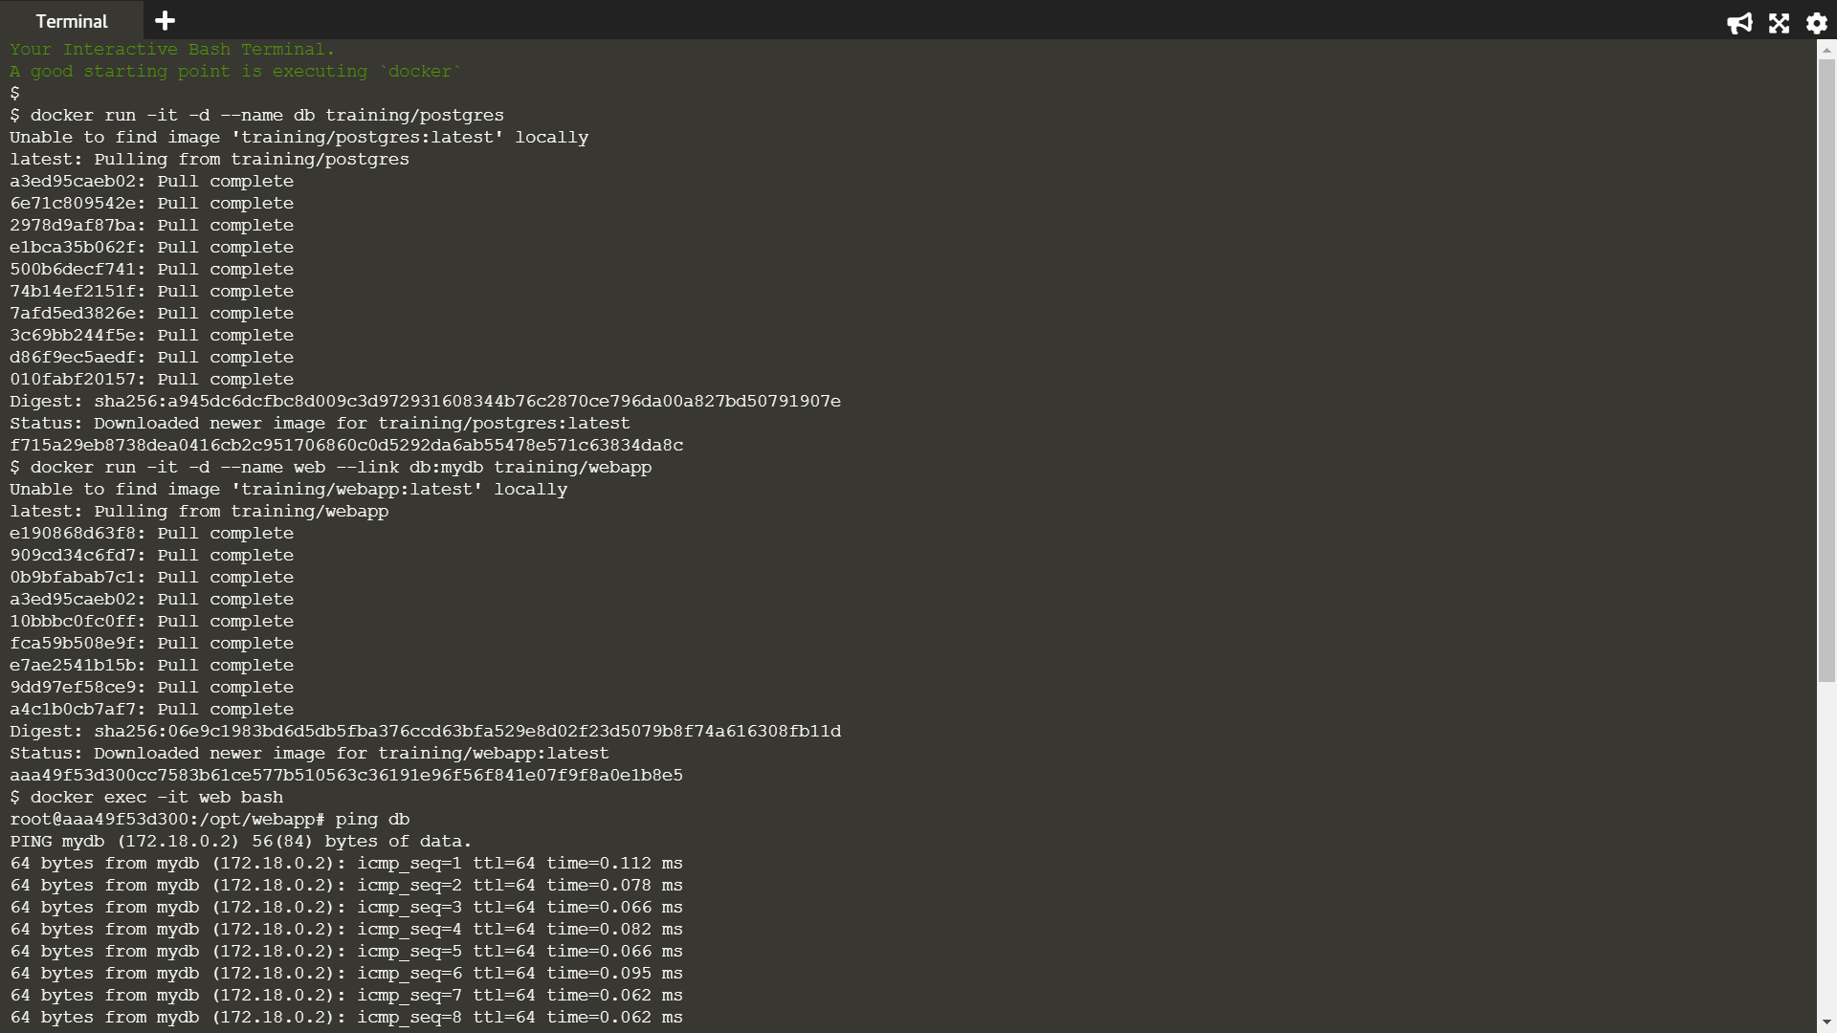

Once the command execution is complete and the pulling of the image gets over, run another container of image webapp linking it with the db container we just created by the command ‘docker run -it -d –name web –link db:mydb training/webapp’.



When the other image is pulled completely and the container is running then switch to the terminal of the container by using ‘docker exec -it web bash’. After logging, ping the container with which we linked the current container



Now run another container without linking it to any of the previous containers and check all the containers with the command ‘docker ps’.

Login to the container again with which we ran the ping command once and try pinging the newly created container, the ping command will fail because the container isn’t linked with the other container.

