Application Containerization Experiment 8

**Docker Ignore**

**Name: Harivansh Mathur, Roll No: R171218043**

Viewing the Dockerfile

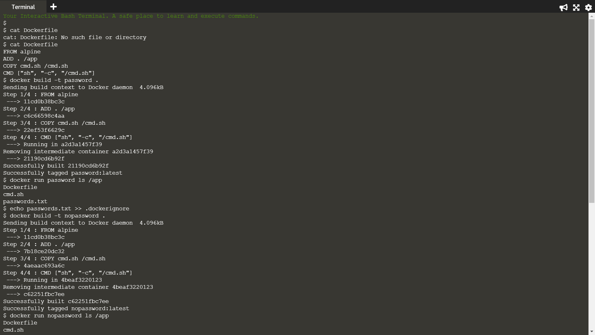

Building the image



Output



The following command would include passwords.txt in the .dockerignore file to ensure that it didn't accidentally end up in a container

And then building the image



Output

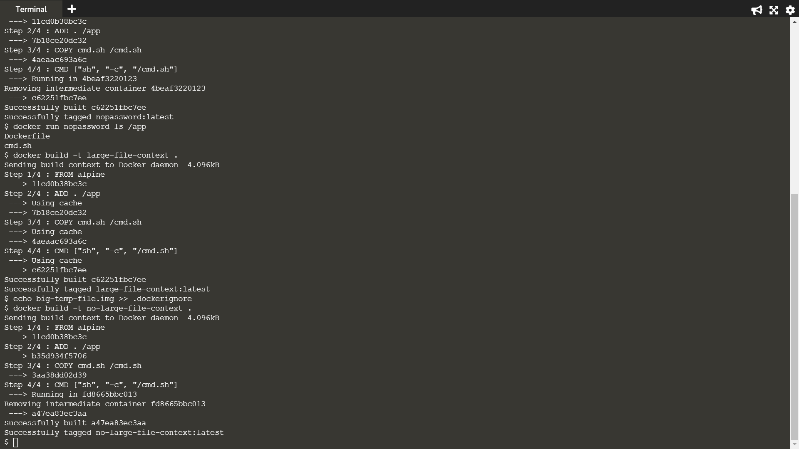

Pushing large files while building image



Using dockerignore to stop 100M files from getting pushed when building the image

