**Lab Experiment-4**

* **Creating a Docker image and pushing it to Docker hub.**

In this experiment, we will create a customized Docker image and then push it to the Docker hub repository.

The steps that need to be followed are:

1. Create a Docker file with the name “Dockerfile” and add the code shown below in it.

Command: nano Dockerfile

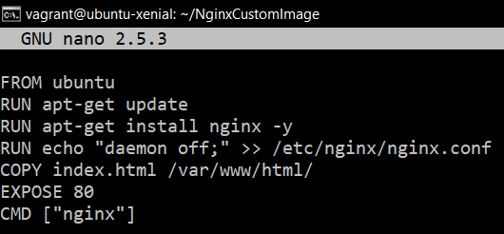`

This code will execute in layers as follows:

Layer 1: Ubuntu image will be used as base OS image.

Layer 2: The image will be updated.

Layer 3: Nginx will be installed on the Ubuntu Image.

Layer 4: Configuration file of Nginx will be altered to set daemon off.

Layer 5: A file named index.html will be copied from current directory to /var/www/html.

Layer 6: Port 80 of the container will be exposed.

Layer 7: Nginx will be started.

2. Create another file named index.html and add some basic webpage code in it.

Command: nano index.html

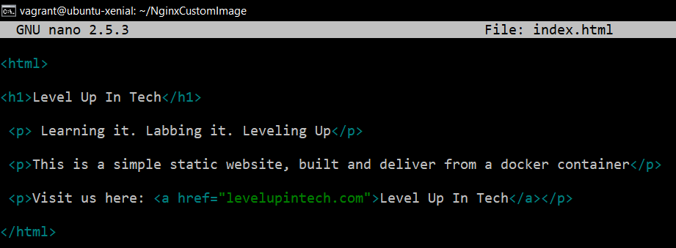

The above code will just create a simple webpage for testing purpose.

3. Now we are ready to build an image using this dockerfile.

Command: docker build .

(Here . specifies current directory)

You will see the layers specified in the Dockerfile being executed as steps.

After successful execution of the steps specified in the Dockerfile, you will see a success message and the image will be built.

The newly created image can be listed as follows:

Command: docker images

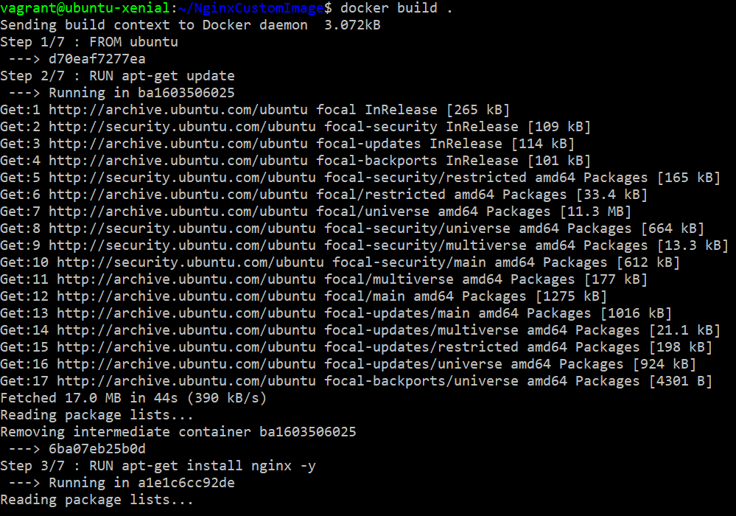

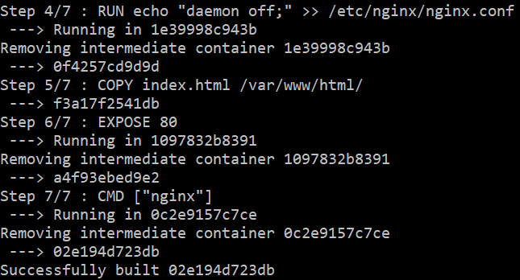

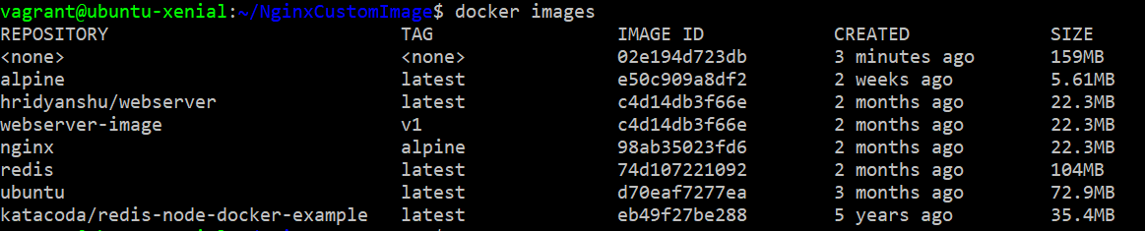

4. Now we will create a repository on Docker hub as follows:

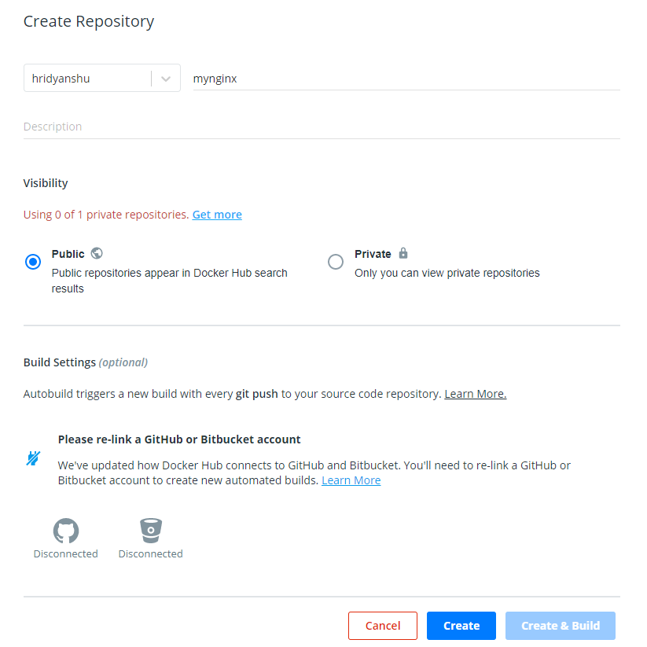

You will get an empty repository as follows:

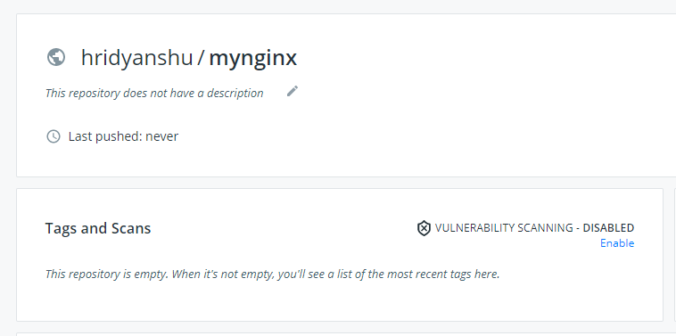

5. Now we will provide a tag to our image.

Command syntax: docker tag <image-id> <repository-with-tag>

Our repository name is “hridyanshu/mynginx” and we will give a tag 1.0 as follows:

Command: docker tag 02e19 hridyanshu/mynginx:1.0

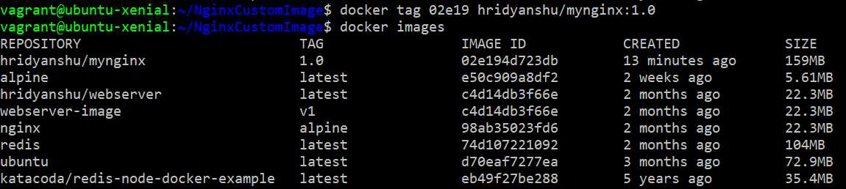

As you can see above, now we have verified that the image has the specified tag.

6. Login to your docker hub account.

Command: docker login

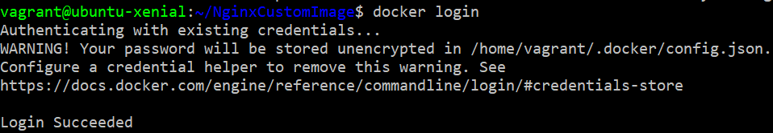

7. Push the image on docker hub.

Command: docker push hridyanshu/mynginx:1.0

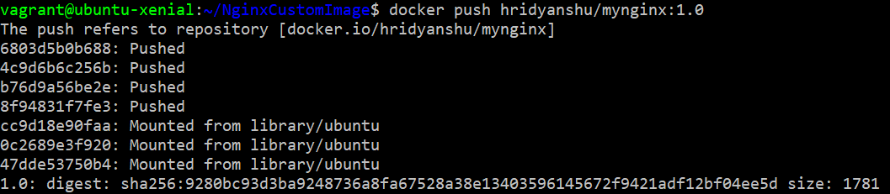

The image will be visible on the repository.

