**Lab Experiment-5**

* **Multi-container setup using Docker Compose.**

Docker Compose is a tool used to create a Docker application that will run on multiple containers. A YAML configuration file is used where the configuration of the containers is given.

In this experiment, we will create a two-service configuration with MySQL as database and Nginx image as web server.

The steps that need to be followed are:

1. Make sure that docker-compose is installed in your machine. If not, then install it as follows:

Command1: sudo curl -L https://github.com/docker/compose/releases/download/1.21.2/docker-compose-$(uname -s)-$(uname -m) -o /usr/local/bin/docker-compose

Command2: sudo chmod +x /usr/local/bin/docker-compose

The installation can be verified by using “docker-compose --version”



2. Make a .env file with the value of environment variables of MySQL as follows:

MYSQL_ROOT_PASSWORD=<password>

MYSQL_DATABASE=<database-name>

MYSQL_USER=<username>

Provide the values of these variables in the file.



As shown above, the values of environment variables is provided in the file.

This file will be used to refer to the value of specified variables.

3. Make a YAML configuration file with the name “docker-compose.yml” and provide the configuration of containers in this file.

Here, we are defining two services namely databases and web. Databases service uses mysql image container and port 3307 of the container is bind to port 3306 of the machine. The environment file created in the previous step is specified for the value of environment variables.

Web service uses nginx image container and port 80 of the container is bind to the port 80 of the machine. The web service depends on the databases service.

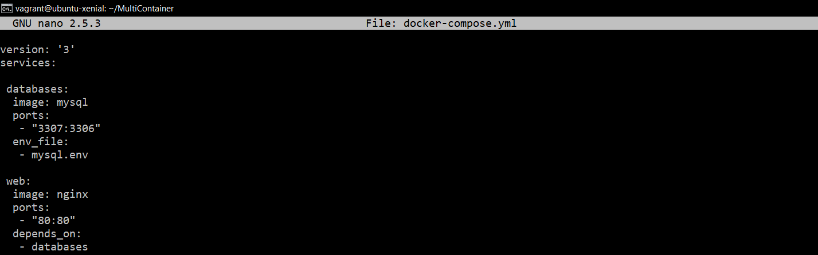

4. Run the services specified in the above files as follows:

Command: docker-compose up

You will see a similar output:

