**Lab Experiment-6**

* **Linking two containers using Docker link.**

Docker link feature allows containers to get aware of the presence of each other and thus, the containers are able to communicate with each other.

Here, we are going to create two different containers and then we will link them using docker link. The steps that need to be followed are:

**1.** Run a container in detached mode (to keep it running in the background). The container is being named db here and the image being used for the container is “training/postgres”.

Command: docker run –it –d --name db training/postgres

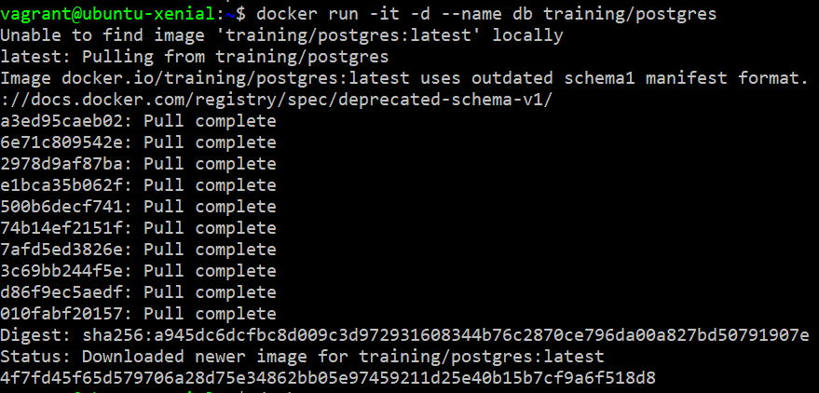

We can verify that the above specified container is running by using the command: docker ps



2. Now we will run another container in detached mode. This container is being named “web” and the image being used to create this container is “training/webapp”.

We will link this container to the container db (that we created in the above step) with alias mydb. We will pass an inline command “python app.py” while running this container.

Command: docker run –it –d --name web --link db:mydb training/webapp python app.py

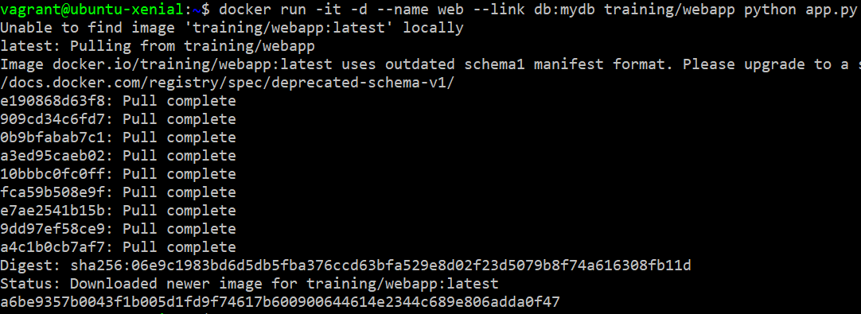

Now, both the containers are linked together and are ready to communicate.

3. Verify the connection between the containers. To do this, open the bash terminal of web container and ping mydb.

Command: docker exec –it web bash

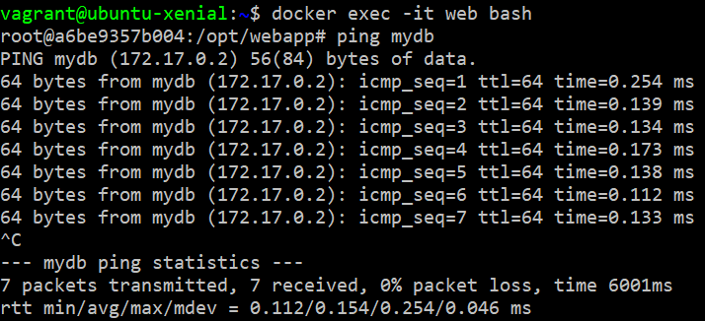

* **Docker stats:** We can see the stats of the running containers and can monitor them using docker stats.

Command: docker stats



Here real time stats of the containers that were run in the above steps are shown.